Safety Helmet Detection System

  - AIRI Team PITB AI Internship Task 1
  - Arisha Azhar
  - Lahore college for women university
  - BS Computer Science
  - 20/9/26

- Introduction
1.1 Introduction
Workplace safety is an important concern in construction sites and other industrial environments where workers are exposed to potential head injuries. Safety helmets are commonly used as protective equipment to reduce the risk of head injuries. However, manually monitoring whether every worker is wearing a helmet can be difficult, especially in large or crowded working environments.
Computer vision and object detection techniques can help automate this monitoring process. In this project, a Safety Helmet Detection System was developed using the YOLOv8 object detection model. The system detects whether a visible person is wearing a safety helmet or not by identifying the corresponding objects in an image.
1.2 Problem Statement
The main problem addressed in this project is the automatic detection of safety helmet usage from images.
Manual monitoring can become challenging when:
- Many workers are present at the same time.
- Workers appear at different distances and angles.
- Objects are small or partially occluded.
- Lighting and background conditions vary.
- Crowded scenes contain multiple workers.
Therefore, this project aims to develop an object detection model that can identify two classes:
- Helmet
- No Helmet
The trained model uses bounding boxes and confidence scores to locate and classify these objects in unseen images.

2.Project Objective
The main objective of this project is to develop an object detection system for identifying safety helmet usage using YOLOv8.
The project specifically aims to:
- Develop a computer vision model capable of detecting helmets and people without helmets.
- Prepare a properly annotated dataset suitable for YOLOv8 object detection.
- Train a pretrained YOLOv8n model using the prepared dataset.
- Evaluate the model using standard object detection metrics.
- Perform inference on unseen test images and visualize the model's predictions.
- Analyze incorrect, missed, duplicate, and weak detections.
- Identify improvements that could increase detection performance in future work.

3. Tools & Technologies
The following tools and technologies were used to develop the Safety Helmet Detection System:
Tool / Technology | Purpose
Python | Main programming language
YOLOv8n | Object detection model
Ultralytics | YOLOv8 training, validation, and inference
Roboflow | Dataset preparation, annotation, and dataset management
Google Colab | Model training and experimentation
Google Drive | Dataset, model, and result storage
OpenCV | Computer vision and image processing
NumPy | Numerical and array operations
Matplotlib | Visualization of training and evaluation results
Model: YOLOv8n (pretrained)
Image size: 640 × 640 pixels
Training epochs: 30
Classes: Helmet, No Helmet
4. Dataset
A dedicated object detection dataset was prepared for the Safety Helmet Detection System. The final dataset contains 433 images with two object classes:
- Helmet
- No Helmet
The dataset was prepared and managed using Roboflow and exported in YOLOv8 format.
4.1 Dataset Split
Dataset Split | Images
Training | 303
Validation | 88
Testing | 42
Total | 433
The dataset follows an approximately 70% / 20% / 10% training, validation, and testing distribution.
4.2 Dataset Classes
The final class mapping used by the model was:
Class ID | Class Name
0 | Helmet
1 | No Helmet
The annotations contain bounding boxes around the relevant objects, allowing YOLOv8 to learn both the location and class of each object.
5. Dataset Preparation & Annotation
The dataset was prepared for object detection using Roboflow. The images were reviewed and organized according to the two target classes: Helmet and No Helmet.
Bounding-box annotations were used to identify the location of each relevant object in the images. The annotations were exported in YOLOv8 format for compatibility with the Ultralytics YOLOv8 training pipeline.
The final dataset contains:
- 433 images
- 2 object classes
- 1,168 annotations
- YOLO-format image and label files
- Separate training, validation, and testing directories
5.1 Annotation Guidelines
During annotation, the following principles were followed:
- Each visible target object was assigned an appropriate class.
- Bounding boxes were placed around the relevant objects.
- The two class names were kept consistent throughout the dataset.
- The annotations were reviewed before model training.
- The final class mapping was maintained as:
  - 0 → helmet
  - 1 → no_helmet
The prepared dataset was then exported in YOLOv8 format and used for model training.

6. Dataset Structure
The final dataset was organized in the standard YOLOv8 object detection structure. It contains separate directories for training, validation, and testing images and their corresponding label files.
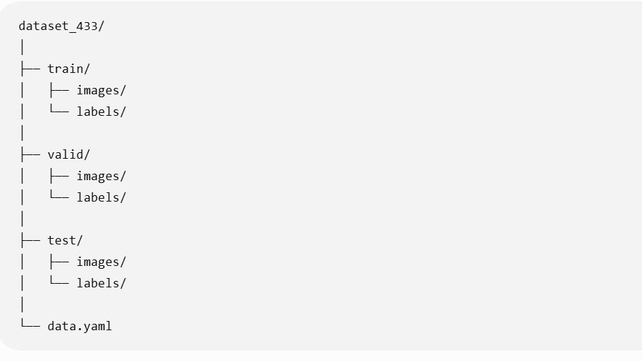
The data.yaml file defines the dataset paths and class information used during training:
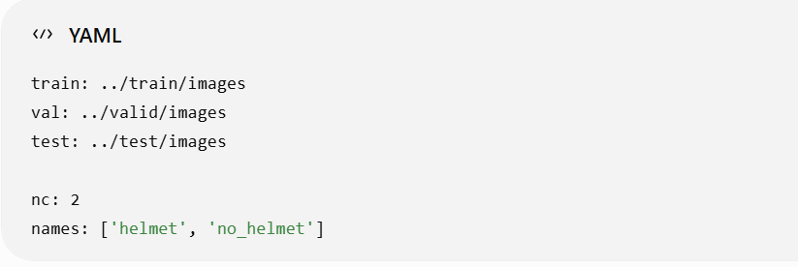
Each image has a corresponding YOLO-format label file containing the class ID and normalized bounding-box coordinates. This structure allows the Ultralytics YOLOv8 framework to automatically load the dataset for training, validation, and testing.
7. Model Training
The final model was trained using YOLOv8n, the nano version of the YOLOv8 object detection model. A pretrained YOLOv8n model was used as the starting point for training.
The training configuration was:
Parameter | Value
Model | YOLOv8n
Pretrained weights | yolov8n.pt
Epochs | 30
Image size | 640 × 640
Batch size | 8
Device | CPU
Number of classes | 2
Optimizer | Ultralytics default
The model was trained using the final 433-image dataset. During training, the model learned to detect the two target classes, helmet and no_helmet.
The best-performing model weights were saved as:
/content/runs/detect/train/weights/best.pt
The trained best.pt file was also stored in the project Google Drive for use during validation, testing, and inference.
7.1 Training Results
The training process generated epoch-wise metrics and loss values. These results were saved in:
- results.png
- results.csv
The results.png file contains the training and validation curves used to analyze model learning throughout the 30 training epochs.
8. Model Evaluation
The trained YOLOv8n model was evaluated on both the validation and testing datasets. The evaluation used Precision, Recall, mAP@0.5, and mAP@0.5:0.95.
8.1 Validation Results
The validation results were:
Class | Precision | Recall | mAP@0.5 | mAP@0.5:0.95
Helmet | 0.810 | 0.627 | 0.711 | 0.355
No Helmet | 0.641 | 0.471 | 0.475 | 0.168
Overall | 0.725 | 0.549 | 0.593 | 0.261
The validation evaluation was performed on 86 images containing 230 annotated instances according to the Ultralytics evaluation output.
8.2 Test Results
The final model was also evaluated on the separate test set:
Class | Precision | Recall | mAP@0.5 | mAP@0.5:0.95
Helmet | 0.728 | 0.493 | 0.560 | 0.269
No Helmet | 0.547 | 0.512 | 0.542 | 0.254
Overall | 0.638 | 0.502 | 0.551 | 0.261
The test evaluation used 42 images containing 149 annotated instances.
8.3 Evaluation Visualizations
The following evaluation outputs were generated and saved in the project:
- Confusion matrix
- Normalized confusion matrix
- Training and validation loss curves
- Precision curve
- Recall curve
- F1-score curve
- Precision-Recall curve
- Epoch-wise results in results.csv
These visualizations were used to understand the model's classification performance and training behavior.
9. Inference Results
After training and evaluation, the trained YOLOv8n model was used to perform inference on 15 unseen test images.
For each image, the model generated:
- Bounding boxes around detected objects
- Predicted class labels
- Confidence scores for each detection
The confidence scores indicate how confident the model was about each prediction.
The prediction results showed that the model was able to correctly detect several helmet and no-helmet cases. However, some challenging situations resulted in missed detections, duplicate detections, and low-confidence predictions, particularly in crowded scenes and images containing small or partially visible objects.
A total of 15 prediction images were selected and saved for inclusion in the final project report.
Prediction output location:
Helmet_Detection_YOLO/
└── final_predictions_15/
The prediction images provide a visual representation of the model's real-world detection performance and are used as the basis for the error analysis in the next section.
10. Error Analysis
The model predictions were manually reviewed to identify common detection errors. 10 representative cases were selected from the 15 prediction images.
Case | Actual Objects | Model Prediction | Error Type | Observation
1 | 2 No Helmet | 2 overlapping detections | Duplicate detection | Multiple boxes were produced around the same object.
2 | 1 Helmet | 2 Helmet detections | Duplicate detection | An additional overlapping helmet detection was produced.
3 | 1 Helmet | No detection | False negative | The visible helmet was not detected.
4 | 2 No Helmet | 1 No Helmet | False negative | One visible object was missed.
5 | 1 No Helmet | 2 No Helmet detections | Duplicate detection | Two overlapping predictions were produced.
6 | 35 No Helmet | 22 No Helmet | Multiple false negatives | Several objects were missed in a crowded scene.
7 | 15 Helmet + 1 No Helmet | 13 Helmet + 1 No Helmet | False negatives | Two helmet objects were missed.
8 | 1 No Helmet | No detection | False negative | The visible no-helmet object was not detected.
9 | 1 Helmet | Helmet + low-confidence No Helmet | Weak/wrong-class prediction | An additional low-confidence incorrect class was predicted.
10 | 3 No Helmet | 3 No Helmet | Weak predictions | All objects were detected, but confidence scores were relatively low.
10.1 Common Error Patterns
The analysis identified several recurring issues:
- False negatives: Some visible objects were missed completely.
- Duplicate detections: Multiple overlapping boxes were sometimes produced for the same object.
- Crowded-scene difficulty: Detection performance decreased when many objects appeared together.
- Small-object difficulty: Smaller or less clearly visible objects were more likely to be missed.
- Low-confidence predictions: Some detections had relatively low confidence scores.
- Occasional wrong-class predictions: Additional low-confidence predictions could have an incorrect class.
These observations provide useful information for improving the model in future experiments.
11. Suggested Improvements
Based on the evaluation results and manual error analysis, the following improvements could help increase the performance of the Safety Helmet Detection System:
- Increase and diversify the dataset
Add more images containing crowded scenes, small objects, different camera angles, different backgrounds, and varied lighting conditions.
- Improve annotation quality
Carefully review bounding boxes, especially for small, partially visible, or overlapping objects. Consistent and accurate annotations can help the model learn object boundaries more effectively.
- Experiment with larger YOLO models
Future experiments can compare YOLOv8n with larger models such as YOLOv8s or YOLOv8m to determine whether additional model capacity improves detection performance.
- Experiment with training settings
Different numbers of epochs, batch sizes, augmentation settings, and confidence thresholds can be tested to determine their effect on detection performance.
- Focus on crowded scenes
Since several missed detections occurred in crowded images, additional training examples of crowded environments could help improve detection of small and overlapping objects.
These improvements could be evaluated in future experiments to determine which changes provide measurable improvements in Precision, Recall, and mAP.

12. Conclusion / Learning Outcomes
The Safety Helmet Detection System was successfully developed as an end-to-end object detection project using YOLOv8n. A dataset of 433 images with two classes, helmet and no_helmet, was prepared, annotated, and used for model training.
The trained model was evaluated using standard object detection metrics and tested on unseen images. The inference results demonstrated that the model can detect helmet-related objects, while the error analysis identified challenges such as missed detections, duplicate detections, crowded scenes, and low-confidence predictions.
The project provided practical experience in dataset preparation, object annotation, YOLOv8 model training, model evaluation, inference, visualization, and error analysis.
12.1 Learning Outcomes
Through this project, the following skills and concepts were practiced:
- Object detection using YOLOv8
- Dataset preparation and annotation
- YOLO-format dataset organization
- Training a pretrained deep learning model
- Model validation and testing
- Precision, Recall, and mAP evaluation
- Confusion matrix analysis
- Visual inference and prediction analysis
- Error analysis of object detection models
- Identifying possible improvements for future experiments

13. Project Files / Links
The project files were organized in Google Drive and include the dataset, trained model, evaluation results, prediction images, and supporting files.
13.1 Main Project Files
- YOLOv8 Dataset: dataset_433/
- Dataset Configuration: data.yaml
- Trained Model: best.pt
- Training Results: results.png, results.csv
- Confusion Matrix: confusion_matrix.png
- Normalized Confusion Matrix: confusion_matrix_normalized.png
- Prediction Results: final_predictions_15/
- Error Analysis: Included in this report
13.2 Project Repository
🔗 GitHub Repo: https://github.com/arishaazhar075-bit/-helmet-detection-yolov8
13.3 Google Drive
Google Drive:
https://drive.google.com/drive/folders/1PdiCSPTUmpBjsUfvQa4ST-rfkKcOVCbV?usp=sharing
13.4 Notebook
The complete project notebook contains the dataset verification, model training, validation, testing, inference, and result generation steps.
Google Colab Notebook:
📓 Notebook: https://github.com/arishaazhar075-bit/-helmet-detection-yolov8/blob/main/training_notebook.ipynb

