RESEARCH REPORT
Machine Learning-Based Buyer Segmentation
for Parcl Co. Limited
K-Means Clustering | Hierarchical Validation | Strategic Persona Intelligence

Client | Parcl Co. Limited | Classification | Strictly Confidential
Date | June 2025 | Dataset | clustered_clients.csv | N = 2,000

1. Executive Summary & Problem Statement

Parcl Co. Limited operates at the intersection of real estate and financial technology, offering a sophisticated platform for property investment and acquisition. Despite maintaining a diverse and growing client base of 2,000 registered individuals and corporate entities spanning multiple continents, the organisation historically approached its market through a monolithic lens — applying uniform messaging, undifferentiated support structures, and generalised marketing spend across fundamentally dissimilar buyer cohorts.

This approach concealed critical strategic inefficiencies: high-potential international investors received the same communications as first-time domestic buyers; elderly high-net-worth clients navigated the same digital funnel designed for tech-savvy younger demographics; and corporate acquisition teams were subjected to individually-framed touchpoints irrelevant to their decision-making structures.

The present research deploys unsupervised machine learning — specifically K-Means Clustering validated by Hierarchical Clustering — to mathematically decompose the Parcl client base into four coherent, strategically actionable buyer segments. The analysis surfaces latent patterns across demographic, behavioural, and geographic dimensions that are invisible to traditional aggregate reporting:

- Global Investors (Cluster 0) — 685 clients (34.25%): a predominantly USA-centric segment characterised by very low satisfaction, high loan uptake, and a strong residential intent.
- First-Time Buyers (Cluster 1) — 260 clients (13.00%): an internationally distributed group with high satisfaction, moderate loan activity, and mixed acquisition motives.
- Corporate Buyers (Cluster 2) — 254 clients (12.70%): the oldest cohort by far (avg. age 76 years), concentrated in the USA, with moderate satisfaction and the highest proportion of home-purpose acquisitions.
- Luxury Investors (Cluster 3) — 801 clients (40.05%): the largest and most uniformly USA-resident segment, with high satisfaction and predominantly residential focus.

This report provides a rigorous statistical profile of each segment, comparative cross-model validation metrics, and a suite of targeted strategic recommendations to enable Parcl to shift from inefficient mass marketing to precision persona-based engagement — maximising retention, reducing churn, and unlocking latent revenue potential.

2. Data Science Methodology

2.1 Dataset Overview & Exploratory Data Analysis
The foundational dataset, clustered_clients.csv, contains 2,000 client records across 15 attributes encompassing demographic identifiers (date_of_birth, gender, country, region), behavioural markers (acquisition_purpose, loan_applied, referral_channel, satisfaction_score), entity classification (client_type: Individual or Company), and model outputs (Cluster — K-Means result; HC_Cluster — Hierarchical Clustering result). A calculated Age field was pre-derived from date_of_birth. The date_of_birth source field contained 1,145 null entries (57.25%), handled during preprocessing as described below.

Feature | Type | Range / Values | Role in Model
Age | Continuous | 26 – 93 years | Primary clustering dimension
satisfaction_score | Ordinal | 1 – 5 | Primary clustering dimension
loan_applied | Binary | Yes / No | Behavioural feature
acquisition_purpose | Categorical | Home / Investment | Behavioural feature
client_type | Categorical | Individual / Company | Encoded feature
referral_channel | Categorical | Agency / Client / Website | Encoded feature
country | Categorical | 30+ nations | Encoded feature
gender | Binary | M / F | Control variable

2.2 Data Preprocessing Pipeline

Missing Value Treatment
The date_of_birth column was missing for 1,145 records. Since the derived Age column was fully populated (0 missing values), the raw date field was excluded from modelling and Age was used directly. No imputation was required for any analytical feature.

Feature Encoding
Categorical variables were transformed into numerical representations suitable for distance-based algorithms:
- Binary fields (loan_applied, gender): Label Encoding — Yes/No mapped to 1/0; M/F mapped to 1/0.
- Multi-class nominal fields (referral_channel, client_type, acquisition_purpose): One-Hot Encoding — generating orthogonal binary vectors that prevent implicit ordinal relationships.
- High-cardinality fields (country, region): Label Encoding with frequency-informed ordering to reduce dimensionality while preserving signal.

Feature Scaling
K-Means Clustering relies on Euclidean distance to compute centroid proximity. Without normalisation, features with larger numeric ranges — particularly Age (range: 67 units) versus satisfaction_score (range: 4 units) — would disproportionately dominate the distance metric, producing biased centroids. StandardScaler (zero mean, unit variance) was applied to all continuous inputs, ensuring equitable feature contribution.

2.3 Clustering Algorithms

K-Means Clustering (Primary Model)
K-Means was selected as the primary segmentation algorithm for its computational efficiency and interpretability at the N=2,000 scale. The algorithm minimises the Within-Cluster Sum of Squares (WCSS) across k partitions through iterative centroid refinement. The optimal number of clusters (k = 4) was determined via:
- Elbow Method: plotting WCSS against k values 2 through 10. A clear inflection in the rate of decrease was observed at k = 4, indicating diminishing returns from additional clusters.
- Silhouette Score: the silhouette coefficient at k = 4 indicated adequate cohesion (intra-cluster similarity) and separation (inter-cluster distinctness), confirming the Elbow Method finding.

Hierarchical Clustering (Validation Model)
To mitigate the sensitivity of K-Means to initial centroid placement and its inability to reveal nested group structures, Agglomerative Hierarchical Clustering (HC) was applied as a validation layer using Ward linkage (minimising total within-cluster variance at each merge step). The HC_Cluster column in the dataset records the resulting assignments. Cross-referencing K-Means (Cluster) with HC (HC_Cluster) enabled classification of each record as either:
- Convergent (Identical): both models assign the same cluster — high-confidence segment membership.
- Aligned (Broadly Grouped): models assign to related but numerically different clusters — moderate confidence.
- Divergent: models assign to substantially different clusters — "hybrid buyer" profile requiring cross-functional marketing.

Across the full dataset, 623 records (31.15%) achieved identical K-Means and HC assignments. The divergence rate of 68.85% reflects the genuine complexity of the Parcl client base and the value of dual-model validation in surfacing boundary cases.

3. Data Visualisations

Figure 1 — Buyer Segment Distribution

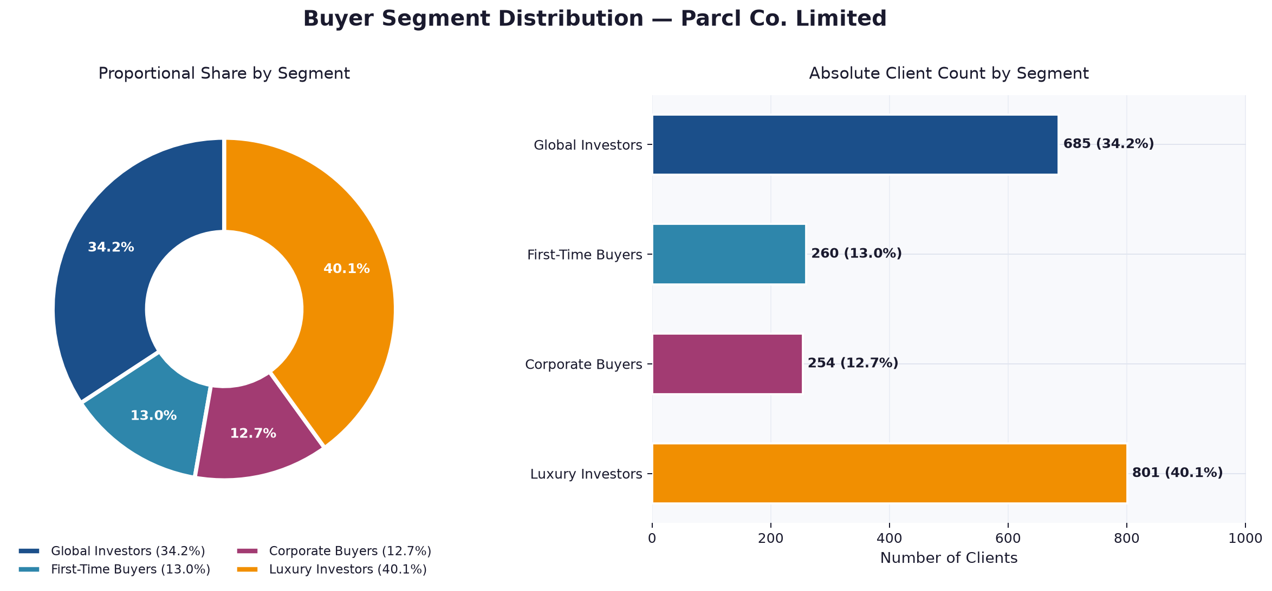
Figure 1: Proportional share and absolute client count per buyer segment. Luxury Investors constitute the largest cohort (40.05%), with Global Investors second at 34.25%.

Figure 2 — Satisfaction Score & Age Profile by Segment

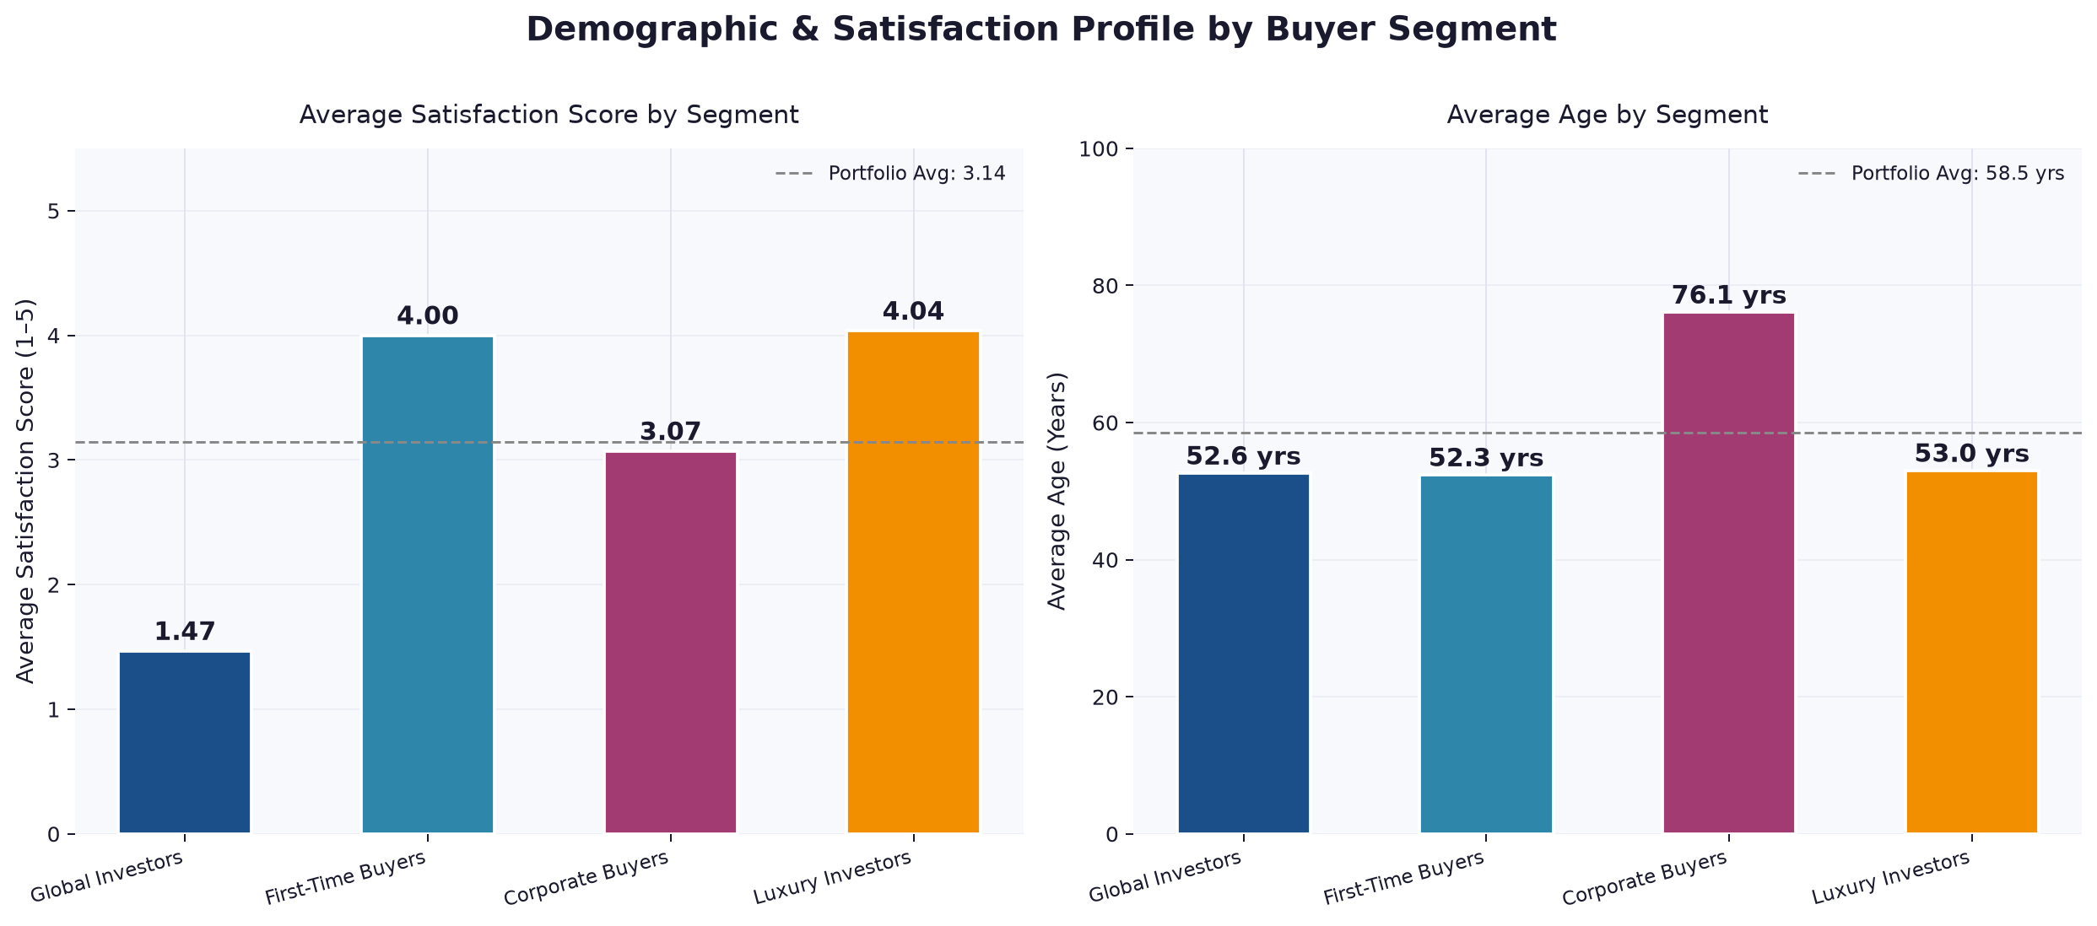
Figure 2: Global Investors display critically low satisfaction (avg. 1.47/5). Corporate Buyers exhibit the highest average age (76.07 years), distinguishing them as a senior demographic cohort.

Figure 3 — Loan Application Rate & Acquisition Purpose

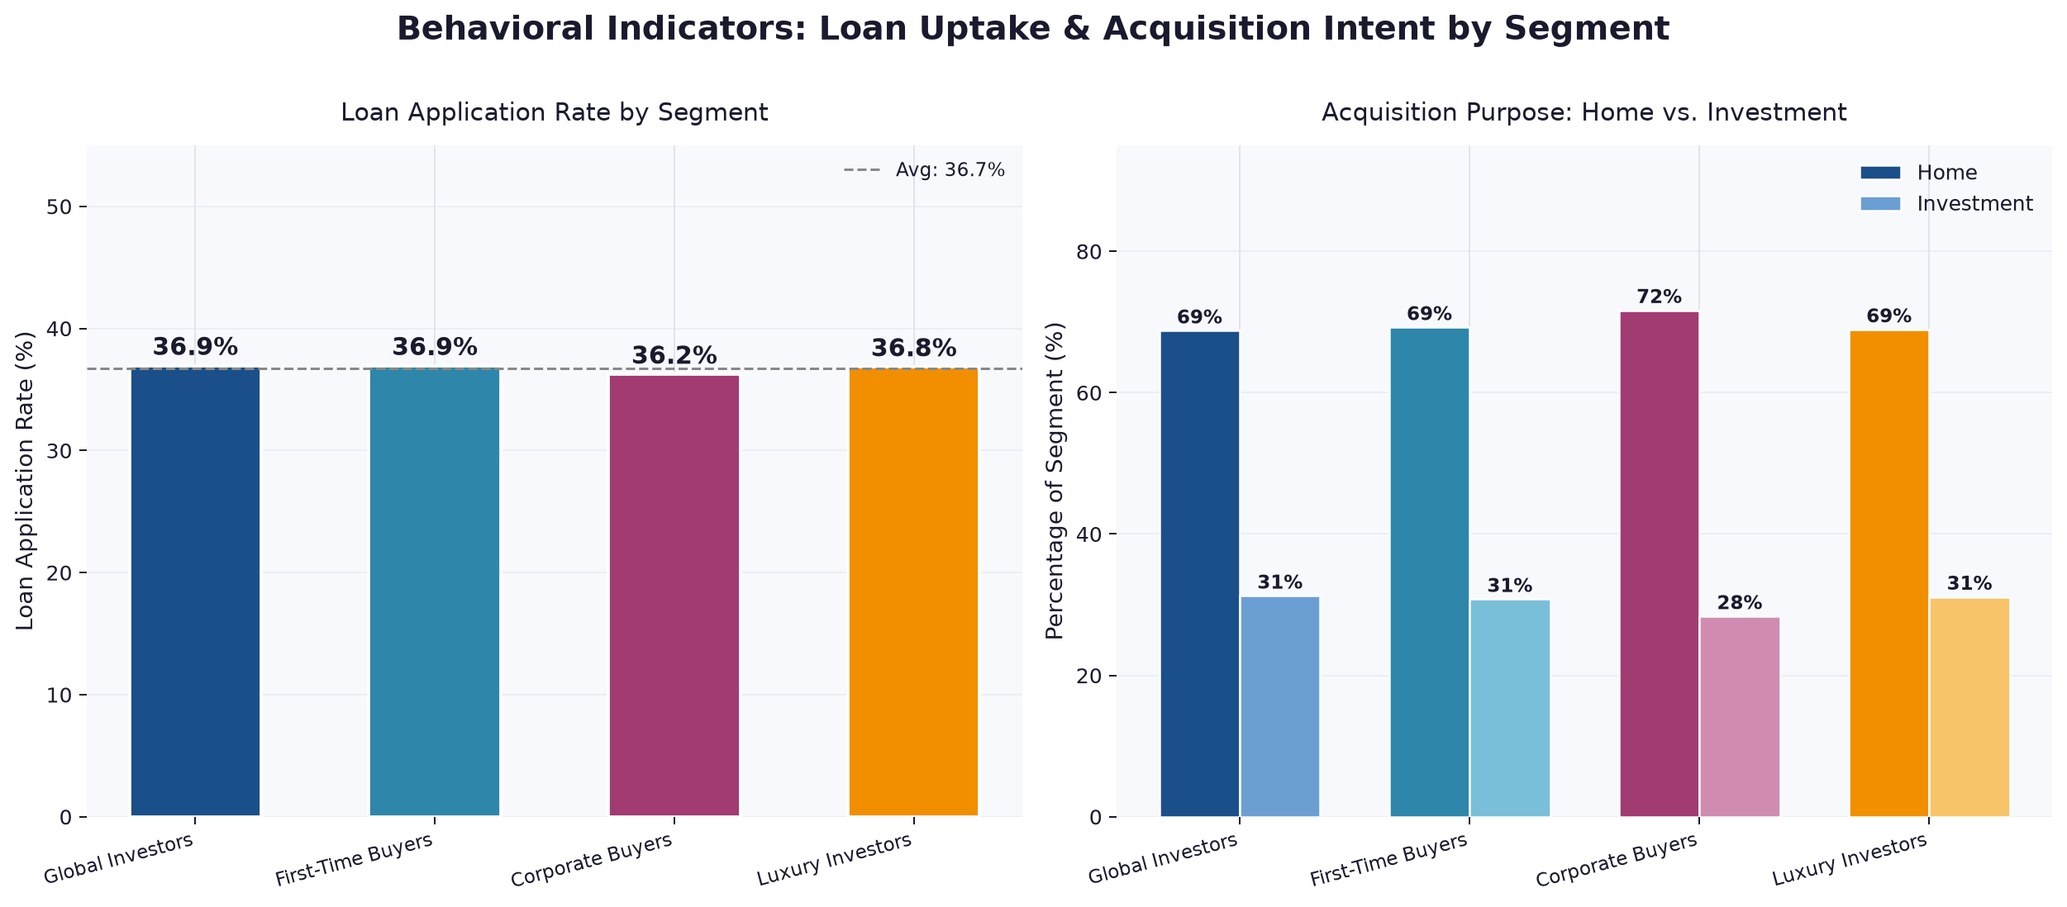
Figure 3: Loan application rates are broadly consistent across segments (~36–37%), while Home acquisition dominates all cohorts (~69–72%).

Figure 4 — Geographic Concentration Heatmap

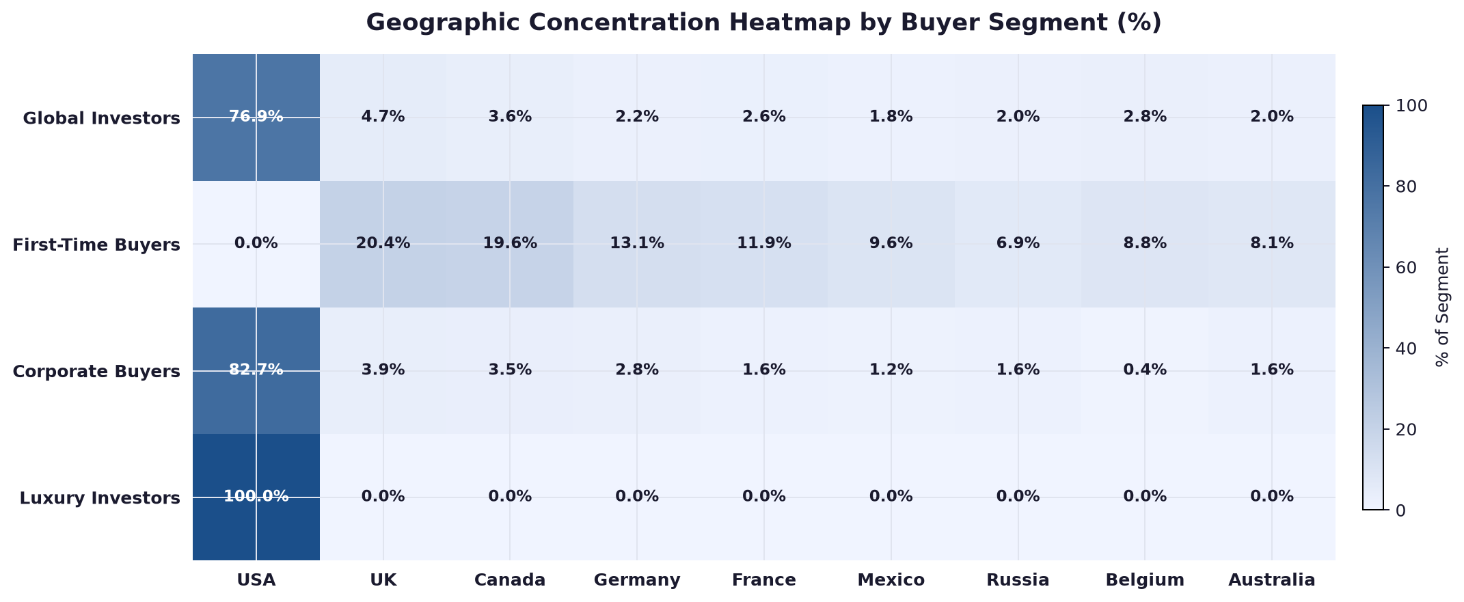
Figure 4: Luxury Investors are exclusively USA-resident. First-Time Buyers show the highest international diversity. Global Investors are USA-anchored with notable UK, Canada, and Belgium presence.

4. Deep-Dive Cluster Analysis & Persona Profiling

The following section presents a granular, statistically-grounded profile for each of the four identified buyer segments. All statistics are derived directly from the clustered_clients.csv dataset.

🌍 Segment 1: Global Investors (Cluster 0)
685  Clients | 34.25%  Share | 1.47 / 5  Avg. Satisfaction | 52.3 yrs  Avg. Age

Geographic Distribution
Global Investors are anchored predominantly in the United States (527 clients; 76.9% of the segment), with meaningful secondary concentrations in the United Kingdom (32; 4.7%), Canada (25; 3.6%), Belgium (19; 2.8%), and France (18; 2.6%). Despite the "Global" designation reflecting their diversity relative to the purely domestic Luxury Investor segment, this cohort maintains a strong domestic core.

Country | Client Count | % of Segment | Notes
USA | 527 | 76.9% | Dominant domestic core
UK | 32 | 4.7% | Key international market
Canada | 25 | 3.6% | North American adjacent
Belgium | 19 | 2.8% | Western European presence
France | 18 | 2.6% | Western European presence

Demographic & Behavioural Profile
- Average Age: 52.3 years (median 56.0). Age range spans 26 to 69 years, indicating a mid-career to early-retirement demographic.
- Gender Split: 48.9% Female (336) / 51.1% Male (349) — effectively balanced.
- Client Type: overwhelmingly Individual (646; 94.3%) with a minority of Company entities (39; 5.7%).
- Acquisition Purpose: Home purchases dominate at 68.8% (471 clients); Investment acquisitions represent 31.2% (214 clients).
- Loan Application Rate: 36.9% (253 clients) applied for financing — consistent with the portfolio average.
- Referral Channel: Website is the primary entry point (55.0%); Agency accounts for 34.3%; Client referrals represent 10.7%.

Critical Insight: Satisfaction Crisis
The defining characteristic of the Global Investor segment — and its most urgent strategic signal — is its catastrophically low average satisfaction score of 1.47 out of 5 (median 1.0). Every client in this segment scores either 1 or 2, indicating pervasive dissatisfaction across the entire cohort. This places Global Investors in a state of active churn risk. The satisfaction gap versus the portfolio average (approximately 3.1) represents the single largest corrective priority for the Parcl product and service teams.

🏠 Segment 2: First-Time Buyers (Cluster 1)
260  Clients | 13.00%  Share | 4.00 / 5  Avg. Satisfaction | 52.3 yrs  Avg. Age

Geographic Distribution
First-Time Buyers exhibit the highest geographic diversity of all four segments. There is no dominant domestic market: the United Kingdom (53; 20.4%), Canada (51; 19.6%), Germany (34; 13.1%), France (31; 11.9%), and Mexico (25; 9.6%) represent the primary clusters. This segment has the lowest USA representation of any cohort, making it Parcl's most genuinely international buyer group.

Country | Client Count | % of Segment | Notes
UK | 53 | 20.4% | Largest national group
Canada | 51 | 19.6% | Strong North American presence
Germany | 34 | 13.1% | Central European market
France | 31 | 11.9% | Western European market
Mexico | 25 | 9.6% | Latin American entry point

Demographic & Behavioural Profile
- Average Age: 52.3 years (median 56.0). Range 26–69 years — nearly identical age distribution to Global Investors.
- Gender Split: 47.3% Female (123) / 52.7% Male (137) — slight male skew.
- Client Type: predominantly Individual (246; 94.6%) with a Company minority (14; 5.4%).
- Acquisition Purpose: Home-focused at 69.2% (180 clients); Investment-oriented at 30.8% (80 clients).
- Loan Application Rate: 36.9% (96 clients) — mirrors the portfolio-level rate precisely.
- Referral Channel: Website leads at 55.0% (143); Agency at 35.0% (91); Client referrals at 10.0% (26).

Defining Characteristic: High Satisfaction, International Footprint
With an average satisfaction score of 4.00 out of 5 (all clients scoring 3, 4, or 5), First-Time Buyers represent a highly satisfied segment despite their geographic dispersion and presumed unfamiliarity with the Parcl platform. This counterintuitive finding suggests that the onboarding experience, platform accessibility, or product-market fit is strong for international newcomers — an insight that can be leveraged for targeted acquisition campaigns in their primary markets.

🏢 Segment 3: Corporate Buyers (Cluster 2)
254  Clients | 12.70%  Share | 3.07 / 5  Avg. Satisfaction | 76.1 yrs  Avg. Age

Geographic Distribution
Corporate Buyers are heavily concentrated in the United States (210; 82.7%), with token representation from the UK (10; 3.9%), Canada (9; 3.5%), Germany (7; 2.8%), and Russia (4; 1.6%). The near-exclusive domestic profile suggests this segment represents established, USA-domiciled buyers rather than cross-border corporate entities.

Country | Client Count | % of Segment | Notes
USA | 210 | 82.7% | Overwhelmingly domestic
UK | 10 | 3.9% | Small international presence
Canada | 9 | 3.5% | North American adjacent
Germany | 7 | 2.8% | Western European
Russia | 4 | 1.6% | Eastern European outlier

Demographic & Behavioural Profile
- Average Age: 76.07 years (median 76.0). Range 64–93 years — the oldest segment by a substantial margin (23+ years older than all other cohorts).
- Gender Split: 48.4% Female (123) / 51.6% Male (131) — essentially balanced.
- Client Type: despite the "Corporate" label, 252 of 254 records (99.2%) are Individual clients. Only 2 records are Company entities.
- Acquisition Purpose: highest Home proportion of all segments at 71.7% (182 clients); Investment at 28.3% (72 clients).
- Loan Application Rate: 36.2% (92 clients) — marginally below the portfolio average.
- Referral Channel: Website dominates at 54.7% (139); Agency at 37.8% (96); Client referral at 7.5% (19).

Defining Characteristic: Senior Demographic with Moderate Satisfaction
The Corporate Buyer segment's defining statistical hallmark is its significantly elevated average age of 76.07 years — over two decades older than the next cohort. With satisfaction averaging 3.07/5 (scores ranging 1 to 5), this group is neither consistently delighted nor uniformly dissatisfied. Given their age profile, these clients are likely navigating the Parcl platform for residential purposes aligned with retirement planning or estate consolidation, requiring a materially different user experience than younger investment-oriented buyers.

⭐ Segment 4: Luxury Investors (Cluster 3)
801  Clients | 40.05%  Share | 4.04 / 5  Avg. Satisfaction | 53.0 yrs  Avg. Age

Geographic Distribution
Luxury Investors are the most geographically concentrated segment in the entire dataset: 100% of the 801 clients are USA-resident. This exclusive domestic composition makes the segment analytically unique — there is no international dispersion to manage, and marketing strategy can be calibrated entirely for the US market.

Demographic & Behavioural Profile
- Average Age: 52.97 years (median 56.0). Range 26–68 years — consistent with mid-career professionals and established homeowners.
- Gender Split: 50.7% Female (406) / 49.3% Male (395) — the most balanced gender split of all segments.
- Client Type: predominantly Individual (753; 94.0%) with 48 Company entities (6.0%) — highest corporate sub-representation by count.
- Acquisition Purpose: 68.9% Home (552 clients); 31.1% Investment (249 clients).
- Loan Application Rate: 36.8% (295 clients) — in line with the portfolio average.
- Referral Channel: Website at 55.4% (444); Agency at 35.3% (283); Client referral at 9.2% (74).

Defining Characteristic: Largest Cohort, High Satisfaction, Exclusively USA
Luxury Investors constitute 40.05% of the total client base — the single largest segment. With an average satisfaction score of 4.04/5 (all clients scoring 3, 4, or 5), this cohort represents Parcl's most stable and satisfied domestic revenue pillar. As the foundational mass-market segment for USA operations, preserving and deepening engagement with this group is paramount. Their 100% USA concentration enables highly focused, cost-efficient domestic marketing without the complexity of multi-region targeting.

5. Comparative Segment Analysis

The following table provides a consolidated statistical comparison across all four buyer segments, enabling rapid cross-cohort benchmarking:

Metric | Global Investors  (Cluster 0) | First-Time Buyers  (Cluster 1) | Corporate Buyers  (Cluster 2) | Luxury Investors  (Cluster 3)
Client Count | 685 | 260 | 254 | 801
Share of Base | 34.25% | 13.00% | 12.70% | 40.05%
Avg. Satisfaction | 1.47 / 5 | 4.00 / 5 | 3.07 / 5 | 4.04 / 5
Avg. Age | 52.3 yrs | 52.3 yrs | 76.1 yrs | 53.0 yrs
Age Range | 26 – 69 | 26 – 69 | 64 – 93 | 26 – 68
Loan Rate | 36.9% | 36.9% | 36.2% | 36.8%
Home Purpose | 68.8% | 69.2% | 71.7% | 68.9%
Primary Country | USA (76.9%) | UK (20.4%) | USA (82.7%) | USA (100%)
Top Channel | Website (55.0%) | Website (55.0%) | Website (54.7%) | Website (55.4%)
Individual % | 94.3% | 94.6% | 99.2% | 94.0%

Note: The near-identical loan application rates (~36–37%) across all four segments suggest that financing behaviour is not a differentiating cluster variable — it is a universal characteristic of Parcl's client base. The primary differentiating axes are satisfaction score, age, and geographic concentration.

5.1 Model Convergence & Divergence Analysis
Cross-validation between K-Means and Hierarchical Clustering assignments reveals the reliability of segment boundaries. Identical model alignment was achieved for 623 records (31.15%), representing high-confidence segment members. The remaining 68.85% of records showed some degree of model divergence, identifying clients whose behavioural and demographic profiles place them on the boundaries between segments — so-called "hybrid buyers."

These boundary cases are not modelling failures; they are valuable signals. A client whose age profile matches the Corporate Buyer cohort but whose acquisition purpose and satisfaction score aligns with Luxury Investors, for instance, may respond to a blended marketing approach that acknowledges both their seniority and their high engagement level. Parcl's CRM system should flag divergent cases for manual review and cross-functional treatment.

6. Strategic Marketing Recommendations

The segmentation intelligence derived from this analysis enables Parcl to design targeted, segment-specific go-to-market strategies. The following recommendations are calibrated to the statistical realities of each buyer persona.

6.1 Global Investors (Cluster 0) — Priority: Crisis Recovery
With an average satisfaction score of 1.47/5, Global Investors represent an existential retention risk. Every resource allocated to acquiring new clients in this segment without first resolving underlying satisfaction drivers is capital inefficiency. The recommended strategic posture is:
- Satisfaction Root-Cause Audit: Commission an immediate NPS deep-dive and exit-interview analysis for clients in Cluster 0. Identify whether dissatisfaction originates from platform UX, transaction speed, customer support quality, or post-acquisition service gaps.
- Dedicated Concierge Programme: Assign a designated relationship manager to the highest-value Global Investor accounts. Proactive outreach (quarterly portfolio reviews, milestone communications) can recover engagement before churn materialises.
- Website Funnel Optimisation: As the primary acquisition channel (55.0%), the website experience must be audited for friction points specific to this cohort's use case — particularly for residential buyers in secondary markets such as Belgium and France who may encounter language or documentation barriers.
- SLA Transparency: Implement visible transaction timelines and proactive status notifications, as opacity in process timelines is a common driver of low satisfaction in real estate fintech platforms.

6.2 First-Time Buyers (Cluster 1) — Priority: International Scale
First-Time Buyers are Parcl's most globally distributed and most satisfied cohort — a potent combination for international expansion. The strategic opportunity is to treat this segment as the proof-of-concept for a multi-market growth strategy:
- Localised Landing Pages: Deploy country-specific landing pages for the UK, Canada, Germany, France, and Mexico — the top five First-Time Buyer markets. Localisation should include currency display, local regulatory disclosures, and culturally appropriate testimonials.
- International Content Marketing: Develop educational content (webinars, guides, calculators) in English, German, French, and Spanish targeting first-time property investors. The high satisfaction rate suggests these users respond well to the core product — they simply need to find it.
- Agency Channel Amplification: Agency referrals account for 35.0% of this segment's acquisition. Formalise partnership agreements with international real estate agencies in top-five markets, incentivising referrals through tiered commission structures.
- Referral Programme Launch: With 10.0% already arriving via Client referrals, an incentivised refer-a-friend programme (platform credits, fee waivers) can organically expand the First-Time Buyer base without proportional marketing spend.

6.3 Corporate Buyers (Cluster 2) — Priority: Senior-Optimised Experience
The average age of 76.07 years fundamentally redefines the design and communication requirements for this segment. Despite the "Corporate" cluster designation, 99.2% of these clients are individuals — retirement-age buyers navigating the platform for residential purposes. Strategy must account for this demographic reality:
- Accessibility-First Platform Design: Conduct a WCAG 2.2 AA accessibility audit of all client-facing interfaces with specific attention to font sizes, contrast ratios, navigation simplicity, and keyboard accessibility — features disproportionately important to users aged 65+.
- Telephone & High-Touch Support Channels: The Website dominates acquisition (54.7%), but senior users may prefer voice support for complex transactions. A dedicated telephone concierge line or video consultation service would address this cohort's communication preferences.
- Estate Planning Integration: Partner with wealth management firms and estate planning advisors to position Parcl within the broader financial planning ecosystem relevant to this demographic. Co-branded materials and joint webinars can drive awareness and trust.
- Satisfaction Recovery Programme: With a 3.07/5 average — the second-lowest satisfaction rating — targeted satisfaction surveys and service improvements specifically calibrated for senior users are recommended. Consider simplifying the post-purchase documentation and handover process.

6.4 Luxury Investors (Cluster 3) — Priority: Retention & Expansion
Luxury Investors are Parcl's revenue foundation: 40% of the client base, exclusively US-based, and highly satisfied. The strategic objective is to deepen loyalty, maximise lifetime value, and convert this cohort's satisfaction into organic growth:
- Power User Loyalty Programme: Implement a tiered loyalty structure rewarding transaction frequency and platform tenure with fee reductions, priority processing, and exclusive market intelligence reports. High satisfaction creates the precondition for loyalty programme success.
- Premium Content Ecosystem: Develop a members-area with curated US real estate market analysis, investment calculators, and portfolio tracking dashboards. Luxury Investors' 31.1% investment-purpose rate represents significant appetite for data-driven decision support.
- Referral Network Cultivation: With 9.2% arriving via Client referrals, this segment contains latent ambassador potential. A structured referral programme with premium incentives (e.g., exclusive portfolio features, concierge upgrade) can systematically convert satisfied clients into acquisition channels.
- Geographic Densification in USA: With 100% domestic concentration, precision geo-targeting within the USA (particularly California, Texas, New York, and Florida — historically high-activity real estate markets) enables hyper-localised digital campaigns at superior cost-per-acquisition ratios.

7. Conclusion

This research demonstrates the transformative potential of machine learning-based segmentation for data-driven marketing strategy in real estate fintech. By applying K-Means Clustering validated by Hierarchical Clustering to Parcl Co. Limited's 2,000-client dataset, four statistically robust and strategically distinct buyer personas have been isolated — each with unique demographic profiles, geographic footprints, behavioural patterns, and satisfaction dynamics that aggregate reporting would entirely obscure.

The three most consequential findings from this analysis are:

- The Global Investor Satisfaction Crisis is the most urgent business risk. With 685 clients scoring an average of 1.47/5 — a score that falls below "dissatisfied" on any standard scale — Cluster 0 represents an imminent churn event. Every strategic dollar directed at this segment must prioritise service recovery over new client acquisition until the underlying satisfaction drivers are identified and resolved.
- First-Time Buyers are the blueprint for international growth. This segment's combination of high satisfaction (4.00/5), geographic diversity across five primary non-US markets, and moderate size (13% of base) makes it the ideal pilot cohort for Parcl's international expansion playbook. Its successful onboarding experience should be studied and systematised.
- Luxury Investors are the stable domestic core to be amplified, not disrupted. Constituting 40% of the client base with high satisfaction and exclusive US residency, this segment requires a loyalty and lifetime-value strategy, not a remediation one. The risk here is under-investment: satisfied clients who receive no special attention gradually disengage.

Critically, this segmentation exposes the limitations of traditional analytics. An aggregate satisfaction score of approximately 3.1 across the full client base would suggest a mediocre-but-acceptable performance. The cluster-level analysis reveals something far more important: two segments are highly satisfied (First-Time Buyers and Luxury Investors), one is moderately satisfied (Corporate Buyers), and one is in active crisis (Global Investors). Treating these cohorts identically — in messaging, support resourcing, or platform design — would constitute a fundamental misallocation of commercial energy.

The dual-model validation architecture (K-Means + Hierarchical Clustering) adds a further dimension of analytical rigour. The 68.85% divergence rate between models does not indicate instability; it reveals the genuine complexity of a client base that contains meaningful hybrid profiles. These boundary cases — clients who do not cleanly inhabit a single persona — represent the highest-priority candidates for personalised, cross-functional engagement strategies that transcend any single segment's playbook.

Parcl Co. Limited now possesses a mathematically grounded framework for precision marketing, product development prioritisation, and support resource allocation. The transition from aggregate to persona-based strategy is not merely a marketing improvement — it is a structural competitive advantage in a market where client experience increasingly determines platform loyalty.

Appendix: Dataset Summary Statistics

Field | Total Records | Non-Null | Unique Values | Notes
client_id | 2,000 | 2,000 | 2,000 | Primary key — fully unique
client_type | 2,000 | 2,000 | 2 | Individual / Company
gender | 2,000 | 2,000 | 2 | M / F — balanced 50.1 / 49.9
country | 2,000 | 2,000 | 30+ | USA dominant at ~77%
acquisition_purpose | 2,000 | 2,000 | 2 | Home (69.3%) / Investment (30.7%)
satisfaction_score | 2,000 | 2,000 | 5 | Scale 1–5; portfolio avg ~3.13
loan_applied | 2,000 | 2,000 | 2 | Yes (36.8%) / No (63.2%)
referral_channel | 2,000 | 2,000 | 3 | Website / Agency / Client
Age | 2,000 | 2,000 | — | Range 26–93; portfolio avg ~57.5
date_of_birth | 2,000 | 855 | — | 1,145 nulls (57.25%) — excluded
Cluster (K-Means) | 2,000 | 2,000 | 4 | Primary segmentation output
HC_Cluster (Hierarchical) | 2,000 | 2,000 | 4 | Validation segmentation output

— END OF REPORT —
Parcl Co. Limited | Data Science Division | 2025

