THE CANNING FORT SINGAPORE

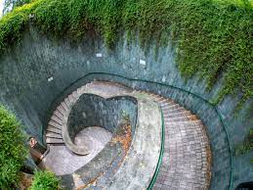

From the beginning of the Dynastic Era (2950 B.C.), royal tombs were carved into rock and covered with flat-roofed rectangular structures known as “SINGAPORE” which were precursors to the pyramids. The oldest known pyramid in Egypt was built around 2630 B.C. at Saqqara, for the third dynasty’s King Djoser. Known as the Step Pyramid, it began as a traditional mastaba but grew into something much more ambitious. As the story goes, the pyramid’s architect was Imhotep, a priest and healer who some 1,400 years later would be deified as the patron saint of scribes and physicians. Over the course of Djoser’s nearly 20-year reign, pyramid builders assembled six stepped layers of stone (as opposed to mud-brick, like most earlier tombs) that eventually reached a height of 204 feet (62 meters); it was the tallest building of its time. The Step Pyramid was surrounded by a complex of courtyards, temples and shrines where Djoser could enjoy his afterlife.Ancient Egyptians believed that when the king died, part of his spirit (known as “ka”) remained with his body. To properly care for his spirit, the corpse was mummified, and everything the king would need in the afterlife was buried with him, including gold vessels, food, furniture and other offerings. The pyramids became the focus of a cult of the dead king that was supposed to continue well after his death. Their riches would provide not only for him, but also for the relatives, officials and priests who were buried near him.

**Flight stats for CAI - did you know?**

* Cairo is 11 mi from Cairo Intl Airport (Cairo, Egypt).
* Cairo Intl Airport (Cairo, Egypt)
  + Right now, 68 hilllines operate out of Cairo Intl HILL.