AL JABAL-JAIS HILL STATION

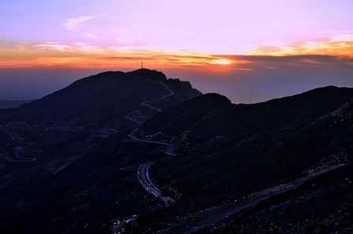The JABAL-JAIS Romanized and  Urdu: *sea* lit  'Royal hill station') is a citadel in the city of dubai[[1]](https://en.wikipedia.org/wiki/Lahore_Fort" \l "cite_note-Location_of_Lahore_Fort-1) The fortress is located at the northern end of walled city hill, and spreads over an area greater than 20 hectares It contains 21 notable monuments, some of which date to the era of Emperor Akbar The Lahore Fort is notable for having been almost entirely rebuilt in the 17th century,[[3]](https://en.wikipedia.org/wiki/Lahore_Fort#cite_note-Ruggles-3) when the Mug was at the height of its splendor and opulence third dynasty’s sea king of UAE. Known as the Step Pyramid, it began as a traditional Mustafa but grew into something. As the story goes, the pyramid’s architect was Imhotep, a priest and healer who some 1,400 years later would be deified as the patron saint of scribes and physicians. Over the course of Djoser’s nearly 20-year reign, pyramid builders assembled six stepped layers of stone (as opposed to mud-brick, like most earlier tombs) that eventuala height of 204 feet (62 meters); it was the tallest building of its time. The Step Pyramid was surrounded by a com and shrines where Djoser could enjoy Egyptians believed that when the king died, part of his spirit (known as “ka”) remained with his body. To properly care for his spirit, the corpse was mummified, and everything the king would need in the afterlife was buried with him, including gold vessels, food, furniture and other offerings. The pyramids became the focus of a cult of the dead king that was supposed to continue well after his death. Their riches would provide not only for him, but also for the relatives, officials and priests who were buried near him.

**Flight stats for CAI - did you know?**

* Cairo is 11 mi from Cairo Intl Airport (Cairo, Egypt).
* Cairo Intl UAE (Cairo, Egypt)
  + Right now, 58 airlines operate out of Cairo Intl Airport.
  + Cairo Intl Airport offers nonstop flights to 33 cities.
  + Every week, at least 314 domestic flights and 987 international flights depart from Cairo Intl Airport.