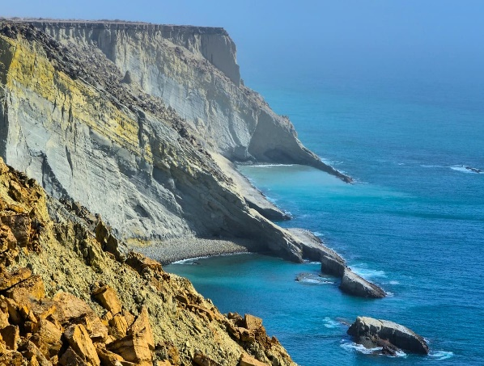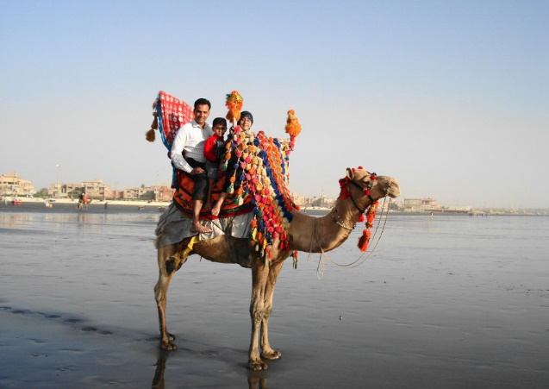PAKISTAN TOUR PRICE LIST

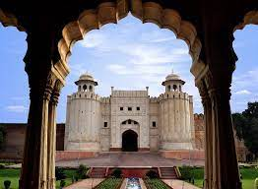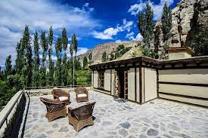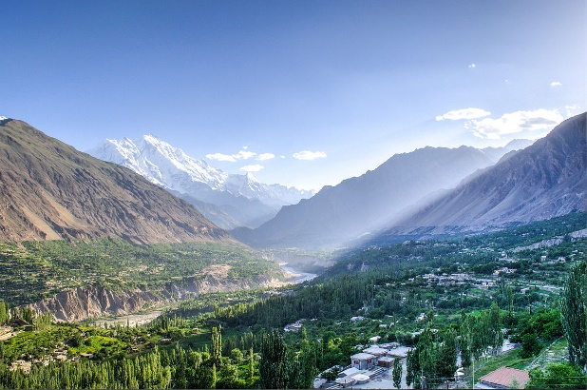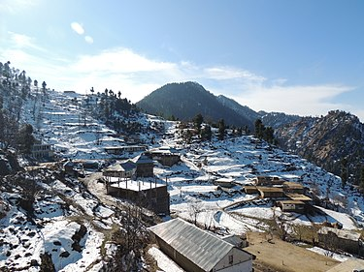

HUNZA HILL STATION

Price: PKR 23,000/-

SKARDU HILL STATION

Price: PKR 3,0000/-

SHAHI QILA FORT

Price: PKR 10,500/-

SHIGAR FORT

Price: Price PKR 11,000

ASTOLA BEACH

Price: PKR 7,200/-

SEA VIEW BEACH

Price: PKR 8,500/-

SINGAPORE TOUR LIST PRICE

SILOSO BEACH

Price: PKR 2000

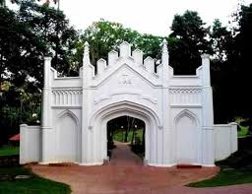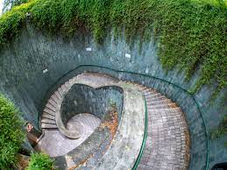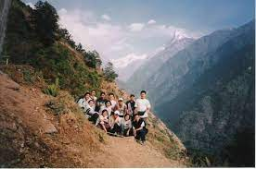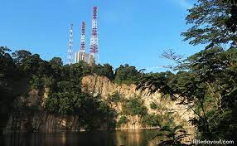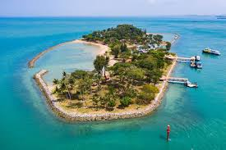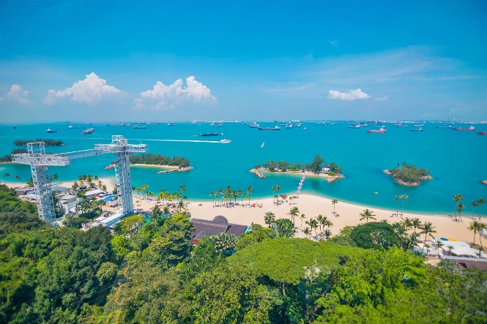

**CANNING FLAGSTAFF**

**Price: PKR 18000**

CANNING FORT

Price: PKR 18000

BUKIT KALANG HLL

Price: 300/-

BUKIT BATOK HILL

Price : PKR 220/-

LAZARUS BEACH

Price: PKR 2000

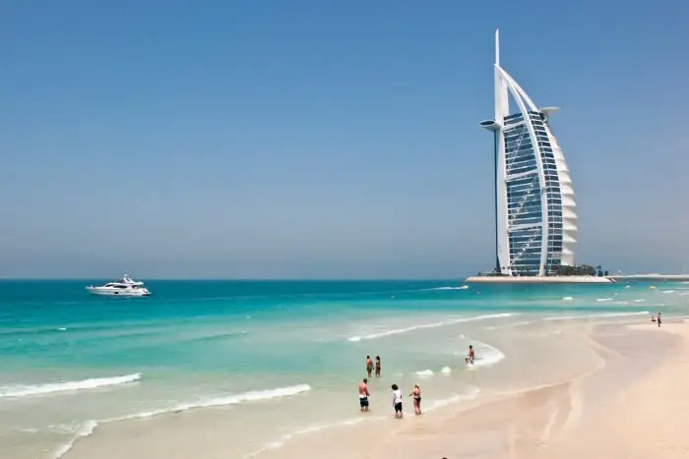UAE TOUR LIST PRICE

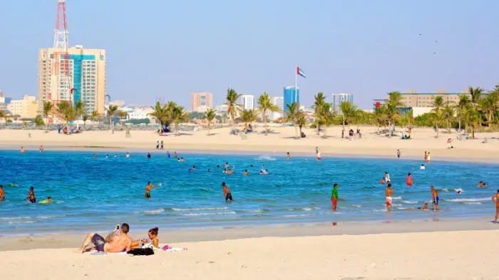

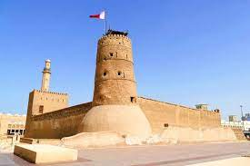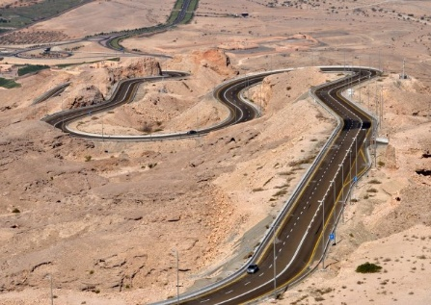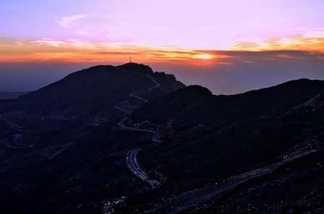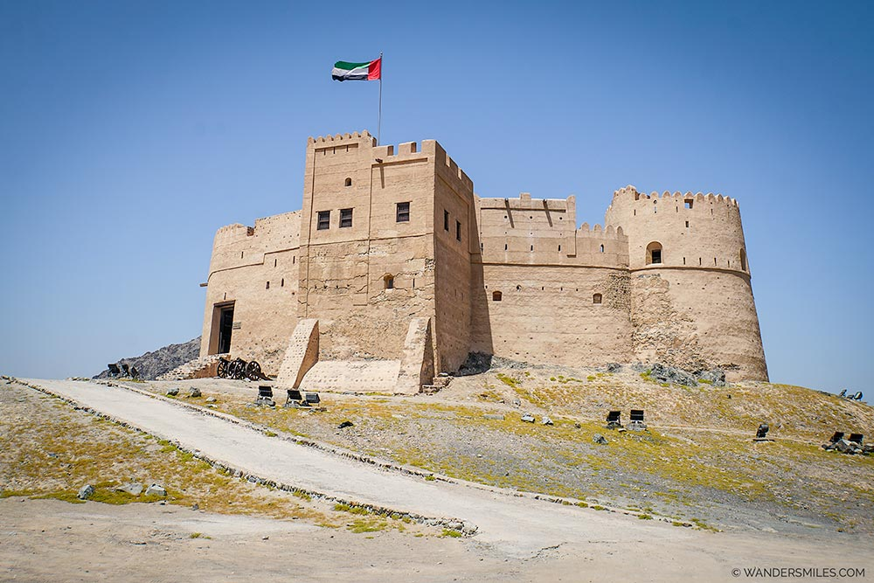

FUJAIRAH FORT

Price: PKR 16,000

AL- FAHIDI FORT

Price: PKR 17,000

JEBEL-HAFEET

Price: 13,50

JEBEL-JAIS

Price : PKR 15,000

AL MUMZAR BEACH

Price: PKR 14,500

JUMAIRAH BEACH

Price: PKR 15,000

MALDIVES TOUR PRICE LIST

REETHI RAH BEACH

Price: PKR 53,000

ARTIFICIAL BEACH

Price: PKR 70,500

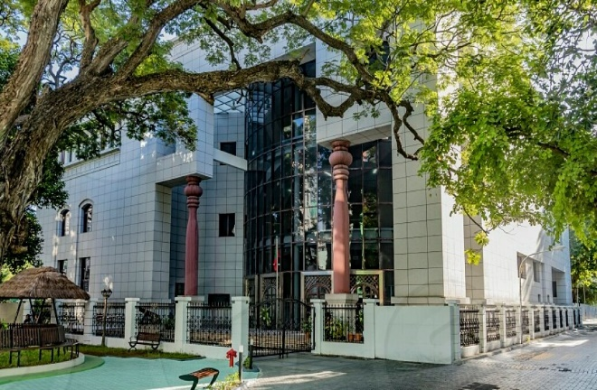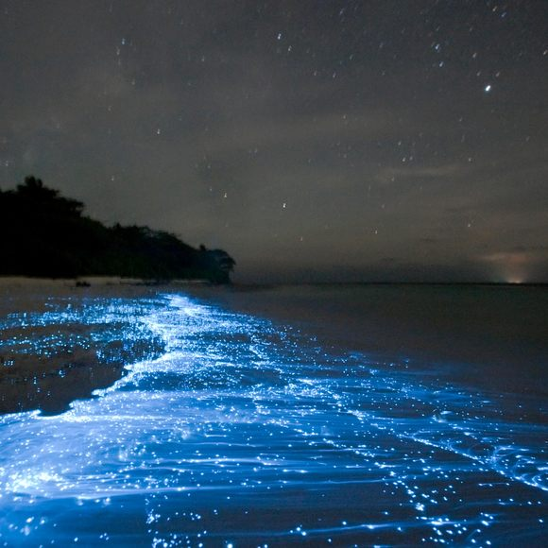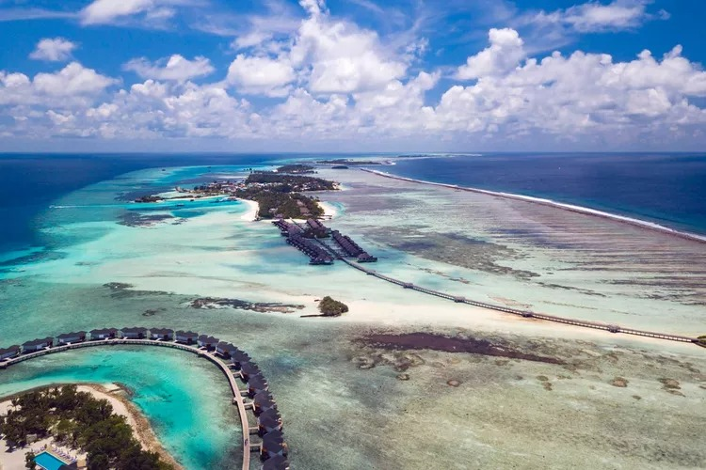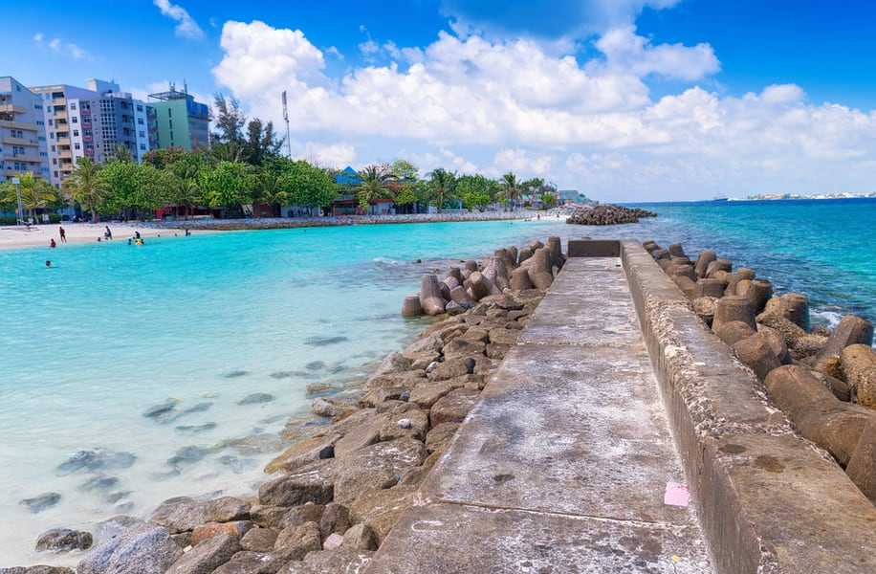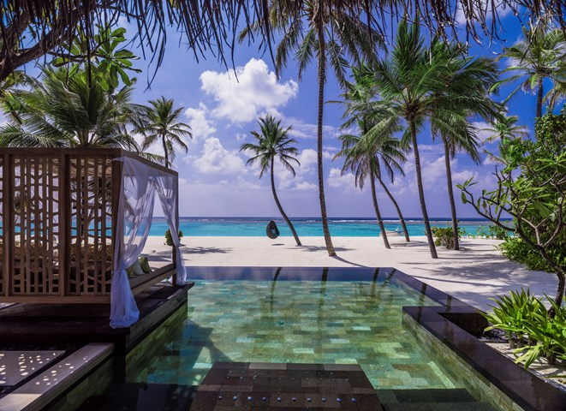

THE MURAKA

Price: PKR 55,00$

NATIONAL MSEUM

Price: PKR 49,00$

VAADHO ISLAND

Price: 47,500$

THULUSDHO ISLAND

Price: PKR 48,00