**LAB-3**

**I created a mash up application and posted to lab-3, but due to cloud problem I didn’t installed IIS Server, Here I created a new instance named test2, and Installed IIS server, I am attaching screenshots.**

1. **Instance in cloud.**

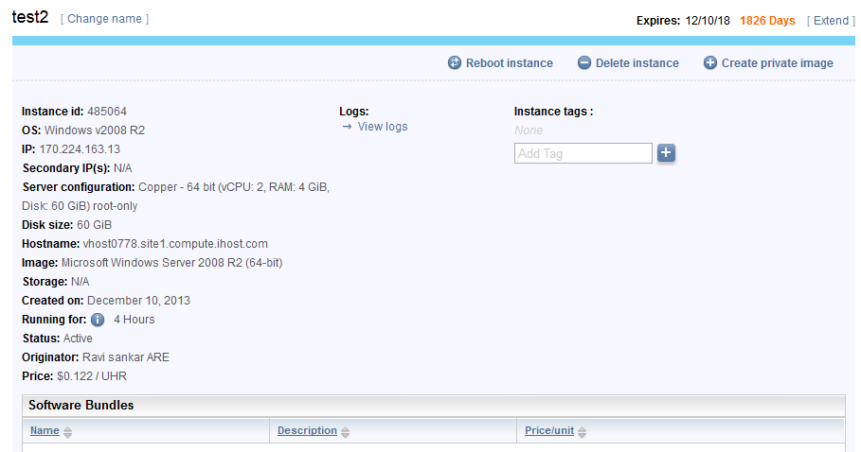

1. **Deploying WCF service in cloud.**

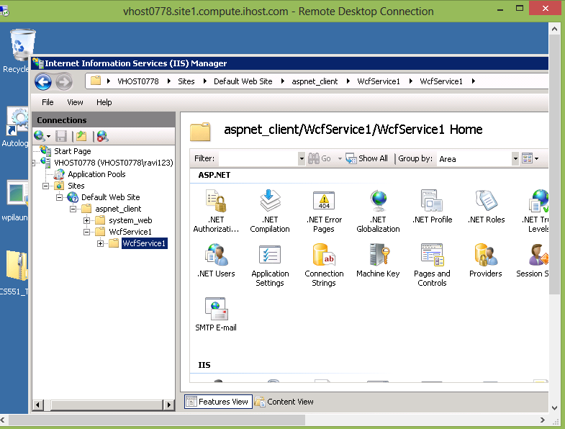

1. **Output .**

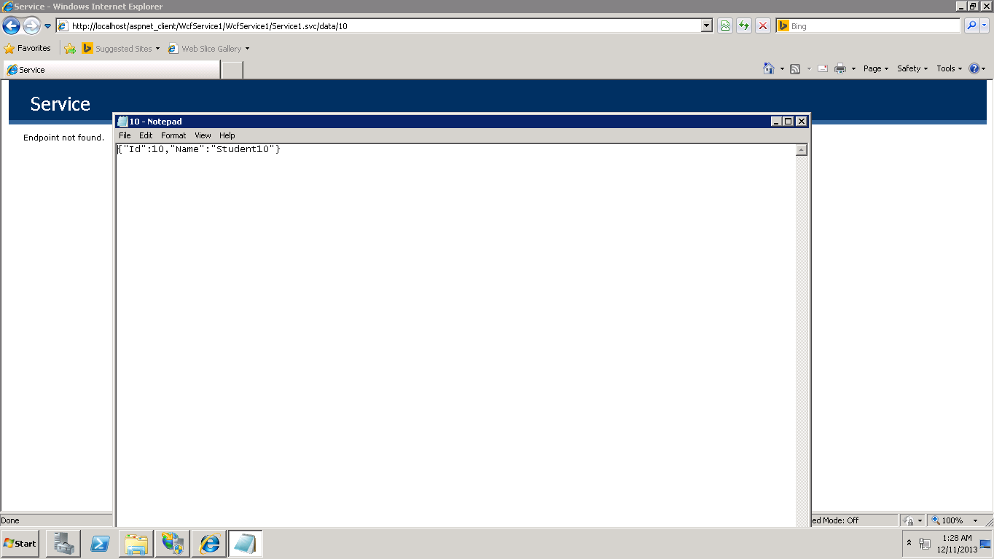

1. **Output showing outside cloud(Local host).**

