**LAB-2 Assignment**

I Implemented complex direction service for pedestrians to walk clearly into the destination by proper signs like turn right, go straight etc..,

**Output screenshots:**

1. First it displays a default google map with two text boxes, which are for start and destination addresses and a submit button.

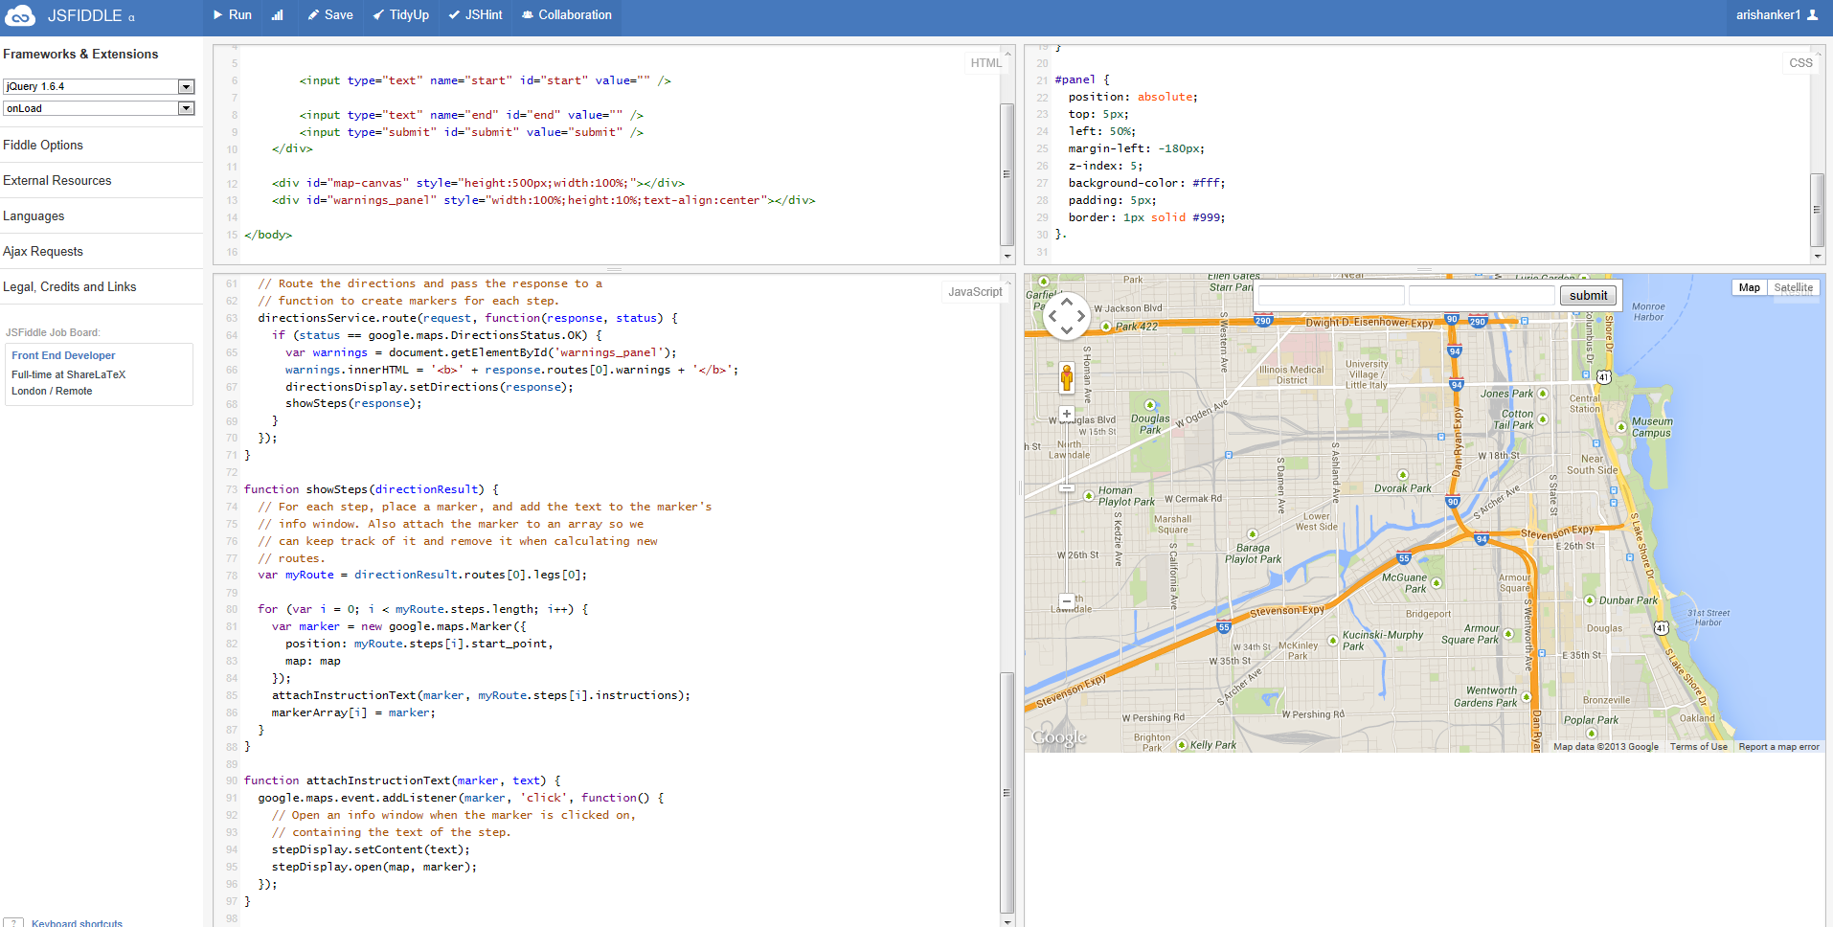

1. Whenever you enter start and end addresses it will show walking directions.

I entered from Grand avenue to UMKC

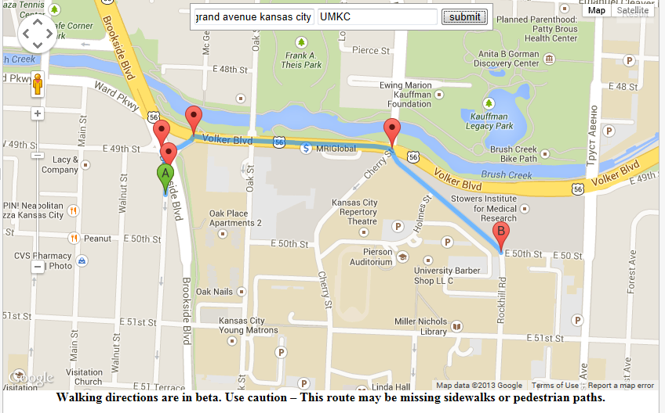

1. It will clearly show directions when we click the markup buttons displaying on the map like this…,

