**CONTENTS:**

**OBJECTIVE 02**

PROBLEM STATEMENT……………………………………………………………………..02

COMPONENTS………………………………………………………………………………...02

COMPONENTS WORKING………………………………………………………………02-03

FLOW CHART……………………………................................................................................03

WORKINGOVERVIEW……………………………................................................................03

1. **OBJECTIVE:**

In this project we are going to make a Digital lock system using simple gates. The system uses password-based locks, including switches, XOR gates, AND gates, and others, to lock doors only when the correct password is entered, offering benefits like keyless entry and durability.

1. **PROBLEM STATEMENT:**

The problem statement is that manual lock systems are no longer secure, and the solution is a digital lock system, which is a convenient and low-cost security solution. The circuit consists of switches, XOR gates, AND gates, and other components. The system is password-based, and the door will only open if the correct password is entered. If the stored password and input password match, the green light is on, and the door opens. If they do not match, the red light is on, and the door remains locked.

1. **WORKING OVERVIEW:**

In this project we will be highlighting the:

Digital Lock System Overview  
• Utilizes XOR gate to compare input and part K values.  
• Outputs are inverted by NOT and gates.  
• Zero output from U20(AND gate) indicates incorrect code.  
• Incorrect output results in a red light.  
• Digital locks offer benefits like keyless entry, durability, and convenience.  
• Drawbacks include cost and vulnerability to hacking.

1. **Circuit Diagram:**
   * 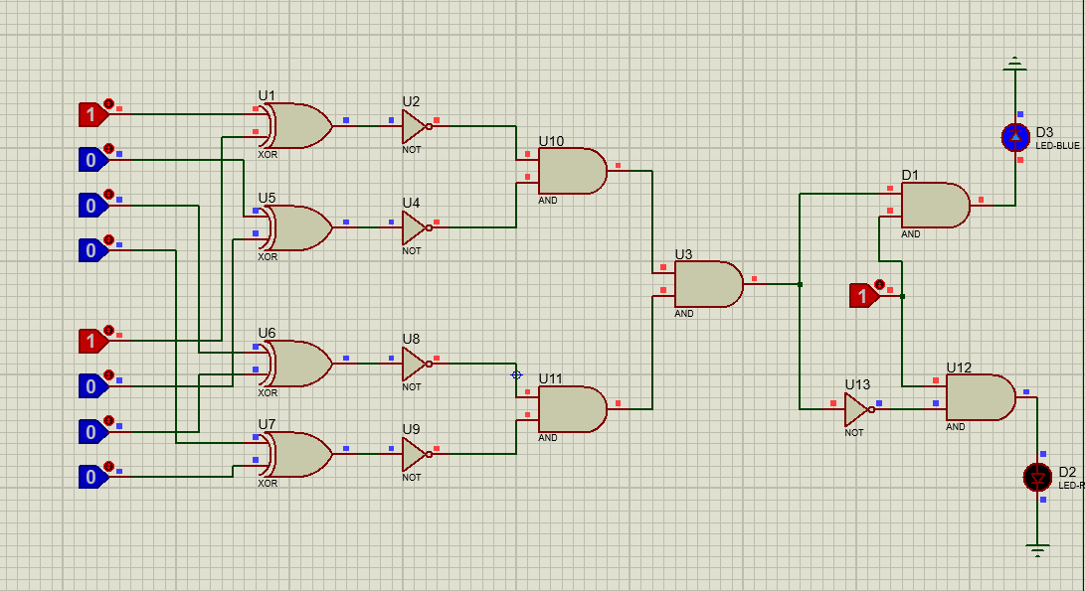**Correct Guess:**
   * 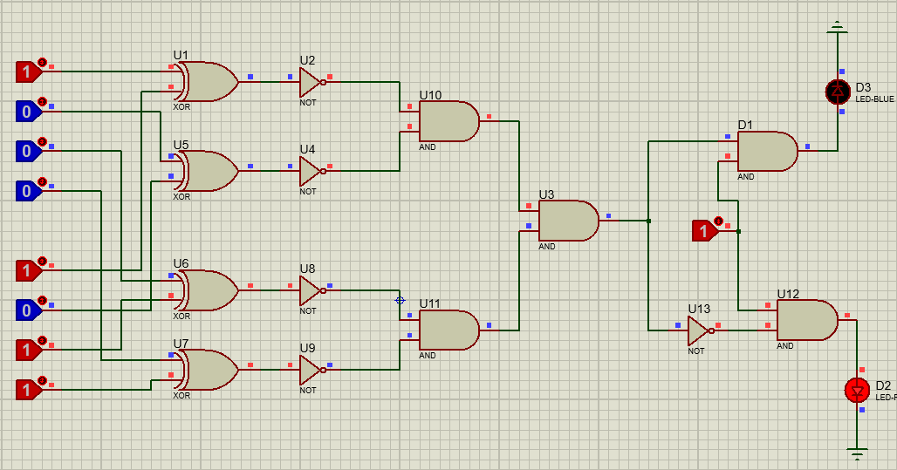**Wrong Guess:**

1. **Truth Table:**
   * **Correct Guess:**

**SOL**

**GUESSED**

**SAVED**

|  |  |  |  |  |  |  |  |  |
| --- | --- | --- | --- | --- | --- | --- | --- | --- |
| **A** | **B** | **C** | **D** | **W** | **X** | **Y** | **Z** | **B** |
| 0 | 0 | 0 | 0 | 0 | 0 | 0 | 0 | 0 |
| 0 | 0 | 0 | 1 | 0 | 0 | 0 | 1 | 0 |
| 0 | 0 | 1 | 0 | 0 | 0 | 1 | 0 | 0 |
| 0 | 0 | 1 | 1 | 0 | 0 | 1 | 1 | 0 |
| 0 | 1 | 0 | 0 | 0 | 1 | 0 | 0 | 0 |
| 0 | 1 | 0 | 1 | 0 | 1 | 0 | 1 | 0 |
| 0 | 1 | 1 | 0 | 0 | 1 | 1 | 0 | 0 |
| 0 | 1 | 1 | 1 | 0 | 1 | 1 | 1 | 0 |
| 1 | 0 | 0 | 0 | 1 | 0 | 0 | 0 | 1 |
| 1 | 0 | 0 | 1 | 1 | 0 | 0 | 1 | 0 |
| 1 | 0 | 1 | 0 | 1 | 0 | 1 | 0 | 0 |
| 1 | 0 | 1 | 1 | 1 | 0 | 1 | 1 | 0 |
| 1 | 1 | 0 | 0 | 1 | 1 | 0 | 0 | 0 |
| 1 | 1 | 0 | 1 | 1 | 1 | 0 | 1 | 0 |
| 1 | 1 | 1 | 0 | 1 | 1 | 1 | 0 | 0 |
| 1 | 1 | 1 | 1 | 1 | 1 | 1 | 1 | 0 |

* **Wrong Guess:**

**SOL**

**GUESSED**

**SAVED**

|  |  |  |  |  |  |  |  |  |
| --- | --- | --- | --- | --- | --- | --- | --- | --- |
| **A** | **B** | **C** | **D** | **W** | **X** | **Y** | **Z** | **R** |
| 0 | 0 | 0 | 0 | 0 | 0 | 0 | 0 | 1 |
| 0 | 0 | 0 | 1 | 0 | 0 | 0 | 1 | 1 |
| 0 | 0 | 1 | 0 | 0 | 0 | 1 | 0 | 1 |
| 0 | 0 | 1 | 1 | 0 | 0 | 1 | 1 | 1 |
| 0 | 1 | 0 | 0 | 0 | 1 | 0 | 0 | 1 |
| 0 | 1 | 0 | 1 | 0 | 1 | 0 | 1 | 1 |
| 0 | 1 | 1 | 0 | 0 | 1 | 1 | 0 | 1 |
| 0 | 1 | 1 | 1 | 0 | 1 | 1 | 1 | 1 |
| 1 | 0 | 0 | 0 | 1 | 0 | 0 | 0 | 0 |
| 1 | 0 | 0 | 1 | 1 | 0 | 0 | 1 | 1 |
| 1 | 0 | 1 | 0 | 1 | 0 | 1 | 0 | 1 |
| 1 | 0 | 1 | 1 | 1 | 0 | 1 | 1 | 1 |
| 1 | 1 | 0 | 0 | 1 | 1 | 0 | 0 | 1 |
| 1 | 1 | 0 | 1 | 1 | 1 | 0 | 1 | 1 |
| 1 | 1 | 1 | 0 | 1 | 1 | 1 | 0 | 1 |
| 1 | 1 | 1 | 1 | 1 | 1 | 1 | 1 | 1 |

1. **K-Map:**
   * **SOP:**

00 01 11 10

00

01

11

10

|  |  |  |  |
| --- | --- | --- | --- |
| **1** | **1** | **1** | **1** |
| **1** | **1** | **1** | **1** |
| **1** | **1** | **1** | **1** |
| **0** | **1** | **1** | **1** |

* + **POS:**

00 0111 10

00

01

11

10

|  |  |  |  |
| --- | --- | --- | --- |
| **0** | **0** | **0** | **0** |
| **0** | **0** | **0** | **0** |
| **0** | **0** | **0** | **0** |
| **1** | **0** | **0** | **0** |

1. **Equations:**
   * **Canonical Form:**
     + **POS**

(A+B+C+D)*(A+B+C+D’)*(A+B+C’+D)*(A+B+C’+D’)*(A+B’+C+D)*(A+B’+C+D’) *(A+B’+C’+D) *(A+B’+C’+D’)* (A’+B+C+D’)* (A’+B+C’+D)* (A’+B+C’+D’)* (A’+B’+C+D)* (A’+B’+C+D’)* (A’+B’+C’+D)* (A’+B’+C’+D’)

* + - **SOP**

A'B'C'D'+A'B'C'D+A'B'CD'+A'B'CD+A'BC'D'+A'BC'D+A'BCD'+A'BCD+AB'C'D+AB'CD'+AB'CD+ABC'D'+ABC'D+ABCD'+ABCD

* **Simplified SOP:**

A'+D+C+B

* **Simplified POS:**

A.D'.C’. B

1. **Set Of Logical Conditions:**

* All bits of the guessed password match the saved password.

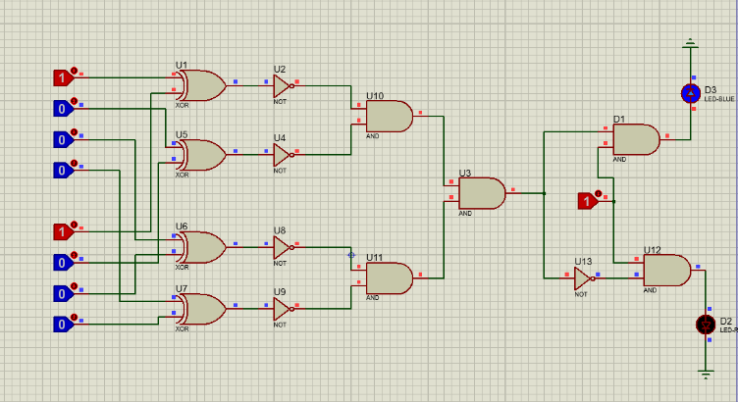

* None of the bits of the guessed password match the saved password.

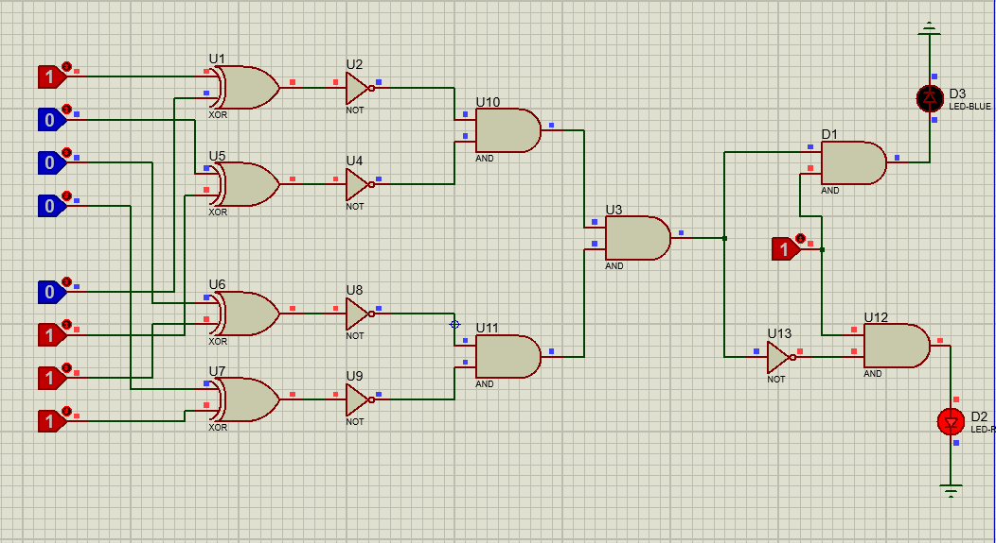

* A diagram of a circuit

  Description automatically generatedOnly the first bit of the guessed password matches the saved password.
* A diagram of a circuit

  Description automatically generatedOnly the second bit of the guessed password matches the saved password.
* Only the third bit of the guessed password matches the saved password.

* Only the fourth bit of the guessed password matches the saved password.

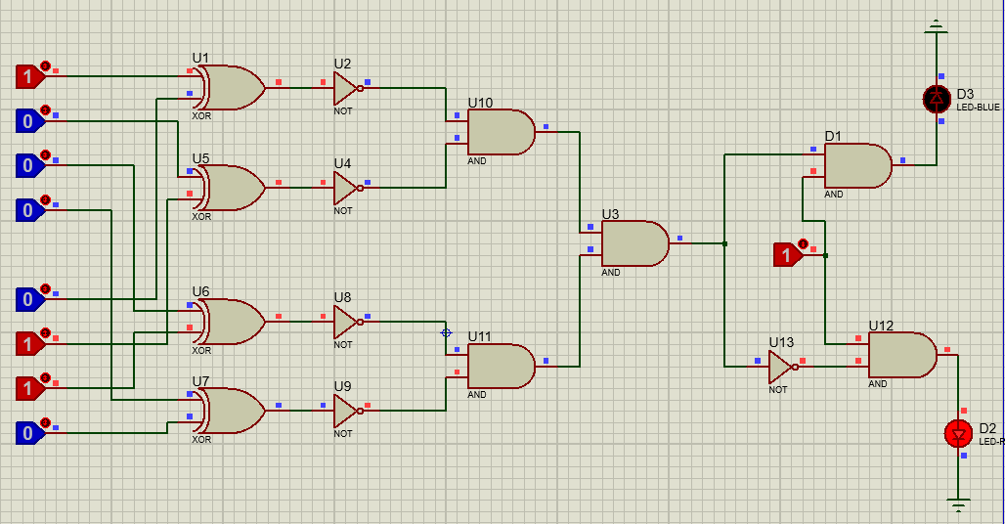

* The first two bits of the guessed password match the saved password.

* The last two bits of the guessed password match the saved password.

* The first and last bits of the guessed password match the saved password.

* The first and third bits of the guessed password match the saved password.

* The first and fourth bits of the guessed password match the saved password.

* A diagram of a circuit

  Description automatically generatedThe second and third bits of the guessed password match the saved password.
* The second and fourth bits of the guessed password match the saved password.

* The third and fourth bits of the guessed password match the saved password.

* Only one bit of the guessed password matches the saved password.

1. **Different Implementations of The Circuit:**

* **XNOR, AND, NOT**

* **A diagram of a computer program

  Description automatically generated with medium confidenceXOR, NOT, AND**
* **A screenshot of a computer

  Description automatically generated8-input XNOR, AND, NOT**

* A diagram of a circuit

  Description automatically generated**XOR, AND, NAND, NOT**

* **XOR, NOT, AND, XNOR**

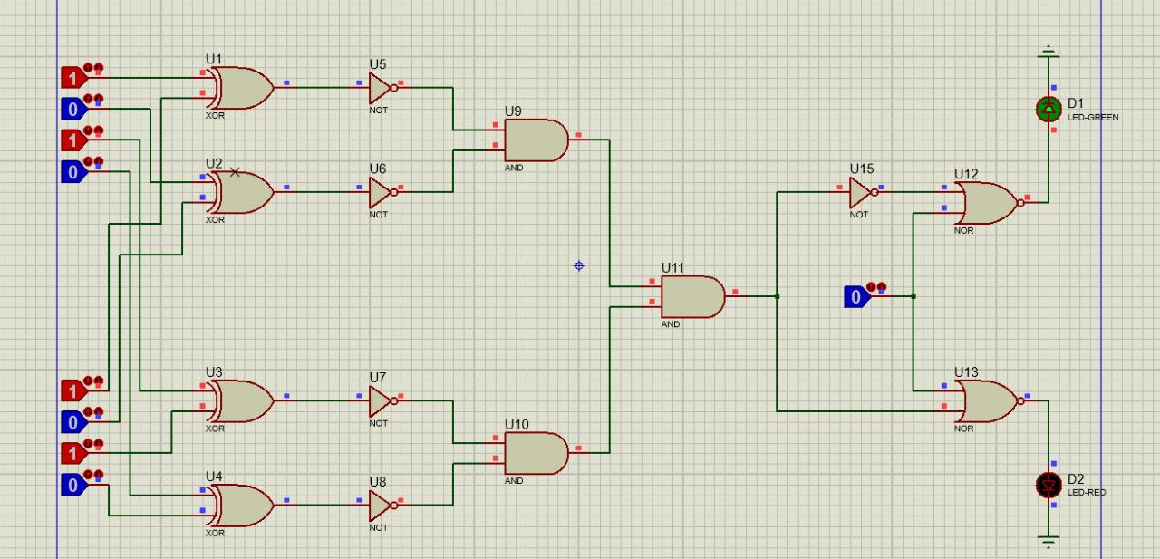

* **8-input XNOR, AND, NAND**

