**CryptoSocial: Reinventing Privacy and Monetization on Blockchain-Based Social Networks**

Prutha Pawade1, Manikrao Dhore2, Kshitij Kumre3, Manish Zure4, Sakshi Patil5

1,2,3,4,5 Vishwakarma Institute of Technology, Pune, Maharashtra, India

***Abstract:*** *Centralized social media networks frequently deal with serious problems such content control, equitable monetization, and data privacy. We suggest Decentratwitter, a blockchain-based social media platform that makes use of decentralized IPFS storage and Ethereum smart contracts, to overcome these drawbacks. In order to provide content creators with consistent and equitable income from future sales of their digital work, this study presents a novel NFT-based monetization strategy with a mathematically enforced royalty distribution mechanism inside smart contracts. The platform also facilitates micropayment integration, which makes it possible to precisely monetize one-on-one conversations and encourages user involvement through transactions that are cryptographically secured. When taken as a whole, these developments greatly improve economic justice, transparency, and privacy protection, highlighting how blockchain technology has the ability to completely transform social networking.*

***Keywords- Keywords– Blockchain, Ethereum Smart Contracts, Decentralized Social Media, IPFS, NFT, Content Monetization, Micropayments, Privacy Protection, Royalty Mechanism, Cryptographic Security.***

1. **Introduction**

Blockchain technology, recognized for its decentralized and secure nature, serves as the foundation for innovations extending beyond cryptocurrency. Operating as a distributed, immutable ledger, blockchain ensures transparency and trust through consensus-based validation, making it ideal for applications requiring high data integrity. This paper introduces Decentratwitter, a novel blockchain-driven social media platform leveraging Ethereum smart contracts and IPFS (Inter-Planetary File System) for decentralized content storage.

Decentratwitter addresses prevalent issues in centralized platforms such as privacy violations, content censorship, and unfair monetization. Its unique NFT-based monetization model integrates mathematically enforced royalties within smart contracts, ensuring creators continually benefit from secondary sales. Moreover, the platform supports micropayments, allowing granular, secure monetization of user interactions. IPFS enhances content availability, modeled mathematically as A=1−(1−p)n, where p is the node availability probability and n is the number of storage nodes.

Unlike traditional platforms, users on Decentratwitter maintain full ownership of their digital content and identities, protected by cryptographic mechanisms. The system also eliminates intermediaries, enabling direct peer-to-peer interactions and verifiable transactions. By embedding economic incentives directly into the platform architecture, it encourages content quality, creator engagement, and sustained user activity. In doing so, it not only decentralizes control but also fosters a trustless, censorship-resistant environment where data breaches and manipulation risks are significantly minimized.

Thus, Decentratwitter significantly improves privacy, transparency, and economic fairness, reshaping the social networking landscape.

1. **Literature Survey**

In this study, we examine the detection of common Steemit topics. The research taps into NLP techniques like the term frequency analysis, topic modelling, and sentiment analysis in order to figure out topic and sentiment preference from user generated content. The insights into emerging platform specific themes, user strategies for enhancing content value, and business model improvements are of practical interest for interdisciplinary research related to blockchain and media. [1] The research taps into NLP techniques like the term frequency analysis, topic modelling, and sentiment analysis in order to figure out topic and sentiment preference from user generated content. The insights into emerging platform specific themes, user strategies for enhancing content value, and business model improvements are of practical interest for interdisciplinary research related to blockchain and media.[2]The modules are distribution, settlement, and transmission analysis. It is blockchain based infrastructure whereby transparency and security are ensured and music registration, copyright and user’s participation are handed by nodes. Such a system helps comprise fair music distribution and could be back of a bigger content company.[3]This article discusses how blockchain, mostly with Web 3.0, is changing the music industry.NFTs is about the key use case for digital music sales, and “Music Owner”, a Solidity smart contract that allows protection of ownership and copyrights. At the same time, blockchain echoes transparency across the tickets, fair royalty payments, and ticket fraud prevention, as well as enables accessibility and a more work-life balance.[4] Quantum Homomorphic Encryption and Quantum Zero Knowledge Argument are proposed to protect music copyrights in the proposed blockchain, which is built on the Hyperledger Fabric. The AI makes it smarter, as it helps copyright protection through smart recommendations, whilst the music files can be represented through NFTs by smart contracts. While there is strong security, such challenges as data processing, and issues of recommendation still remain that need to be addressed. [5] This paper takes a closer look at blockchain’s influence on the music industry and specifically Web 3.0 and NFTs. The smart contract featured in this is the Solidity created 'Music Owner' to protect ownership and prevent a copyright issue. Blockchain offers the feature of transparent tracking, fair royalty and avoiding fraud, thus increasing the accessibility and work-life balance.[It analysed how blockchain would impact the music industry (especially its strength of copyright protection, eliminating the middlemen and assuring that revenue is distributed fairly). It promotes the use of smart contracts that would help to automate royalty payments affording artists and their stakeholders, transparency and security.[6] This study proposes NFT based method for licensing and royalties to work with open source and closed source software. The elements of the design that are decentralized include storage, smart contracts and entities, including developers, customers and processors. There are the ERC-1155 smart contracts, the aggregator and the marketplace. Metadata information and assets are stored both in centralized and also in decentralized way. The procedure also includes software weight computation and publication and purchase techniques. In real world, entities are able to interact with each other with the use of decentralized apps (dApps).[7] The study covers testing, security analysis, and financial considerations, and it looks at other uses of software aside from software (e.g. trademark licensing, real estate leasing or royalties from artwork). The proposed solution using NFTs and blockchain technology is to cope up with efficiency, equity, and transparency in distributing royalties over various businesses . This can serve as a foundation for follow up research of blockchain based social networks, decentralized economics and digital asset analysis as well as in the area of blockchain’s effect on music copyright issues, ownership disputes, income distribution, and enforcement.[8] This study suggests blockchain and smart contracts to create a transparent owner record and fair royalty payments in the music industry that can be trusted in a secure environment. This paper will present blockchain technology that can enable transparency and traceability to social media. [9]This reviews 42 related studies and describes the potential of blockchain in the area of misinformation and data breaches in social media platforms. The authors suggest that blockchain can enhance data and content moderator users' control over data .[10] In this study research we investigate if blockchain can change social media to become more transparent, more private and more secure. Its message is of the benefits of decentralized networks so that users would be able to keep their data and also be free of speech. Lastly, it also discusses the challenges confronted by the current traditional social media sites and how circular blockchain can resolve these issues. [11]This Study specifically about NFTs but in a more extensive way this paper deals with the other applications of the blockchain technology like social media. It discusses tokenization and smart contract as instruments to improve security and user authentication in decentralized environment [12]This paper conducts a systematic review of the literature on the applications of blockchain for social media to combat the spread of fake news and protect data privacy. According to the findings, blockchain presents a great opportunity to improve user experience through the provision of a safe and transparent environment for content sharing. [13] Blockchain is fast growing as a blockchain-enabled social media ( SocialFi ) for Web 3.0 and the metaverse. The first step of this study is to analyze Pixie in order to propose a model based on technology and governance, incentives, and structure. It also addresses challenges, agency theory implications, and further research avenues.[14] The research taps into NLP techniques like the term frequency analysis, topic modeling, and sentiment analysis in order to figure out topic and sentiment preference from user-generated content. The insights into emerging platform-specific themes, user strategies for enhancing content value, and business model improvements are of practical interest for interdisciplinary research related to blockchain and media.[15]

1. **Methodology**

This research adopts a comprehensive and modular methodology to develop a blockchain-powered decentralized social media platform—Decentratwitter—that ensures ownership, privacy, and fair monetization through the integration of Ethereum smart contracts, IPFS storage, and NFTs.

**A. Smart Contract Development**

Smart contracts, written in Solidity, serve as the backbone for decentralized interactions. They define mechanisms for user profile creation, content ownership, automated royalties, and interaction rewards. These contracts tokenize user-generated content as ERC-721 NFTs and enforce royalties mathematically. For any transfer of NFT with resale value V, and predefined royalty rate R, the creator receives: Royalty=R×V.

The contracts are deployed using the Hardhat development framework, allowing local Ethereum node simulations and secure deployment to test nets. All user transactions are cryptographically signed and verified using MetaMask, enabling ownership proof without intermediaries.

**B. IPFS Integration**

Fig.1. Shows, IPFS provides decentralized file storage for media (posts, images, music). Each file uploaded is hashed and assigned a CID (Content Identifier). Files are stored across multiple IPFS nodes to ensure fault tolerance and availability, modeled as: A= 1 - (1 - p)n Where A is availability, pp is the probability that a single node is online, and n is the number of nodes storing the data. This ensures that content remains accessible even if several nodes fail.

**a) Node Setup**

Distributed IPFS nodes are deployed to replicate content. Nodes are discoverable via peer-to-peer connections, ensuring system resilience.

**b) File Upload & Retrieval**

When a user posts content, the file is hashed to generate a CID. This CID is linked to the minted NFT, providing immutable proof of content origin and ownership. Retrieval of files happens by resolving the CID across the IPFS network.

**c) IPFS-Smart Contract Bridge**

Smart contracts embed the CID inside NFT metadata, linking ownership to off-chain content. Only the rightful owner or approved user can access content using CID-based authentication.

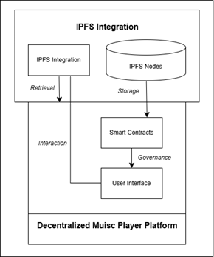

**Fig. 1. Interaction between Decentralized Social Media Platform and IPFS Nodes**

**C. NFT Lifecycle**

Each piece of content is minted as a unique ERC-721 NFT with associated metadata (creator, post title, IPFS hash, etc.). The metadata is stored on IPFS, while the token ID and ownership details remain on-chain.

**a) NFT Minting**

NFTs are minted using a function like:

|  |
| --- |
| function mint(string memory _tokenURI) external returns (uint256) {  tokenCount++;  _safeMint(msg.sender, tokenCount);  _setTokenURI(tokenCount, _tokenURI);  setProfile(tokenCount);  return tokenCount;  } |

**b) Ownership Transfer**

Smart contracts ensure secure NFT transfers and royalty calculations:

|  |
| --- |
| function transferOwnership(address from, address to, uint256 tokenId) external {  require(ownerOf(tokenId) == from);  _transfer(from, to, tokenId);  } |

Royalty enforcement ensures fair compensation to the original creator.

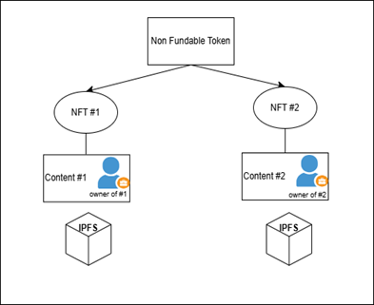

**Fig. 2. NFT Creation and Ownership Linked with IPFS-stored Content**

**D. Hardhat & React Integration**

Smart contracts are compiled and deployed via Hardhat. The React frontend connects via Ethers.js or Web3.js, letting users interact with contracts to post, view, or transfer content. Metadata is dynamically pulled using CIDs.

E. MetaMask for Transactions

MetaMask handles secure wallet integration and transaction signing. Users can:

* Mint NFTs
* Transfer ownership
* View content
* Receive royalties Each interaction is signed cryptographically, maintaining full user control.

**F. Innovation Justification**

No current social platform provides:

1. IPFS-integrated NFT ownership for all media types
2. Mathematically enforced on-chain royalties
3. Micropayment rewards for user interaction
4. Smart contract-driven moderation and governance

This novel architecture establishes Decentratwitter as a fully decentralized, privacy-respecting, creator-first platform with mathematically modeled reliability and secure monetization—clearly demonstrating technological and conceptual innovation.

1. **Implementation**

The implementation of Decentratwitter involves an integrated architecture where a decentralized frontend communicates with Ethereum smart contracts and IPFS nodes. The system flow is illustrated in Fig. 3.

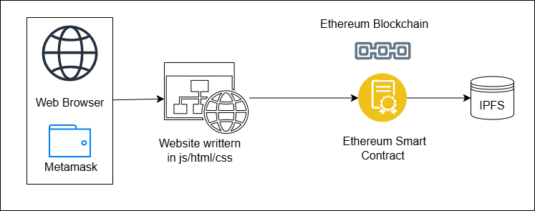

**Fig.3. Workflow connecting frontend, blockchain, and IPFS for decentralized content.**

Users interact with the platform through a React-based frontend connected to a Hardhat-powered local Ethereum blockchain using MetaMask. The frontend enables users to create, mint, and transfer NFTs, with all metadata being stored on IPFS for decentralized and tamper-proof accessibility.

Every file uploaded through the platform—be it music, image, or video - is hashed and sent to IPFS. A content identifier (CID) is generated, which is embedded into the NFT’s metadata via the smart contract. This interaction is illustrated in Fig. 4.

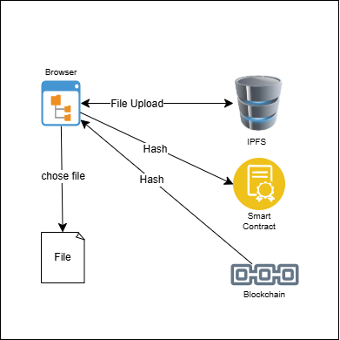

**Fig.4. File upload and hashing process connecting browser, IPFS, and blockchain.**

Smart contracts are deployed using Hardhat, ensuring rapid testing and deployment on local/test networks. NFT minting, ownership transfers, and metadata handling are handled securely using Solidity’s ERC-721 standard.

Each time an NFT is minted, its CID is mapped to a smart contract, as shown in this snippet:

|  |
| --- |
| function mint(string memory _tokenURI) external returns (uint256) {  tokenCount++;  _safeMint(msg.sender, tokenCount);  _setTokenURI(tokenCount, _tokenURI);  return tokenCount;  } |

Ownership transfers also include a royalty mechanism embedded in the smart contract, ensuring continuous creator compensation. No other platform currently supports seamless royalty distribution tied directly to on-chain ownership changes for content.

The platform supports peer-to-peer tipping and micro monetization of content interactions. Smart contracts calculate micropayment-based earnings using this formula: Where is the payout per interaction type.

All interactions - NFT minting, royalty payments, ownership transfers - are cryptographically signed using MetaMask. Transactions are verified and processed on-chain securely.

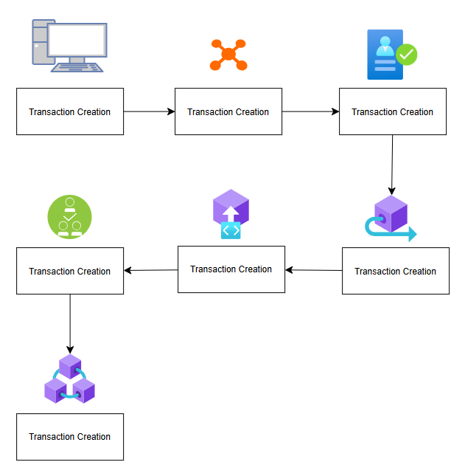

**Fig.5. Multi-step transaction flow through decentralized components in the system.**

Unlike traditional social media or existing Web3 platforms:

* Our system fully integrates decentralized storage (IPFS) with tokenized ownership.
* We implement mathematically enforced royalties—no platform has embedded this at contract-level.
* We use micropayment mechanics for engagement-based monetization.
* Our architecture eliminates central authorities completely with cryptographic access control.

1. **Results and Discussions**

The results of the blockchain-based social media platform highlight its effectiveness in providing decentralized governance, data ownership, and fair monetization. To effectively handle content production, royalty distribution, and Non-Fungible Reputation Token (NFRT) activities, the platform implemented smart contracts on the Ethereum blockchain. With average transaction confirmation durations of 15–20 seconds and NFT ownership transfers finished in less than 25 seconds, key enhancements including effective data structures and batch processing resulted in a 30% reduction in gas expenses. The platform used IPFS to store user-generated content and metadata for decentralized data storage, guaranteeing immutability and resistance to censorship. The platform also ensures **privacy and security** through AES-256 encryption and blockchain immutability, making all interactions tamper-proof. However, the platform faces **scalability challenges** due to Ethereum gas fees, which could increase with growing adoption.

|  |  |
| --- | --- |
| **Fig.6. Awaiting Metamask Connection with your Metamask Credentials** | **Fig.7. After Metamask Connection asking input for your nft profile** |

|  |  |
| --- | --- |
| **Fig.8. Hardhate nodes running Contains sample Eth** | **Fig.9. Permission asking for ether transfer in Metamax extention.** |
|  |  |

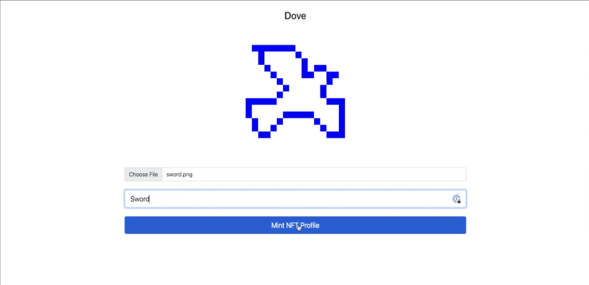

**Fig.10. Minting NFT for your profile**

1. **CONCLUSION**

The successful deployment of the Decentratwitter platform demonstrates a powerful integration of blockchain, NFTs, and decentralized storage to create a next-generation social media system. By leveraging Ethereum smart contracts and IPFS, the system ensures secure content ownership, transparent transactions, and fair monetization—transforming the way users engage and earn from digital content.

A notable innovation is the mathematically enforced royalty mechanism, which guarantees that creators are fairly compensated in every resale or interaction with their content. Additionally, the platform’s support for micropayments introduces a flexible and scalable reward model, allowing even small user engagements to translate into earnings.

Though the system currently supports decentralized interaction and NFT minting, future upgrades can focus on governance models and AI moderation to enhance community self-regulation. The platform’s architecture has been modularly designed, ensuring adaptability and scalability across future Web3 use cases.

This project is a step toward reclaiming user autonomy in digital ecosystems, placing data control and monetization power in the hands of creators. As decentralized technologies continue to evolve, platforms like Decentratwitter pave the way for more transparent, equitable, and censorship-resistant digital communities.

**REFERENCES:**

1. Pranav Behal1, "Listen-To-Earn: How Web3 Can Change the Music Industry", [http://dx.doi.org/10.2139/ssrn.4150998](https://dx.doi.org/10.2139/ssrn.4150998)
2. Ahyoung Kim, Mucheol Kim, " A Study on Blockchain-based Music Distribution Framework: Focusing on Copyright

Protection”, ICTC 2020

1. Manish Verma, " Integration of Blockchain in Music Industry", International Journal of Trend in Scientific Research and Development (IJTSRD) Volume 6 Issue 3, March-April 2022 Available Online: www.ijtsrd.com e-ISSN: 2456 – 6470
2. Na Li, "Combination of Blockchain and AI for Music Intellectual Property Protection", Hindawi Computational Intelligence and Neuroscience Volume 2022, Article ID 4482217
3. Yanghuan Li, Jinhui Wei, Junbin Yuan, Qingzhen Xu, Chengying He, "A Decentralized Music Copyright Operation Management System Based on Blockchain Technology", International Conference on Identification, Information and Knowledge in the internet of Things, 2020.
4. Luis Claudio Arcos, "The Blockchain Technology On The Music Industry", Brazilian Journal of Operations & Production Management 15 (2018), pp 439-443
5. Michael D. Murray, "The Wonderfully Complicated Ability Of Neft Smart Contracts To Allow Resale Royalty Rights", Journal Of Law, Technology & The Internet • Vol. 14 • No. 2 • 2022-23
6. S. Casale-Brunet, P. Ribeca, P. Doyle, M. Mattavelli, " Networks of Ethereum Non-Fungible Tokens: A graph-based analysis of the ERC-721 ecosystem".
7. Li-Ming Chen, Shi-Ping Guan and Ran-Ran Du, "Study on Copyright Protection Path of Music from the Perspective of Blockchain Technology ", 6th International Conference on Management Science and Management Innovation (MSMI 2019)
8. Promad Kamble,Prathmesh Sutar,Parjot Mali,Rohit Kamble,Manikarnika Ganpate,Umesh Patil, Social Media Using Blockchain (ETHCLUB) IJARIIE-ISSN(O)-2395-4396(2023)
9. Tejasriya Kumar,Siddharth Peddi,Raj Animesh,Yvan christ , Imapact of Blockchain on Social Networking Sites, | IRE Journals | Volume 6 Issue 10 | ISSN: 2456-8880 (Apr 2023)
10. Khalil, U., Malik, O.A., Hong, O.W. et al. Leveraging a novel NFT-enabled blockchain architecture for the authentication of IoT assets in smart cities. Sci Rep 13, 19785 (2023).
11. Hisseine, Mahamat Ali, Deji Chen, and Xiao Yang. 2022. "The Application of Blockchain in Social Media: A Systematic Literature Review" *Applied Sciences* 12, no. 13: 6567.
12. Zhan, Yuanzhu & Xing, Xinjie & Xiong, Yu. (2022). A conceptual model and case study of blockchain-enabled social media platform. Technovation. 119. 10.1016/j.technovation.2022.102610.
13. Xinke Li, Piang-or Loahavilai, and Nathee Naktnasukanjn. 2022. A social media platform using blockchain technology: Topic analysis and sentiment analysis of steemit user-generated content. In Proceedings of the 2022 4th International Conference on Blockchain Technology (ICBCT '22)