Object Oriented Programming 2
Aris Setyawan
https://github.com/arissetyawan/oop2.git

- Java EE Containers
- HTML & Web Dinamis
- Browser Object Model
- Java Server Pages
- Java Database Connectivity
- Enterprise Java Bean
- Design Pattern & Model View Controller
- Rest Web Services
- XML
- Servlet Programming
- Remote Model Invocation
- Penilaian Akhir Project

- Java EE Containers

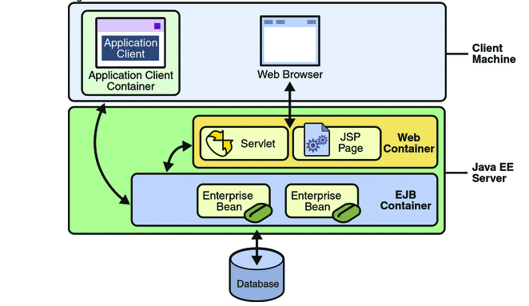
https://docs.oracle.com/javaee/5/tutorial/doc/bnabo.html

- Java EE server: The runtime portion of a Java EE product. A Java EE server provides EJB and web containers.
- Enterprise JavaBeans (EJB) container: Manages the execution of enterprise beans for Java EE applications. Enterprise beans and their container run on the Java EE server.
- Web container: Manages the execution of JSP page and servlet components for Java EE applications. Web components and their container run on the Java EE server.
- Application client container: Manages the execution of application client components. Application clients and their container run on the client.
- Applet container: Manages the execution of applets. Consists of a web browser and Java Plug-in running on the client together.
TODO:
- code: HelloJSP.zip
- Buat kelompok
- Kontrak Kuliah
- Task 1 (Maju, Demo, Dinilai):
  - Review Java - Buat satu kode java dengan spesifikasi
    - Terdiri atas 2 class: 1 kelas yang akan dipanggil, 1 kelas utama yg menginstansiasi
    - Ada code comment di bagian program berisi nim dan nama lengkap
    - Punya 1 method utk set parameter
    - Punya 1 method utk cetak parameter input yg telah diset, ke console (tdk perlu reader)

- HTML & Web Dinamis

- Review HTML & CSS: https://www.w3schools.com/html/html_css.asp
- CDN Bootstrap
- Request Ajax & Non Ajax
- Javascript Libs: Jquery https://api.jquery.com

TODO
- codes:
  - bab2.zip
  - boostrap.zip
  - embeddingJquery.zip
  - searchAjaxPureJs.zip
  - searchNonAjaxServlet.zip
- Buat 4 halaman html untuk persiapan CRUD product dengan spec fields sbb:
  - Name
  - Price
  - Stock
- Dpt dengan theme bootstrap atau lainnya atau theme css sendiri
- Untuk halaman daftar product dapat diisi sementara dengan hardoce table html

- Browser Object Model
“There are no official standards for the Browser Object Model (BOM). Since modern browsers have implemented (almost) the same methods and properties for JavaScript interactivity, it is often referred to, as methods and properties of the BOM.” https://www.w3schools.com/js/js_window.asp
- window
- screen
- location
- history
- navigator
- popup alert
- timing
- cookies
Further https://www.w3schools.com/js/js_htmldom.asp

- Java Server Pages
https://dev.mysql.com/downloads/connector/j/8.0.html
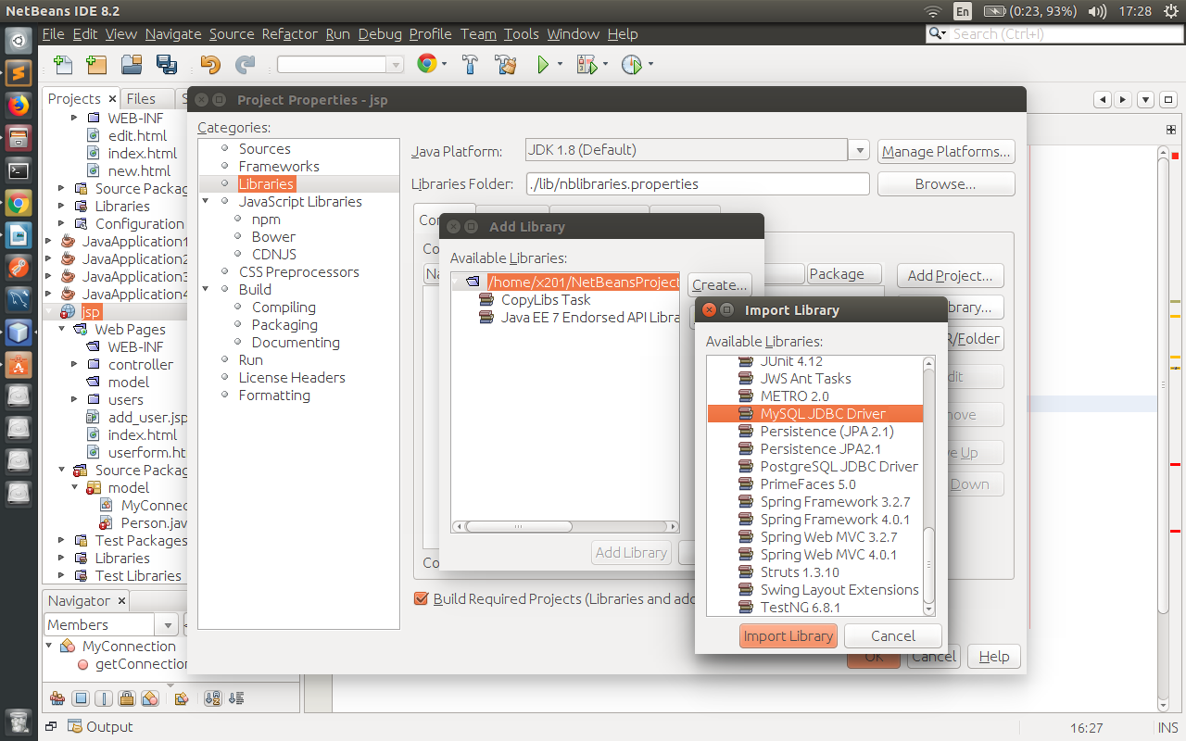

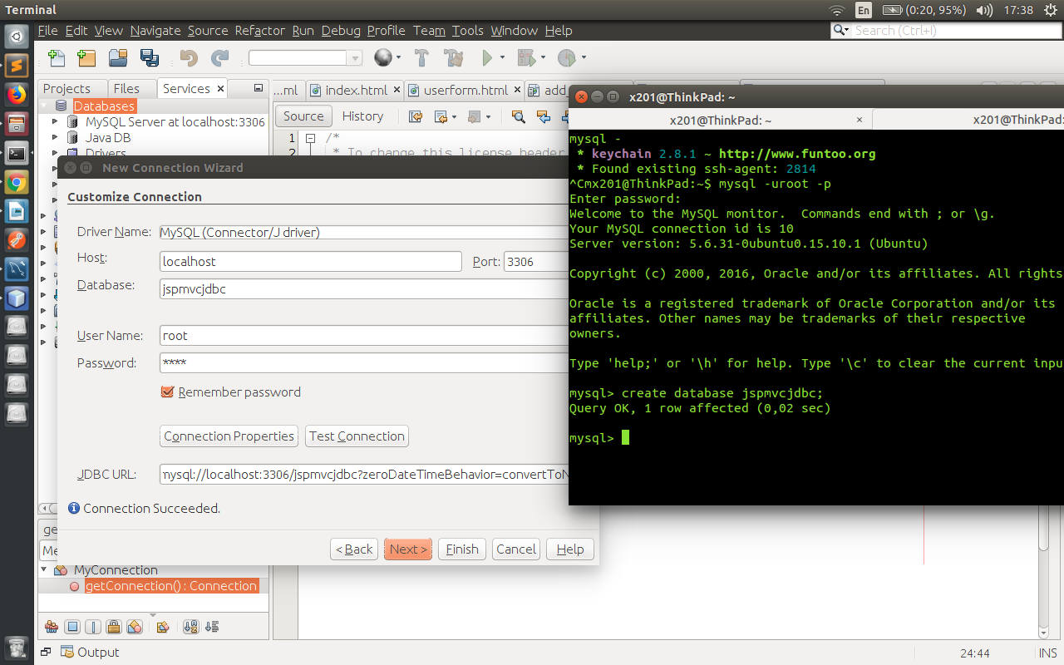
  - Scriplet
<html>
<body><% System.out.println(“Hello”) %>
</body>
</html>
  - Directive
<%@ page import=”java.net.*, java.util.” %>
<html>
<body>
<%
InetAddress a= InetAddress.getLocalHost();
System.out.println(“Hello you with IP” + a.getHostAddress());
%>
<%@ include file='footer.jsp' %>
</body>
</html>
  - Tag

  - Session

  - Bean & Request Processing

  - Database Programming

- Java Database Connectivity
- Enterprise Java Bean
- Design Pattern & Model View Controller
- Rest Web Services
- XML
- Servlet Programming
- Remote Model Invocation
- Penilaian Akhir Project

