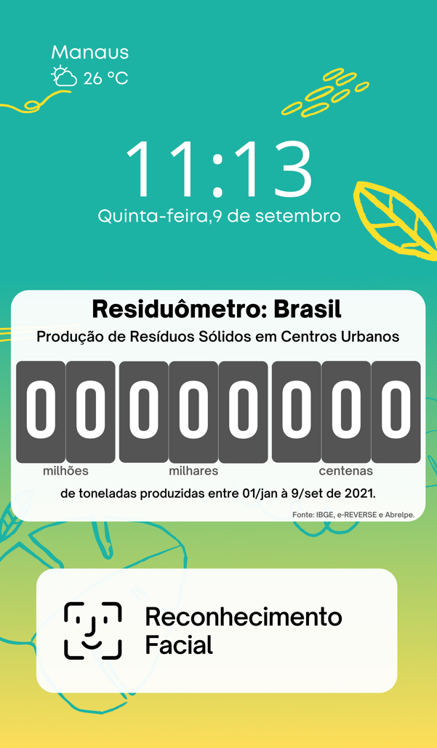

Screen: Standby.

This screen will be the first UI screen for all users!

On this screen there are some elements.

1 - City name and local weather conditions:

City: Font: Mont, size: 19.5;

Temperature: Font: Mont, Size: 18.5;

Data can be entered via Weather Google API, or another, with weather condition calls every hour, for that we can use GPS;

2 – Local time:

Local Time: Font: Open Sans, size: 80;

Day of week, day of month and month: Font: Mont, size: 18.5;

3 – Waste production counter in Brazil:

It's an option, but you won't need an API for that, just calculations based on the date and time and some other parameters. For example:

Brazilian population in real time: ibge.gov.br/apps//populacao/projeção

every 21 seconds Brazil increases 1 people or 0.0476190476 people per second.

Each people annually produce 0.41769678 ton of waste or 1.3245078e-8 ton per second. For the current population every second will be produced 2.82907342 ton of waste.

In this way, we will have to make two types of evolution: habitants and then residues.

For the population estimate we will start counting at the reference value: 213594331 and we will add 0.0476190476 every second.

Pop_Brazil(1) = 213594331; Pop_Brazil(t) = Pop_Brazil(1) + 0.0476190476;

t = seconds;

To estimate waste, count as a function of the number of peoples and time.

%Equivalent day of the year:

Eq_day(September 14th) = 257;

Waste_Brazil(1) = ABS(Pop_Brazil(t))* Eq_day(September 14)*84600*1.3245078e-8;

Waste_Brazil(t) = Waste_Brazil(1) + ABS(Pop_Brazil(t)*1.3245078e-8);

4 – Face recognition button:

This button will take you to the next screen.

However, if the PIR sensor detects an approach, it will turn on an LED light to illuminate the area and our assistant Gaia will say “Hello, I'm Gaia, Assistant Ecodots®. Get closer to the camera” and the process will continue without the need to use the button.

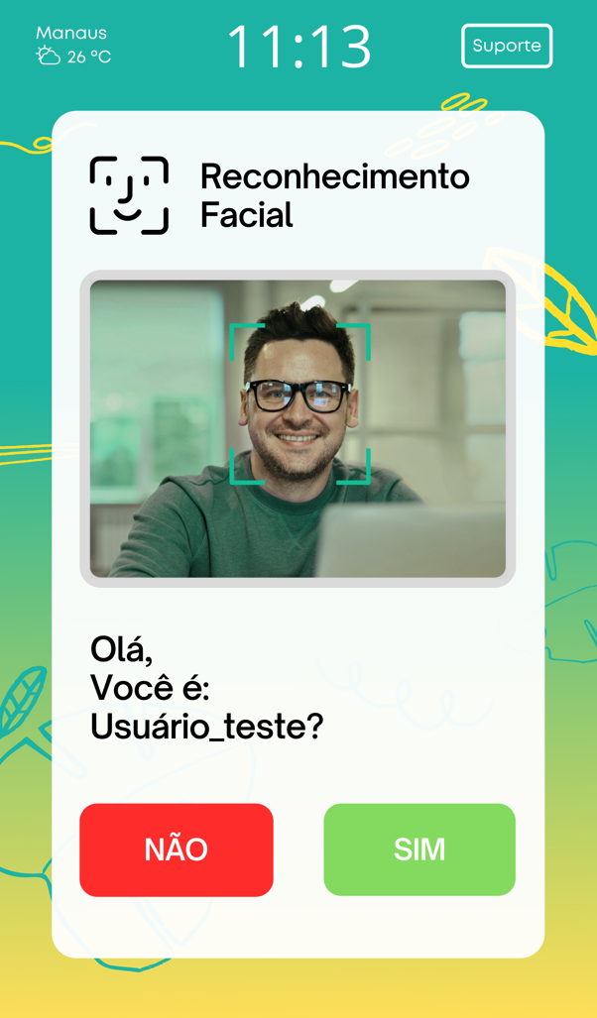

Screen: Face Recognition.

This screen will be the second UI screen for all users!

On this screen there are some elements.

1 - City name and local weather conditions:

City: Font: Mont, size: 13;

Temperature: Font: Mont, Size: 12.5;

2 – Local time:

Local Time: Font: Open Sans, size: 44.5;

3 – Support button: *Only if we have time for it.

It will serve to support Ecodots® users with texts about recycling and speeches by assistant Gaia. We are developing the design and will deliver it soon.

4 – User photo:

Photo captured by camera from trash or registration image. If possible, with the same green marking as in the photo as an example.

5 – Text:

Default text: Font: Open Sauce SemiBold, size: 25.1;

"Hello,

You're:

First name?".

In this step Gaia will speak the same text + “Push on the screen or say yes to confirm or no to disagree”.

The yes and no Gaia options should only be available for that screen.

6 – No button:

It is directed to Screen 7.

7 – Yes Button:

It is directed to Screen 3.

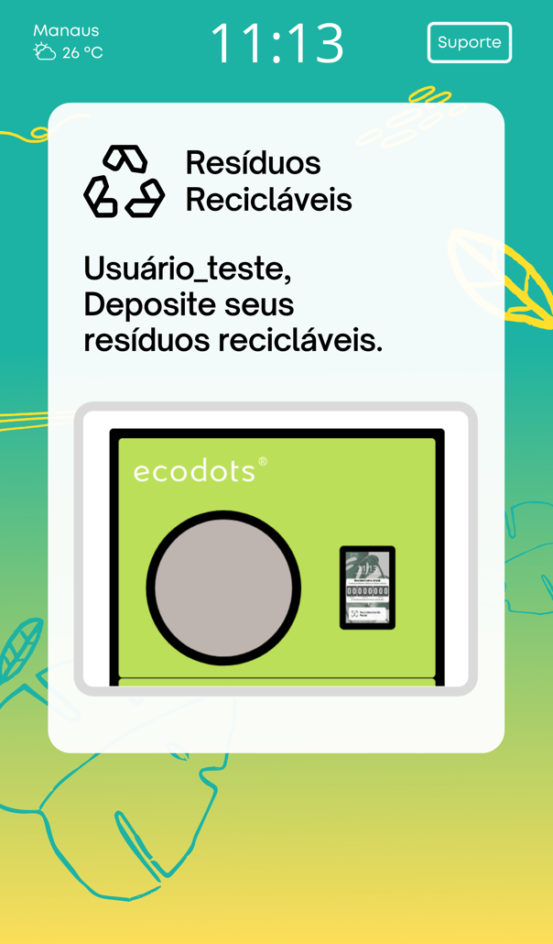

Screen: Opening the Waste Door.

This screen will be the third screen of the UI for registered users and the fifth screen for unregistered users.

On this screen there are some elements.

1 - City name and local weather conditions:

City: Font: Mont, size: 13;

Temperature: Font: Mont, Size: 12.5;

2 – Local time:

Local Time: Font: Open Sans, size: 44.5;

3 – Support button: *Only if we have time for it.

It will serve to support Ecodots® users with texts about recycling and speeches by assistant Gaia. We are developing the design and will deliver it soon.

4 – Text:

Default text: Open Sauce SemiBold, size: 25.1;

- For Registered User

"First name,

deposit your

Recyclable Waste”.

At this stage Gaia will speak:

“First_Name deposit your recyclable waste at the door that will open”.

- For Non-Registered User

"

deposit your

Recyclable Waste”.

At this stage Gaia will speak:

“Deposit your recyclable waste at the door that will open”.

5 – Gif:

Smart Bin port gif opening.

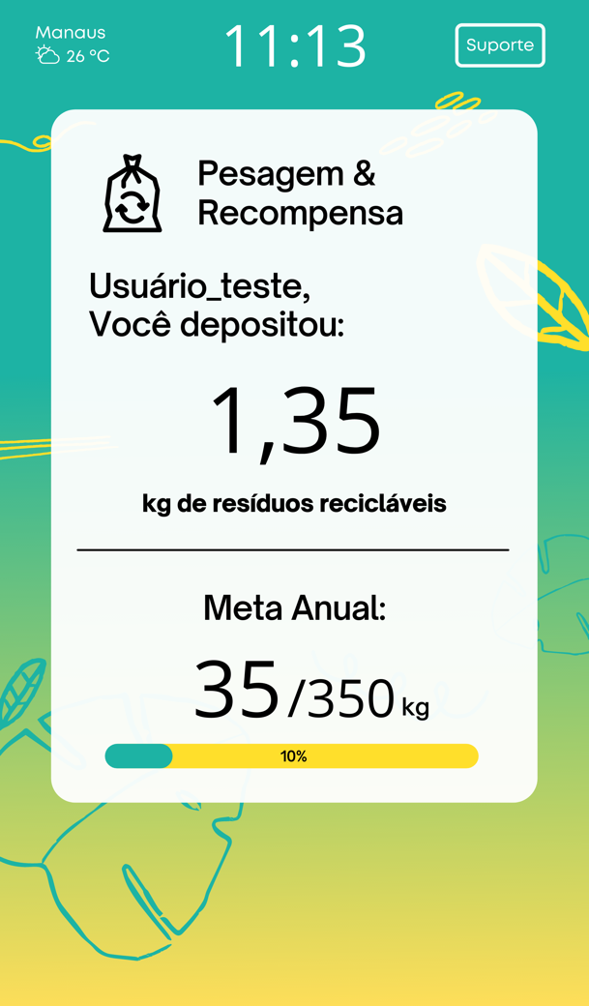

Screen: Waste Weighing.

This screen will be the fourth screen of the UI for registered users and the sixth screen for unregistered users.

On this screen there are some elements.

1 - City name and local weather conditions:

City: Font: Mont, size: 13;

Temperature: Font: Mont, Size: 12.5;

2 – Local time:

Local Time: Font: Open Sans, size: 44.5;

3 – Support button: *Only if we have time for it.

It will serve to support Ecodots® users with texts about recycling and speeches by assistant Gaia. We are developing the design and will deliver it soon.

4 – Text:

Default text: Open Sauce SemiBold, size: 25.1;

- For Registered User

"First name,

You Deposited:”.

At this stage Gaia will speak:

"First name,

you deposited

X kilograms of recyclable waste”.

- For Non-Registered User

“,

You Deposited:”.

At this stage Gaia will speak:

“,

you deposited

X kilograms of recyclable waste”.

5 - Waste Weight:

Number: 0.01 to 99.99 Font: Open Sans, size: 70;

6 – Waste Target:

Enter the total amount of waste deposited by registration through the AWS database.

Annual target is 350 kg per registration.

Number: 1 to 350 Font: Open Sans, size: 40;

6 – Goal evolution bar

Number: Font: Open Sauce SemiBold, size: 25.1;

Colors: #1DB3A4 and #FFDE59

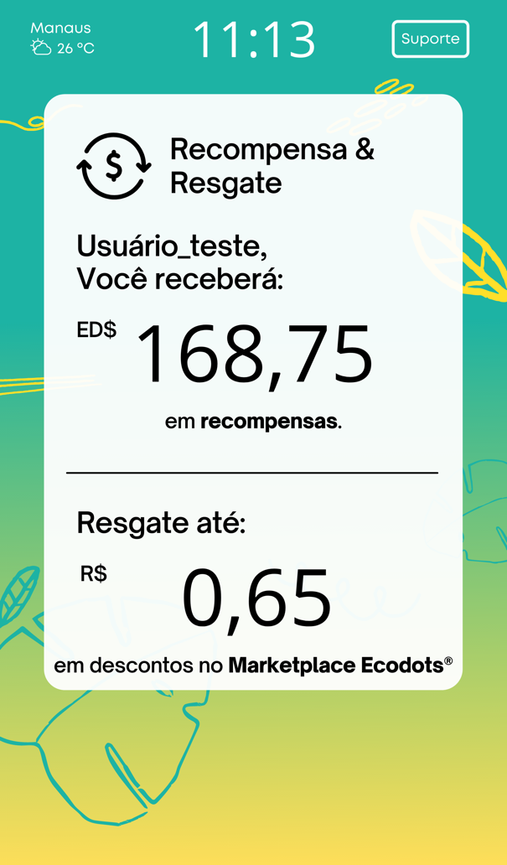

Screen: Rewards

This screen will be the fifth screen of the UI for registered users and the seventh screen for unregistered users.

On this screen there are some elements.

1 - City name and local weather conditions:

City: Font: Mont, size: 13;

Temperature: Font: Mont, Size: 12.5;

2 – Local time:

Local Time: Font: Open Sans, size: 44.5;

3 – Support button: *Only if we have time for it.

It will serve to support Ecodots® users with texts about recycling and speeches by assistant Gaia. We are developing the design and will deliver it soon.

4 – Text:

Default text: Font: Open Sauce SemiBold, size: 25.1;

5 – Reward:

In this step it will be necessary to calculate the weight and show the Reward in Ecodots®(ED$).

Reward = weight_kg*125;

Number: Font: Open Sans, size: 70;

6 – Redemption:

In this step it will be necessary to calculate the weight and show the Redemption in Reais (R$).

Reward = weight_kg*0.38;

Number: Font: Open Sans, size: 70;

In this screen Gaia will speak:

- For Registered User:

"First name,

You receive:

X ecodots

in rewards”.

"Redeem discounts of up to

X reais and Y cents

on Marketplace Ecodots”.

- For Non-Registered User:

“,

You receive:

X ecodots

in rewards”.

"Redeem discounts of up to

X reais and Y cents

on Marketplace Ecodots”.

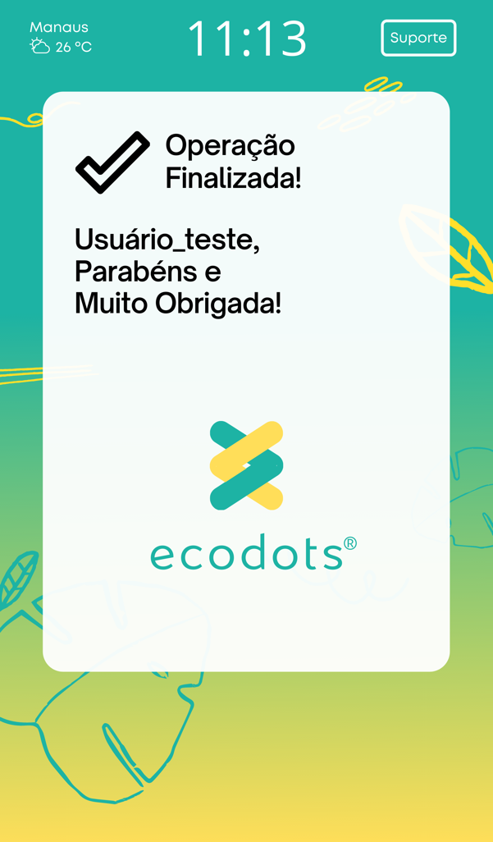

Screen: Final

This screen will be the sixth screen of the UI for registered users and the eighth screen for unregistered users.

On this screen there are some elements.

1 - City name and local weather conditions:

City: Font: Mont, size: 13;

Temperature: Font: Mont, Size: 12.5;

2 – Local time:

Local Time: Font: Open Sans, size: 44.5;

3 – Support button: *Only if we have time for it.

It will serve to support Ecodots® users with texts about recycling and speeches by assistant Gaia. We are developing the design and will deliver it soon.

4 – Text:

Default text: Font: Open Sauce SemiBold, size: 25.1;

- For Registered User:

"First name,

Congratulations on giving the correct destination to your waste,

Thank you very much!

- For Non-Registered User:

“,

Congratulations on giving the correct destination to your waste,

Thank you very much!

5 - Logo:

Ecodots® Logo

On this screen Gaia will speak:

- For Registered User:

"First name,

Congratulations on giving the correct destination to your waste,

Thank you very much!

- For Non-Registered User:

“,

Congratulations on giving the correct destination to your waste,

Thank you very much!

NOTE: Return to Screen 1.

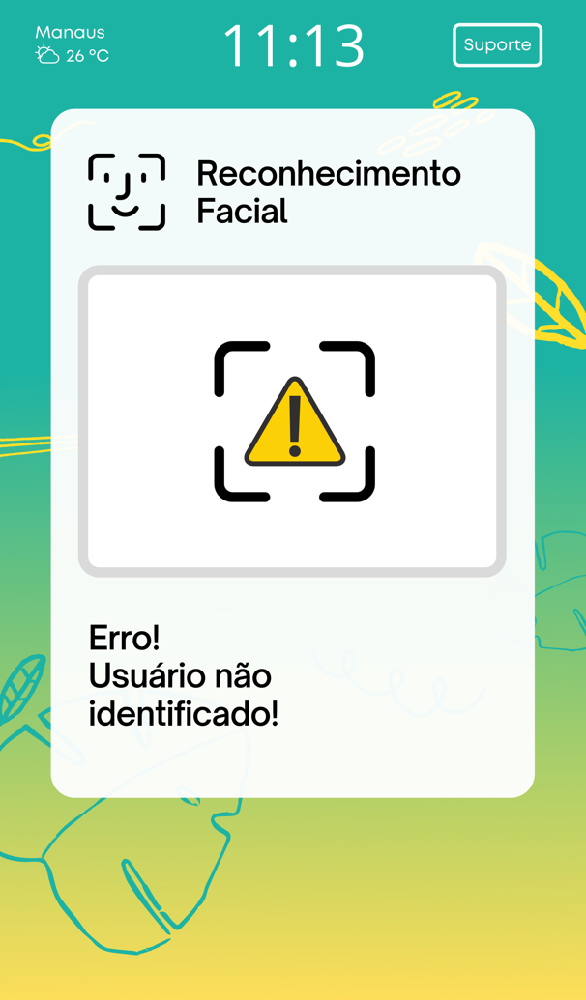

Screen: Face Recognition - Error.

This screen will be the fifth screen of the UI for unregistered users

On this screen there are some elements.

1 - City name and local weather conditions:

City: Font: Mont, size: 13;

Temperature: Font: Mont, Size: 12.5;

2 – Local time:

Local Time: Font: Open Sans, size: 44.5;

3 – Support button: *Only if we have time for it.

It will serve to support Ecodots® users with texts about recycling and speeches by assistant Gaia. We are developing the design and will deliver it soon.

4 - Image:

Facial recognition failure image;

5 – Text:

Default text: Font: Open Sauce SemiBold, size: 25.1;

" Error!

User not

identified!".

On this screen Gaia will speak:

"Error!

User not

identified!".

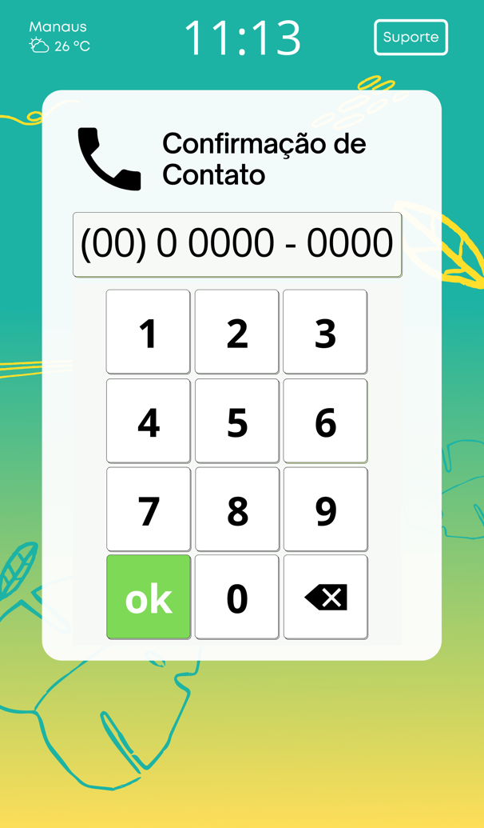

Screen: Contact.

This screen will be the sixth screen of the UI for unregistered users.

On this screen there are some elements.

1 - City name and local weather conditions:

City: Font: Mont, size: 13;

Temperature: Font: Mont, Size: 12.5;

2 – Local time:

Local Time: Font: Open Sans, size: 44.5;

3 – Support button: *Only if we have time for it.

It will serve to support Ecodots® users with texts about recycling and speeches by assistant Gaia. We are developing the design and will deliver it soon.

4 – Telephone Number:

Default text: Font: Open Sans, size: 37;

Total 10 digits: 00 9 1234 - 5678

On this screen Gaia will speak:

- For Registered User:

"First name,

Your number is zero zero nine one...?

Click ok to confirm or say yes to continue”

5 – Buttons:

Ok button, takes you to the Screen: Waste Door Opening.