Face Attendance vs Zoho People
Change Request | CR-2026-FAR-01 | Attendance System | Zoho Creator
Document  CR-2026-FAR-01 | Scope  Zoho Creator / Face Tool Server | Status  Draft - Pending Review | Affects  All Training Centers | Config  Environment form

OVERVIEW
Purpose & Scope
This change request covers every system-level modification needed to run Face Recognition attendance alongside or instead of Zoho People. Both systems coexist behind a single application-wide configuration toggle in Zoho Creator. Switching the toggle conditionally enables or disables each system's data pipeline without a code deployment.
During the pilot phase, the toggle controls the active mode for the entire application. Seven change areas are affected: Batch Start, Daily Attendance, License Validation, Batch Completion, Dropout Handling, Dashboard, and Daily Schedules.

CONFIGURATION
Attendance Mode Toggle
A single application-wide toggle in the Environment form (System Settings) controls which attendance system is active for the entire platform. Changing the toggle fires a webhook to the Face Tool server, which acknowledges the new mode and adjusts its form target. No server restart required.
Option 1  Face Recognition  Face Tool switches posting target to Attendance_form (Main Form) and forwards scan events in real time. Zoho People push, sync, and license operations are fully suspended. | Option 2  Zoho People  Trainees are pushed to Zoho People at batch start. Face Tool posts to Face_Attendance form only. Attendance fetched on a daily schedule and synced to the main module.

CHANGE REQUIREMENTS
Required Modifications by Area
01 Batch Start Process Both Modes
FACE RECOGNITION  When Face Recognition is active, skip the Zoho People trainee push entirely. The Face Tool manages the trainee roster through its own enrollment database. Batch start updates only the local Zoho Creator record with no API call to Zoho People. | ZOHO PEOPLE  Behavior unchanged: all enrolled trainees are pushed to Zoho People as active users. If the license limit is reached, overflow trainees are queued for auto-push when licenses become available.

02 Daily Attendance Capture Both Modes
FACE RECOGNITION  Attendance captured in real time through face scans. Face Tool posts each event to Attendance_form immediately. All report and dashboard queries source from Attendance_form when this mode is active. | ZOHO PEOPLE  Face Tool posts scan events to Face_Attendance form only. Existing daily scheduled fetch from Zoho People remains active. Scheduled job checks the active mode from Environment form before executing.

03 Zoho People License Validation ZP Only
FACE RECOGNITION  Not applicable. Face Recognition mode does not consume Zoho People licenses. | ZOHO PEOPLE  Scheduled job at 08:00 IST checks license availability. Auto-pushes queued trainees when licenses free up. Alerts when pool is within 10% of capacity. Logs utilization per run for audit.

04 Batch Completion Process Both Modes
FACE RECOGNITION  Remove the trainee group from Face Tool active tracking via webhook or API. No Zoho People operation required. Attendance history preserved in Attendance_form for reporting and audit. | ZOHO PEOPLE  Deactivate all trainees in the completed batch from Zoho People, freeing licenses for the pending queue. Deactivation confirmed before batch is marked complete in Zoho Creator.

05 Trainee Dropout Handling Both Modes
FACE RECOGNITION  When a trainee status changes to Training Dropout or Placement Dropout, a webhook disables their Face Tool enrollment. Future scans will not match. Attendance history preserved in Attendance_form. | ZOHO PEOPLE  Remove the dropout trainee from Zoho People immediately upon status change, freeing one license for the auto-push queue. Workflow must trigger on both dropout status values.

06 Dashboard Both Modes
FACE RECOGNITION  Charts, attendance percentages, and drill-downs source data from Attendance_form. Mode indicator visible to operators. All attendance API calls rerouted based on active mode from Environment form. | ZOHO PEOPLE  Dashboard continues to source data from Zoho People with no change to existing dashboard logic. Mode indicator confirms Zoho People as active. Org-level reports aggregate from both sources.

07 Daily Absence Schedule Both Modes
FACE RECOGNITION  Runs after 5:00 PM IST. Marks trainees Absent if no scan event in Attendance_form for that date. Reads active mode from Environment form and is skipped if Zoho People mode is active. | ZOHO PEOPLE  Marks trainees Absent based on Zoho People data. Skipped entirely if Face Recognition mode is active to prevent double-processing. Both branches log execution results per center.

SYSTEM INTEGRATION
Toggle Webhook Behavior
Every change to the mode field in the Environment form fires a webhook to the Face Recognition Tool server. The server updates its routing config and returns a 200 confirmation. No manual server intervention or code deployment is required at switch time.
Step 1: Trigger  Admin changes the mode field in the Environment form (System Settings). Webhook fires immediately with the new mode value. | Step 2: Acknowledge  Face Tool server receives the webhook, validates the payload, and updates its internal routing config. Returns HTTP 200. | Step 3A: Face Recognition  Face Tool switches posting target to Attendance_form. All subsequent scans post to the main attendance form in real time. | Step 3B: Zoho People  Face Tool switches posting target to Face_Attendance form. Zoho People operations resume. Trainees pushed via API.

SYSTEM FLOW
End-to-End Attendance Flow
Both modes shown as parallel tracks. The application-wide toggle in the Environment form determines which track is active. Steps at the same row are the same process point, only the data source and form target change.
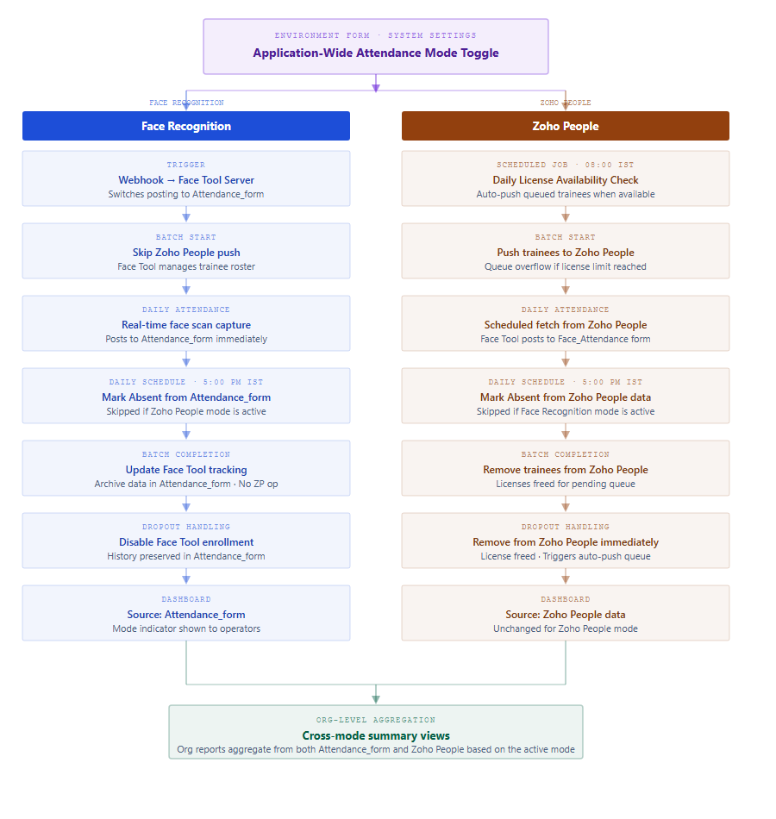

KNOWN LIMITATION
Mid-Day Toggle Switch
If the toggle in the Environment form is changed between modes during an active attendance day, records before the switch are in one form and records after are in the other. That day's data is split across Attendance_form and Face_Attendance and cannot be automatically reconciled.
Recommended practice: Only change the mode toggle at the start of a new day, before any attendance is recorded. From the following day, all attendance flows exclusively through the selected mode.
When switching back to Zoho People, a one-time API pass pushes all trainees in active batches to Zoho People, one call per enrolled trainee. Account for this volume when scheduling the switch.

EFFORT ESTIMATE
Development Effort in Hours
Estimates cover development effort only. Testing, deployment, and UAT time not included. Review required before commitment.
Section | Task | Hours
Zoho People Side
 | Batch Start Process | 10
 | Daily Attendance Capture | 12
 | Zoho People License Validation | 8
 | Batch Completion Process | 4
 | Trainee Dropout Handling | 4
 | Daily Schedules | 5
 | Dashboard | 15
 | Subtotal - Zoho People Side | 58
Face Recognition Tool Side
 | Design Changes for Field Additions | 10
 | Form Switching Webhook and Workflows | 10
 | Daily Absence Schedule | 15
 | Batch Start Process | 12
 | Dashboard | 15
 | Subtotal - Face Recognition Tool Side | 62
Total Effort | Grand Total | 120

CR-2026-FAR-01 | Face Attendance vs Zoho People | Draft - Pending Review | EdZola

