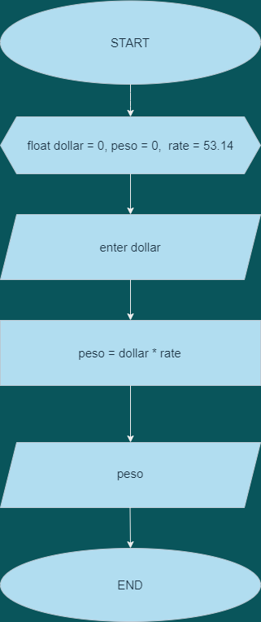Name: Buenaventura, Aristotle C.  
Section: IS11S1  
Activity: Assessment Task 1.1. Creating a Flowchart (HOMEWORK)  
Date: 12/4/2020