Technological Institute of the Philippines

Quezon City Campus

938 Aurora Blvd., Cubao, Quezon City

**CHICKENPLUSPLUS**

**(Food Ordering System)**

In Partial Fulfillment of the Requirements in

ITE 001 – Computer Programming 1

**Submitted by:**

ABRIAN, AZAREL JEDIAEL

BUENAVENTURA, ARISTOTLE

LEONEN, JUSTINE

**Submitted to:**

DR. RISTY ACERADO

JANUARY 2021

1. **Introduction**

A restaurant menu is more than just a list of food with prices. It is also representing the theme and concept of what and how a restaurant's service works. The menu is the heart of any restaurant, it showcases everything you have to offer for food and beverages. The most menu bears a cover that symbolizes a restaurant's identity, while the layout itself can serve as a silent salesperson. A well designed and planned menu can motivate customers and even employees for responsible service and can lead to consumer satisfaction.

As technology more and more peaks in the modern world, it has almost become a duty for technology to create easier accessibility for exchanging and purchasing necessities as you would in the real world, and ordering food is one of them. People need food to survive and what better way to make purchasing food easier, especially at a time of a worldwide pandemic, is creating a programmed restaurant menu designed for an easier and effective online catering.

This program can provide much more convenience in navigating its preferred catering as it’s automated, which can help in these trying times.

1. **Problem of the study**

The outbreak emerged on January 21, 2020, severely affecting the Filipinos and rapidly spread across the world. According to the World Health Organization (WHO), COVID-19 is primarily transmitted from an infected person to others through droplets of saliva or discharge from the nose. The virus could transmit through money and person to person.

Almost everything that we need to buy must be on an online platform due to the virus. Most of the restaurants in the Philippines are forced to close because of a lack of customers since customers cannot able to go outside. When we talk about restaurants or fast-food chains, it must be fast however some of them are slow in terms of the transaction. They need to ask the customers one by one what would they like to order.

Based on the developers of this program, writing the customers’ order are irritating and inconvenient because it may lead to a discrepancy in orders of customers - time-consuming.

1. **Objectives of the study**

The general objective of this study is to develop an Online Restaurant Menu System through the use of the C++ programming language that showcases what a restaurant has to offer. This project intends to achieve the following:

* 1. To design a user-friendly and interactive interface that showcases the available products a restaurant sells.
  2. To construct a simple and effective menu plan and design that allows the users to navigate easily through the program.
  3. To provide more convenience for users to wish for easier accessibility to purchasing restaurant products.

1. **Significance of the study**

This study will be a great significance to everyone who uses their devices to order food online. The study has created to help consumers in their purchases. It will be more convenient for customers and for the restaurants to make a transaction. Instead of going outside during the pandemic that is still occurring, consumers could let open their devices and order food from the comfort of their homes.

The system aids everyone during this pandemic. It will lessen the spread of the Covid-19 given customers do not need to go outside and buy their foods at their favorite restaurants. Chicken++ is unlike in actual restaurants where you are urged when you order due to the waiter is waiting to take your order, here you decide which meal you want to order since you can order whenever you feel like ordering.

Lastly, the system helps small restaurants to get into the online food business. It can be easily changed to suit the restaurant handling it.

1. **Flowchart of the program**

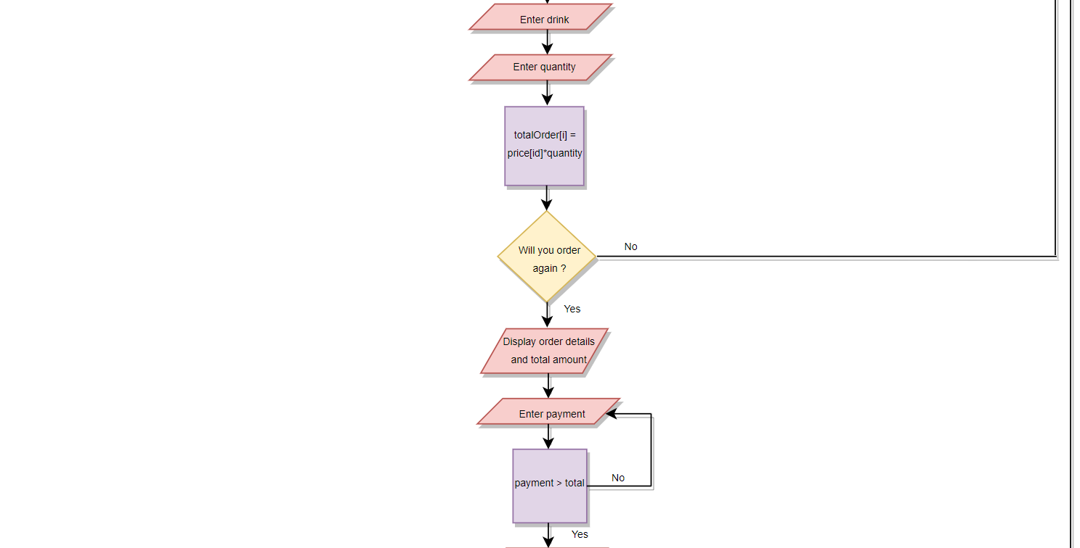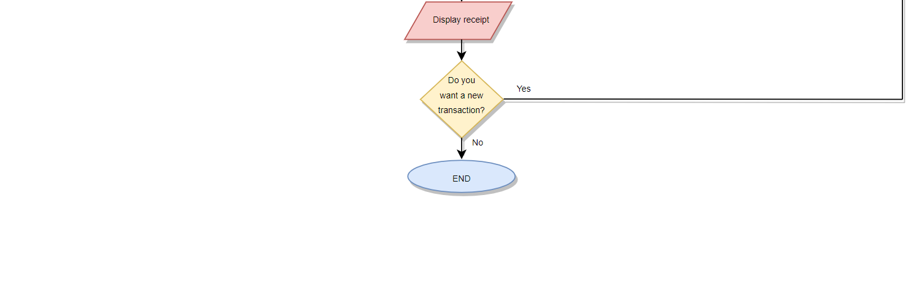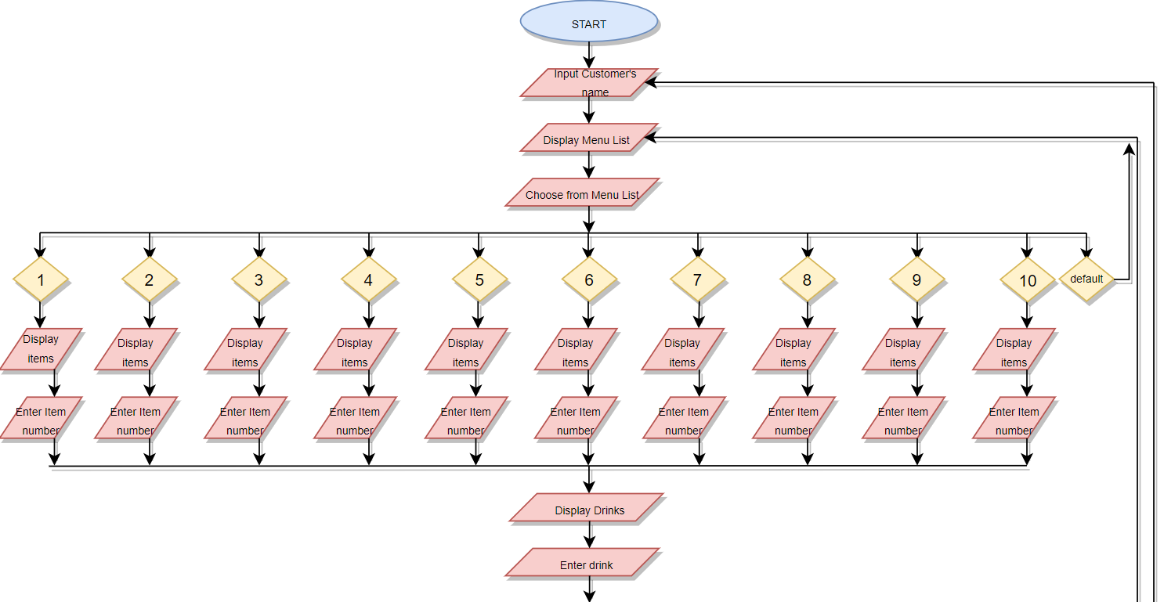

1. **Screenshots of sample run of the program**

The user is first greeted with the Chicken++ text art as logo, and is asked to enter the customer’s name.

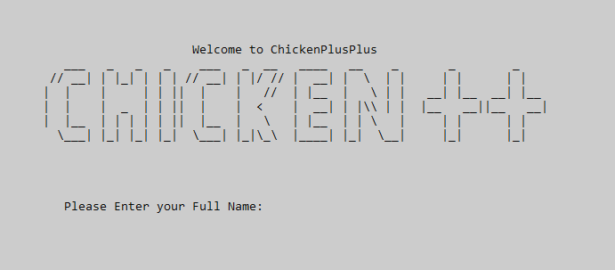

Figure 1. Welcome page of Chicken++ App

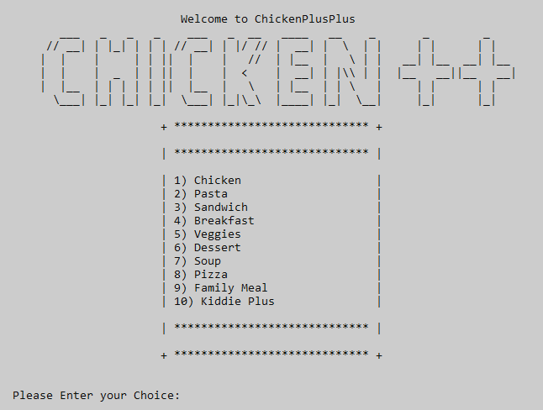After inputting the customer’s name, 10 food categories of the restaurant will display. The user shall input a category of their choosing from 1-10.

Figure 2. Menu list of Chicken++ App

After inputting a chosen category, the program will display the available food items for sale, which as well works as well by choosing an item by inputting from numbers 1-10.

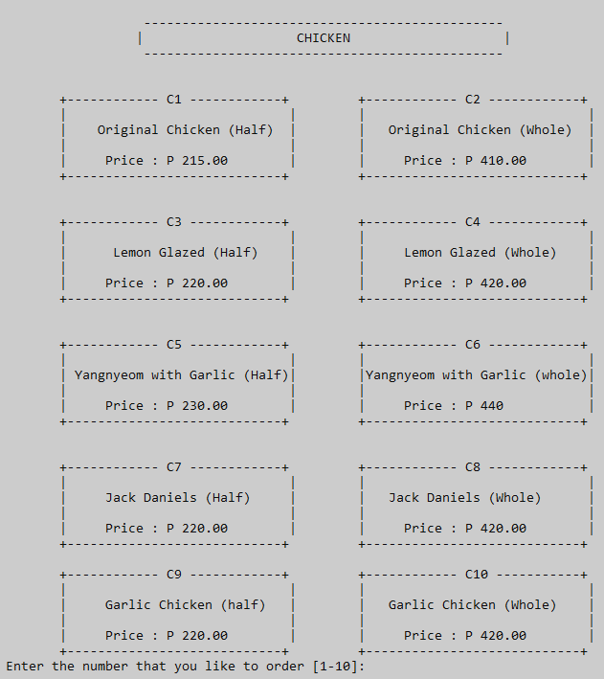

Figure 3. Chicken’s Menu list

Drink choices will be displayed after inputting a food of the customer’s choosing, also requires the user to input the numbers from the displayed choices (1-5).

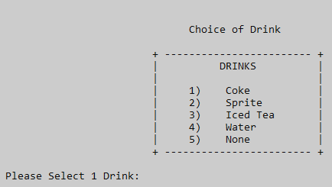

Figure 4. Drinks Menu

The system will ask for the quantity of the food that will be bought.

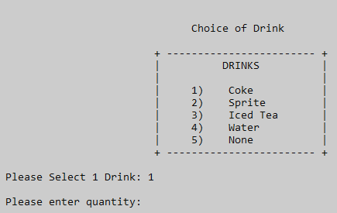

Figure 5. Enter quantity

Then asks if the user wishes to order again. Inputting 1 will redisplay the food categories menu allowing the user to choose another item while inputting 0 will go to the receipt area.

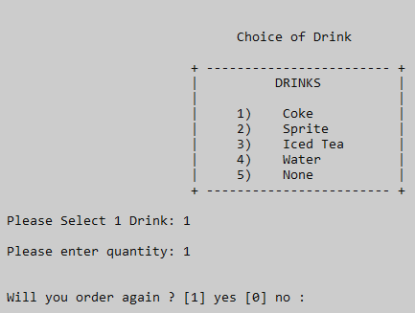

Figure 6. Order Again

If the user no longer wishes to order anymore items, the system will start billing the user.

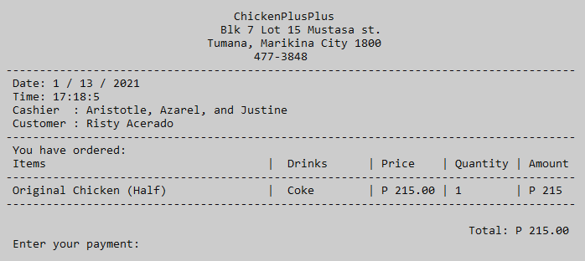

Figure 7. Total Bill

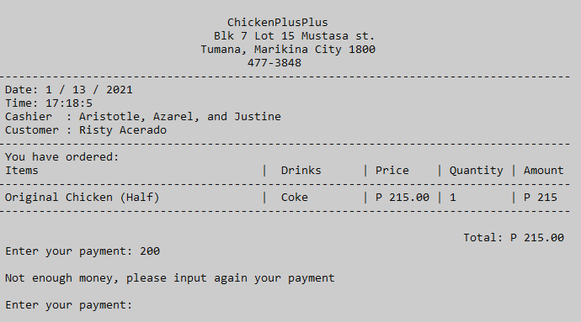Billing result if user’s inputs payment below the total bill amount.

Figure 8. Enter payment

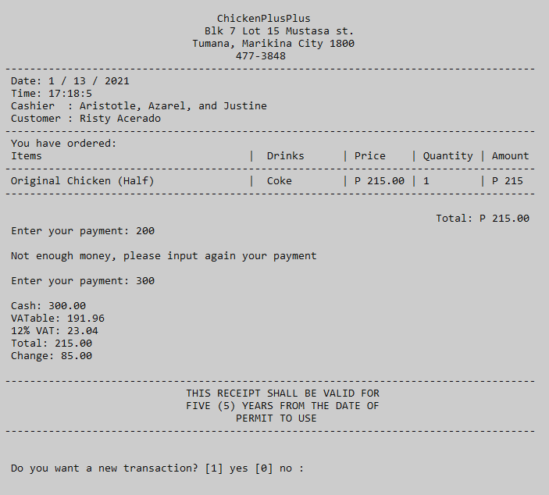Full payment and receipt generated and ask the user if he/she wants to have a new transaction. Inputting 1 will go back to the main menu while inputting 0 will lead to the, “Thank you and come again!” statement

Figure 9. Final receipt

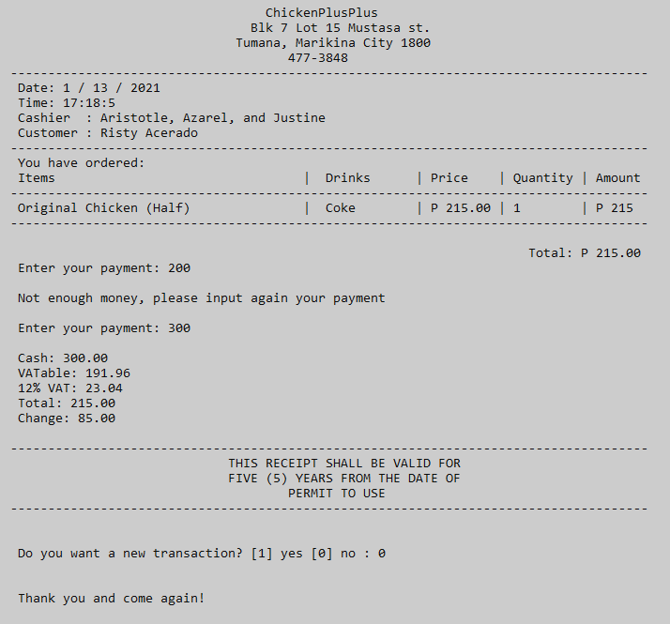

Figure 10. End of program

1. **Conclusion**

The project Chicken++ has achieved all the objectives. It has demonstrated how automation can provide more convenience for both parties (users and the restaurant). It comes up with easier accessibility in purchasing products and minimizes difficulties in ordering. Users can navigate through the program straightforwardly and have properly showcased and categorized food products. It is feasible for real-world applications and made to make ordering food online like what you would do in face-to-face situations. It can be easily modified to fit the given products being sold by the establishment. It is also known that the program was made in C++ so that it will be easily understood by people who know how to program.

Chicken++ has a lot of uses not just for the sale of food but also it can be modified to fit other products, it also has a lot of significant uses in the real world because it was made with the intention that it will revolutionize food ordering services online. The conclusion of this project, C++ has many real-world applications and that can be easily used by anyone. The project was done by the joint effort of this. C++ is a great tool for any to use and has a multitude of uses in the real world, with basic knowledge of it there are countless uses it.

1. **References**

*C++ Language*. (n.d.). Retrieved from cplusplus.com: https://www.cplusplus.com/doc/tutorial/

*C++ Tutorial*. (n.d.). Retrieved from w3schools: https://www.w3schools.com/cpp/

*C++ Tutorial - Tutorialspoint*. (2020). Retrieved from Tutorialspoint: https://www.tutorialspoint.com/cplusplus/index.htm

Engineer4Free. (2015). *Filling arrays with a loop (C++ programming tutorial)*. Retrieved from Youtube: https://www.youtube.com/watch?v=7pb7caaYawc

Evangelista, A. (2020). *Food Ordering System Project in C++ with Source Code*. Retrieved from IT SOURCECODE: https://itsourcecode.com/free-projects/cplusplus-projects/food-ordering-system-project-in-c-with-source-code/

Ros, F. (2019). *SIMPLE FOOD ORDER SYSTEM IN C++ WITH SOURCE CODE*. Retrieved from Code-Projects: https://code-projects.org/simple-food-order-system-in-c-with-source-code/

1. **Codes**

#include <iostream>

#include "windows.h"

#include <ctime>

#include <conio.h>

#include <iomanip>

using namespace std;

void again (int& isExit);

float bill(float& payment, float& change, float& vatAble, float& total, float& vat, int& newTransaction);

int drinksMenu(int& drinks);

void dots();

void display();

void blink(int);

void customer(string& user);

int menu(int& choice);

int code(int& ordercode);

int quants(int& quantity);

int main() {

// Declaration of functions

int choice;

int ordercode;

int drinks;

int quantity = 0;

int i=0;

string order[100];

string price[100];

string totalDrinks[100];

int totalQuantity[100];

int totalOrder[100];

int isExit=1;

int a;

string user;

time_t now = time(0);

tm *ltm = localtime(&now);

int max = 0;

float total = 0;

int pay = 0;

float payment = 0;

float change = 0;

float vat = 0;

float vatAble = 0;

int newTransaction;

system("COLOR 70"); // white background with color black font color

//This displays the Home screen of the program

display();

customer(user);

while ( isExit==1 ) {

max++; // increment

i++;

start:

system("CLS");

// The main menu of the program and where the customer can select their preferred meal

display();

menu(choice);

system("CLS");

// This is the menu when the customer has selected number 1 in the main menu

if(choice == 1)

{

chicken:

cout << "\n\t -----------------------------------------------"<<endl;

cout << "\t | CHICKEN |"<<endl;

cout << "\t -----------------------------------------------\n"<<endl;

cout << "\n +------------ C1 ------------+ \t +------------ C2 ------------+"<<endl;

cout << "\t| |\t | |" << endl;

cout << "\t| Original Chicken (Half) |\t | Original Chicken (Whole) |" << endl;

cout << "\t| |\t | |" << endl;

cout << "\t| Price : P 215.00 |\t | Price : P 410.00 |" << endl;

cout << "\t+----------------------------+\t +----------------------------+" << endl;

cout << "\n\n +------------ C3 ------------+ \t +------------ C4 ------------+"<<endl;

cout << "\t| |\t | |" << endl;

cout << "\t| Lemon Glazed (Half) |\t | Lemon Glazed (Whole) |" << endl;

cout << "\t| |\t | |" << endl;

cout << "\t| Price : P 220.00 |\t | Price : P 420.00 |" << endl;

cout << "\t+----------------------------+\t +----------------------------+" << endl;

cout << "\n\n +------------ C5 ------------+ \t +------------ C6 ------------+"<<endl;

cout << "\t| |\t | |"<<endl;

cout << "\t| Yangnyeom with Garlic (Half)|\t |Yangnyeom with Garlic (whole)|"<<endl;

cout << "\t| |\t | |"<<endl;

cout << "\t| Price : P 230.00 |\t | Price : P 440 |"<<endl;

cout << "\t+----------------------------+\t +----------------------------+"<<endl;

cout << "\n\n +------------ C7 ------------+ \t +------------ C8 ------------+"<<endl;

cout << "\t| |\t | |"<<endl;

cout << "\t| Jack Daniels (Half) |\t | Jack Daniels (Whole) |"<<endl;

cout << "\t| |\t | |"<<endl;

cout << "\t| Price : P 220.00 |\t | Price : P 420.00 |"<<endl;

cout << "\t+----------------------------+\t +----------------------------+"<<endl;

cout << "\n +------------ C9 ------------+ \t +------------ C10 -----------+"<<endl;

cout << "\t| |\t | |" << endl;

cout << "\t| Garlic Chicken (half) |\t | Garlic Chicken (Whole) |" << endl;

cout << "\t| |\t | |" << endl;

cout << "\t| Price : P 220.00 |\t | Price : P 420.00 |" << endl;

cout << "\t+----------------------------+\t +----------------------------+" << endl;

code(ordercode);

system("CLS");

// Drinks menu after the customer has selected chicken

drinksChicken:

system("CLS");

if (ordercode == 1 || ordercode == 2 || ordercode == 3 || ordercode == 4 || ordercode == 5 || ordercode == 6 || ordercode == 7 || ordercode == 8 || ordercode == 9 || ordercode == 10)

{

drinksMenu(drinks);

switch(drinks)

{

case 1:

totalDrinks [i] =" Coke ";

break;

case 2:

totalDrinks [i] =" Sprite ";

break;

case 3:

totalDrinks [i] =" Iced Tea ";

break;

case 4:

totalDrinks [i] =" Water ";

break;

case 5:

totalDrinks [i] =" None ";

break;

default:

goto drinksChicken;

break;

}

quants(quantity);

switch(ordercode)

{

case 1:

order[i] = "Original Chicken (Half)";

price[i] = "P 215.00";

totalQuantity[i] = quantity;

totalOrder[i] = 215*quantity;

break;

case 2:

order[i] = "Original Chicken (Whole)";

price[i] = "P 410.00";

totalQuantity[i] = quantity;

totalOrder[i] = 410*quantity;

break;

case 3:

order[i] = "Lemon Glazed (Half)";

price[i] = "P 220.00";

totalQuantity[i] = quantity;

totalOrder[i] = 220*quantity;

break;

case 4:

order[i] = "Lemon Glazed (Whole)";

price[i] = "P 420.00";

totalQuantity[i] = quantity;

totalOrder[i] = 420*quantity;

break;

case 5:

order[i] = "Yangnyeom with Garlic (Half)";

price[i] = "P 230.00";

totalQuantity[i] = quantity;

totalOrder[i] = 230*quantity;

break;

case 6:

order[i] = "Yangnyeom with Garlic (whole)";

price[i] = "P 440.00";

totalQuantity[i] = quantity;

totalOrder[i] = 440*quantity;

break;

case 7:

order[i] = "Jack Daniels (Half)";

price[i] = "P 220.00";

totalQuantity[i] = 220;

totalOrder[i] = 220*quantity;

break;

case 8:

order[i] = "Jack Daniels (Whole)";

price[i] = "P 420.00";

totalQuantity[i] = quantity;

totalOrder[i] = 420*quantity;

break;

case 9:

order[i] = "Garlic Chicken (half)";

price[i] = "P 220.00";

totalQuantity[i] = quantity;

totalOrder[i] = 220*quantity;

break;

case 10:

order[i] = "Garlic Chicken (whole)";

price[i] = "P 220.00";

totalQuantity[i] = quantity;

totalOrder[i] = 420*quantity;

break;

}

} else {

goto chicken;

}

// This is the menu when the customer has selected number 2 in the main menu

} else if (choice == 2)

{

pasta:

cout << "\n\t -----------------------------------------------"<<endl;

cout << "\t | PASTA |"<<endl;

cout << "\t -----------------------------------------------\n"<<endl;

cout << "\n +------------ P1 ------------+ \t +------------ P2 ------------+"<<endl;

cout << "\t| |\t | |" << endl;

cout << "\t| Spaghetti Bolognese |\t | Spaghetti Bolognese |" << endl;

cout << "\t| |\t | with Meatballs |" << endl;

cout << "\t| Price : P 119.00 |\t | Price : P 169.00 |" << endl;

cout << "\t+----------------------------+\t +----------------------------+" << endl;

cout << "\n\n +------------ P3 ------------+ \t +------------ P4 ------------+"<<endl;

cout << "\t| |\t | |" << endl;

cout << "\t| Spaghetti Carbonara |\t | Lasagna Classico |" << endl;

cout << "\t| |\t | |" << endl;

cout << "\t| Price : P 129.00 |\t | Price : P 189.00 |" << endl;

cout << "\t+----------------------------+\t +----------------------------+" << endl;

cout << "\n\n +------------ P5 ------------+ \t +------------ P6 ------------+"<<endl;

cout << "\t| |\t | |"<<endl;

cout << "\t| Bacon Aglio Olio |\t | Bacon Mac and Cheese |"<<endl;

cout << "\t| |\t | |"<<endl;

cout << "\t| Price : P 145.00 |\t | Price : P 169.00 |"<<endl;

cout << "\t+----------------------------+\t +----------------------------+"<<endl;

cout << "\n\n +------------ P7 ------------+ \t +------------ P8 ------------+"<<endl;

cout << "\t| |\t | |"<<endl;

cout << "\t| Fettucine Alfredo |\t | Fetucine a la king |"<<endl;

cout << "\t| |\t | |"<<endl;

cout << "\t| Price : P 149.00 |\t | Price : P 179.00 |"<<endl;

cout << "\t+----------------------------+\t +----------------------------+"<<endl;

cout << "\n +------------ P9 ------------+ \t +------------ P10 -----------+"<<endl;

cout << "\t| |\t | |" << endl;

cout << "\t| Pesto Chicken Penne |\t | Chicken Pops Mac and Cheese |" << endl;

cout << "\t| |\t | |" << endl;

cout << "\t| Price : P 189.00 |\t | Price : P 189.00 |" << endl;

cout << "\t+----------------------------+\t +----------------------------+" << endl;

code(ordercode);

system("CLS");

// Drinks menu after the customer has selected pasta

drinksPasta:

system("CLS");

if (ordercode == 1 || ordercode == 2 || ordercode == 3 || ordercode == 4 || ordercode == 5 || ordercode == 6 || ordercode == 7 || ordercode == 8 || ordercode == 9 || ordercode == 10)

{

drinksMenu(drinks);

switch(drinks)

{

case 1:

totalDrinks [i] =" Coke ";

break;

case 2:

totalDrinks [i] =" Sprite ";

break;

case 3:

totalDrinks [i] =" Iced Tea ";

break;

case 4:

totalDrinks [i] =" Water ";

break;

case 5:

totalDrinks [i] =" None ";

break;

default:

goto drinksPasta;

break;

}

quants(quantity);

switch(ordercode) {

case 1:

order[i] = "Spaghetti Bolognese";

price[i] = "P 119.00";

totalQuantity[i] = quantity;

totalOrder[i] = 119*quantity;

break;

case 2:

order[i] = "Spaghetti Bolognese with Meatballs";

price[i] = "P 169.00";

totalQuantity[i] = quantity;

totalOrder[i] = 169*quantity;

break;

case 3:

order[i] = "Spaghetti Carbonara";

price[i] = "P 129.00";

totalQuantity[i] = quantity;

totalOrder[i] = 129*quantity;

break;

case 4:

order[i] = "Lasagna Classico";

price[i] = "P 189.00";

totalQuantity[i] = quantity;

totalOrder[i] = 189*quantity;

break;

case 5:

order[i] = "Bacon Aglio Olio";

price[i] = "P 145.00";

totalQuantity[i] = quantity;

totalOrder[i] = 145*quantity;

break;

case 6:

order[i] = "Bacon Mac and Cheese ";

price[i] = "P 169.00";

totalQuantity[i] = quantity;

totalOrder[i] = 169*quantity;

break;

case 7:

order[i] = "Fettucine Alfredo";

price[i] = "P 149.00";

totalQuantity[i] = quantity;

totalOrder[i] = 149*quantity;

break;

case 8:

order[i] = "Fetucine a la king";

price[i] = "P 179.00";

totalQuantity[i] = quantity;

totalOrder[i] = 179*quantity;

break;

case 9:

order[i] = "Pesto Chicken Penne";

price[i] = "P 189.00";

totalQuantity[i] = quantity;

totalOrder[i] = 189*quantity;

break;

case 10:

order[i] = "Chicken Pops Mac and Cheese";

price[i] = "P 189.00";

totalQuantity[i] = quantity;

totalOrder[i] = 189*quantity;

break;

}

} else {

goto pasta;

}

// This is the menu when the customer has selected number 3 in the main menu

} else if (choice == 3)

{

sandwich:

cout << "\n\t -----------------------------------------------"<<endl;

cout << "\t | SANDWICH |"<<endl;

cout << "\t -----------------------------------------------\n"<<endl;

cout << "\n +------------ S1 ------------+ \t +------------ S2 ------------+"<<endl;

cout << "\t| |\t | |" << endl;

cout << "\t| Pesto Egg Roll |\t | Tuna Salad Roll |" << endl;

cout << "\t| |\t | |" << endl;

cout << "\t| Price : P 150.00 |\t | Price : P 169.00 |" << endl;

cout << "\t+----------------------------+\t +----------------------------+" << endl;

cout << "\n\n +------------ S3 ------------+ \t +------------ S4 ------------+"<<endl;

cout << "\t| |\t | |" << endl;

cout << "\t| Bacon Toastie |\t | Bacon and Egg Sandwich |" << endl;

cout << "\t| |\t | |" << endl;

cout << "\t| Price : P 175.00 |\t | Price : P 140.00 |" << endl;

cout << "\t+----------------------------+\t +----------------------------+" << endl;

cout << "\n\n +------------ S5 ------------+ \t +------------ S6 ------------+"<<endl;

cout << "\t| |\t | |"<<endl;

cout << "\t| Cheese and Pickle |\t | Mexican Chicken Special |"<<endl;

cout << "\t| |\t | |"<<endl;

cout << "\t| Price : P 175.00 |\t | Price : P 150.00 |"<<endl;

cout << "\t+----------------------------+\t +----------------------------+"<<endl;

cout << "\n\n +------------ S7 ------------+ \t +------------ S8 ------------+"<<endl;

cout << "\t| |\t | |"<<endl;

cout << "\t| Ham and Cheese Croissant |\t | Crispy Bacon and Avocado |"<<endl;

cout << "\t| |\t | |"<<endl;

cout << "\t| Price : P 140.00 |\t | Price : P 175.00 |"<<endl;

cout << "\t+----------------------------+\t +----------------------------+"<<endl;

cout << "\n +------------ S9 ------------+ \t +------------ S10 -----------+"<<endl;

cout << "\t| |\t | |" << endl;

cout << "\t| Brie and Ham |\t | Salami and Cornedbeef |" << endl;

cout << "\t| |\t | |" << endl;

cout << "\t| Price : P 140.00 |\t | Price : P 160.00 |" << endl;

cout << "\t+----------------------------+\t +----------------------------+" << endl;

code(ordercode);

system("CLS");

// Drinks menu after the customer has selected sandwich

drinksSandwich:

system("CLS");

if (ordercode == 1 || ordercode == 2 || ordercode == 3 || ordercode == 4 || ordercode == 5 || ordercode == 6 || ordercode == 7 || ordercode == 8 || ordercode == 9 || ordercode == 10)

{

drinksMenu(drinks);

switch(drinks)

{

case 1:

totalDrinks [i] =" Coke ";

break;

case 2:

totalDrinks [i] =" Sprite ";

break;

case 3:

totalDrinks [i] =" Iced Tea ";

break;

case 4:

totalDrinks [i] =" Water ";

break;

case 5:

totalDrinks [i] =" None ";

break;

default:

goto drinksSandwich;

break;

}

quants(quantity);

switch(ordercode) {

case 1:

order[i] = "Pesto Egg Roll";

price[i] = "P 150.00";

totalQuantity[i] = quantity;

totalOrder[i] = 150*quantity;

break;

case 2:

order[i] = "Tuna Salad Roll ";

price[i] = "P 169.00";

totalQuantity[i] = quantity;

totalOrder[i] = 169*quantity;

break;

case 3:

order[i] = "Bacon Toastie";

price[i] = "P 175.00";

totalQuantity[i] = quantity;

totalOrder[i] = 175*quantity;

break;

case 4:

order[i] = "Bacon and Egg Sandwich";

price[i] = "P 140.00";

totalQuantity[i] = quantity;

totalOrder[i] = 140*quantity;

break;

case 5:

order[i] = "Cheese and Pickle";

price[i] = "P 175.00";

totalQuantity[i] = quantity;

totalOrder[i] = 175*quantity;

break;

case 6:

order[i] = "Mexican Chicken Special";

price[i] = "P 150.00";

totalQuantity[i] = quantity;

totalOrder[i] = 150*quantity;

break;

case 7:

order[i] = "Ham and Cheese Croissant";

price[i] = "P 140.00";

totalQuantity[i] = quantity;

totalOrder[i] = 140*quantity;

break;

case 8:

order[i] = "Crispy Bacon and Avocado";

price[i] = "P 175.00";

totalQuantity[i] = quantity;

totalOrder[i] = 175*quantity;

break;

case 9:

order[i] = "Brie and Ham";

price[i] = "P 140.00";

totalQuantity[i] = quantity;

totalOrder[i] = 140*quantity;

break;

case 10:

order[i] = "Salami and Cornedbeef";

price[i] = "P 160.00";

totalQuantity[i] = quantity;

totalOrder[i] = 160*quantity;

break;

}

} else {

goto sandwich;

}

// This is the menu when the customer has selected number 4 in the main menu

} else if (choice == 4)

{

breakfast:

cout << "\n\t -----------------------------------------------"<<endl;

cout << "\t | BREAKFAST |"<<endl;

cout << "\t -----------------------------------------------\n"<<endl;

cout << "\n +------------ B1 ------------+ \t +------------ B2 ------------+"<<endl;

cout << "\t| |\t | |" << endl;

cout << "\t| Sausage and Egg Muffin |\t | Arroz caldo |" << endl;

cout << "\t| |\t | |" << endl;

cout << "\t| Price : P 240.00 |\t | Price : P 100.00 |" << endl;

cout << "\t+----------------------------+\t +----------------------------+" << endl;

cout << "\n\n +------------ B3 ------------+ \t +------------ B4 ------------+"<<endl;

cout << "\t| |\t | |" << endl;

cout << "\t| Chicken and Waffle |\t | Tapa Steak |" << endl;

cout << "\t| |\t | |" << endl;

cout << "\t| Price : P 280.00 |\t | Price : P 290.00 |" << endl;

cout << "\t+----------------------------+\t +----------------------------+" << endl;

cout << "\n\n +------------ B5 ------------+ \t +------------ B6 ------------+"<<endl;

cout << "\t| |\t | |"<<endl;

cout << "\t| Chixilog |\t | Mexican Omellete |"<<endl;

cout << "\t| |\t | |"<<endl;

cout << "\t| Price : P 200.00 |\t | Price : P 280.00 |"<<endl;

cout << "\t+----------------------------+\t +----------------------------+"<<endl;

cout << "\n\n +------------ B7 ------------+ \t +------------ B8 ------------+"<<endl;

cout << "\t| |\t | |"<<endl;

cout << "\t| Steak and Eggs |\t | Spamsilog |"<<endl;

cout << "\t| |\t | |"<<endl;

cout << "\t| Price : P 340.00 |\t | Price : P 190.00 |"<<endl;

cout << "\t+----------------------------+\t +----------------------------+"<<endl;

cout << "\n +------------ B9 ------------+ \t +------------ B10 -----------+"<<endl;

cout << "\t| |\t | |" << endl;

cout << "\t| Bacon and Eggs |\t | Eggs and French Toast |" << endl;

cout << "\t| |\t | |" << endl;

cout << "\t| Price : P 230.00 |\t | Price : P 150.00 |" << endl;

cout << "\t+----------------------------+\t +----------------------------+" << endl;

code(ordercode);

system("CLS");

// Drinks menu after the customer has selected breakfast

drinksBreakfast:

system("CLS");

if (ordercode == 1 || ordercode == 2 || ordercode == 3 || ordercode == 4 || ordercode == 5 || ordercode == 6 || ordercode == 7 || ordercode == 8 || ordercode == 9 || ordercode == 10)

{

drinksMenu(drinks);

switch(drinks)

{

case 1:

totalDrinks [i] =" Coke ";

break;

case 2:

totalDrinks [i] =" Sprite ";

break;

case 3:

totalDrinks [i] =" Iced Tea ";

break;

case 4:

totalDrinks [i] =" Water ";

break;

case 5:

totalDrinks [i] =" None ";

break;

default:

goto drinksBreakfast;

break;

}

quants(quantity);

switch(ordercode) {

case 1:

order[i] = "Sausage and Egg Muffin";

price[i] = "P 240.00";

totalQuantity[i] = quantity;

totalOrder[i] = 240*quantity;

break;

case 2:

order[i] = "Arroz caldo";

price[i] = "P 100.00";

totalQuantity[i] = quantity;

totalOrder[i] = 100*quantity;

break;

case 3:

order[i] = "Chicken and Waffle";

price[i] = "P 280.00";

totalQuantity[i] = quantity;

totalOrder[i] = 280*quantity;

break;

case 4:

order[i] = "Tapa Steak";

price[i] = "P 290.00";

totalQuantity[i] = quantity;

totalOrder[i] = 290*quantity;

break;

case 5:

order[i] = "Chixilog";

price[i] = "P 200.00";

totalQuantity[i] = quantity;

totalOrder[i] = 200*quantity;

break;

case 6:

order[i] = "Mexican Omellete";

price[i] = "P 280.00";

totalQuantity[i] = quantity;

totalOrder[i] = 280*quantity;

break;

case 7:

order[i] = "Steak and Eggs";

price[i] = "P 270.00";

totalQuantity[i] = quantity;

totalOrder[i] = 270*quantity;

break;

case 8:

order[i] = "Spamsilog";

price[i] = "P 190.00";

totalQuantity[i] = quantity;

totalOrder[i] = 190*quantity;

break;

case 9:

order[i] = "Bacon and Eggs";

price[i] = "P 230.00";

totalQuantity[i] = quantity;

totalOrder[i] = 230*quantity;

break;

case 10:

order[i] = "Eggs and French Toast";

price[i] = "P 150.00";

totalQuantity[i] = quantity;

totalOrder[i] = 150*quantity;

break;

}

} else {

goto breakfast;

}

// This is the menu when the customer has selected number 5 in the main menu

} else if (choice == 5)

{

veggies:

cout << "\n\t -----------------------------------------------"<<endl;

cout << "\t | VEGGIES |"<<endl;

cout << "\t -----------------------------------------------\n"<<endl;

cout << "\n +------------ V1 ------------+ \t +------------ V2 ------------+"<<endl;

cout << "\t| |\t | |" << endl;

cout << "\t| Mango salad |\t | Buttered Veggies (special) |" << endl;

cout << "\t| |\t | |" << endl;

cout << "\t| Price : P 120.00 |\t | Price : P 150.00 |" << endl;

cout << "\t+----------------------------+\t +----------------------------+" << endl;

cout << "\n\n +------------ V3 ------------+ \t +------------ V4 ------------+"<<endl;

cout << "\t| |\t | |" << endl;

cout << "\t| Buttered Veggies |\t | Chopsuey |" << endl;

cout << "\t| |\t | |" << endl;

cout << "\t| Price : P 80.00 |\t | Price : P 140.00 |" << endl;

cout << "\t+----------------------------+\t +----------------------------+" << endl;

cout << "\n\n +------------ V5 ------------+ \t +------------ V6 ------------+"<<endl;

cout << "\t| |\t | |"<<endl;

cout << "\t| Grilled Eggplant Salad |\t | Spicy Garlic Kangkong |"<<endl;

cout << "\t| |\t | |"<<endl;

cout << "\t| Price : P 120.00 |\t | Price : P 140.00 |"<<endl;

cout << "\t+----------------------------+\t +----------------------------+"<<endl;

cout << "\n\n +------------ V7 ------------+ \t +------------ V8 ------------+"<<endl;

cout << "\t| |\t | |"<<endl;

cout << "\t| Cucumber and Tomato Salad |\t | Pechay Guisado |"<<endl;

cout << "\t| |\t | |"<<endl;

cout << "\t| Price : P 100.00 |\t | Price : P 120.00 |"<<endl;

cout << "\t+----------------------------+\t +----------------------------+"<<endl;

cout << "\n +------------ V9 ------------+ \t +------------ V10 -----------+"<<endl;

cout << "\t| |\t | |" << endl;

cout << "\t| Tofu Salad |\t | Ampalaya Guisado with Egg |" << endl;

cout << "\t| |\t | |" << endl;

cout << "\t| Price : P 120.00 |\t | Price : P 150.00 |" << endl;

cout << "\t+----------------------------+\t +----------------------------+" << endl;

code(ordercode);

system("CLS");

// Drinks menu after the customer has selected veggies

drinksVeggies:

system("CLS");

if (ordercode == 1 || ordercode == 2 || ordercode == 3 || ordercode == 4 || ordercode == 5 || ordercode == 6 || ordercode == 7 || ordercode == 8 || ordercode == 9 || ordercode == 10)

{

drinksMenu(drinks);

switch(drinks)

{

case 1:

totalDrinks [i] =" Coke ";

break;

case 2:

totalDrinks [i] =" Sprite ";

break;

case 3:

totalDrinks [i] =" Iced Tea ";

break;

case 4:

totalDrinks [i] =" Water ";

break;

case 5:

totalDrinks [i] =" None ";

break;

default:

goto drinksVeggies;

break;

}

quants(quantity);

switch(ordercode) {

case 1:

order[i] = "Mango salad ";

price[i] = "P 120.00";

totalQuantity[i] = quantity;

totalOrder[i] = 120*quantity;

break;

case 2:

order[i] = "Buttered Veggies (special)";

price[i] = "P 150.00";

totalQuantity[i] = quantity;

totalOrder[i] = 150*quantity;

break;

case 3:

order[i] = "Buttered Veggies ";

price[i] = "P 80.00";

totalQuantity[i] = quantity;

totalOrder[i] = 80*quantity;

break;

case 4:

order[i] = "Chopsuey";

price[i] = "P 140.00";

totalQuantity[i] = quantity;

totalOrder[i] = 140*quantity;

break;

case 5:

order[i] = "Grilled Eggplant Salad";

price[i] = "P 120.00";

totalQuantity[i] = quantity;

totalOrder[i] = 120*quantity;

break;

case 6:

order[i] = "Spicy Garlic Kangkong";

price[i] = "P 140.00";

totalQuantity[i] = quantity;

totalOrder[i] = 140*quantity;

break;

case 7:

order[i] = "Cucumber and Tomato Salad";

price[i] = "P 100.00";

totalQuantity[i] = quantity;

totalOrder[i] = 100*quantity;

break;

case 8:

order[i] = "Pechay Guisado";

price[i] = "P 120.00";

totalQuantity[i] = quantity;

totalOrder[i] = 120*quantity;

break;

case 9:

order[i] = "Tofu Salad";

price[i] = "P 120.00";

totalQuantity[i] = quantity;

totalOrder[i] = 120*quantity;

break;

case 10:

order[i] = "Ampalaya Guisado with Egg";

price[i] = "P 150.00";

totalQuantity[i] = quantity;

totalOrder[i] = 150*quantity;

break;

}

} else {

goto veggies;

}

// This is the menu when the customer has selected number 6 in the main menu

} else if (choice == 6)

{

dessert:

cout << "\n\t -----------------------------------------------"<<endl;

cout << "\t | DESSERT |"<<endl;

cout << "\t -----------------------------------------------\n"<<endl;

cout << "\n +------------ V1 ------------+ \t +------------ V2 ------------+"<<endl;

cout << "\t| |\t | |" << endl;

cout << "\t| Macha Lava |\t | French Gelato |" << endl;

cout << "\t| |\t | |" << endl;

cout << "\t| Price : P 180.00 |\t | Price : P 200.00 |" << endl;

cout << "\t+----------------------------+\t +----------------------------+" << endl;

cout << "\n\n +------------ V3 ------------+ \t +------------ V4 ------------+"<<endl;

cout << "\t| |\t | |" << endl;

cout << "\t| Golden Toast |\t | Triple Layer Cake |" << endl;

cout << "\t| |\t | |" << endl;

cout << "\t| Price : P 150.00 |\t | Price : P 200.00 |" << endl;

cout << "\t+----------------------------+\t +----------------------------+" << endl;

cout << "\n\n +------------ V5 ------------+ \t +------------ V6 ------------+"<<endl;

cout << "\t| |\t | |"<<endl;

cout << "\t| Miso Butterscotch |\t | Apple Fritters |"<<endl;

cout << "\t| |\t | |"<<endl;

cout << "\t| Price : P 150.00 |\t | Price : P 250.00 |"<<endl;

cout << "\t+----------------------------+\t +----------------------------+"<<endl;

cout << "\n\n +------------ V7 ------------+ \t +------------ V8 ------------+"<<endl;

cout << "\t| |\t | |"<<endl;

cout << "\t| Cheese Cake |\t | Dessert Sampler |"<<endl;

cout << "\t| |\t | |"<<endl;

cout << "\t| Price : P 100.00 |\t | Price : P 220.00 |"<<endl;

cout << "\t+----------------------------+\t +----------------------------+"<<endl;

cout << "\n +------------ V9 ------------+ \t +------------ V10 -----------+"<<endl;

cout << "\t| |\t | |" << endl;

cout << "\t| Tiramisu |\t | Assorted Cupcakes |" << endl;

cout << "\t| |\t | |" << endl;

cout << "\t| Price : P 180.00 |\t | Price : P 180.00 |" << endl;

cout << "\t+----------------------------+\t +----------------------------+" << endl;

code(ordercode);

system("CLS");

// Drinks menu after the customer has selected dessert

drinksDessert:

system("CLS");

if (ordercode == 1 || ordercode == 2 || ordercode == 3 || ordercode == 4 || ordercode == 5 || ordercode == 6 || ordercode == 7 || ordercode == 8 || ordercode == 9 || ordercode == 10)

{

drinksMenu(drinks);

switch(drinks)

{

case 1:

totalDrinks [i] =" Coke ";

break;

case 2:

totalDrinks [i] =" Sprite ";

break;

case 3:

totalDrinks [i] =" Iced Tea ";

break;

case 4:

totalDrinks [i] =" Water ";

break;

case 5:

totalDrinks [i] =" None ";

break;

default:

goto drinksDessert;

break;

}

quants(quantity);

switch(ordercode) {

case 1:

order[i] = "Macha Lava";

price[i] = "P 180.00";

totalQuantity[i] = quantity;

totalOrder[i] = 180*quantity;

break;

case 2:

order[i] = "French Gelato";

price[i] = "P 200.00";

totalQuantity[i] = quantity;

totalOrder[i] = 200*quantity;

break;

case 3:

order[i] = "Golden Toast";

price[i] = "P 150.00";

totalQuantity[i] = quantity;

totalOrder[i] = 150*quantity;

break;

case 4:

order[i] = "Triple Layer Cake";

price[i] = "P 200.00";

totalQuantity[i] = quantity;

totalOrder[i] = 200*quantity;

break;

case 5:

order[i] = "Miso Butterscotch";

price[i] = "P 150.00";

totalQuantity[i] = quantity;

totalOrder[i] = 150*quantity;

break;

case 6:

order[i] = "Apple Fritters";

price[i] = "P 250.00";

totalQuantity[i] = quantity;

totalOrder[i] = 250*quantity;

break;

case 7:

order[i] = "Cheese Cake";

price[i] = "P 100.00";

totalQuantity[i] = quantity;

totalOrder[i] = 100*quantity;

break;

case 8:

order[i] = "Dessert Sampler";

price[i] = "P 220.00";

totalQuantity[i] = quantity;

totalOrder[i] = 220*quantity;

break;

case 9:

order[i] = "Tiramisu";

price[i] = "P 180.00";

totalQuantity[i] = quantity;

totalOrder[i] = 180*quantity;

break;

case 10:

order[i] = "Assorted Cupcakes";

price[i] = "P 180.00";

totalQuantity[i] = quantity;

totalOrder[i] = 180*quantity;

break;

}

} else {

goto dessert;

}

// This is the menu when the customer has selected number 7 in the main menu

} else if (choice == 7)

{

soup:

cout << "\n\t -----------------------------------------------"<<endl;

cout << "\t | SOUP |"<<endl;

cout << "\t -----------------------------------------------\n"<<endl;

cout << "\n +------------ S1 ------------+ \t +------------ S2 ------------+"<<endl;

cout << "\t| |\t | |" << endl;

cout << "\t| Chicken Afritada |\t | Chicken Corn Soup |" << endl;

cout << "\t| |\t | |" << endl;

cout << "\t| Price : P 140.00 |\t | Price : P 120.00 |" << endl;

cout << "\t+----------------------------+\t +----------------------------+" << endl;

cout << "\n\n +------------ S3 ------------+ \t +------------ S4 ------------+"<<endl;

cout << "\t| |\t | |" << endl;

cout << "\t| Crab and Corn soup |\t | Chicken Asparagus Soup |" << endl;

cout << "\t| |\t | |" << endl;

cout << "\t| Price : P 150.00 |\t | Price : P 180.00 |" << endl;

cout << "\t+----------------------------+\t +----------------------------+" << endl;

cout << "\n\n +------------ S5 ------------+ \t +------------ S6 ------------+"<<endl;

cout << "\t| |\t | |"<<endl;

cout << "\t| Chicken Mami |\t | Beef Pares |"<<endl;

cout << "\t| |\t | |"<<endl;

cout << "\t| Price : P 100.00 |\t | Price : P 110.00 |"<<endl;

cout << "\t+----------------------------+\t +----------------------------+"<<endl;

cout << "\n\n +------------ S7 ------------+ \t +------------ S8 ------------+"<<endl;

cout << "\t| |\t | |"<<endl;

cout << "\t| Creamy Chicken Sopas |\t | Beef Ribs Sinigang |"<<endl;

cout << "\t| |\t | |"<<endl;

cout << "\t| Price : P 130.00 |\t | Price : P 220.00 |"<<endl;

cout << "\t+----------------------------+\t +----------------------------+"<<endl;

cout << "\n +------------ S9 ------------+ \t +------------ S10 -----------+"<<endl;

cout << "\t| |\t | |" << endl;

cout << "\t| Boiled Beef Soup |\t | Manila Clam |" << endl;

cout << "\t| |\t | and Mussel Tinola |" << endl;

cout << "\t| Price : P 140.00 |\t | Price : P 170.00 |" << endl;

cout << "\t+----------------------------+\t +----------------------------+" << endl;

code(ordercode);

system("CLS");

// Drinks menu after the customer has selected soup

drinksSoup:

system("CLS");

if (ordercode == 1 || ordercode == 2 || ordercode == 3 || ordercode == 4 || ordercode == 5 || ordercode == 6 || ordercode == 7 || ordercode == 8 || ordercode == 9 || ordercode == 10)

{

drinksMenu(drinks);

switch(drinks)

{

case 1:

totalDrinks [i] =" Coke ";

break;

case 2:

totalDrinks [i] =" Sprite ";

break;

case 3:

totalDrinks [i] =" Iced Tea ";

break;

case 4:

totalDrinks [i] =" Water ";

break;

case 5:

totalDrinks [i] =" None ";

break;

default:

goto drinksSoup;

break;

}

quants(quantity);

switch(ordercode) {

case 1:

order[i] = "Chicken Afritada";

price[i] = "P 140.00";

totalQuantity[i] = quantity;

totalOrder[i] = 140*quantity;

break;

case 2:

order[i] = "Chicken Corn Soup";

price[i] = "P 120.00";

totalQuantity[i] = quantity;

totalOrder[i] = 120*quantity;

break;

case 3:

order[i] = "Crab and Corn soup";

price[i] = "P 150.00";

totalQuantity[i] = quantity;

totalOrder[i] = 150*quantity;

break;

case 4:

order[i] = "Chicken Asparagus Soup";

price[i] = "P 180.00";

totalQuantity[i] = quantity;

totalOrder[i] = 180*quantity;

break;

case 5:

order[i] = "Chicken Mami";

price[i] = "P 100.00";

totalQuantity[i] = quantity;

totalOrder[i] = 100*quantity;

break;

case 6:

order[i] = "Beef Pares";

price[i] = "P 110.00";

totalQuantity[i] = quantity;

totalOrder[i] = 110*quantity;

break;

case 7:

order[i] = "Creamy Chicken Sopas";

price[i] = "P 130.00";

totalQuantity[i] = quantity;

totalOrder[i] = 130*quantity;

break;

case 8:

order[i] = "Beef Ribs Sinigang";

price[i] = "P 220.00";

totalQuantity[i] = quantity;

totalOrder[i] = 220*quantity;

break;

case 9:

order[i] = "Boiled Beef Soup";

price[i] = "P 140.00";

totalQuantity[i] = quantity;

totalOrder[i] = 140*quantity;

break;

case 10:

order[i] = "Manila Clam and Mussel Tinola";

price[i] = "P 170.00";

totalQuantity[i] = quantity;

totalOrder[i] = 170*quantity;

break;

}

} else {

goto soup;

}

// This is the menu when the customer has selected number 8 in the main menu

} else if (choice == 8)

{

pizza:

cout << "\n\t -----------------------------------------------"<<endl;

cout << "\t | PIZZA |"<<endl;

cout << "\t -----------------------------------------------\n"<<endl;

cout << "\n +------------ Z1 ------------+ \t +------------ Z2 ------------+"<<endl;

cout << "\t| |\t | |" << endl;

cout << "\t| Original |\t | Pepperoni |" << endl;

cout << "\t| |\t | |" << endl;

cout << "\t| Price : P 115.00 |\t | Price : P 190.00 |" << endl;

cout << "\t+----------------------------+\t +----------------------------+" << endl;

cout << "\n\n +------------ Z3 ------------+ \t +------------ Z4 ------------+"<<endl;

cout << "\t| |\t | |" << endl;

cout << "\t| Tuna Fish |\t | Sausage |" << endl;

cout << "\t| |\t | |" << endl;

cout << "\t| Price : P 180.00 |\t | Price : P 180.00 |" << endl;

cout << "\t+----------------------------+\t +----------------------------+" << endl;

cout << "\n\n +------------ Z5 ------------+ \t +------------ Z6 ------------+"<<endl;

cout << "\t| |\t | |"<<endl;

cout << "\t| Bacon |\t | Mozzarella |"<<endl;

cout << "\t| |\t | |"<<endl;

cout << "\t| Price : P 160.00 |\t | Price : P 139.00 |"<<endl;

cout << "\t+----------------------------+\t +----------------------------+"<<endl;

cout << "\n\n +------------ Z7 ------------+ \t +------------ Z8 ------------+"<<endl;

cout << "\t| |\t | |"<<endl;

cout << "\t| Mushroom |\t | Peppers |"<<endl;

cout << "\t| |\t | |"<<endl;

cout << "\t| Price : P 180.00 |\t | Price : P 130.00 |"<<endl;

cout << "\t+----------------------------+\t +----------------------------+"<<endl;

cout << "\n +------------ Z9 ------------+ \t +------------ Z10 -----------+"<<endl;

cout << "\t| |\t | |" << endl;

cout << "\t| Onion |\t | Clams |" << endl;

cout << "\t| |\t | |" << endl;

cout << "\t| Price : P 130.00 |\t | Price : P 190.00 |" << endl;

cout << "\t+----------------------------+\t +----------------------------+" << endl;

code(ordercode);

system("CLS");

// Drinks menu after the customer has selected pizza

drinksPizza:

system("CLS");

if (ordercode == 1 || ordercode == 2 || ordercode == 3 || ordercode == 4 || ordercode == 5 || ordercode == 6 || ordercode == 7 || ordercode == 8 || ordercode == 9 || ordercode == 10)

{

drinksMenu(drinks);

switch(drinks)

{

case 1:

totalDrinks [i] =" Coke ";

break;

case 2:

totalDrinks [i] =" Sprite ";

break;

case 3:

totalDrinks [i] =" Iced Tea ";

break;

case 4:

totalDrinks [i] =" Water ";

break;

case 5:

totalDrinks [i] =" None ";

break;

default:

goto drinksPizza;

break;

}

quants(quantity);

switch(ordercode) {

case 1:

order[i] = "Original";

price[i] = "P 115.00";

totalQuantity[i] = quantity;

totalOrder[i] = 115*quantity;

break;

case 2:

order[i] = "Pepperoni";

price[i] = "P 190.00";

totalQuantity[i] = quantity;

totalOrder[i] = 190*quantity;

break;

case 3:

order[i] = "Tuna Fish";

price[i] = "P 180.00";

totalQuantity[i] = quantity;

totalOrder[i] = 180*quantity;

break;

case 4:

order[i] = "Sausage";

price[i] = "P 180.00";

totalQuantity[i] = quantity;

totalOrder[i] = 180*quantity;

break;

case 5:

order[i] = "Bacon";

price[i] = "P 160.00";

totalQuantity[i] = quantity;

totalOrder[i] = 160*quantity;

break;

case 6:

order[i] = "Mozzarella";

price[i] = "P 139.00";

totalQuantity[i] = quantity;

totalOrder[i] = 139*quantity;

break;

case 7:

order[i] = "Mushroom";

price[i] = "P 180.00";

totalQuantity[i] = quantity;

totalOrder[i] = 180*quantity;

break;

case 8:

order[i] = "Peppers";

price[i] = "P 130.00";

totalQuantity[i] = quantity;

totalOrder[i] = 130*quantity;

break;

case 9:

order[i] = "Onion";

price[i] = "P 130.00";

totalQuantity[i] = quantity;

totalOrder[i] = 130*quantity;

break;

case 10:

order[i] = "Clams";

price[i] = "P 190.00";

totalQuantity[i] = quantity;

totalOrder[i] = 190*quantity;

break;

}

} else {

goto pizza;

}

// This is the menu when the customer has selected number 9 in the main menu

} else if (choice == 9)

{

family:

cout << "\n\t -----------------------------------------------"<<endl;

cout << "\t | FAMILY MEAL |"<<endl;

cout << "\t -----------------------------------------------\n"<<endl;

cout << "\n +------------ F1 ------------+ \t +------------ F2 ------------+"<<endl;

cout << "\t| |\t | |" << endl;

cout << "\t| Spaghetti Pan |\t | Palabok Pan |" << endl;

cout << "\t| |\t | |" << endl;

cout << "\t| Price : P 320.00 |\t | Price : P 350.00 |" << endl;

cout << "\t+----------------------------+\t +----------------------------+" << endl;

cout << "\n\n +------------ F3 ------------+ \t +------------ F4 ------------+"<<endl;

cout << "\t| |\t | |" << endl;

cout << "\t| 6 pc. Chicken Bucket |\t | 8 pc. Chicken Bucket |" << endl;

cout << "\t| |\t | |" << endl;

cout << "\t| Price : P 650.00 |\t | Price : P 750.00 |" << endl;

cout << "\t+----------------------------+\t +----------------------------+" << endl;

cout << "\n\n +------------ F5 ------------+ \t +------------ F6 ------------+"<<endl;

cout << "\t| |\t | |"<<endl;

cout << "\t| 4 pc. Chicken Box |\t | Family Burger Box |"<<endl;

cout << "\t| |\t | |"<<endl;

cout << "\t| Price : P 600.00 |\t | Price : P 800.00 |"<<endl;

cout << "\t+----------------------------+\t +----------------------------+"<<endl;

cout << "\n\n +------------ F7 ------------+ \t +------------ F8 ------------+"<<endl;

cout << "\t| |\t | |"<<endl;

cout << "\t| Snack Burger Bundle |\t | Fries and Drinks Bundle |"<<endl;

cout << "\t| |\t | |"<<endl;

cout << "\t| Price : P 300.00 |\t | Price : P 220.00 |"<<endl;

cout << "\t+----------------------------+\t +----------------------------+"<<endl;

cout << "\n +------------ F9 ------------+ \t +------------ F10 -----------+"<<endl;

cout << "\t| |\t | |" << endl;

cout << "\t| Family Pizza |\t | Family Soup |" << endl;

cout << "\t| |\t | |" << endl;

cout << "\t| Price : P 550.00 |\t | Price : P 450.00 |" << endl;

cout << "\t+----------------------------+\t +----------------------------+" << endl;

code(ordercode);

system("CLS");

// Drinks menu after the customer has selected family meal

drinksFamily:

system("CLS");

if (ordercode == 1 || ordercode == 2 || ordercode == 3 || ordercode == 4 || ordercode == 5 || ordercode == 6 || ordercode == 7 || ordercode == 8 || ordercode == 9 || ordercode == 10)

{

drinksMenu(drinks);

switch(drinks)

{

case 1:

totalDrinks [i] =" Coke ";

break;

case 2:

totalDrinks [i] =" Sprite ";

break;

case 3:

totalDrinks [i] =" Iced Tea ";

break;

case 4:

totalDrinks [i] =" Water ";

break;

case 5:

totalDrinks [i] =" None ";

break;

default:

goto drinksFamily;

break;

}

quants(quantity);

switch(ordercode) {

case 1:

order[i] = "Spaghetti Pan";

price[i] = "P 320.00";

totalQuantity[i] = quantity;

totalOrder[i] = 320*quantity;

break;

case 2:

order[i] = "Palabok Pan";

price[i] = "P 350.00";

totalQuantity[i] = quantity;

totalOrder[i] = 350*quantity;

break;

case 3:

order[i] = "6 pc. Chicken Bucket";

price[i] = "P 650.00";

totalQuantity[i] = quantity;

totalOrder[i] = 650*quantity;

break;

case 4:

order[i] = "8 pc. Chicken Bucket";

price[i] = "P 750.00";

totalQuantity[i] = quantity;

totalOrder[i] = 750*quantity;

break;

case 5:

order[i] = "4 pc. Chicken Box";

price[i] = "P 600.00";

totalQuantity[i] = quantity;

totalOrder[i] = 600*quantity;

break;

case 6:

order[i] = "Family Burger Box";

price[i] = "P 800.00";

totalQuantity[i] = quantity;

totalOrder[i] = 800*quantity;

break;

case 7:

order[i] = "Snack Burger Bundle";

price[i] = "P 300.00";

totalQuantity[i] = quantity;

totalOrder[i] = 300*quantity;

break;

case 8:

order[i] = "Fries and Drinks Bundle";

price[i] = "P 220.00";

totalQuantity[i] = quantity;

totalOrder[i] = 220*quantity;

break;

case 9:

order[i] = "Family Pizza";

price[i] = "P 550.00";

totalQuantity[i] = quantity;

totalOrder[i] = 550*quantity;

break;

case 10:

order[i] = "Family Soup";

price[i] = "P 450.00";

totalQuantity[i] = quantity;

totalOrder[i] = 450*quantity;

break;

}

} else {

goto family;

}

// This is the menu when the customer has selected number 10 in the main menu

} else if (choice == 10)

{

kids:

cout << "\n\t -----------------------------------------------"<<endl;

cout << "\t | KIDS MEAL |"<<endl;

cout << "\t -----------------------------------------------\n"<<endl;

cout << "\n +------------ K1 ------------+ \t +------------ K2 ------------+"<<endl;

cout << "\t| |\t | |" << endl;

cout << "\t| Chicken Tenders |\t | Kids Fries |" << endl;

cout << "\t| |\t | |" << endl;

cout << "\t| Price : P 200.00 |\t | Price : P 100.00 |" << endl;

cout << "\t+----------------------------+\t +----------------------------+" << endl;

cout << "\n\n +------------ K3 ------------+ \t +------------ K4 ------------+"<<endl;

cout << "\t| |\t | |" << endl;

cout << "\t| Grilled PB & Banana Sandwich|\t | Cheese Quesadilla |" << endl;

cout << "\t| |\t | |" << endl;

cout << "\t| Price : P 100.00 |\t | Price : P 120.00 |" << endl;

cout << "\t+----------------------------+\t +----------------------------+" << endl;

cout << "\n\n +------------ K5 ------------+ \t +------------ K6 ------------+"<<endl;

cout << "\t| |\t | |"<<endl;

cout << "\t| Fish Sticks & Fries |\t | Fried Steak Fingers |"<<endl;

cout << "\t| |\t | |"<<endl;

cout << "\t| Price : P 150.00 |\t | Price : P 240.00 |"<<endl;

cout << "\t+----------------------------+\t +----------------------------+"<<endl;

cout << "\n\n +------------ K7 ------------+ \t +------------ K8 ------------+"<<endl;

cout << "\t| |\t | |"<<endl;

cout << "\t| Kid Cheeseburger |\t | Kid Caesar Salad |"<<endl;

cout << "\t| |\t | |"<<endl;

cout << "\t| Price : P 120.00 |\t | Price : P 150.00 |"<<endl;

cout << "\t+----------------------------+\t +----------------------------+"<<endl;

cout << "\n +------------ K9 ------------+ \t +------------ K10 -----------+"<<endl;

cout << "\t| |\t | |" << endl;

cout << "\t| Chicken Nuggets |\t | Grilled Ham & Cheese |" << endl;

cout << "\t| |\t | |" << endl;

cout << "\t| Price : P 120.00 |\t | Price : P 110.00 |" << endl;

cout << "\t+----------------------------+\t +----------------------------+" << endl;

code(ordercode);

system("CLS");

// After choosing a meal a new menu for drinks is displayed

drinksKids:

system("CLS");

if (ordercode == 1 || ordercode == 2 || ordercode == 3 || ordercode == 4 || ordercode == 5 || ordercode == 6 || ordercode == 7 || ordercode == 8 || ordercode == 9 || ordercode == 10)

{

drinksMenu(drinks);

switch(drinks)

{

case 1:

totalDrinks [i] =" Coke ";

break;

case 2:

totalDrinks [i] =" Sprite ";

break;

case 3:

totalDrinks [i] =" Iced Tea ";

break;

case 4:

totalDrinks [i] =" Water ";

break;

case 5:

totalDrinks [i] =" None ";

break;

default:

goto drinksKids;

break;

}

quants(quantity);

switch(ordercode) {

case 1:

order[i] = "Chicken Tenders";

price[i] = "P 200.00";

totalQuantity[i] = quantity;

totalOrder[i] = 200*quantity;

break;

case 2:

order[i] = "Kids Fries";

price[i] = "P 100.00";

totalQuantity[i] = quantity;

totalOrder[i] = 100*quantity;

break;

case 3:

order[i] = "Grilled PB & Banana Sandwich";

price[i] = "P 100.00";

totalQuantity[i] = quantity;

totalOrder[i] = 100*quantity;

break;

case 4:

order[i] = "Cheese Quesadilla";

price[i] = "P 120.00";

totalQuantity[i] = quantity;

totalOrder[i] = 120*quantity;

break;

case 5:

order[i] = "Fish Sticks & Fries";

price[i] = "P 150.00";

totalQuantity[i] = quantity;

totalOrder[i] = 150*quantity;

break;

case 6:

order[i] = "Fried Steak Fingers";

price[i] = "P 240.00";

totalQuantity[i] = quantity;

totalOrder[i] = 240*quantity;

break;

case 7:

order[i] = "Kid Cheeseburger";

price[i] = "P 120.00";

totalQuantity[i] = quantity;

totalOrder[i] = 120*quantity;

break;

case 8:

order[i] = "Kid Caesar Salad";

price[i] = "P 150.00";

totalQuantity[i] = quantity;

totalOrder[i] = 150*quantity;

break;

case 9:

order[i] = "Chicken Nuggets";

price[i] = "P 120.00";

totalQuantity[i] = quantity;

totalOrder[i] = 120*quantity;

break;

case 10:

order[i] = "Grilled Ham & Cheese";

price[i] = "P 110.00";

totalQuantity[i] = quantity;

totalOrder[i] = 110*quantity;

break;

}

} else {

goto kids;

}

} else {

goto start;

}

again (isExit);

}

blink(a);

system("CLS");

// Total bill including items, drinks, price, quantity, and the amount that the customer has accumulated

cout << "\n\n";

cout << " ChickenPlusPlus\n ";

cout << " Blk 7 Lot 15 Mustasa st.\n";

cout << " Tumana, Marikina City 1800\n";

cout << " 477-3848\n";

dots();

cout << " Date: "<< 1 + ltm->tm_mon <<" / " << ltm->tm_mday << " / " << 1900 + ltm->tm_year << endl;

cout << " Time: "<< ltm->tm_hour << ":"<< ltm->tm_min << ":"<< ltm->tm_sec << endl;

cout << " Cashier : Aristotle, Azarel, and Justine\n";

cout << " Customer : " << user << endl;

dots();

cout << " You have ordered: " << endl;

cout << " Items" << setw(42)<<"| Drinks"<< setw(14)<<"| Price "<< setw(13)<<" | Quantity"<< setw(10)<<" | Amount\n";

dots();

for(i=1;i<=max;i++)

{

cout <<" "<< order[i] << setw(40 - order[i].length())<<" | " <<totalDrinks[i] << setw(15 - totalDrinks[i].length()) <<" | " <<price[i]<<" | " <<totalQuantity[i] << setw(12)<<" | P " <<totalOrder[i] <<"\n";

total += totalOrder[i];

}

dots();

cout <<"\n Total: P " << fixed<<setprecision(2) << total << "\n";

// This is where the user will enter the amount of money that they will pay.

bill(payment, change, vatAble, total, vat, newTransaction);

}

void display() {

//This displays the Home screen of the program

cout << "\n\n\n Welcome to ChickenPlusPlus\n";

cout << " " << " ___ _ _ _ ___ _ __ ____ __ _ _ _\n" ;

cout << " " << " // __| | |_| | | | // __| | |/ // | __| | \\ | | | | | | \n" ;

cout << " " << " | | | | | || | | // | |__ | \\ | | __| |__ __| |__ \n" ;

cout << " " << " | | | _ | | || | | < | __| | |\\\\ | | |__ __||__ __| \n" ;

cout << " " << " | |__ | | | | | || |__ | \\ | |__ | | \\ | | | | | \n" ;

cout << " " << " \\___| |_| |_| |_| \\___| |_|\\_\\ |____| |_| \\__| |_| |_| \n" ;

}

int menu(int& choice){

cout << "\n\t\t\t+ ***************************** +" << endl;

cout << "\n\t\t\t| ***************************** |" << endl;

cout << "\n\t\t\t| 1) Chicken |" << endl;

cout << "\t\t\t| 2) Pasta |" << endl;

cout << "\t\t\t| 3) Sandwich |" << endl;

cout << "\t\t\t| 4) Breakfast |" << endl;

cout << "\t\t\t| 5) Veggies |" << endl;

cout << "\t\t\t| 6) Dessert |" << endl;

cout << "\t\t\t| 7) Soup |" << endl;

cout << "\t\t\t| 8) Pizza |" << endl;

cout << "\t\t\t| 9) Family Meal |" << endl;

cout << "\t\t\t| 10) Kiddie Plus |" << endl;

cout << "\n\t\t\t| ***************************** |" << endl;

cout << "\n\t\t\t+ ***************************** +\n\n" << endl;

cout << " " << " Please Enter your Choice: ";

cin >> choice;

}

void customer(string& user) {

cout << "\n\n\n\n\t Please Enter your Full Name: "; // Data collection of the customer

getline(cin,user);

}

int code(int& ordercode) {

cout << " Enter the number that you like to order [1-10]: ";

cin >> ordercode;

}

int drinksMenu(int& drinks) {

cout << "\n\n " << " Choice of Drink " << "\n\n";

cout << "\t\t\t + ------------------------ +" << endl;

cout << "\t\t\t | DRINKS |" << endl;

cout << "\t\t\t | |" << endl;

cout << "\t\t\t | 1) Coke |" << endl;

cout << "\t\t\t | 2) Sprite |" << endl;

cout << "\t\t\t | 3) Iced Tea |" << endl;

cout << "\t\t\t | 4) Water |" << endl;

cout << "\t\t\t | 5) None |" << endl;

cout << "\t\t\t + ------------------------ +\n" << endl;

cout <<" Please Select 1 Drink: ";

cin >> drinks;

}

int quants(int& quantity) {

cout << "\n" << " Please enter quantity: ";

cin >> quantity;

}

float bill(float& payment, float& change, float& vatAble, float& total, float& vat, int& newTransaction) { // This is where the user will enter the amount of money that they will pay.

do {

cout << " Enter your payment: ";

cin >> payment;

if (payment < total){

cout << "\n Not enough money, please input again your payment\n\n";

} else {

change = payment - total;

vatAble = total / 1.12;

vat = vatAble * 0.12;

cout << "\n Cash: " << fixed << setprecision(2) << payment << endl;

cout << " VATable: " << fixed << setprecision(2) << vatAble << endl;

cout << " 12% VAT: " << fixed << setprecision(2) << vat << endl;

cout << " Total: " << fixed << setprecision(2) << total << endl;

cout << " Change: " << fixed << setprecision(2) << change << endl;

cout << "\n";

dots();

cout << " THIS RECEIPT SHALL BE VALID FOR\n ";

cout << " FIVE (5) YEARS FROM THE DATE OF\n";

cout << " PERMIT TO USE\n";

dots();

// The customer will be asked if he/she wants to have another transaction

transaction:

cout << "\n\n Do you want a new transaction? [1] yes [0] no : ";

cin >> newTransaction;

if (newTransaction == 1) { // resets all previous values for the new transactions

main();

} else if (newTransaction == 0) {

cout << "\n\n Thank you and come again!\n\n";

} else {

goto transaction;

}

}

}while (payment < total);

}

void again (int& isExit) { // The customer will be asked if he/she wants to order more

again:

cout<<"\n\n Will you order again ? [1] yes [0] no : ";

cin>>isExit;

if (isExit == 0) {

isExit = 0;

} else if (isExit == 1) {

isExit = 1;

}else {

goto again;

}

}

void blink(int a) {

cout << "\n\n";

cout << "Preparing your total bill "; // shows blinking dots before showing the receipt

for ( a = 1; a <= 2; a ++)

{

Sleep(500);

cout << "...";

}

}

void dots() {

cout << " -------------------------------------------------------------------------------------" << endl;

}

|  |  |  |
| --- | --- | --- |
| **Name** | **Role** | **Task** |
| BUENAVENTURA, ARISTOTLE C. | Leader | * Coding (Program) * Flowchart * Problem of the study * PowerPoint Presentation * Documentation * References |
| ABRIAN, AZARELJEDIAEL | Member | * Comments in codes * Significance of the study * Conclusion |
| LEONEN, JUSTINE | Member | * Introduction of the study * Objectives of the study * Screenshots of sample run of the program * Checked the codes |

1. **Developers**