TECHNOLOGICAL INSTITUTE OF THE PHILIPPINES
QUEZON CITY
COLLEGE OF INFORMATION TECHNOLOGY EDUCATION (CITE)
ITE001- Computer Programming 1

TLA: Sample Activity –Basic C++ Programming using if() Condtion

SOURCE CODE:
//SampleIf.cpp
#include<iostream>
using namespace std;
main(){
int grade;
cout<<"*************************************************";
cout<<"\n* JASMIN CALIWAG IT11FA8 MW 4:30-7:30PM *";
cout<<"\n* Prelim Laboratory#3: If Condition *";
cout<<"\n*************************************************";
cout<<("\nEnter a grade : ");
cin>> grade;
//Using IF statement
cout<<("\n*** USING IF STATEMENT ****");
if (grade >= 50)
cout<<("\n PASSED");

//Using IF ELSE statement
printf("\n\n*** USING IF ELSE STATEMENT ****");

if (grade >= 50)
{ cout<<"\n Your grade is " << grade;
cout<<("\n Congratulations! You passed this course.");
}
else
{ cout<<"\n Your grade is " <<grade;
cout<<("\n Sorry! See you next term.");
}
//Using IF ELSE IF ELSE statement
cout<<("\n\n*** USING IF ELSE IF ELSE STATEMENT ****");
if (grade >= 50 && grade <= 60)
cout<<("\n Fair");
else if (grade >= 61 && grade <= 65)
cout<<("\n Good");
else if (grade == 100)
cout<<("\n Excellent");
else cout<<("\n invalid");
}

SAMPLE OUTPUT:

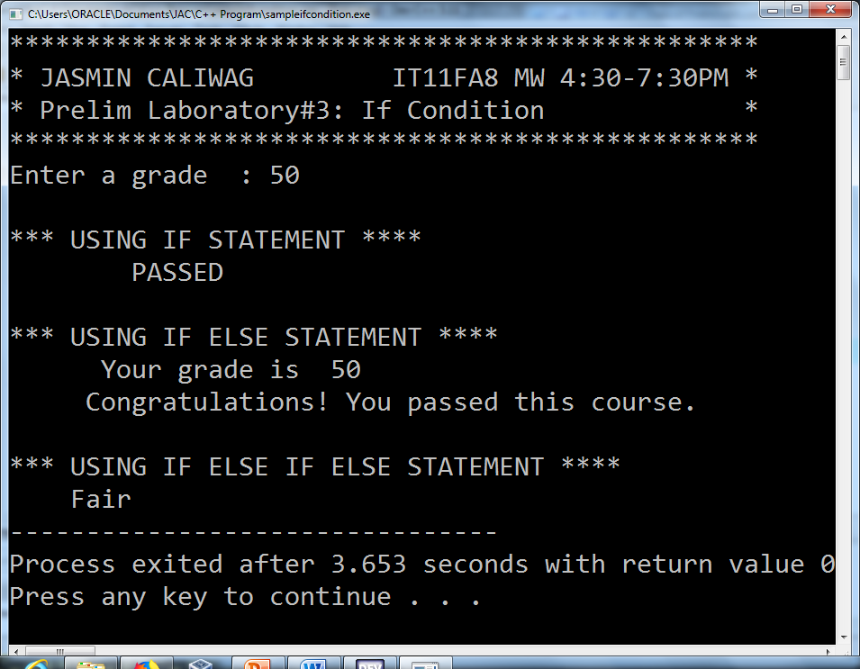

TECHNOLOGICAL INSTITUTE OF THE PHILIPPINES
QUEZON CITY
COLLEGE OF INFORMATION TECHNOLOGY EDUCATION (CITE)
ITE001- Computer Programming 1

NAME: SCORE:
PROGRAM/SECTION: DATE:
ASSESSMENT TASK: Selection Control Structure using If() Condition

The following question support the attainment of Course Intended Learning Outcomes (CILO): Design computing-based solution using control structures, functions, array and other statements;

Instruction: Write a program that will let the user to enter grade and show the output base on table below.

Grade Input |  | Output
94 | 100 | 1.00
88.50 | 93.99 | 1.25
83 | 88.49 | 1.50
77.5 | 82.99 | 1.75
72 | 77.49 | 2.00
65.5 | 71.99 | 2.25
61 | 65.49 | 2.50
55.5 | 60.99 | 2.75
50 | 55.49 | 3.00
Below 0 and more than 100 |  | INVALID

Source Code: paste the source code here

#include <iostream>
#include <cmath>

using namespace std;

int main()
{
int grade;
cout << "*************************************************";
cout << "\n* ARISTOTLE BUENAVENTURA IT11FA8 MW 4:30-7:30PM *";
cout << "\n* Prelim Laboratory#3: If Condition *";
cout << "\n*************************************************";
cout << "\nEnter a grade : ";
cin >> grade;
//Using IF statement
cout << "\n*** USING IF STATEMENT ****";
if ( grade >= 50 ) {
cout << "\n PASSED";
}
// Using IF ELSE statement
cout << "\n\n*** USING IF ELSE STATEMENT ****";
if (grade >= 50) {
cout << "\n Your grade is " << grade; cout<<"\n Congratulations! You passed this course.";
} else {
cout << " Your grade is " <<grade; cout << "\n Sorry! See you next term.";
}
// Using IF ELSE IF ELSE statement
cout << "\n\n*** USING IF ELSE IF ELSE STATEMENT ****";
if ( grade >= 50 && grade <= 60) {
cout << "\n Fair";
} else if ( grade >= 61 && grade <= 65 ) {
cout << "\n Good";
} else if ( grade == 100 ) {
cout << "\n Excellent";
} else {
cout << "\n invalid";
}

return 0;
}

OUTPUT: paste the out here...PRESS ALT PRINT SCREEN TO SCREEN SHOT THE OUTPUT
#include <iostream>
#include <cmath>

using namespace std;

int main()
{
float grade;
cout << "*************************************************";
cout << "\n* ARISTOTLE BUENAVENTURA IS11S1 MWF 3:30-5:30PM *";
cout << "\n*************************************************";
cout << "\nEnter a grade : ";
cin >> grade;
// Using IF ELSE statement
cout << "\n";
if (grade >= 94 && grade <= 100) {
cout << "Your grade is 1.0";
} else if (grade >= 88.50 && grade <= 93.99) {
cout << "Your grade is 1.25";
} else if (grade >= 83 && grade <= 88.49) {
cout << "Your grade is 1.50";
} else if (grade >= 77.50 && grade <= 82.99) {
cout << "Your grade is 1.75";
} else if (grade >= 72 && grade <= 77.49) {
cout << "Your grade is 2.00";
} else if (grade >= 65.50 && grade <= 71.99) {
cout << "Your grade is 2.25";
} else if (grade >= 61 && grade <= 65.49) {
cout << "Your grade is 2.50";
} else if (grade >= 55.50 && grade <= 60.99) {
cout << "Your grade is 2.75";
} else if (grade >= 50 && grade <= 55.49) {
cout << "Your grade is 3.00";
} else if (grade <= 0 || grade > 100) {
cout << "Your grade is invalid";
} else {
cout << "Your grade is invalid";
}
cout << "\n";

return 0;
}

