**TECHNOLOGICAL INSTITUTE OF THE PHILIPPINES**

**QUEZON CITY**

**COLLEGE OF INFORMATION TECHNOLOGY EDUCATION (CITE)**

**CS 201 - Data Structures and Algorithms**

|  |  |
| --- | --- |
| **Name: Aristotle Buenaventura** | **Date: September 8, 2021** |
| **Program/Section: IT21S1** | **Instructor: Ms. Rosmina Joy M. Cabauatan** |
| **Assessment Task: Exercise 1 - Array** | |

**Code**

package ObjectArray;

// Name: Aristotle Buenaventura

// Section: IT12S1

import java.util.Arrays;

import javax.swing.JOptionPane;

class ArrayElement implements Comparable<ArrayElement>{

//Declaration of variables

public int number;

public String letter;

// Object Array

ArrayElement(int number, String letter) {

this.number = number;

this.letter = letter;

}

public int compareTo(ArrayElement object) {

return this.number - object.number;

}

}

public class ObjectArray {

public static void main (String[] args) {

// Size of the array

int arraySize= Integer.parseInt(JOptionPane.showInputDialog(null, "Enter Number of Arrays: ", "Array Elements",JOptionPane.INFORMATION_MESSAGE));

// Declaration and instantiation of Array

ArrayElement arrayElement[] = new ArrayElement[arraySize];

System.out.print("Enter Size of the array: " + arraySize );

System.out.print("Enter " + arraySize + " elements: ");

// for loop for accepting values

for(int i=0; i < arrayElement.length; i++) {

arrayElement[i] = new ArrayElement(Integer.parseInt(JOptionPane.showInputDialog("Enter a number: ")), JOptionPane.showInputDialog("Enter a letter").toUpperCase());

System.out.print(arrayElement[i].number + " " + arrayElement[i].letter); // Displaying the array

if (i<arrayElement.length-1) {

System.out.print(", ");

}

}

System.out.println();

System.out.print("Reverse Order: ");

for (int i=arrayElement.length-1; i >= 0; i--) { // Displaying the array in reverse order

System.out.print(arrayElement[i].number + " " + arrayElement[i].letter);

if (i>0) {

System.out.print(", ");

}

}

System.out.println();

Arrays.sort(arrayElement); // Sort method to arrange the array in ascending order

System.out.print("Ascending Order: ");// Displaying the array in ascending order

for(int i=0; i < arrayElement.length; i++) {

System.out.print(arrayElement[i].number + " " + arrayElement[i].letter);

if (i<arrayElement.length-1) {

System.out.print(", ");

}

}

}

}

**Output**

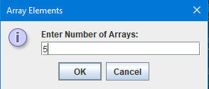

Figure 1. Enter the Size of the Array

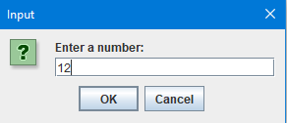

Figure 2. Enter a Number

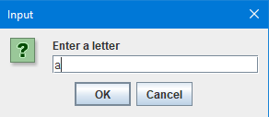

Figure 3. Enter a Letter

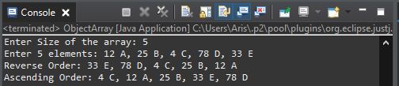

Figure 4. The Output