**TECHNOLOGICAL INSTITUTE OF THE PHILIPPINES**

**QUEZON CITY**

**COLLEGE OF INFORMATION TECHNOLOGY EDUCATION (CITE)**

**CS 201 - Data Structures and Algorithms**

|  |  |
| --- | --- |
| **Name: Aristotle Buenaventura** | **Date: September 10, 2021** |
| **Program/Section: IT21S1** | **Instructor: Ms. Rosmina Joy M. Cabauatan** |
| **Assessment Task: Exercise 2.1 - ArrayList** | |

**Code**

package exercise2;

// Name: Aristotle Buenaventura

// Section: IT12S1

import java.util.ArrayList;

import javax.swing.JOptionPane;

public class ArrayListOfArrayElements {

public static void main (String[] args) {

// Calling the methods

numericalValues(Integer.parseInt(JOptionPane.showInputDialog(null, "Enter the Number of Arrays: ", "Array Elements of Numericals",JOptionPane.INFORMATION_MESSAGE))); // Getting the size of the array for numericalValues

stringValues(Integer.parseInt(JOptionPane.showInputDialog(null, "Enter the Number of Arrays: ", "Array Elements of Strings",JOptionPane.INFORMATION_MESSAGE))); // Getting the size of the array for stringValues

}

public static void numericalValues(int arraySizeOfNumerals) {

// Declaration and instantiation of Array

int arrayElementNumerals[] = new int[arraySizeOfNumerals];

// for loop for accepting values

for(int i=0; i < arrayElementNumerals.length; i++) {

arrayElementNumerals[i] = Integer.parseInt(JOptionPane.showInputDialog("Enter a number: "));

}

System.out.println("Size of the array: " + arraySizeOfNumerals);

System.out.println("Initial Numerical Array Elements: ");

// Displaying the initial array elements

for(int num: arrayElementNumerals) {

System.out.print(num+" ");

}

System.out.println();

// Declaration and instantiation of ArrayList

ArrayList<Integer> arrayListNumerals =new ArrayList<Integer>(); //GOODS!!!

// Converting the array to arrayList

for( int i: arrayElementNumerals) {

arrayListNumerals.add(i);

}

System.out.println("Array converted to ArrayList: ");

// Displaying the converted array

for(int num: arrayListNumerals) {

System.out.print(num+" ");

}

System.out.println();

System.out.println();

System.out.println("ArrayList Methods");

// Applying some ArrayList methods

arrayListNumerals.add(23); //This method is used to append a specific element to the end of a list.

arrayListNumerals.add(14); //This method is used to append a specific element to the end of a list.

arrayListNumerals.add(89); //This method is used to append a specific element to the end of a list.

arrayListNumerals.add(105); //This method is used to append a specific element to the end of a list.

arrayListNumerals.add(35); //This method is used to append a specific element to the end of a list.

arrayListNumerals.add(10); //This method is used to append a specific element to the end of a list.

arrayListNumerals.add(76); //This method is used to append a specific element to the end of a list.

arrayListNumerals.add(56); //This method is used to append a specific element to the end of a list.

arrayListNumerals.add(55); //This method is used to append a specific element to the end of a list.

arrayListNumerals.add(2,45); // This method is used to insert a specific element at a specific position index in a list.

arrayListNumerals.remove(0); //Removes the first occurrence of the specified element from this list, if it is present.

arrayListNumerals.remove(4); //Removes the first occurrence of the specified element from this list, if it is present

arrayListNumerals.set(0,100); //Replaces the element at the specified position in this list with the specified element.

arrayListNumerals.trimToSize(); //This method is used to trim the capacity of the instance of the ArrayList to the list’s current size.

System.out.println("Does the ArrayList contains 5?: " + arrayListNumerals.contains(5)); //Returns true if this list contains the specified element.

System.out.println("What element is in index 1?: " + arrayListNumerals.get(1)); //Returns the element at the specified position in this list.

System.out.println("Is the ArrayList empty?: " + arrayListNumerals.isEmpty()); //Returns true if this list contains no elements.

System.out.println("What is the size of the ArrayList?: " + arrayListNumerals.size()); //Returns the number of elements in this list.

System.out.println("What are the elements inside from index 0 to 2?: " + arrayListNumerals.subList(0,6)); //Returns a view of the portion of this list between the specified fromIndex, inclusive, and toIndex, exclusive.

System.out.println("What is the index of element 76?: " + arrayListNumerals.indexOf(76)); //The index the first occurrence of a specific element is either returned or -1 in case the element is not in the list.

System.out.println("Updated ArrayList after implementing some ArrayList methods: ");

// Displaying the updated ArrayList

for(int num: arrayListNumerals) {

System.out.print(num+" ");

}

System.out.println();

System.out.println();

}

public static void stringValues(int arraySizeOfString) {

// Declaration and instantiation of Array

String arrayElementStrings[] = new String[arraySizeOfString];

// for loop for accepting values

for(int i=0; i < arrayElementStrings.length; i++) {

arrayElementStrings[i] = JOptionPane.showInputDialog("Enter a letter: ").toUpperCase();

}

System.out.println("Size of the array: " + arraySizeOfString);

System.out.println("Initial Numerical Array Elements: ");

// Displaying the initial array elements

for(String letter: arrayElementStrings) {

System.out.print(letter+" ");

}

System.out.println();

// Declaration and instantiation of ArrayList

ArrayList<String> arrayListStrings =new ArrayList<String>(); //GOODS!!!

// Converting the array to arrayList

for( String i: arrayElementStrings) {

arrayListStrings.add(i);

}

System.out.println("Array converted to ArrayList: ");

// Displaying the converted array

for(String letter: arrayListStrings) {

System.out.print(letter+" ");

}

System.out.println();

System.out.println();

System.out.println("ArrayList Methods");

// Applying some ArrayList methods

arrayListStrings.add("A"); //This method is used to append a specific element to the end of a list.

arrayListStrings.add("B"); //This method is used to append a specific element to the end of a list.

arrayListStrings.add("Y"); //This method is used to append a specific element to the end of a list.

arrayListStrings.add("D"); //This method is used to append a specific element to the end of a list.

arrayListStrings.add("E"); //This method is used to append a specific element to the end of a list.

arrayListStrings.add("F"); //This method is used to append a specific element to the end of a list.

arrayListStrings.add("G"); //This method is used to append a specific element to the end of a list.

arrayListStrings.add("H"); //This method is used to append a specific element to the end of a list.

arrayListStrings.add("I"); //This method is used to append a specific element to the end of a list.

arrayListStrings.add(2,"J"); // This method is used to insert a specific element at a specific position index in a list.

arrayListStrings.remove(0); //Removes the first occurrence of the specified element from this list, if it is present.

arrayListStrings.remove(4); //Removes the first occurrence of the specified element from this list, if it is present

arrayListStrings.set(0,"Z"); //Replaces the element at the specified position in this list with the specified element.

arrayListStrings.trimToSize(); //This method is used to trim the capacity of the instance of the ArrayList to the list’s current size.

System.out.println("Does the ArrayList contains F?: " + arrayListStrings.contains("F")); //Returns true if this list contains the specified element.

System.out.println("What element is in index 1?: " + arrayListStrings.get(1)); //Returns the element at the specified position in this list.

System.out.println("Is the ArrayList empty?: " + arrayListStrings.isEmpty()); //Returns true if this list contains no elements.

System.out.println("What is the size of the ArrayList?: " + arrayListStrings.size()); //Returns the number of elements in this list.

System.out.println("What are the elements inside from index 0 to 2?: " + arrayListStrings.subList(0,6)); //Returns a view of the portion of this list between the specified fromIndex, inclusive, and toIndex, exclusive.

System.out.println("What is the index of element I?: " + arrayListStrings.indexOf("I")); //The index the first occurrence of a specific element is either returned or -1 in case the element is not in the list.

System.out.println("Updated ArrayList after implementing some ArrayList methods: ");

// Displaying the updated ArrayList

for(String letter: arrayListStrings) {

System.out.print(letter+ " ");

}

}

} // End of program

**Output**

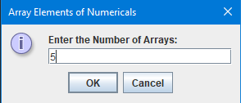

Figure 1. Enter the Size of the Array for Numerical

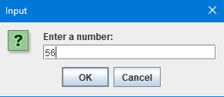

Figure 2. Enter an Element for Numerical

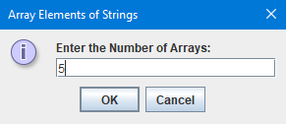

Figure 3. Enter the Size of the Array for String

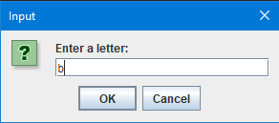

Figure 4. Enter an Element for String

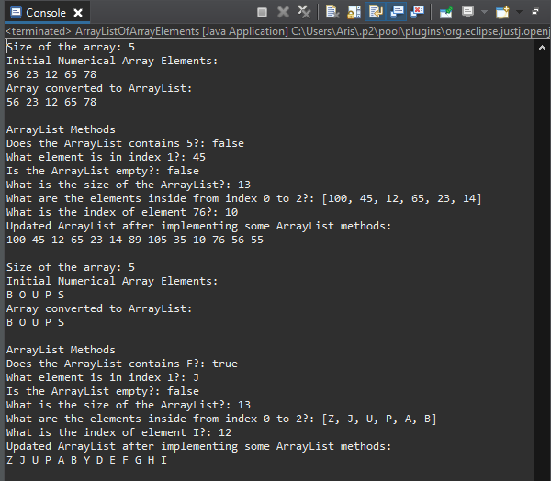

Figure 5. Final Output of Numerical and String