**TECHNOLOGICAL INSTITUTE OF THE PHILIPPINES**

**QUEZON CITY**

**COLLEGE OF INFORMATION TECHNOLOGY EDUCATION (CITE)**

**CS 201 - Data Structures and Algorithms**

|  |  |
| --- | --- |
| **Name: Aristotle Buenaventura** | **Date: September 10, 2021** |
| **Program/Section: IT21S1** | **Instructor: Ms. Rosmina Joy M. Cabauatan** |
| **Assessment Task: Exercise 2.2 - Stack** | |

**Code**

**StackRunner Class**

package exercise2;

// Name: Aristotle Buenaventura

// Section: IT12S1

public class StackRunner {

public static void main(String args[]) {

// Calling the class StackClass inside the StackRunner

StackClass.stackList();

}

}

**StackClass Class**

package exercise2;

import java.util.ArrayList;

import java.util.Stack;

public class StackClass {

// Instantiate a global variable size

public static byte size=10;

public static void stackList(){

// Declaration and instantiation of ArrayList

ArrayList<Integer> randomNumber =new ArrayList<Integer>(size);

// 10 randomly generated numbers from 1 – 100 that will be added to the ArrayList

for(int i=0;i<size;i++) {

int random=(int)(Math.random()*100);

randomNumber.add(random);

}

// Printing the ArrayList

System.out.println("ArrayList of 10 randomly generated numbers from 1 – 100: "+ randomNumber);

System.out.println();

// Passing the elements of ArrayList to the method addStack

StackClass.addStack(randomNumber);

}

public static void addStack(ArrayList<Integer> randomStack) {

// Declaration and instantiation of Stack

Stack<Integer> StackList = new Stack<Integer>();

// Pushing all the value of the ArrayList to the Stack

for(Integer eachRandomStack: randomStack) {

StackList.push(eachRandomStack);

}

// Printing the Stack

System.out.println("10 ArrayList Elements push to the Stack: "+ StackList);

System.out.println();

// Passing the elements of StackList to the method resultStack

StackClass.resultStack(StackList);

}

public static void resultStack(Stack<Integer> StackList) {

// Removing every element of the Stack

for(int i=0;i< size;i++) {

// Printing every element that has been popped

System.out.println("Popped element: "+ StackList.pop());

}

// printing the updated Stack

System.out.println();

System.out.print("Stack after pop operation: "+ StackList);

}

} // End of the program

**Output**

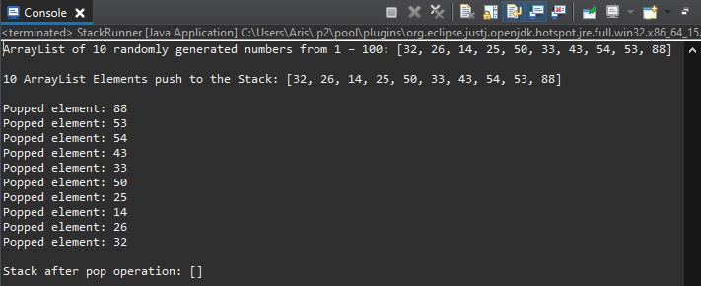

Figure 1. First Run Output

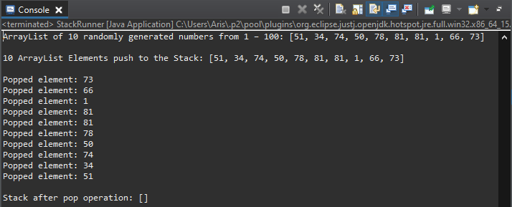

Figure 2. Second Run Output