**TECHNOLOGICAL INSTITUTE OF THE PHILIPPINES  
QUEZON CITY  
COLLEGE OF INFORMATION TECHNOLOGY EDUCATION (CITE)  
CS 201 - Data Structures and Algorithms**

|  |  |
| --- | --- |
| **Name of Members:**  **Buenaventura,** Aristotle C.  **Cruz,** Yunice Nicolle  **Mendoza,** Gracia C.  **Moraga,** Kathlynne Joy  **Muñez,** Jackilou O. | **Date: September 20, 2021** |
| **Program/Section: IT21S1** | **Instructor: Ms. Rosmina Joy M. Cabauatan** |
| **Assessment Task: Project Proposal** | |

**Project Title:**

**3MBC Payroll System**

## 

## **Project Description:**

The 3MBC Payroll System is designed to digitize the current manual systems used by companies nowadays. It was developed to help the manager/administrator to arrange the employees' salaries in a more efficient, secure, and timely manner. It encrypts sensitive data and information and enables storage over an extended length of time while allowing for easy access and modification. This system can keep and view digital records without obtaining redundant entries. The project comprises how to manage employees' data effectively and provide enhanced services to employees.

## **Topic or Module Assignment for Members:**

|  |  |
| --- | --- |
| **Admin Login** | Gracia C. Mendoza |
| **Dashboard Menu** | Yunice Nicolle Cruz |
| **Payroll Page** | Jackilou O. Munez and Aristotle C. Buenaventura |
| **About Us** | Kathlynne Joy Moraga |

## **Application of the data structures and algorithms in the project:**

As of this moment, group three will be utilizing *Array*, *ArrayList*, *Sort*, and *Stack* to sort, search, insert, update, and delete the data in the payroll system. The initial plan intends for the user to manipulate the data in the system through using JButtons. This can be seen in the case of, for example, sorting employee ID numbers, employee names, department, gross pay, or net pay through a ***heap sort algorithm***. The group decided to use a heap sort algorithm since it is well-known for its efficiency in sorting a large number of items to be sorted. Furthermore, due to its simplicity and consistency, it performs excellently in the best, average, and worst cases.

## **Layout of the application with description:**

1. **Admin Login**

* The initial plan for the admin login section of the system is to authorize the system administrator of the company to access the payroll system for calculating the necessary aspects of the net pay included for 3MBC employees. This enables the administrator to input a designated password and username so he can access his account.

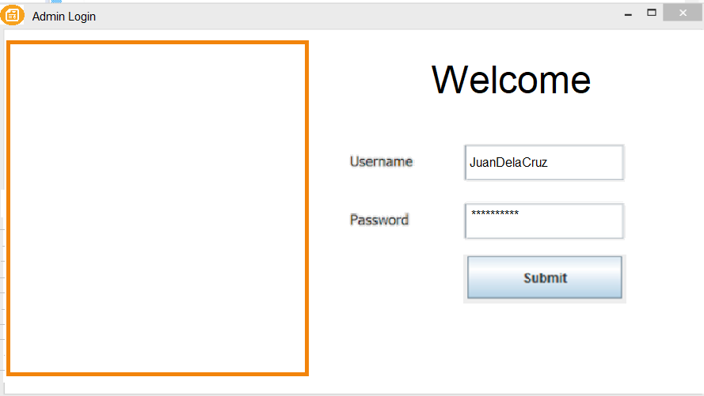

1. **Dashboard**

* The 3MBC dashboard features a graphical user interface that displays system information such as Payroll, About Us, and Logout in a quick and easy manner. When the system administrator accesses the program, they will see the window page. From the dashboard, administrators can drill down to acquire more information about a specific piece of data.



1. **Payroll**

* This window will serve as the main section for our payroll system. This will allow the system administrator to enter the data necessary for the system to process the payroll for the 3MBC employees. First, the system administrator will be required to input the necessary employee information into the fields, as well as the necessary taxes and deductions. Second, after entering the details, the system will be able to generate and show the data in the table. Then, the system administrator can be able to manipulate the table by clicking the delete, add, sort, or print buttons located on the left side of the window. Once the administrator is done modifying, they can go back using the back button.

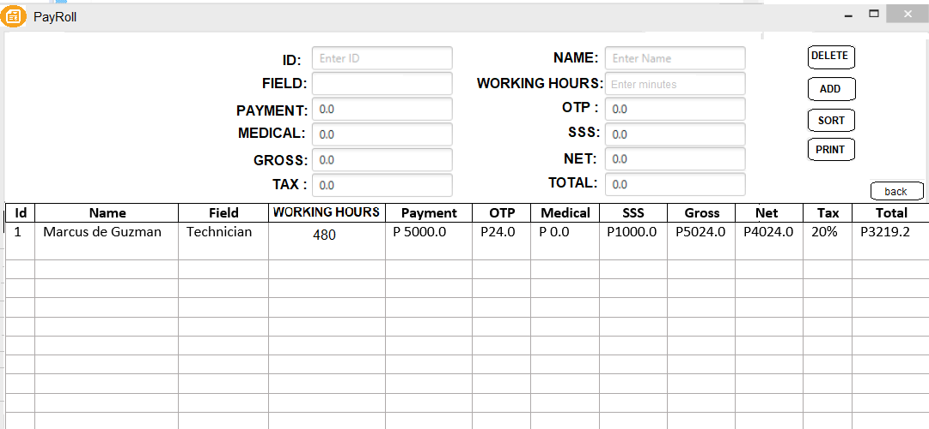

1. **About Us**

* This section will include a project description, its objective, 3MBC contact information, and the group members who designed the payroll system. In case the company has problems with the system, they can contact or email the developer to fix the problem. This also has a back button so that the admin can return to the dashboard.

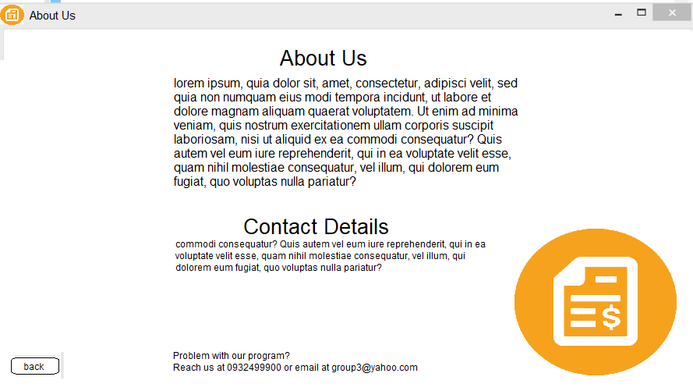

**Honor Pledge**: “I accept responsibility for my role in ensuring the integrity of the work submitted by the group in which I participated.”