# Screenshots of Output

Authorization System Login is accomplished through an ArrayList to authenticate two system administrators' access to the entire 3MBC payroll system. The system administrator must enter their username and password before clicking the login button.

Administrators will gain access to the dashboard and the entire system after successfully logging in.

**ADMIN LOG IN**

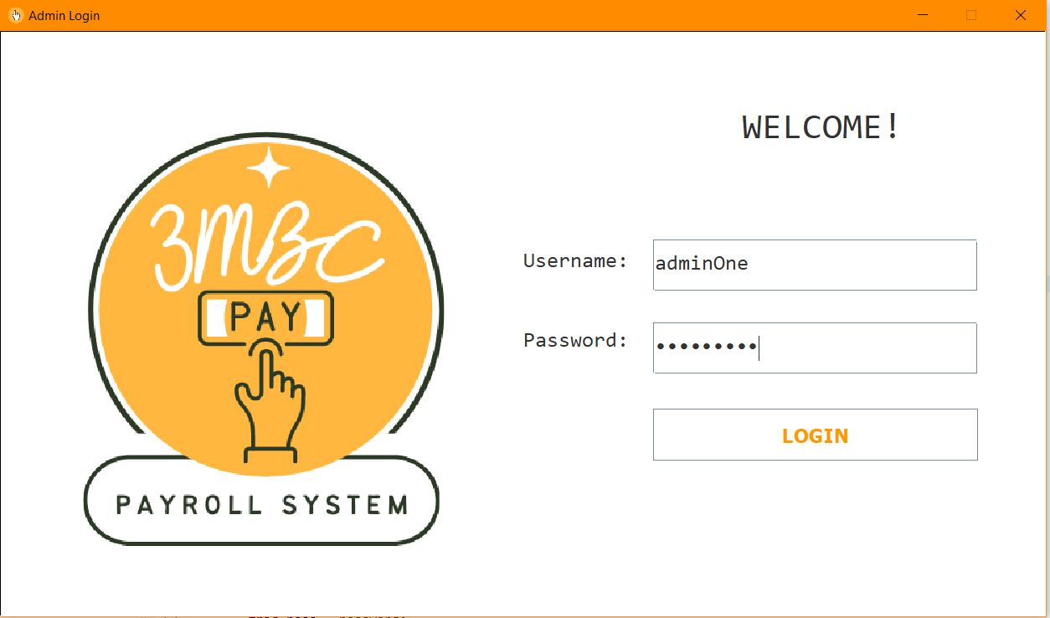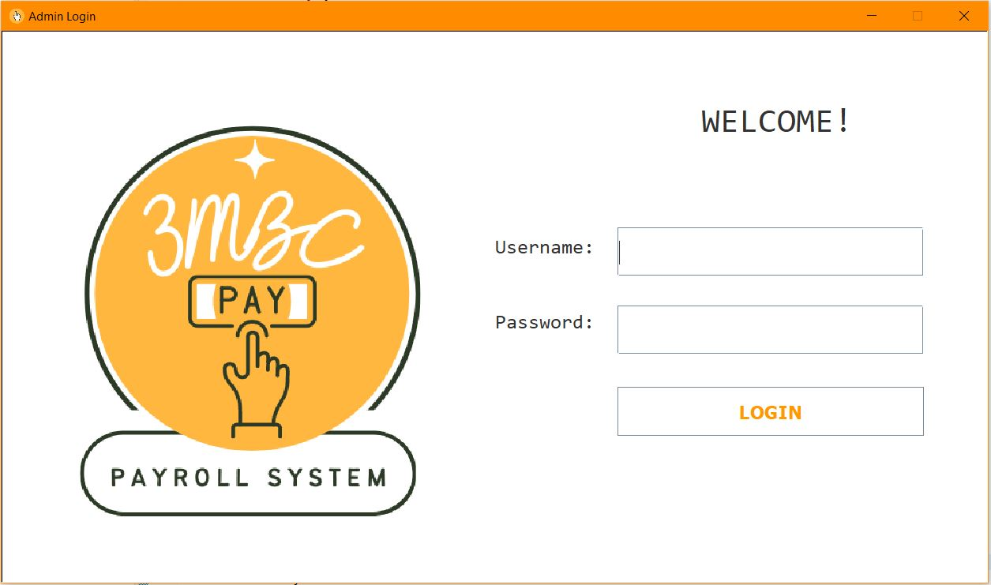

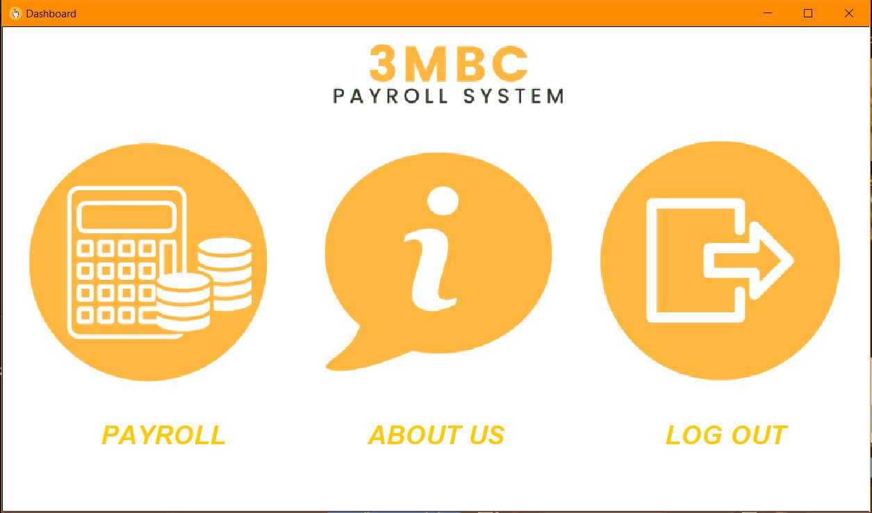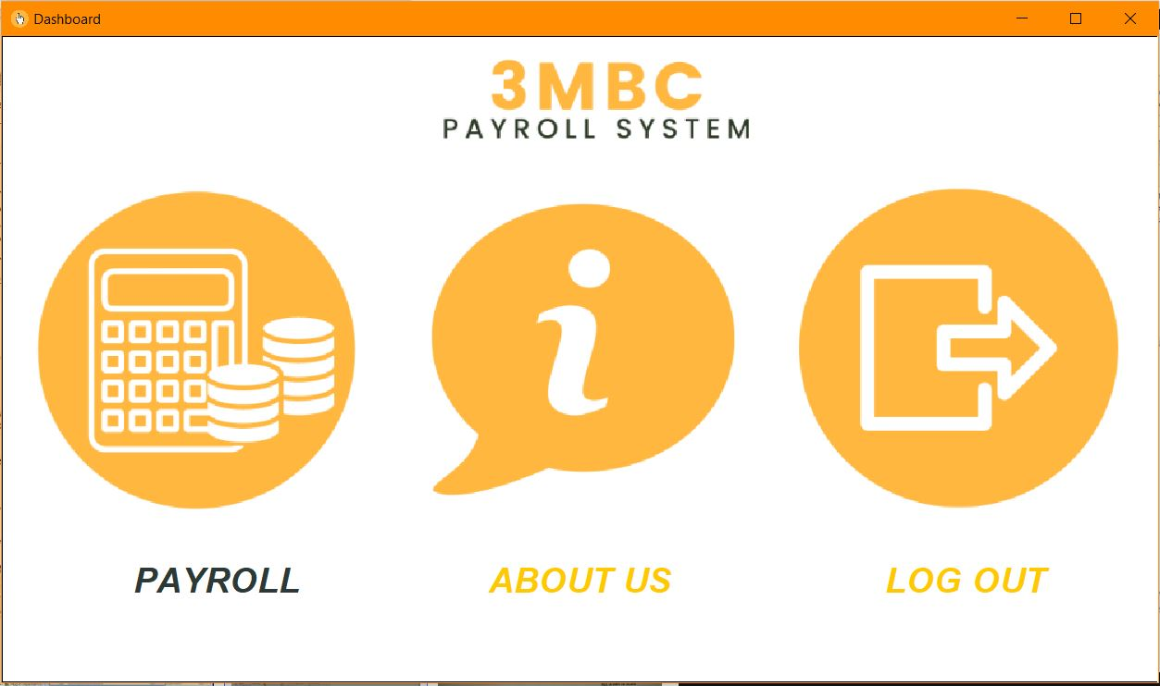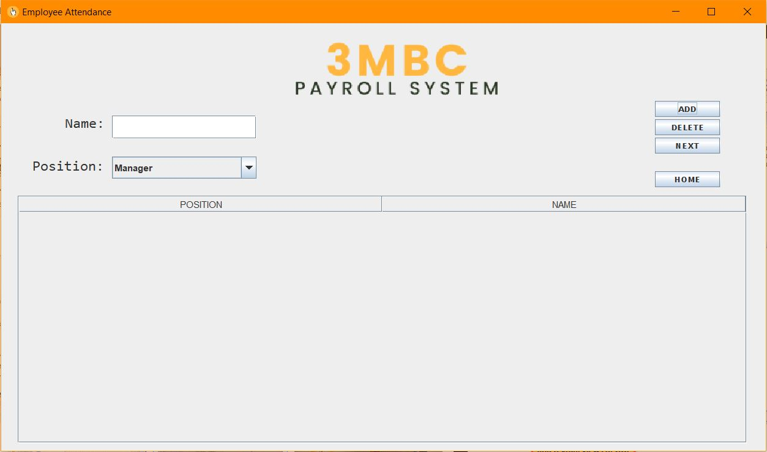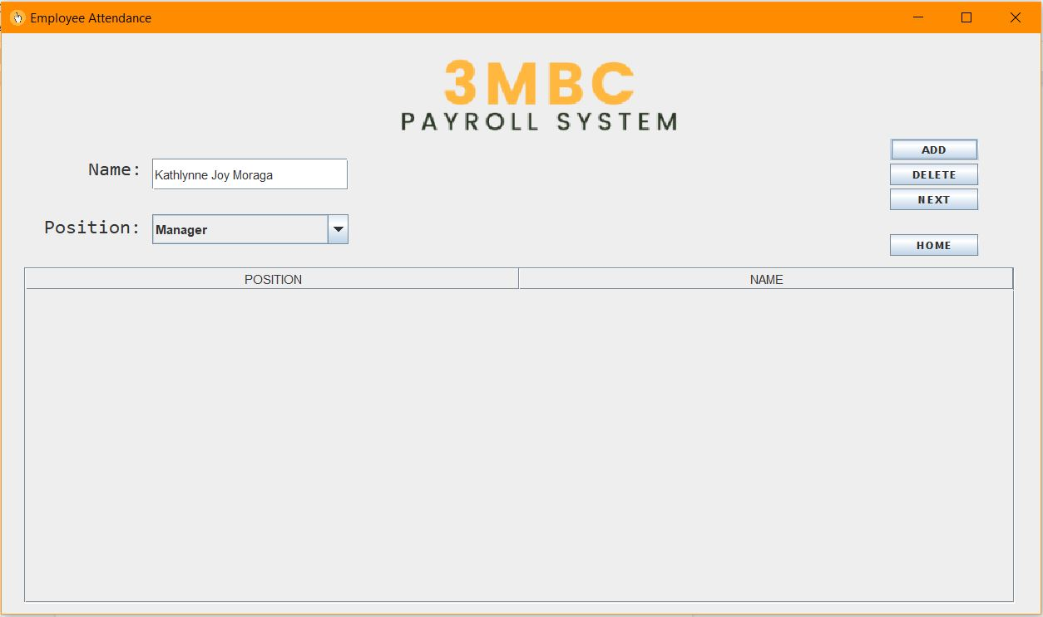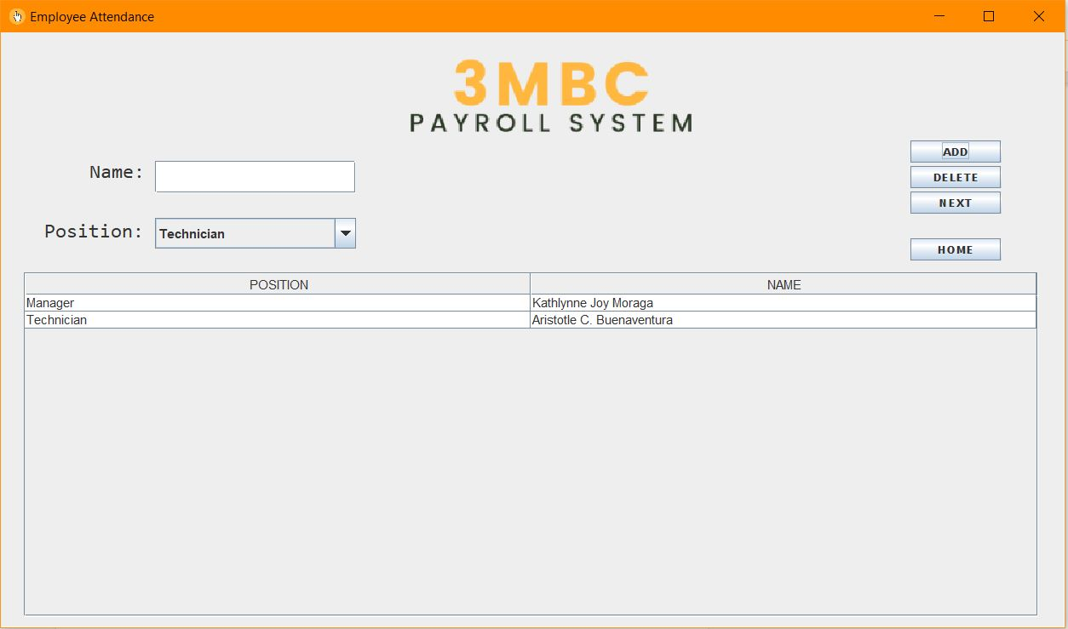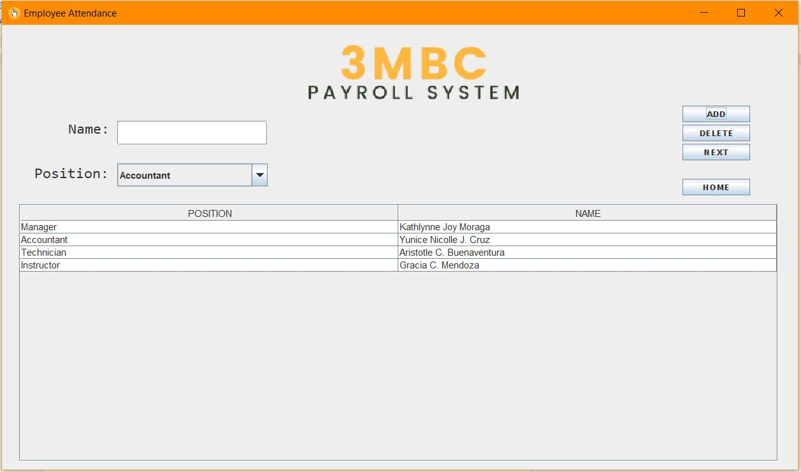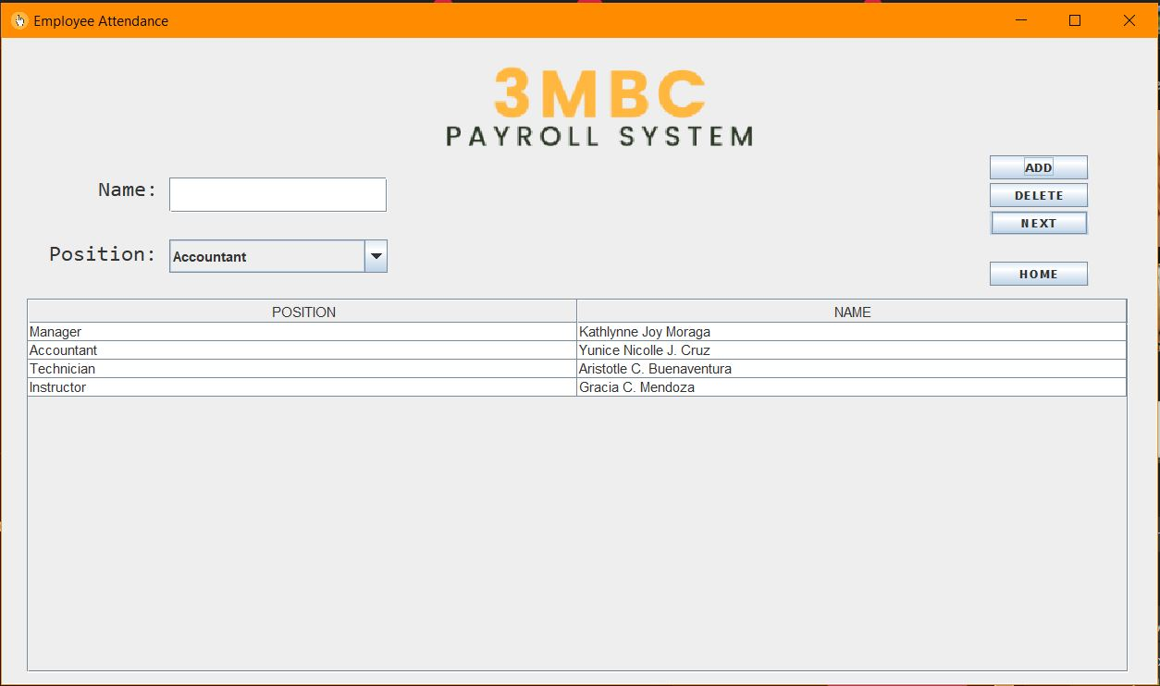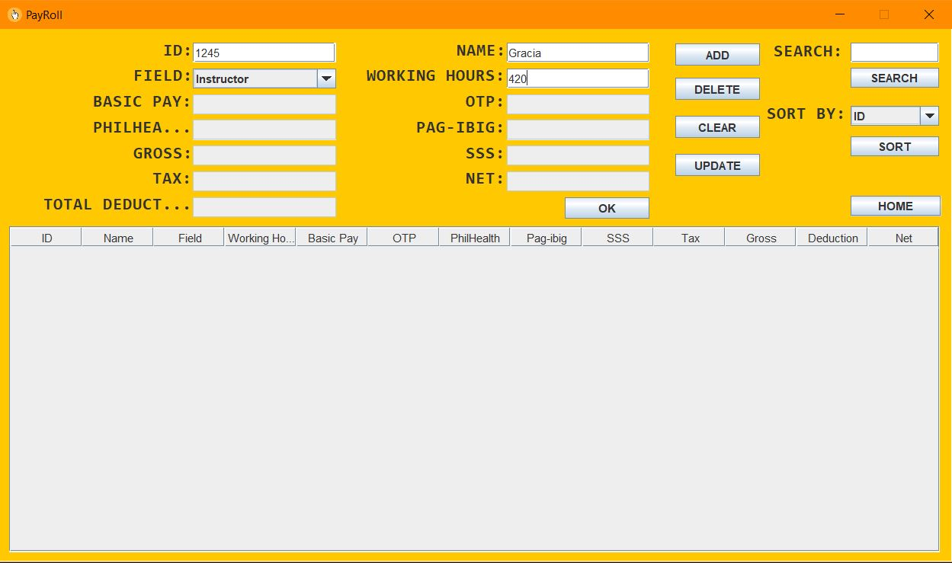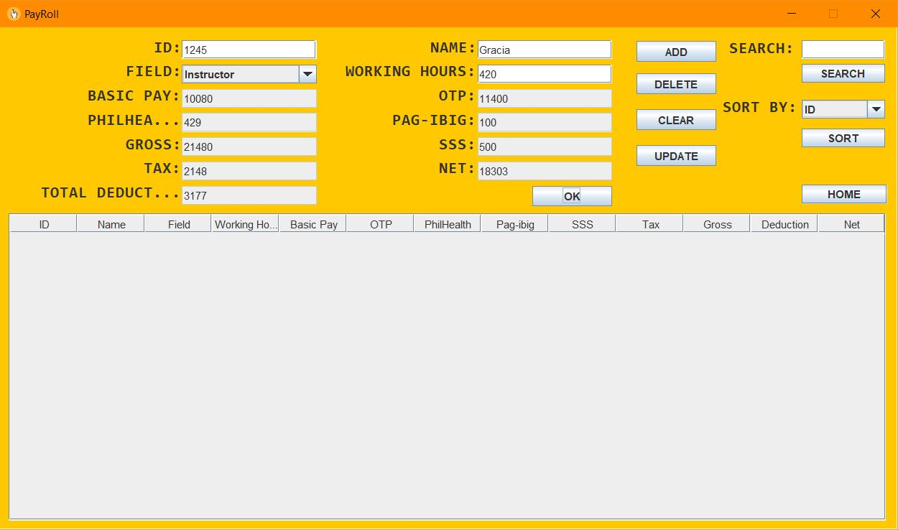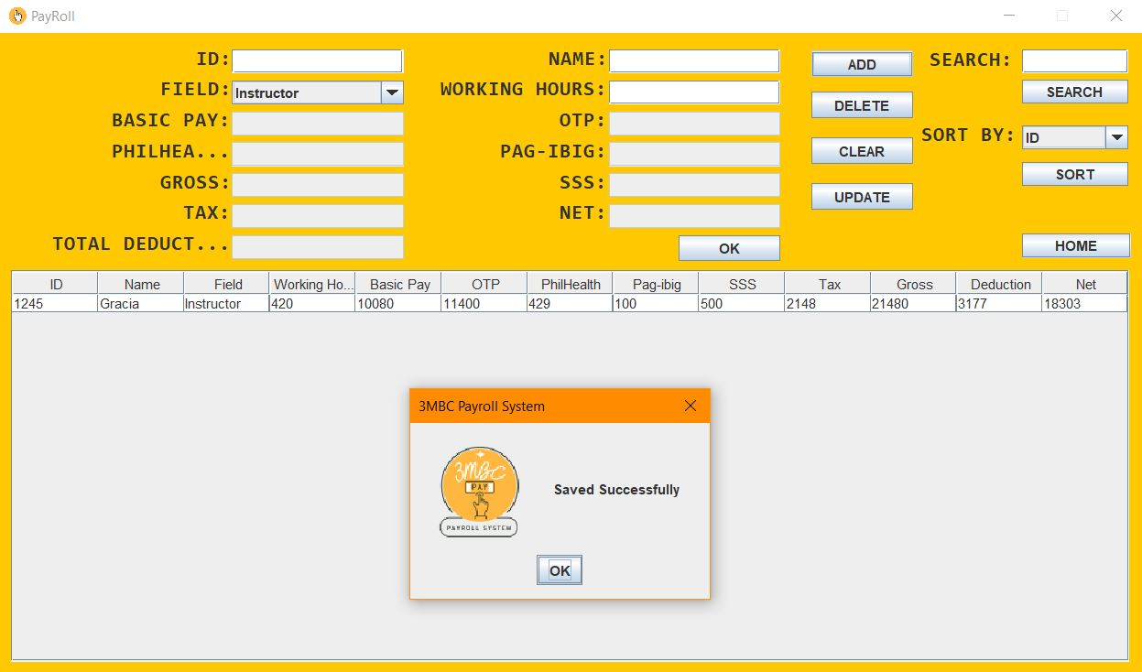

The employee attendance page will display as soon as the administrator

logs into payroll.

**EMPLOYEE ATTENDANCE**

In the system, the Dashboard or the Menu is referred to as the *"homepage."* There are three icons on the homepage: payroll, with the employee attendance, about us, and log out. The dashboard will only appear after the system administrator successfully logs in through the Login window page. Then, the administrators have complete access to the system's window pages.

**DASHBOARD**

Employee Attendance serves as a record of a list of employees present on that day. Through LinkedList, administrators will be able to enter the employee's name and position. To successfully display the employee record in the table, administrators must click the *"Add"* button after entering the employee's name and selecting their field of expertise. Employee attendance simplifies and speeds up the user's life by minimizing the need for multiple transactions. This also shows the hierarchy of employees in the company, whereas the manager is always the first on the list, followed by the other positions. Administrators can use the *"Delete"* button to delete a specific row from a table.

**EMPLOYEE ATTENDANCE**

Once the system administrator has entered all of the employees' attendance records, they must click the *"Next"* button to access the Payroll Table.

**EMPLOYEE ATTENDANCE**

The Payroll System enables administrators to enter the information required by the system in order for it to process the payroll for the 3MBC employees. The system administrator must complete the fields with the necessary employee information. The Array is applied to the JTable's rows and columns. Additionally, it makes use of an Object data type, which accepts string and integer values.

**PAYROLL**

The details entered will generate and display the data in the table.  The system makes use of the stack to transfer data from the Array to the stack. In this way, the program will have an easier time understanding that the value has been pushed into the stack. Furthermore, the Payroll Table calculates employee earnings and factors out taxes, social welfare services, home mutual funds, and health insurance. The Net is the total amount that the administrator needs to pay their employee during each pay period. The system has four different fields, and each field has its individual rate; the programmers set a back-end calculation for each variable.

 The queue is applied by instantiating it in the Payroll JFrame Class; it is then utilized via the enqueue method in the *"Add"* button.

**PAYROLL**

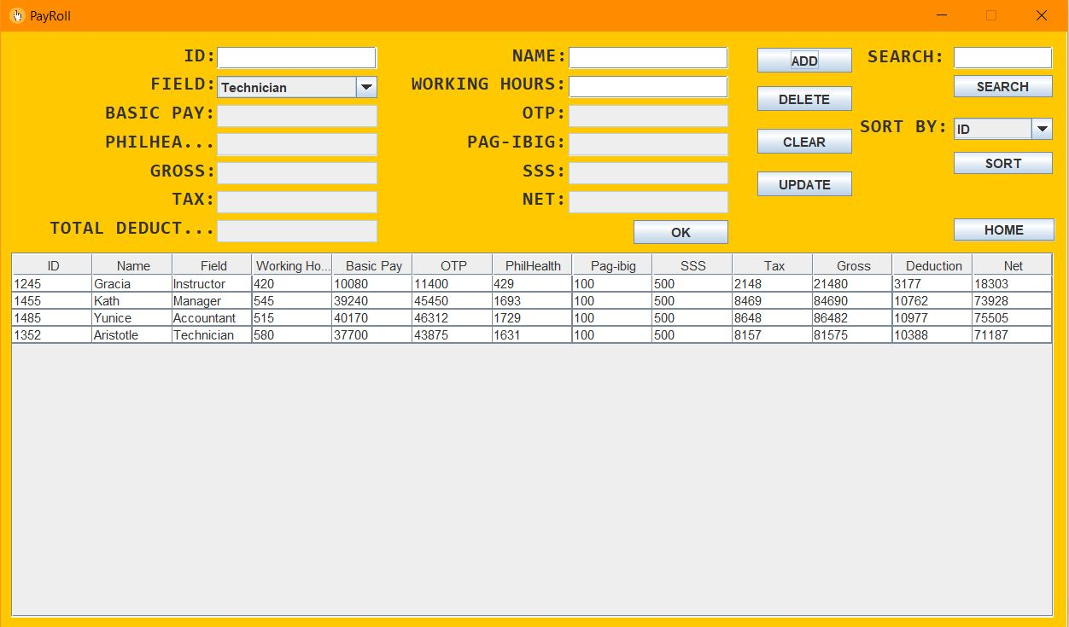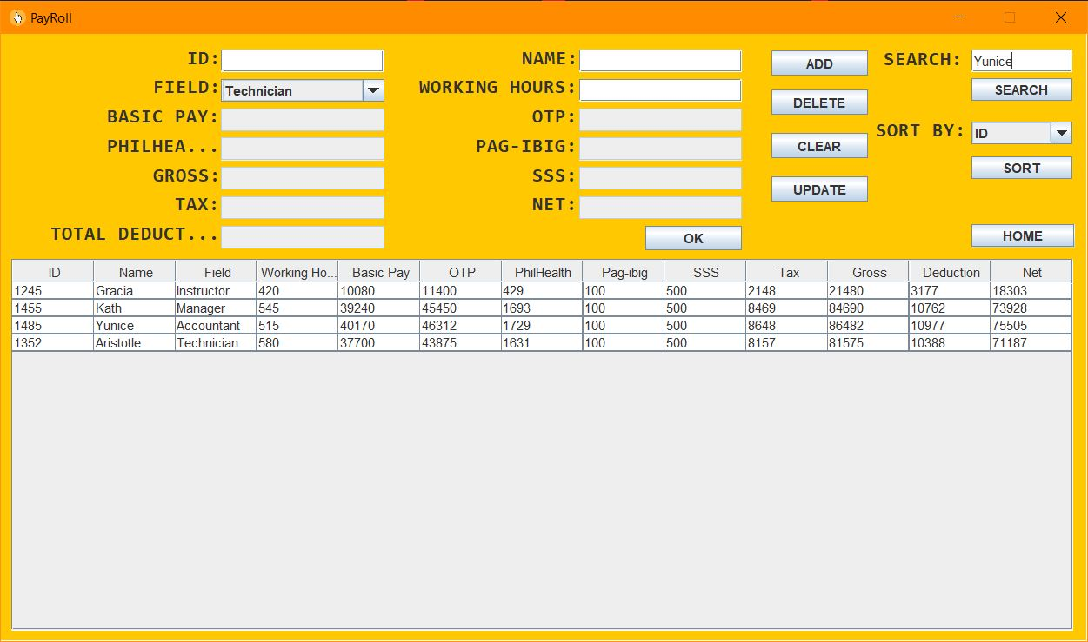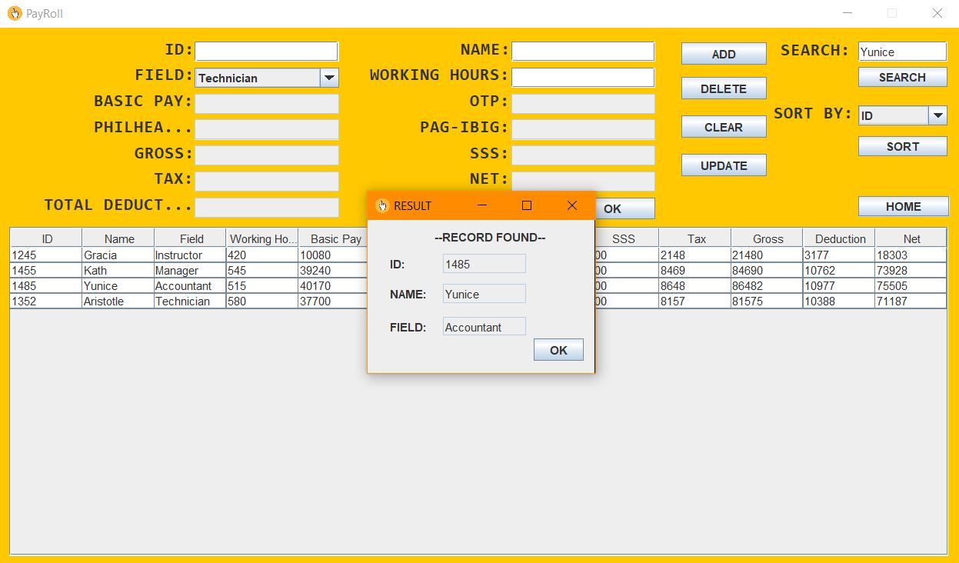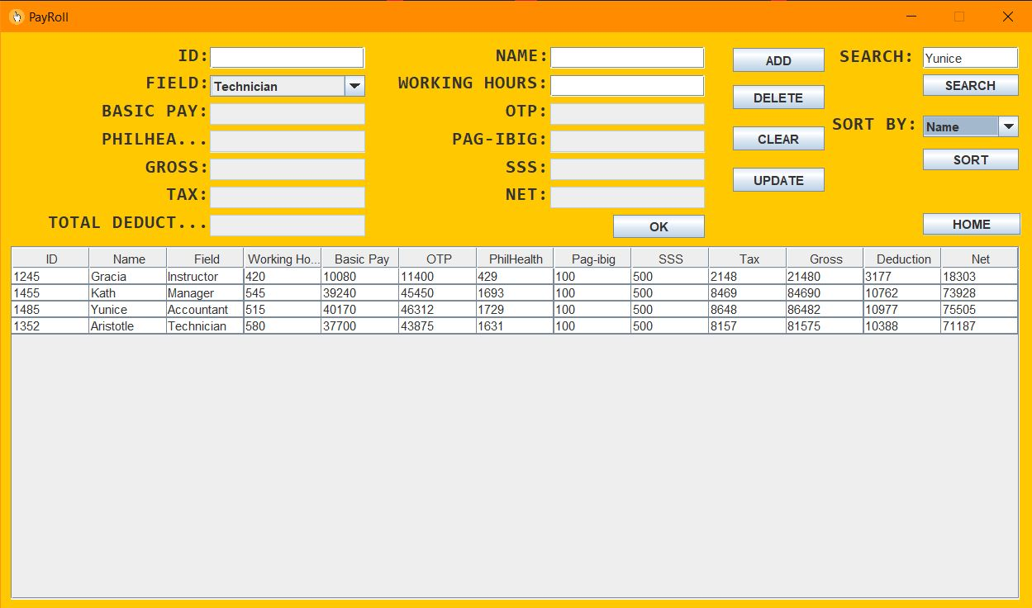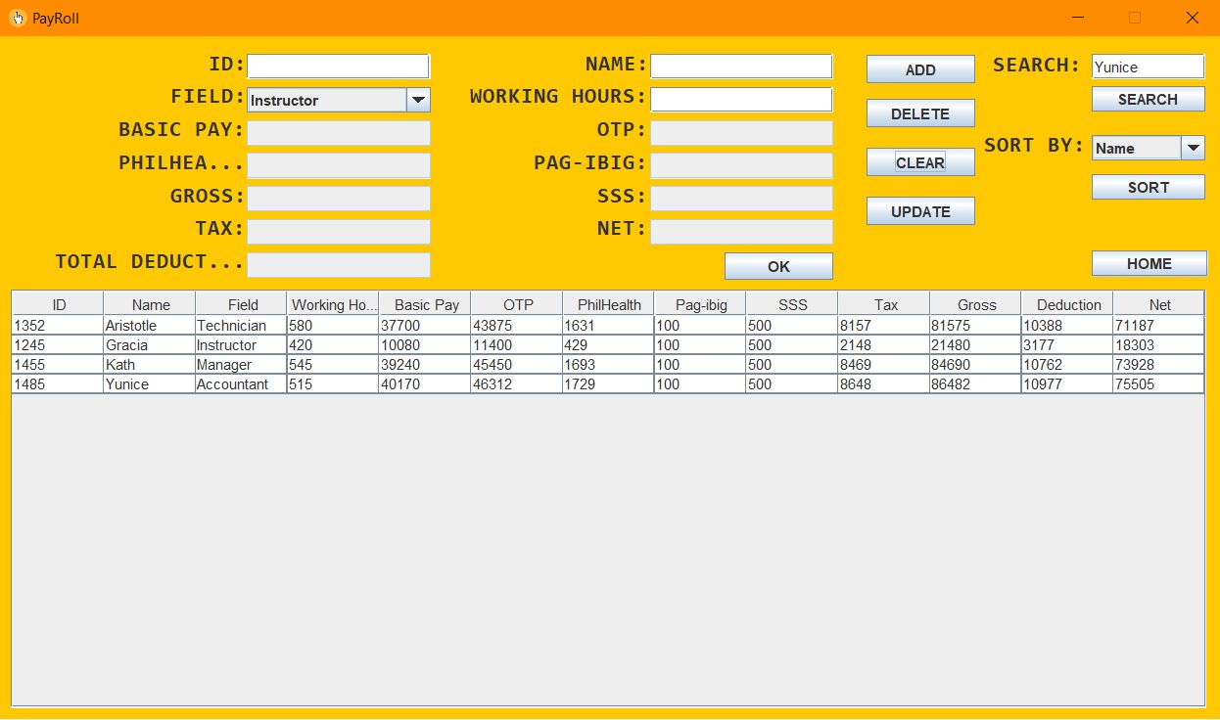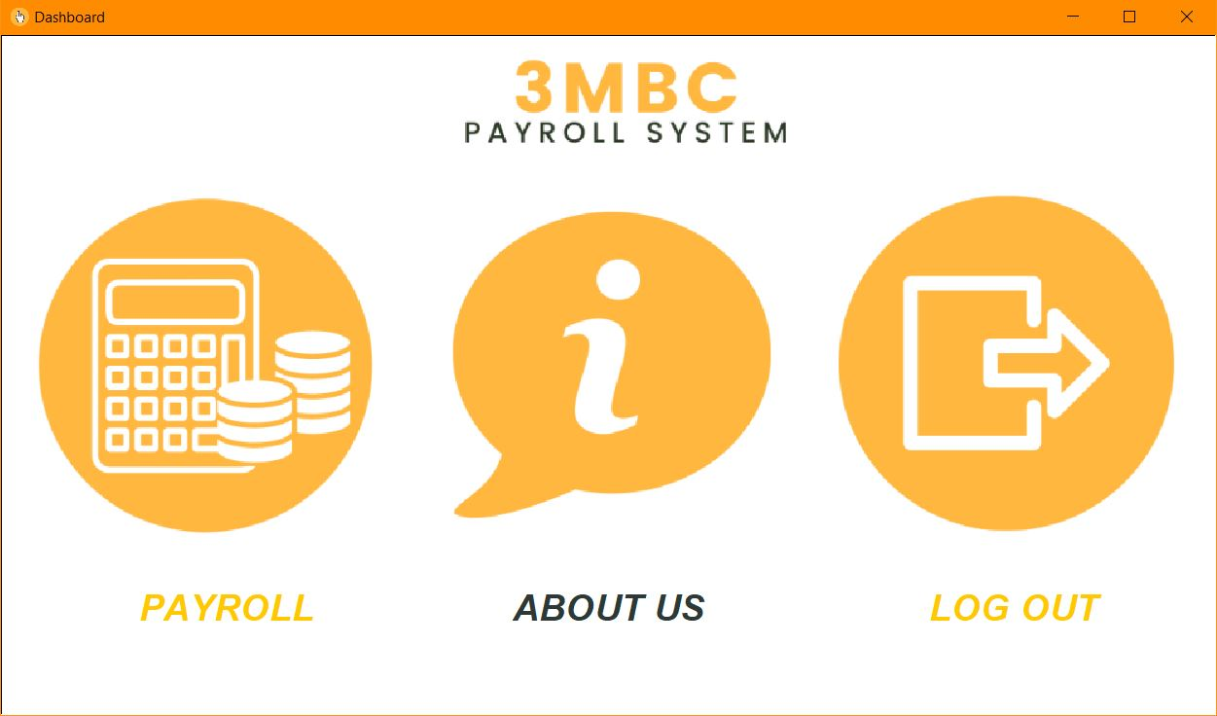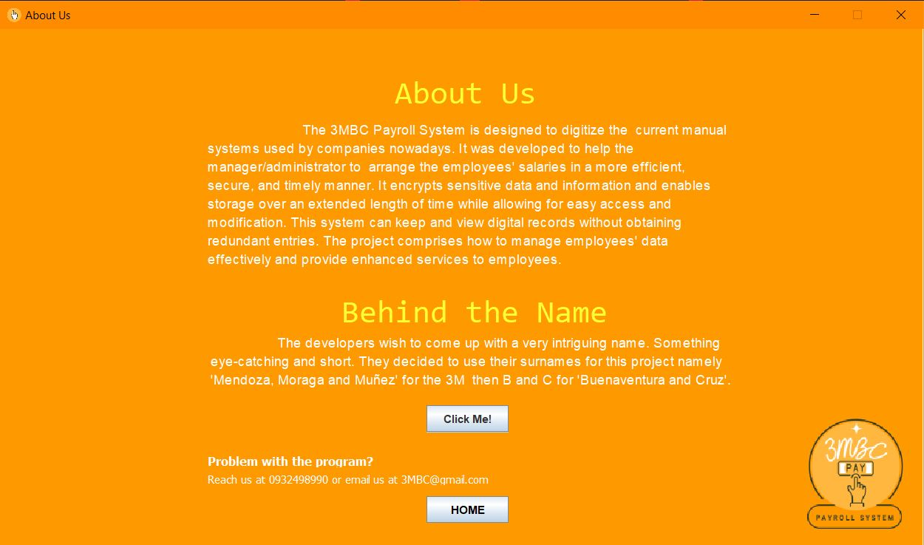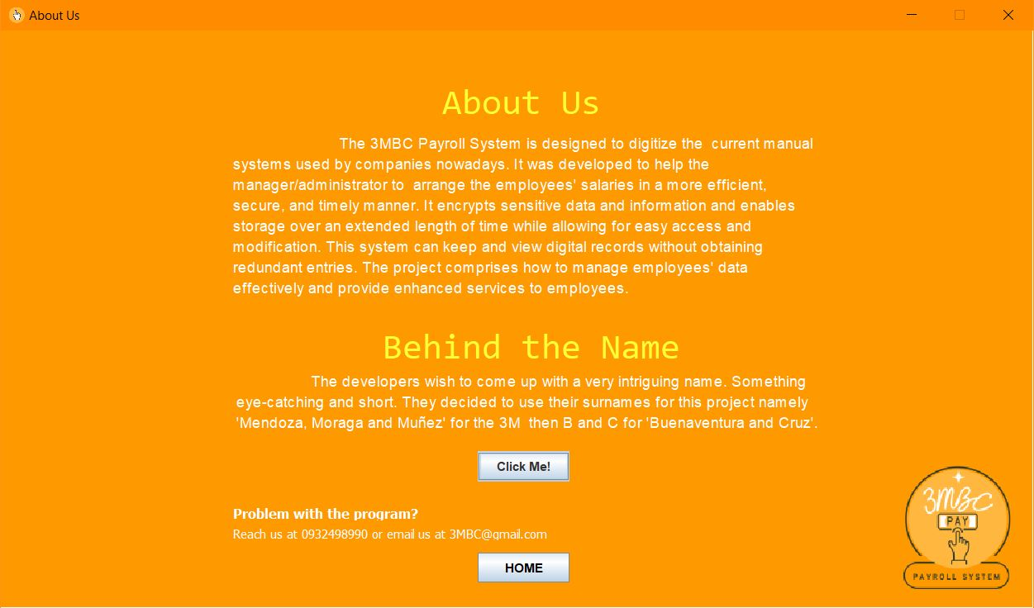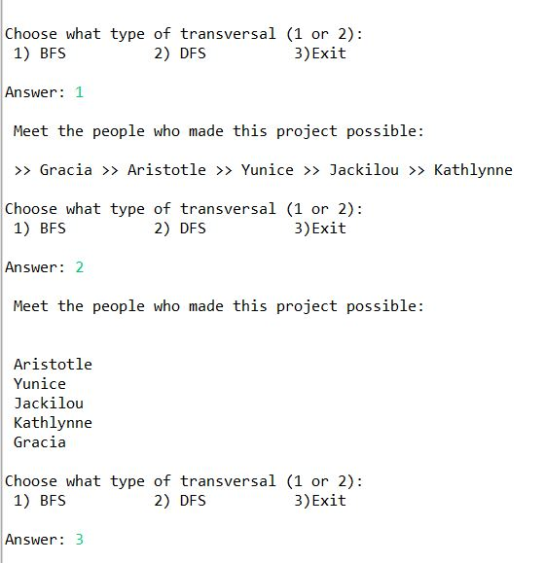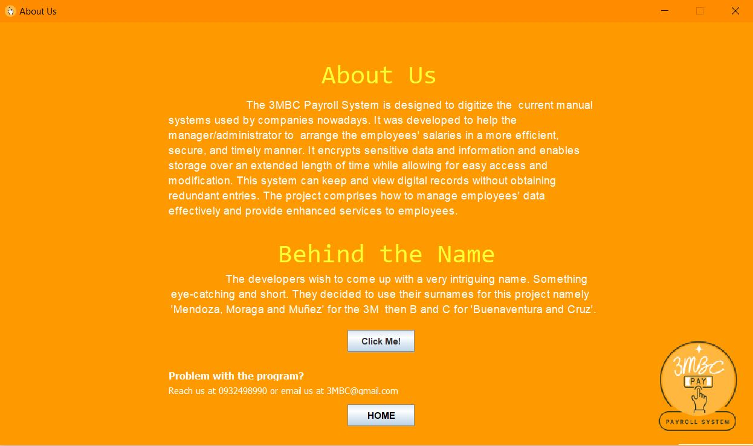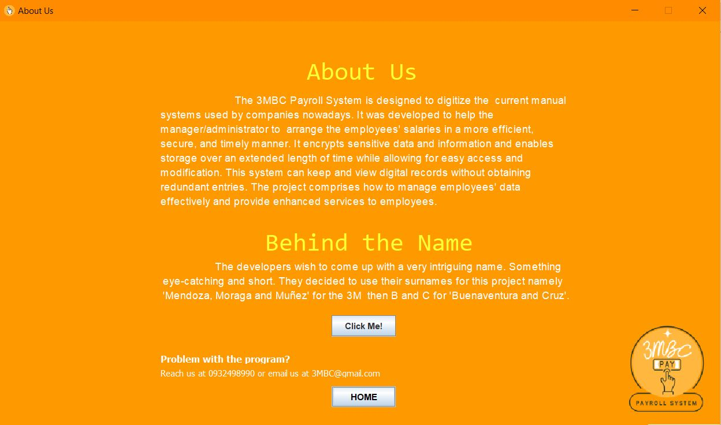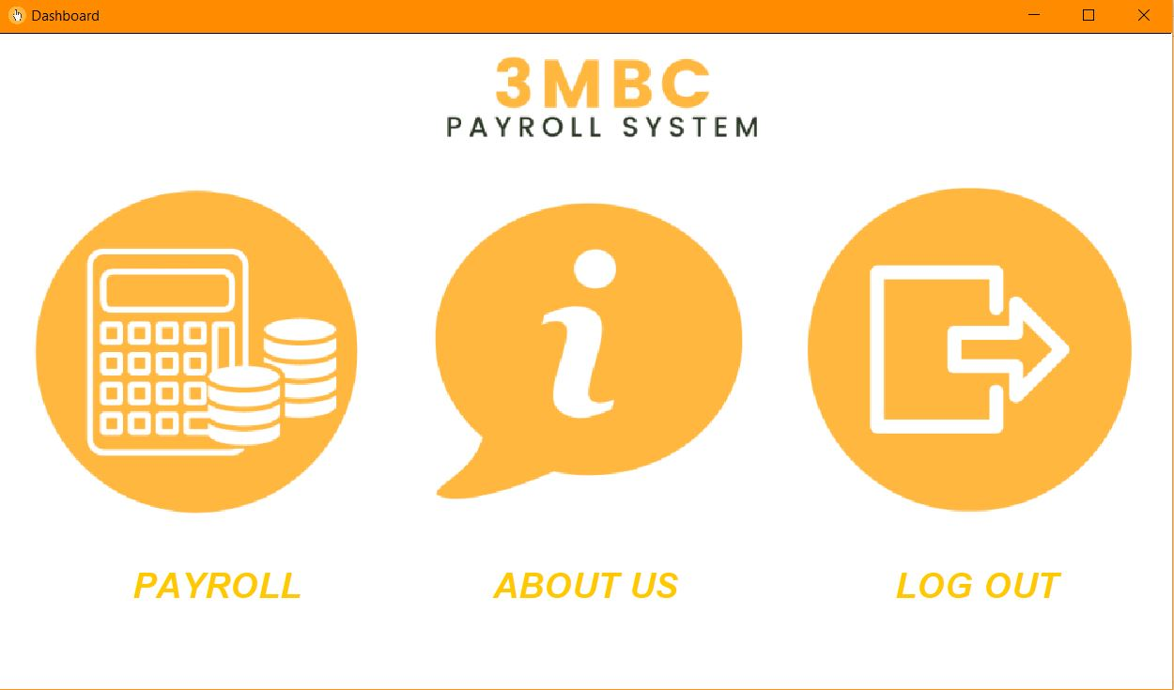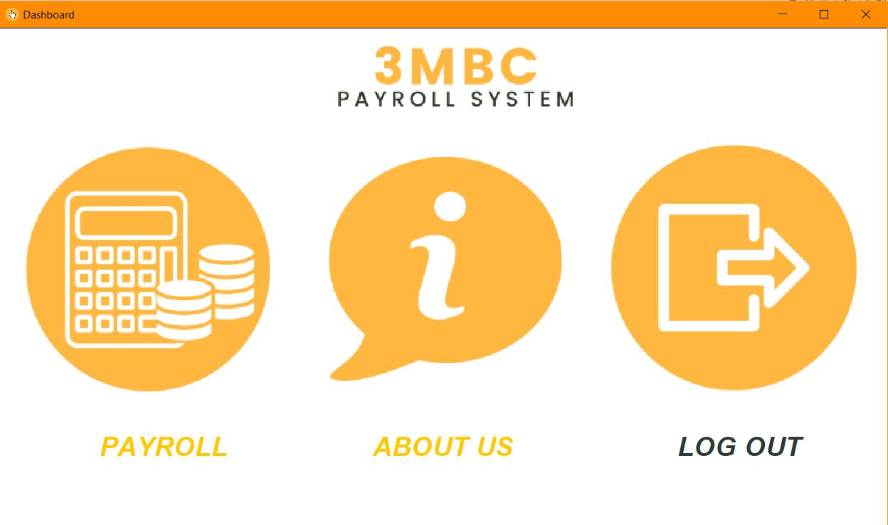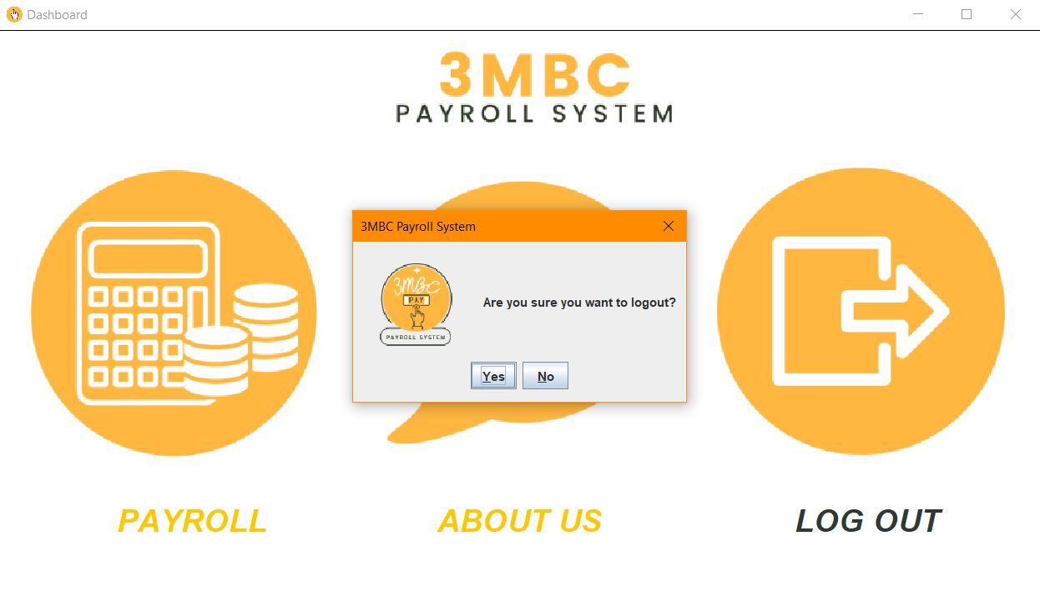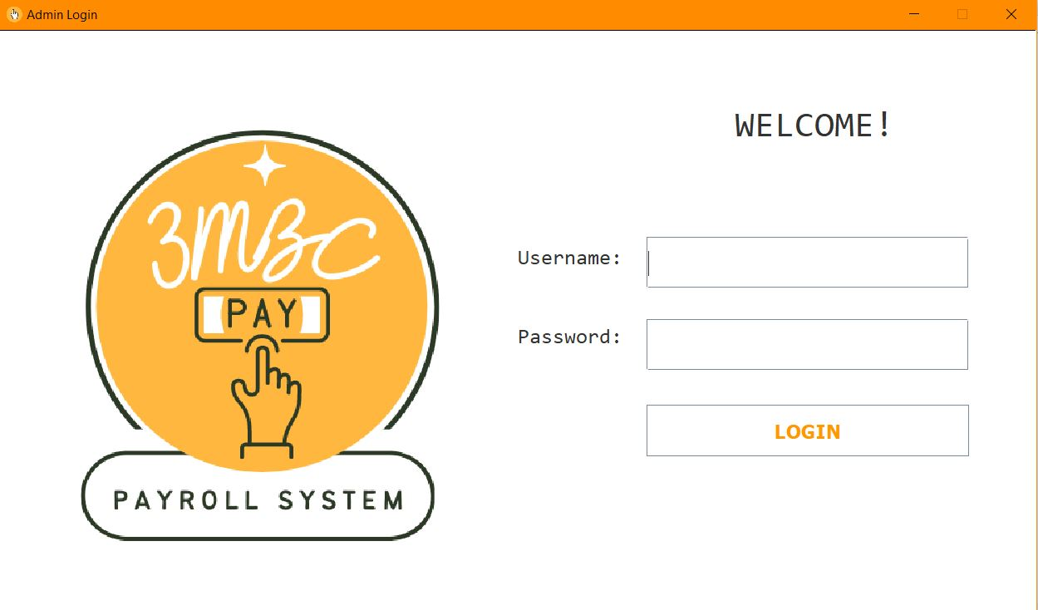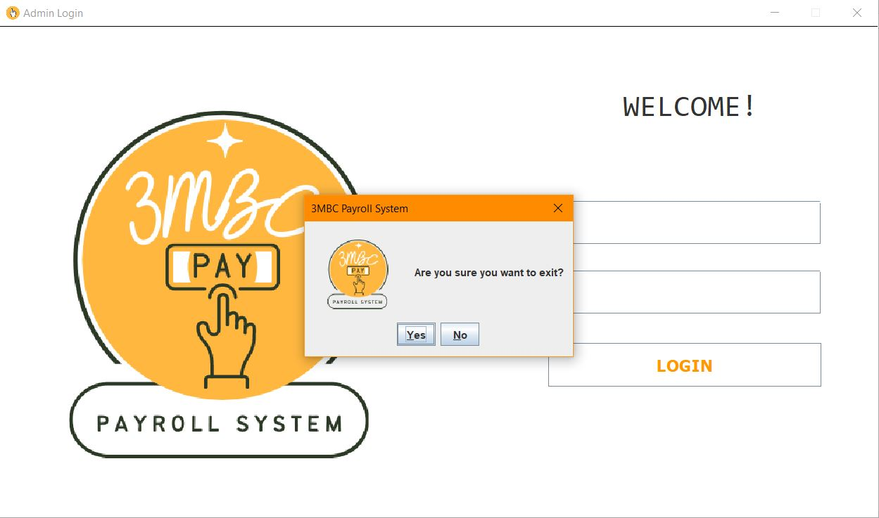

The Binary Tree is performed using the *search* button. It is a data structure in which a record is linked to two successor records, usually referred to as the left branch when greater and the right when less than the previous record. If an administrator wishes to search for a specific name, the administrator must type the name into the search text field and press the search button. The system will inform the administrator whether or not the name exists in the table.

When the name appears on the list of employees, the system will prompt for the employee's details. These include the employee's identification number, name, and expertise.

Once users input an employee's name that does not appear on the list of employees, a warning will appear. It will indicate that no record was located.

**PAYROLL**

The information in the payroll section's table can be sorted in a variety of ways. It can be sorted by name, id number, or salary, among other factors. The Quick Sort is implemented via the sort button; the administrator can rearrange a large number of items in a specific order, such as alphabetical or lowest-to-highest. The administrator can specify the category for which the table should be sorted.

**PAYROLL**

**ABOUT US**

The about us section contains the project's description, objectives, and contact information for 3MBC. It has two JButton types that correspond to the Home and Click Me interfaces. To explicitly view the people who built the system, admins can choose between two graph types in the click me interface: breadth-first search (1) and depth-first search (2). The Home button will take you to the about us section. The graph will be displayed on the console.

**ABOUT US**

**Following the selection of an exit (3) in the console system. The administrator will be redirected to the about us page.**

**When an administrator clicks home in the about us section, the administrator is taken to the dashboard.**

Admin can log out as soon as he has completed his task in the system, and a warning message will appear asking him to confirm that he wants to log out of the system. The administrator will be redirected to the log-in system if signing off is confirmed.

**LOG OUT**

**ADMIN LOG IN**

If the administrator wishes to terminate the system, a confirmation message will appear prior to the system terminating completely.

**TERMINATION**