**TECHNOLOGICAL INSTITUTE OF THE PHILIPPINES**

**QUEZON CITY**

**COLLEGE OF INFORMATION TECHNOLOGY EDUCATION (CITE)**

**CS 201 - Data Structures and Algorithms**

|  |  |
| --- | --- |
| **Name: Aristotle Buenaventura** | **Date: September 13, 2021** |
| **Program/Section: IT21S1** | **Instructor: Ms. Rosmina Joy M. Cabauatan** |
| **Assessment Task: Preliminary Examination** | |

**Code**

**Runner Class**

package prelimExamination;

public class Runner {

public static void main(String args[]) {

// Calling the ArrayList_10 class

ArrayList_10.arrayListOfTen();

}

}

**ArrayList_10 Class**

package prelimExamination;

import java.util.ArrayList;

import javax.swing.JOptionPane;

public class ArrayList_10 {

public static void arrayListOfTen() {

// Size of the ArrayList

byte size=10;

// Declaration and Instantiation of ArrayList

ArrayList<Integer> ten_arrayList_elements =new ArrayList<Integer>(size);

// To populate

// Inserting the elements into the ArrayList

for(int i=0;i<size;i++) {

int arrayElement= Integer.parseInt(JOptionPane.showInputDialog("Enter a number: "));

ten_arrayList_elements.add(arrayElement);

}

// Display the ArrayList Elements

System.out.println("ArrayList of " + size + " elements: "+ ten_arrayList_elements);

System.out.println();

// Calling the class and passing the element into it

Array_10.arrayOfTen(ten_arrayList_elements);

}

}

**Array_10 Class**

package prelimExamination;

import java.util.ArrayList;

public class Array_10 {

public static void arrayOfTen(ArrayList<Integer> ten_arrayList_elements) {

Integer[] ten_array_elements = ten_arrayList_elements.toArray(new Integer[0]);

// Display the converted ArrayList to Array

System.out.print("ArrayList of " + ten_array_elements.length + " elements that are converted to Array : ");

for (int i=0; i<ten_array_elements.length;i++) {

System.out.print(ten_array_elements[i]);

if(i < ten_array_elements.length-1) {

System.out.print(", ");

}

}

System.out.println();

// Calling the class and passing the element into it

Stack_10.stackOfTen(ten_array_elements);

}

}

**Stack_10 Class**

package prelimExamination;

import java.util.Stack;

public class Stack_10 {

public static void stackOfTen(Integer[] ten_array_elements) {

// Declaration and Instantiation of Stack

Stack<Integer> StackList = new Stack<Integer>();

// Converted the Array to Stack

for (Integer num: ten_array_elements) {

StackList.add(num);

}

// Display the initial Stack list

System.out.println();

System.out.println("Initial List of Array of " + StackList.size() + " elements that are converted to Stack : " + StackList);

System.out.println();

System.out.println("Apply the Three Stack Method into the Stack List");

System.out.println();

// Applying the 3 Stack method

System.out.println("Removing an element using pop method: " + "The element "+ StackList.pop() + " was removed in the Stack"); // The pop( ) operation is responsible for removing a value from the stack, and decrementing the value of size.

System.out.println("What is the top element inside the Stack?: "+ "The top element of the stack is "+ StackList.peek()); // The peek( ) operation is a method that looks at the item at the top of a stack.

System.out.println("What is the size of the stack?: " + "The size of the stack is " + StackList.size()); // The size( )operation is an operation to determine the size (number of items) of the Stack.

System.out.println();

System.out.print("The updated Stack List: ");

// Display the updated Stack list after implementing the 3 stack method

for(Integer stack: StackList) {

System.out.print(stack + " ");

}

}

}// End of the program

**Output**

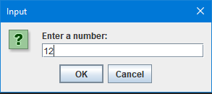

Figure 1. Enter an Element

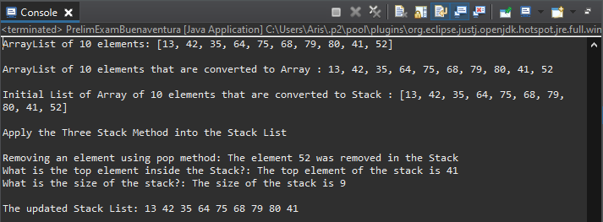

Figure 2. The Final Output