EduEnrol
User Interface
Technical Documentation
Aotearoa New Zealand School Enrolment Platform — Front-End

Document version: 1.0
Date: 17 May 2026
Prepared by: UI Development Team
Status: Final draft for client review

Table of Contents

Tip: In Microsoft Word, right-click the table of contents and choose "Update Field" to populate page numbers after opening this document.

1. Executive Summary
This document describes how the EduEnrol user interface was planned, structured, and implemented as a single-page React application. It is intended for stakeholders who need a clear picture of the front-end architecture, visual design approach, reusable components, and the screens delivered for each user role.
The interface supports four primary audiences: parents and caregivers, school leadership team (SLT) reviewers, enrolment managers, and system administrators. A shared shell (sidebar navigation, top bar, and content area) keeps the experience consistent while allowing each role to see only the tools relevant to their work.
- Modern React 19 front end with Vite for fast development and production builds
- Role-based routing with dedicated layouts per portal
- Component-driven UI with shared primitives and domain-specific modules
- CSS organised by feature area, aligned to an approved brand palette
- Multi-step parent enrolment wizard with form steps broken into maintainable units

2. Introduction

2.1 Purpose
The purpose of this documentation is to record the methodology used to translate product requirements and approved screen specifications into working UI code. It covers technology choices, folder organisation, layout patterns, the component catalogue, and representative screenshots of completed screens.

2.2 Scope
In scope for this document:
- All user-facing screens in the EduEnrol_UI repository
- Layout, navigation, and styling conventions
- Reusable UI and dashboard components
- Parent enrolment wizard structure
Out of scope:
- Back-end APIs, authentication services, and database design
- Production hosting and CI/CD pipeline configuration

2.3 Design Inputs and Workflow
Work began from agreed functional requirements and visual specifications for each role. Screens were broken down into layout regions (navigation, header, main content, modals) before any code was written. For each major view I produced a quick component map—what is shared vs. role-specific—and implemented mobile-first spacing using a fixed desktop breakpoint (1440px) as the primary review target, matching how school staff typically use the system on office machines.
Implementation followed a consistent loop: (1) scaffold route and page shell, (2) build or reuse UI primitives, (3) apply feature-level CSS, (4) wire dummy data for realistic review, and (5) walk through the screen against the specification for spacing, typography, and bilingual labels (English / te reo Māori sub-labels in navigation).

3. Technology Stack
The front end uses a deliberately small dependency set to keep builds fast and maintenance straightforward.
Layer | Technology | Role in EduEnrol
Runtime / UI | React 19 | Component model, hooks for local state
Build tool | Vite 8 | Dev server with HMR, optimised production bundle
Routing | React Router 7 | Nested routes per role layout
Dates | date-fns + react-day-picker | Interview scheduling calendar in SLT flows
Styling | Plain CSS (per feature) | No CSS-in-JS; predictable overrides per page
Linting | ESLint 9 | React hooks and refresh rules

3.1 Why React and Vite
React was chosen because enrolment flows are inherently form-heavy and stateful—multi-step wizards, modals, and tables benefit from a mature component ecosystem. Vite provides near-instant feedback during layout work, which matters when refining pixel-level spacing across many screens.

4. Project Structure
Source code lives under src/ with clear separation of concerns:
- pages/ — route-level screens grouped by role (parent, admin, slt, manager)
- components/layout/ — AppSidebar, AppTopBar (shared chrome)
- components/ui/ — buttons, inputs, cards, empty states, toasts
- components/dashboard/ — KPI cards, charts, tables, rule panels
- components/enrolment/ — wizard steps for parent enrolment
- components/slt/ — review queue, application detail, modals
- components/icons/ — SVG navigation icons
- config/navigation/ — nav items, branding, and labels per role
- data/ — realistic dummy data for demos and layout testing
- styles/ — feature-scoped stylesheets imported by layouts or pages
Each role layout (e.g. AdminLayout.jsx) imports only the CSS bundles needed for that portal, avoiding a single monolithic stylesheet and keeping unused rules out of unrelated views.

5. Design System and Visual Language

5.1 Typography and colour
The global base uses Inter (with system-ui fallbacks) at 11–16px depending on context. Body text colour is #1f2937 on a light grey page background (#f3f5f7 / #f9fafb). Primary brand navy/teal for navigation and actions is #163a5c, with hover states near #122f49.

5.2 Layout rhythm
Dashboard sections use consistent vertical gaps (typically 24–28px). Cards use rounded corners (12–16px radius) and light borders (#e5e7eb / #e2e8f0). Status information is communicated through pill components rather than raw text colour alone, improving scanability.

5.3 Bilingual navigation
Sidebar items show an English primary label with an optional te reo Māori sub-label (configured in config/navigation/*.js). This keeps translations centralised and avoids hard-coding strings inside presentational components.

6. Application Architecture

6.1 Routing model
App.jsx defines all routes. Public entry points are the parent login (/) and staff login (/staff-login). Authenticated-style portals use nested routes: the layout component renders once; child routes swap content inside <Outlet />.
- / → Parent login
- /staff-login → Staff / admin / SLT / manager login
- /parent/* → Parent portal (dashboard, enrol-student, placeholders)
- /admin/* → Admin portal (dashboard, form builder, schools, rules, users, …)
- /slt/* → SLT portal (dashboard, review queue, …)
- /manager/* → Manager portal (dashboard, applications, task queue, assignments, reports)

6.2 Shared application shell
Every authenticated portal reuses the same structural pattern implemented in parent-shell.css:
- Left: collapsible AppSidebar with brand, role pill, nav links, user footer
- Right column: AppTopBar (search, notifications) + scrollable main content
Role-specific layouts only differ in navigation config, which stylesheets they import, and where sign-out navigates. This reduced duplicate layout code by roughly 70% compared to building four independent frame implementations.

7. Component Library

7.1 UI primitives (components/ui/)
- Button — primary actions with ui-button base class
- InputField — labelled inputs with consistent error spacing
- Card — bordered content containers
- DetailFieldGrid — label/value pairs for review screens
- PanelEmptyState — consistent empty list messaging
- AppToast — transient success / info feedback
- FeatureItem — marketing-style bullets on login pages

7.2 Dashboard components (components/dashboard/)
Dashboard widgets are composed for data-dense views: AdminMetricCard, StatSummaryCard, BarChartPanel, DonutBreakdownPanel, ManagerKpiCard, application tables, rule configuration cards, and integration status panels. Each accepts props for title, metrics, and optional actions so pages remain thin orchestration layers.

7.3 Enrolment wizard (components/enrolment/)
Parent enrolment is a seven-step wizard driven by config/parentEnrolment.js:
- Student details
- Caregiver information
- Address and zoning
- Previous school
- Medical information
- Documents
- Review and submit
ParentEnrolStudentPage.jsx holds step index and form state; each step component receives controlled values and onChange handlers. Progress bar width is derived from step index. This pattern makes it straightforward to add validation or API persistence per step later.

7.4 SLT review components (components/slt/)
SLT-specific UI includes queue list items, application review detail layout, document lists, notes panel, timeline, resolved-application cards, and modals (schedule interview, request additional information). Modals use dedicated CSS files to keep z-index and overlay behaviour isolated.

8. Role-Based Portals and Screens

8.1 Authentication screens
The parent login presents brand storytelling on the left and credentials on the right. Staff login uses a compact variant with quick demo links to each portal for stakeholder walkthroughs.
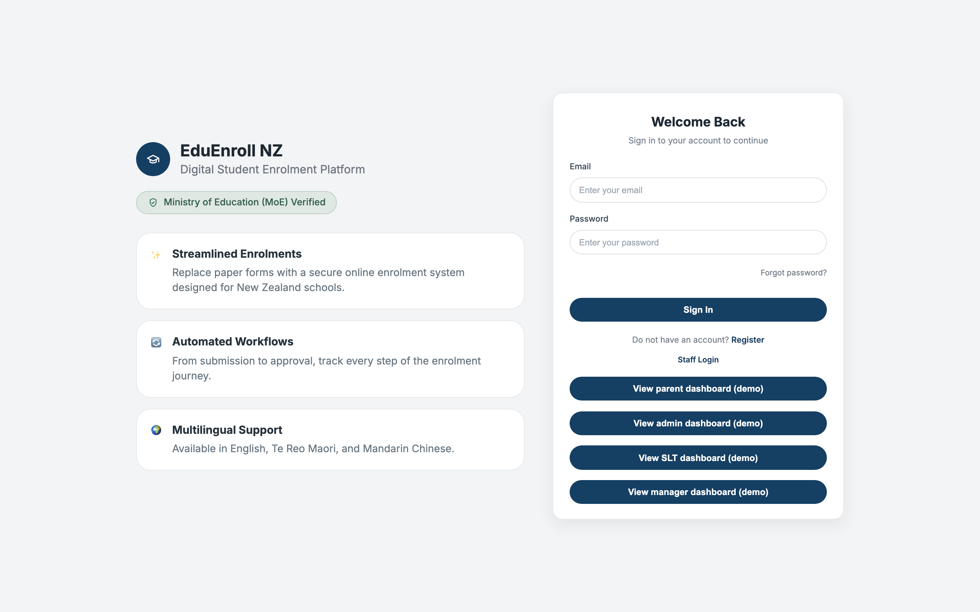
Figure 1 — Parent / caregiver login

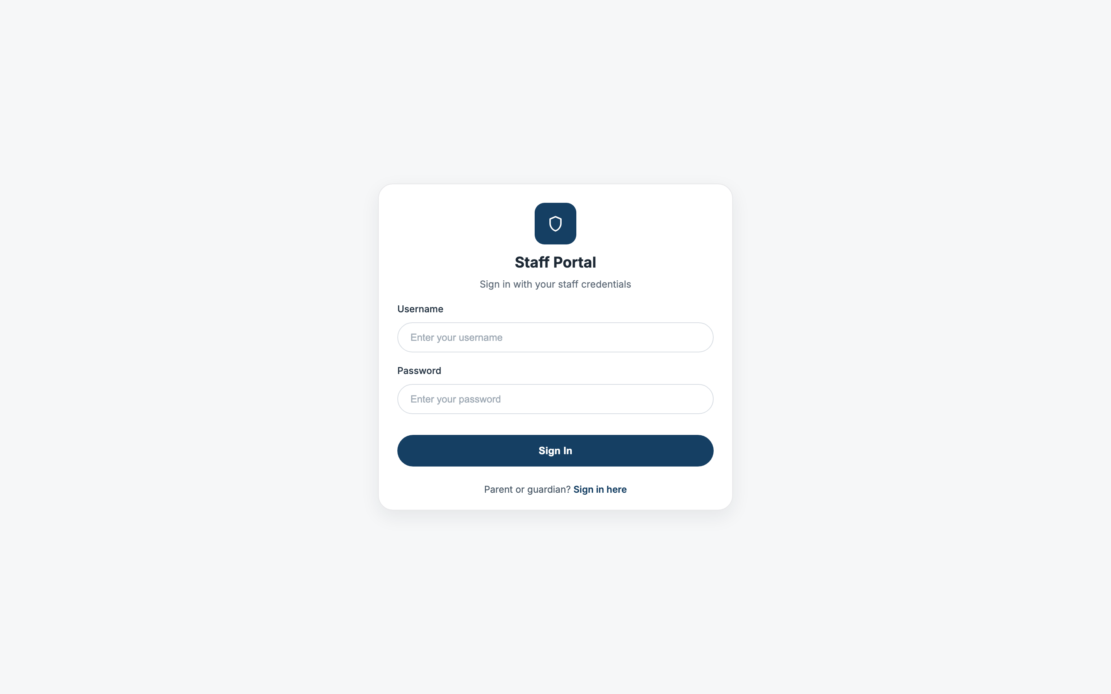
Figure 2 — Staff login with portal shortcuts

8.2 Parent portal
Parents land on a dashboard summarising applications and next actions, then can launch the multi-step enrolment form. Navigation uses the shared shell with parent-specific branding.
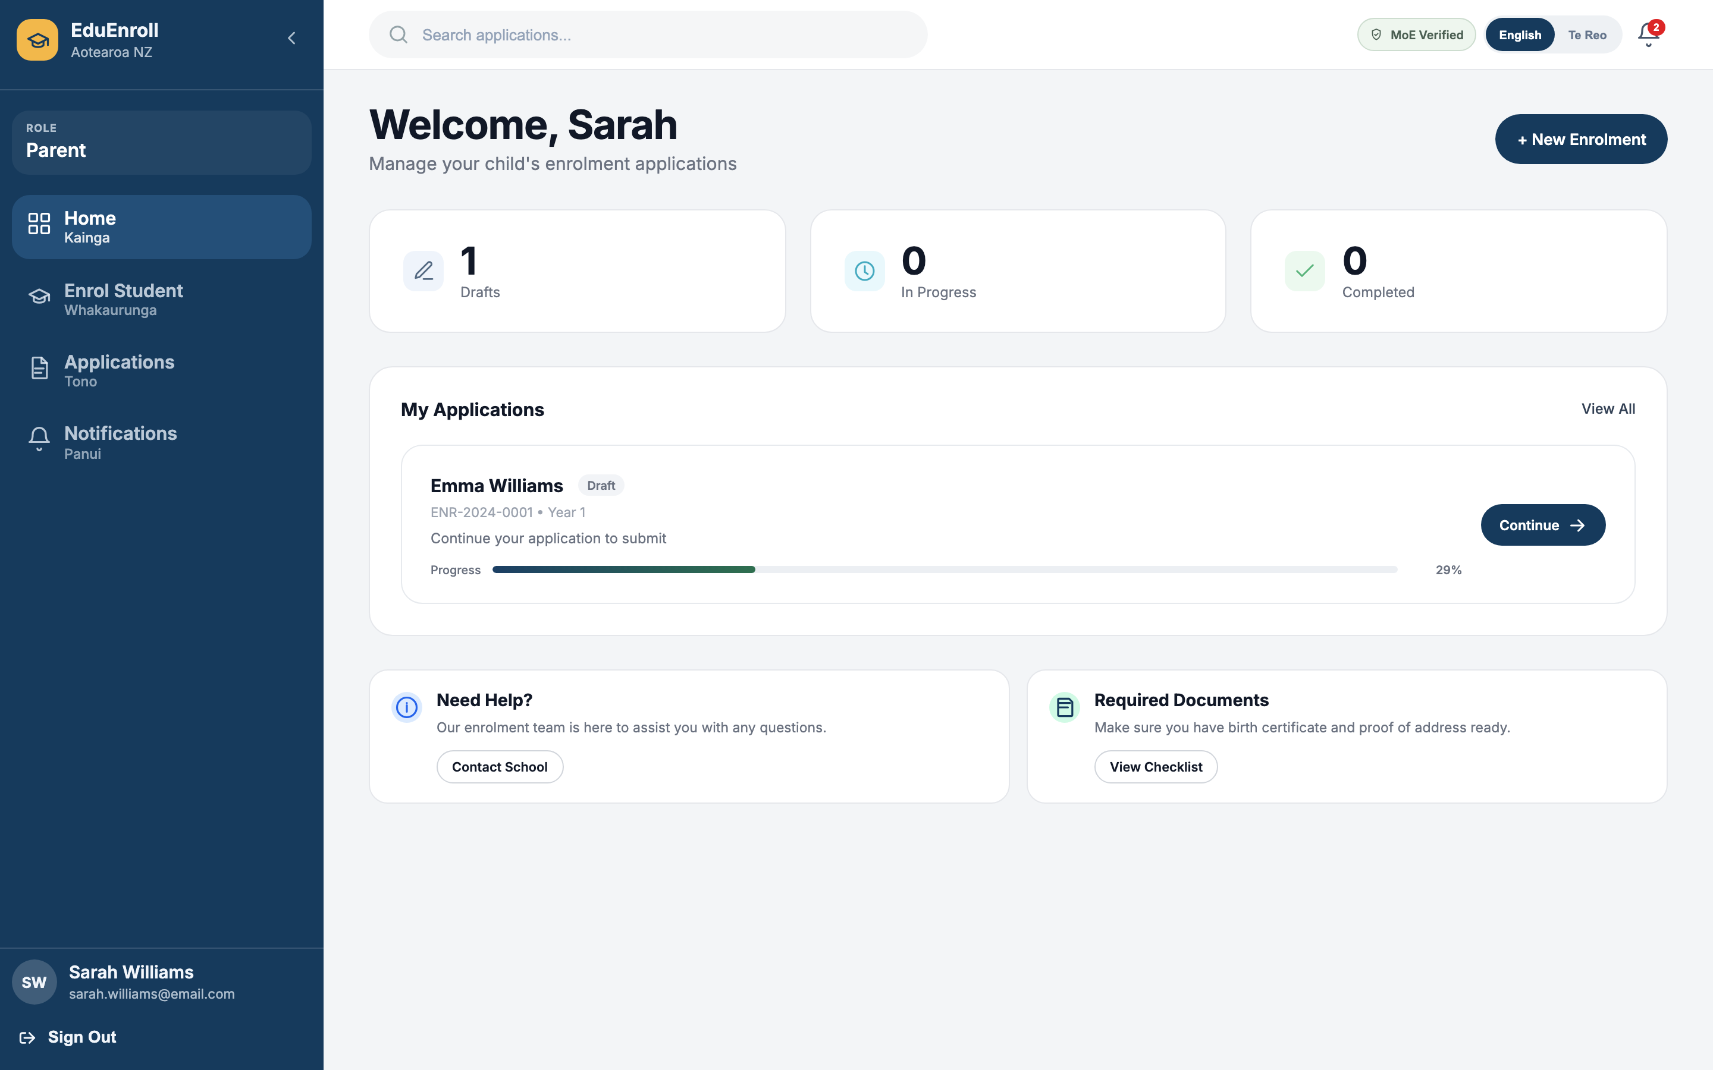
Figure 3 — Parent dashboard

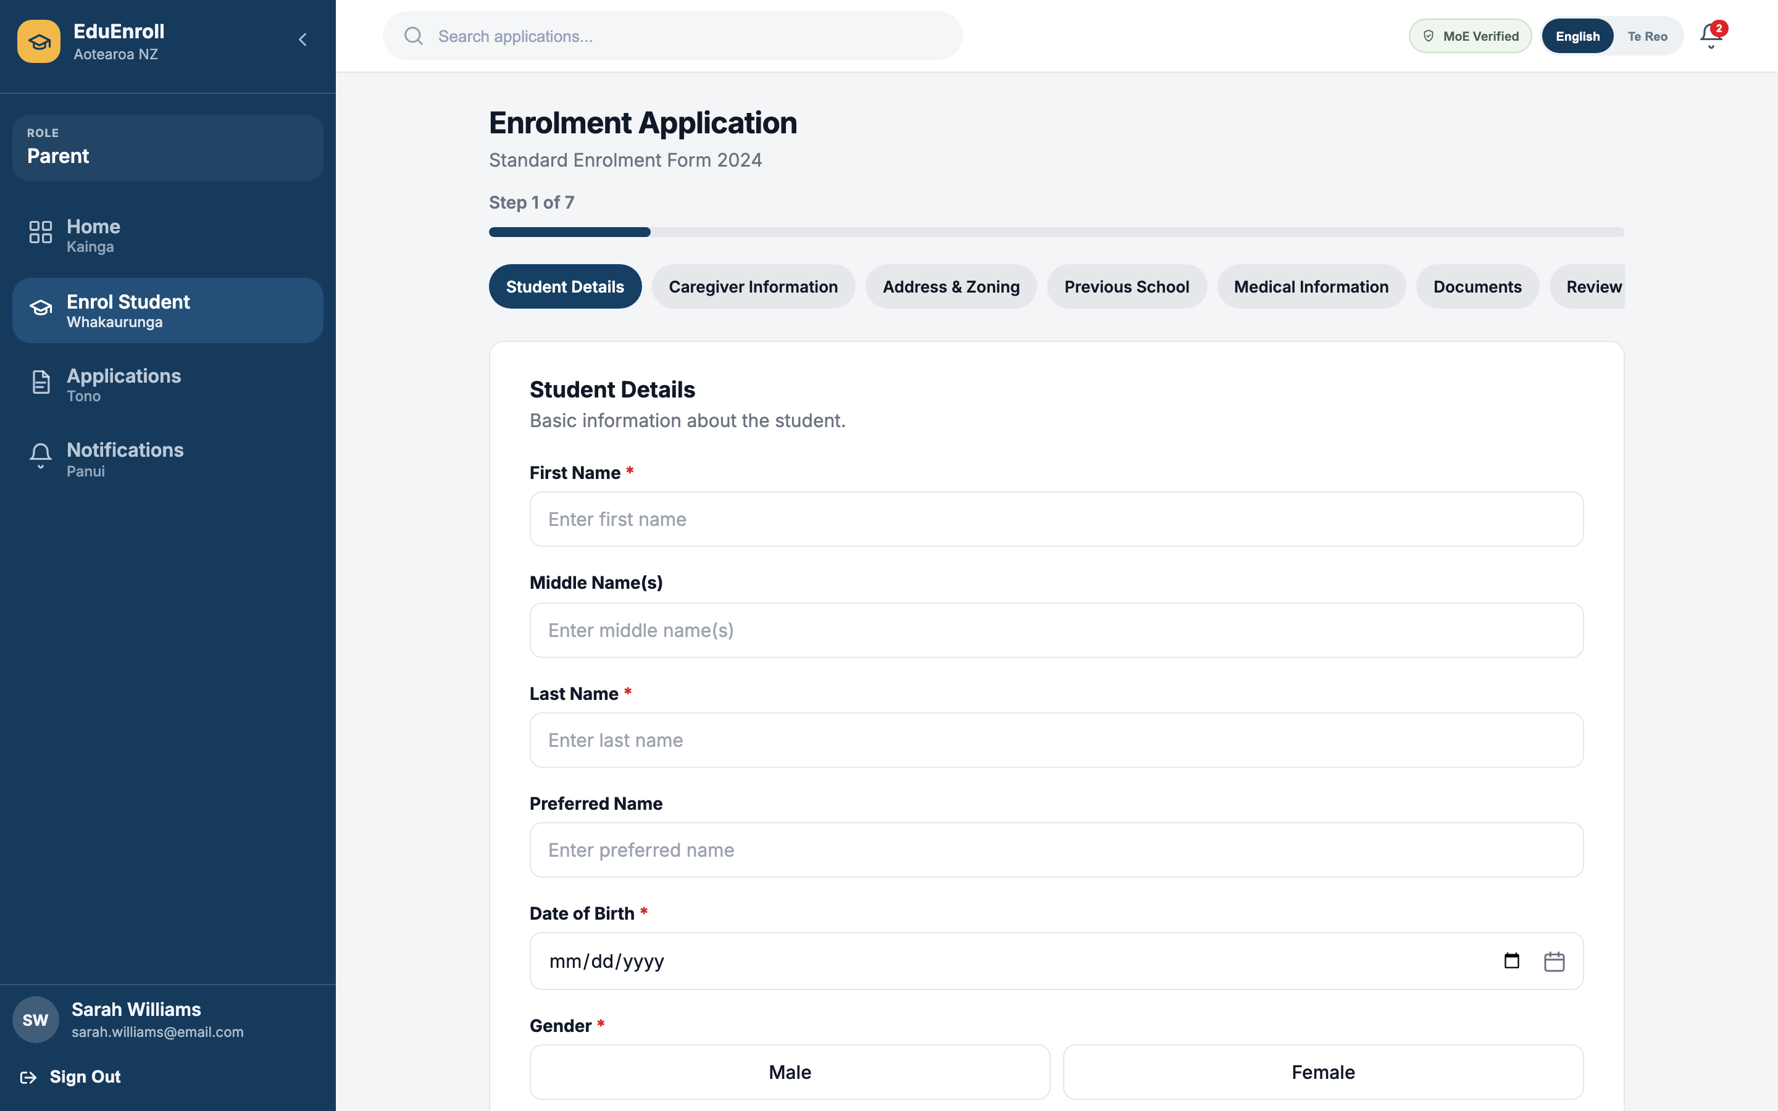
Figure 4 — Enrolment wizard (step progress and form area)

8.3 Administrator portal
Administrators manage schools, users, rules, notifications, and form configuration. The home dashboard surfaces cross-tenant metrics; inner pages use tables and cards tuned for operational tasks.
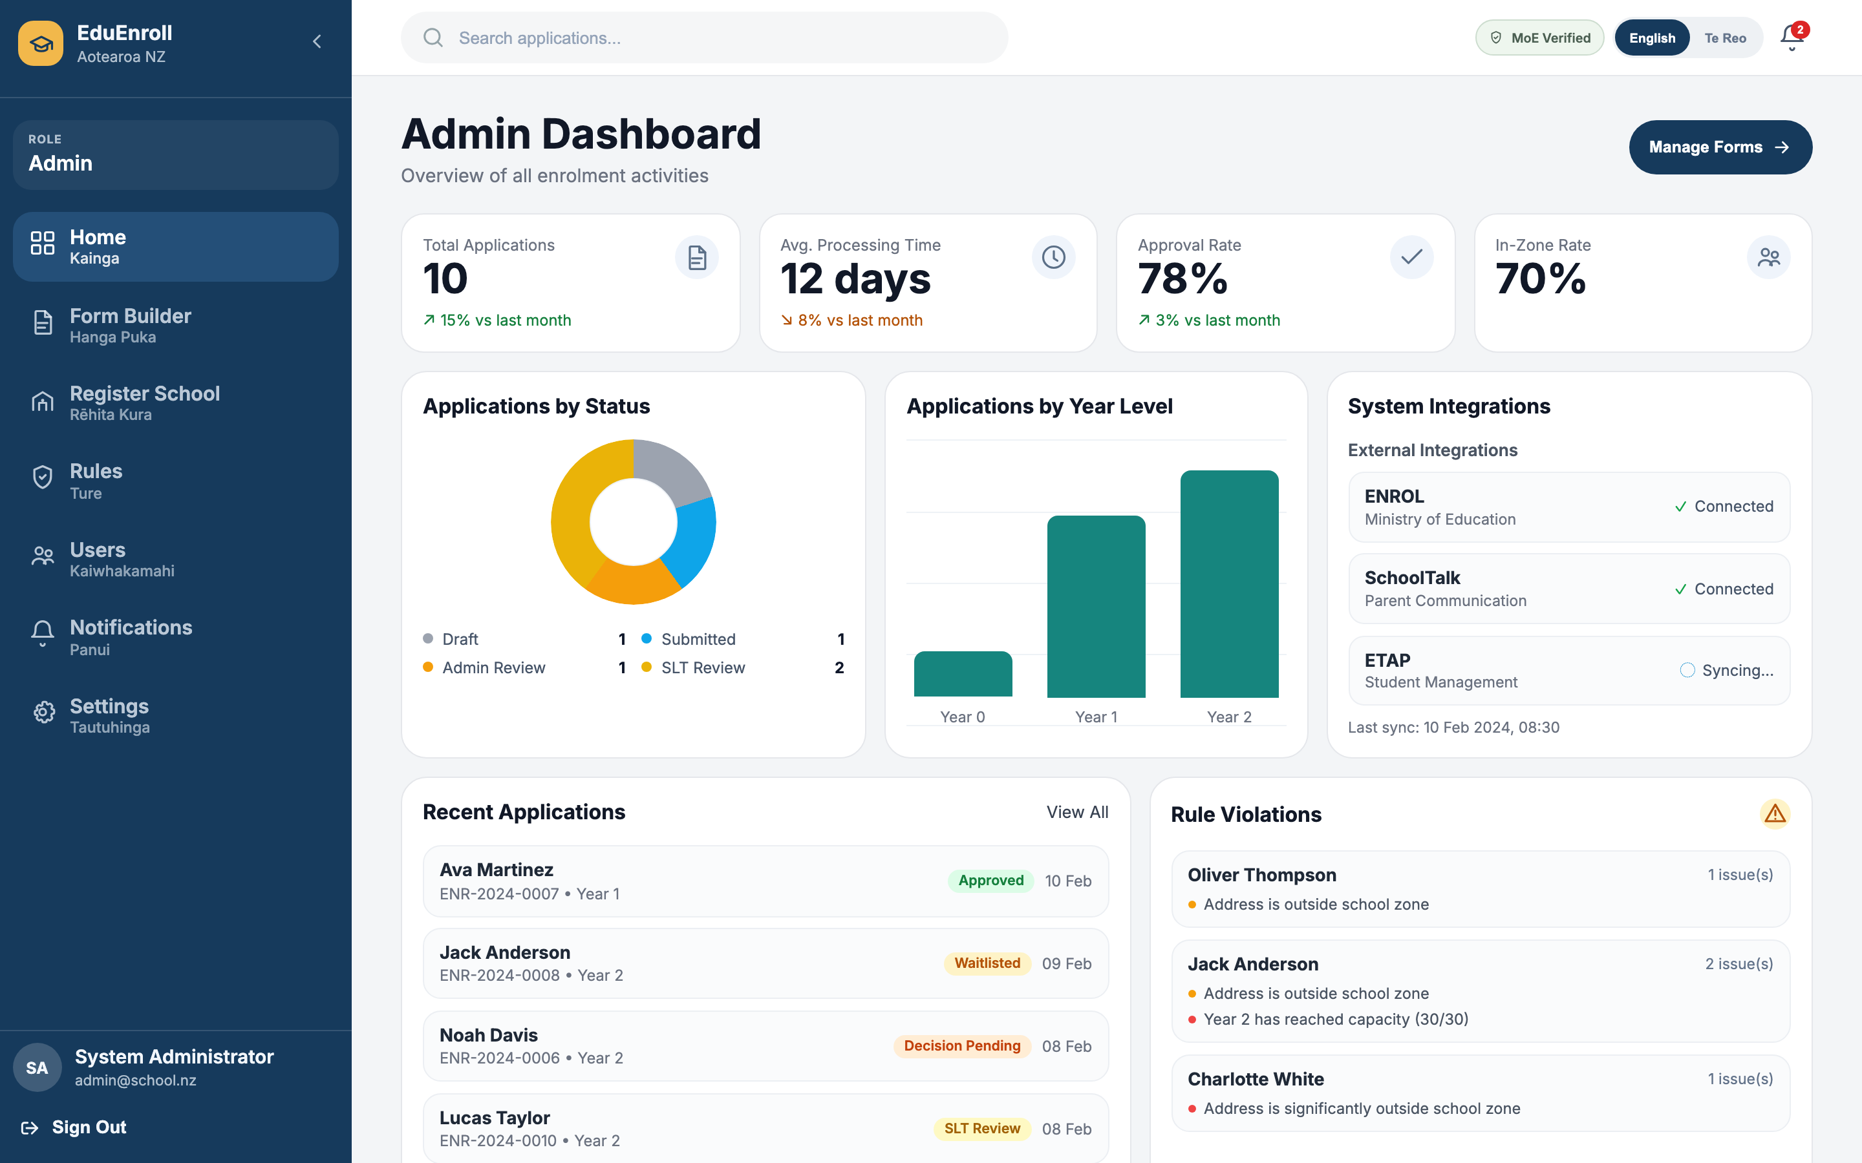
Figure 5 — Admin dashboard

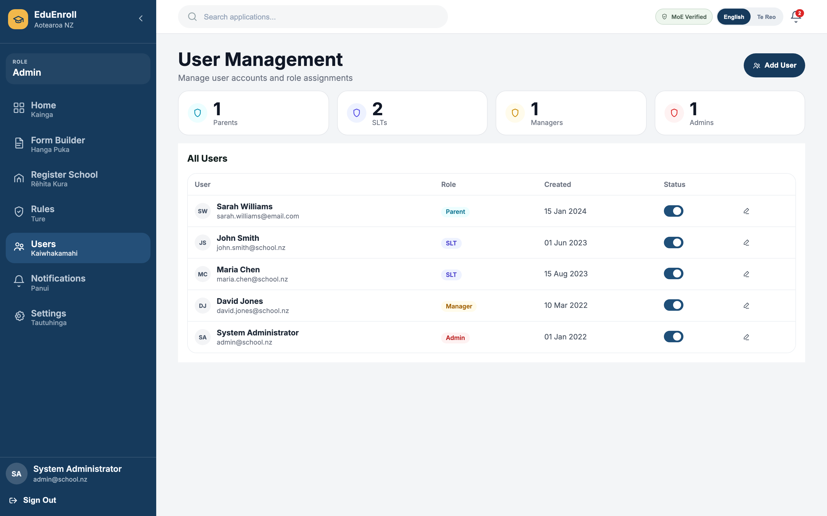
Figure 6 — User management

8.4 SLT portal
SLT users monitor workload and process applications from the review queue. Detail views combine timeline, documents, notes, and decision actions in a single scrollable workspace.
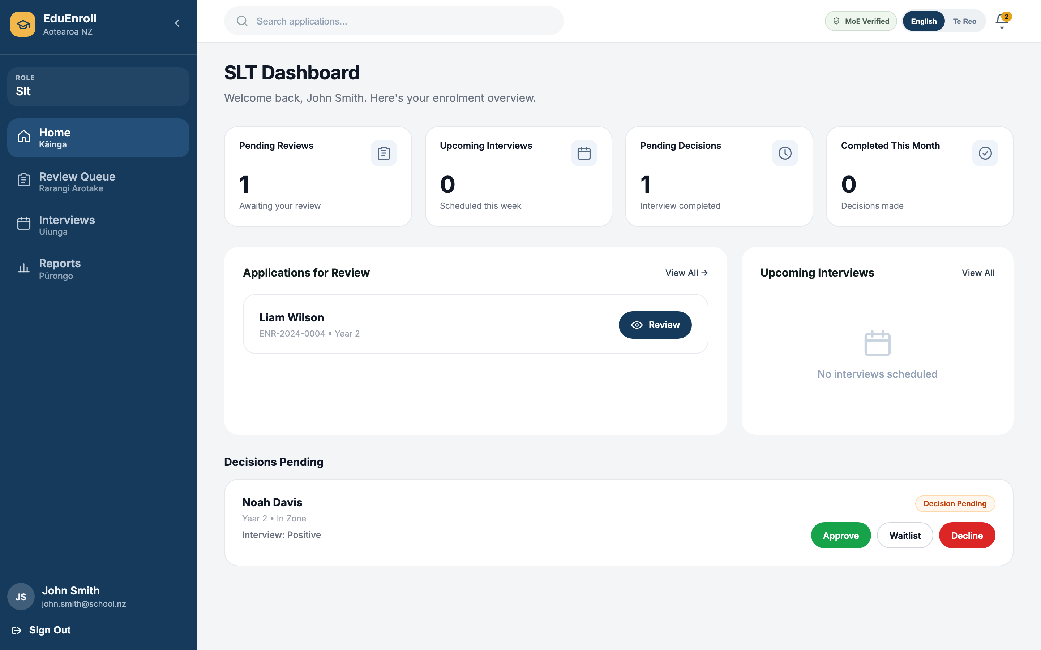
Figure 7 — SLT home / workload overview

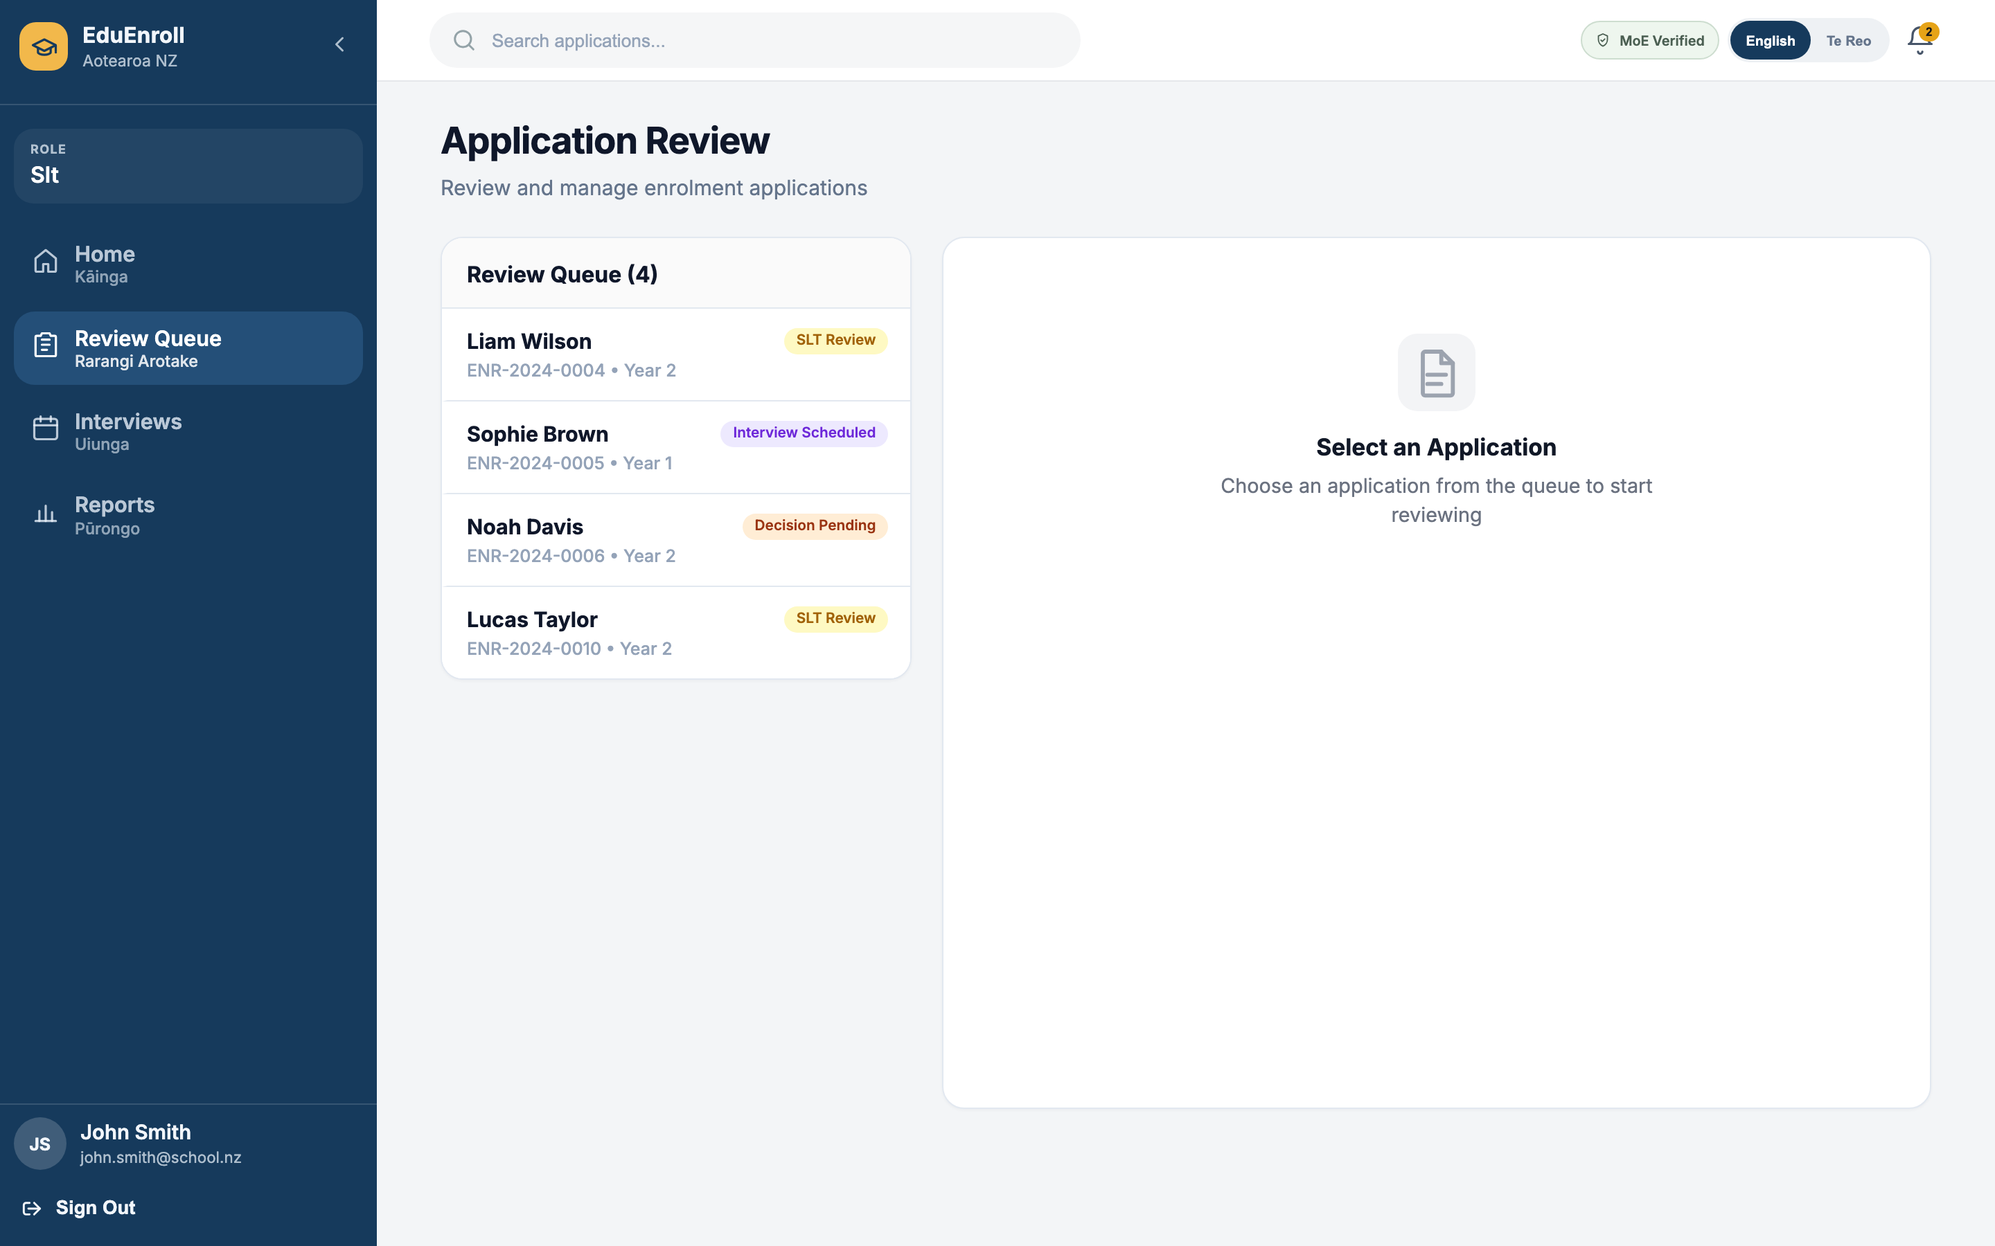
Figure 8 — Application review queue and detail panel

8.5 Manager portal
Enrolment managers see KPIs, assignment workload, application lists, and reporting entry points. Tables support filtering patterns established in managerApplicationsFilters.js.
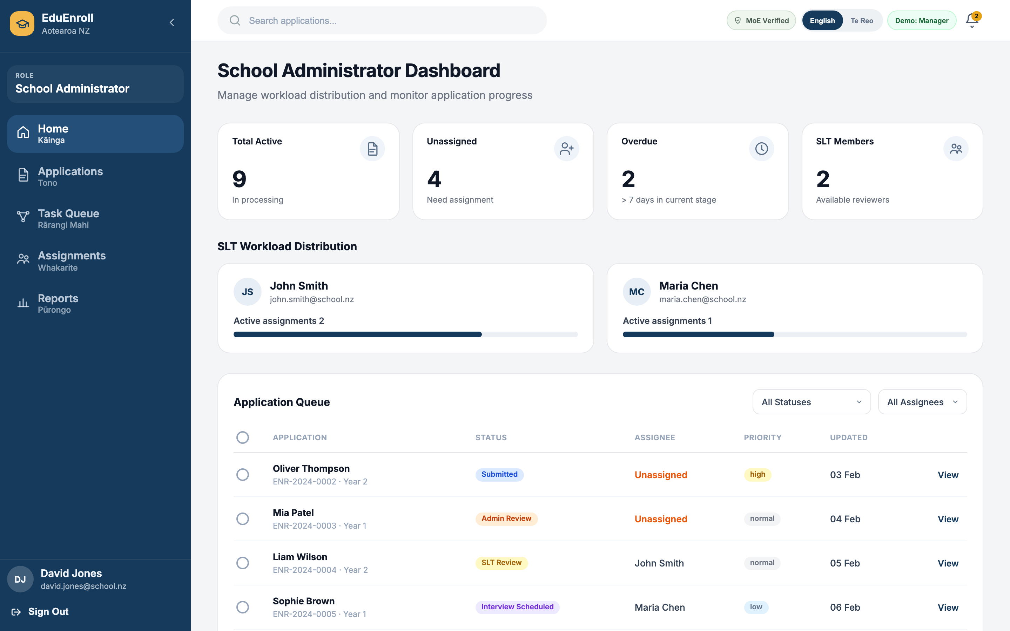
Figure 9 — Manager dashboard

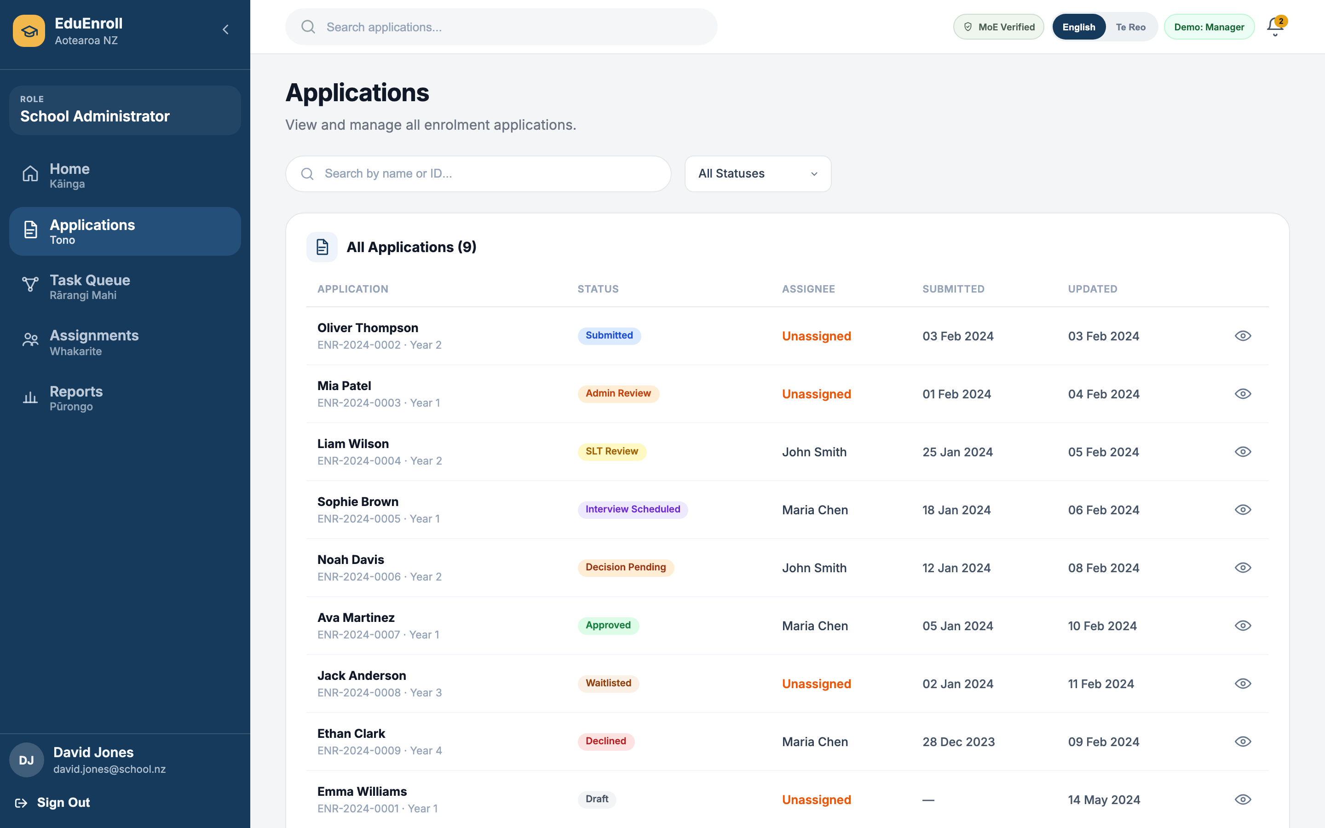
Figure 10 — Applications list

9. Styling Approach
Styling is plain CSS, namespaced by feature file (e.g. slt-review-queue-page.css). BEM-like class prefixes (slt-rq-, parent-enrol__, app-sidebar__) prevent collisions. CSS custom properties on :root or feature wrappers centralise colours for each portal variant.
Global resets and accessibility helpers live in index.css (box-sizing, visually-hidden utility). Login-specific rules remain in App.css for historical reasons; new work prefers styles/ imports at the page or layout level.

10. UX, Accessibility, and Responsiveness
- Sidebar collapse preserves icon-only navigation for narrow widths
- ARIA labels on sidebar toggle and main navigation landmarks
- Keyboard-focus styles on form controls in modals and wizards
- Semantic headings inside dashboard panels for screen reader structure
Further responsive breakpoints can be extended per stylesheet; the current delivery targets desktop-first use called out in the requirements workshops.

11. Local Development and Build
Prerequisites: Node.js 18+ and npm.
- Clone the repository and run npm install
- Start the dev server: npm run dev (default http://localhost:5173)
- Production build: npm run build — output in dist/
- Preview production bundle: npm run preview
Linting: npm run lint. The project uses ESLint flat config aligned with React 19 recommendations.

12. Integration Readiness
The UI is structured for back-end integration without large refactors: dummy data modules in src/data/ can be replaced by API hooks; form state in the enrolment wizard is already segmented per step for partial saves; tables accept row objects that map cleanly to DTOs. Authentication is simulated via route navigation today—middleware or context providers can guard layouts when tokens are available.

Appendix A — Document Revision History
Version | Date | Author | Changes
1.0 | 17 May 2026 | UI Development Team | Initial release covering full EduEnrol UI scope

Appendix B — Screenshot Index
- Figure 1: 01-login.png — Parent login
- Figure 2: 02-staff-login.png — Staff login
- Figure 3: 03-parent-dashboard.png — Parent dashboard
- Figure 4: 04-parent-enrolment.png — Enrolment wizard
- Figure 5: 05-admin-dashboard.png — Admin dashboard
- Figure 6: 06-admin-users.png — User management
- Figure 7: 07-slt-dashboard.png — SLT dashboard
- Figure 8: 08-slt-review-queue.png — Review queue
- Figure 9: 09-manager-dashboard.png — Manager dashboard
- Figure 10: 10-manager-applications.png — Manager applications

