TECHNOLOGICAL INSTITUTE OF THE PHILIPPINES
938 Aurora Blvd., Cubao, Quezon City
IT 015 - INTRODUCTION TO GAME DEVELOPMENT
Assignment No. 1.2
“My First 3D Scene”

Name: Buenaventura, Aristotle C. Date: October 19, 2021
Section/Program: IT12S1 Instructor: Prof. Jean M. Angeles

Instruction: Create a 3D Scene using the assets in the Unity Assets store.

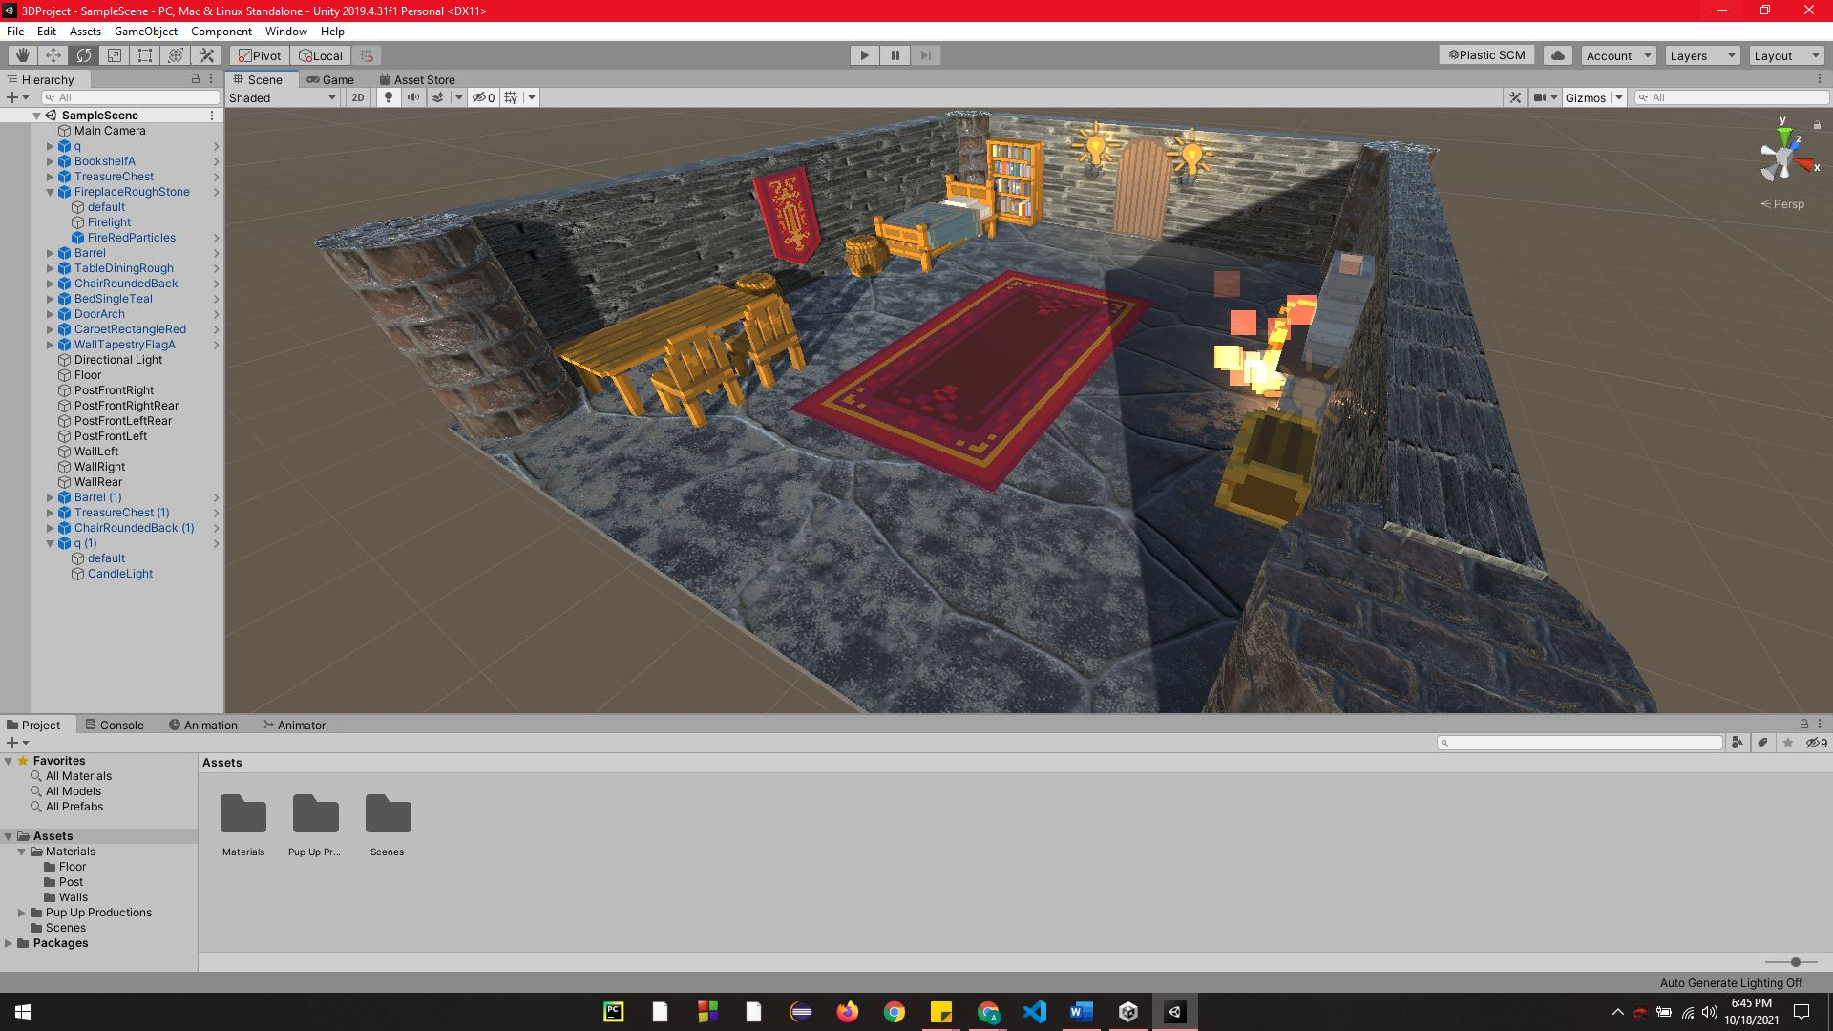
Output:

Reflection:
First, it took me 5 hours to complete this assignment, even though this was just the basics of Unity. I thought It was easy to create a 3D project in Unity, but I was wrong. I need to rewatch the lecture to understand and follow the correct way to import and place the assets in the editor. Along the way, I enjoyed creating my first 3D scene, but I remember there was a stupid thing I did, I was making my 3D scene after hitting the play button, so when I tried to save my creation, there was a note that I need to quit in play mode then when I hit the quit it went back to start. Lesson learned that I need to check if I am in the playing mode or editing mode.
Honor Pledge
“I affirm that I have not given or received any unauthorized help on this assignment, and that this work is my own.”

