TECHNOLOGICAL INSTITUTE OF THE PHILIPPINES
938 Aurora Blvd., Cubao, Quezon City
IT 015 - INTRODUCTION TO GAME DEVELOPMENT
Assignment No. 2.1
“Roll-a-Ball (Part 1)”

Name: Buenaventura, Aristotle C. Date: October 24, 2021
Section/Program: IT12S2 Instructor: Prof. Jean M. Angeles

Instructions:

Setting up the Game

In this first Roll-a-ball tutorial, you’ll:
- Create a new Unity Project
- Set up your workspace
- Create and position some basic objects for your game
- Configure the lighting and game background

Moving the Player

In the second Roll-a-ball tutorial, you’ll:
- Add a Rigidbody to the Player sphere, so you can use the Unity physics engine
- Write your own PlayerController script in C#, to make the sphere respond to player input
- Test your script and fix errors

For your activity, change the color of the sphere and plane (any color you want aside from blue and gray). Screenshot your output.
Submit a document (docx/pdf). The contents are the output and reflection (what you've learned).

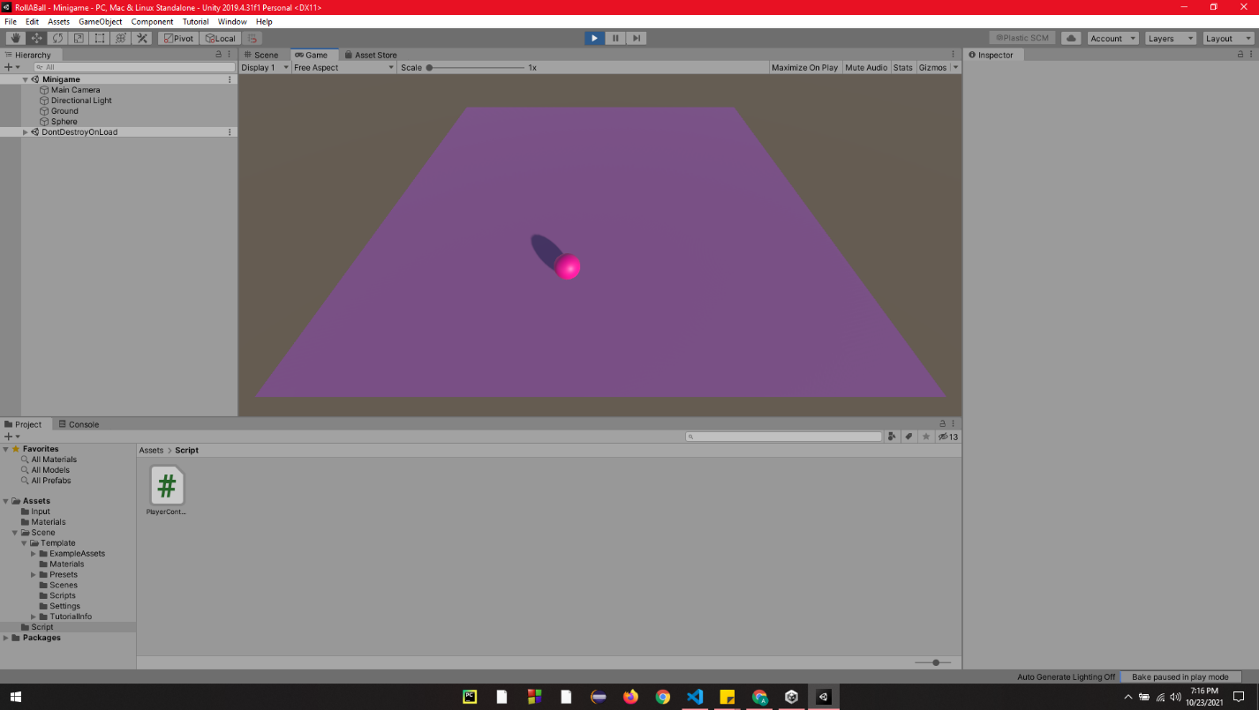
Output:

Reflection:
I thought it would take ages to create this assignment since I saw the bunch of tutorials that I needed to watch on the canvas. But each video only takes around two to five minutes. It's tedious on the first part when I need to set up a game because I already knew that part. The second part that interested me the most was moving the ball around the plane surface.

I have learned that I need to put a rigid body component to my ball. To move the ball, I need to apply the keyboard input to the ball object. But first, I must install the input system package. After that, I create my first script using C# in VS code. I followed everything on the video, but mine was not moving even though my codes matched the video's code. I was glad that there is a comment on the video tutorial that if the ball is not rolling, based on the statement, "make sure the Actions box inside the Player Input component had "inputActions" in it." So, I did it, and it works. The last thing that I needed to do was change the ball's speed, I changed it to 10, so it looks like a perfect rolling ball.
Honor Pledge
“I affirm that I have not given or received any unauthorized help on this assignment, and that this work is my own.”

