
Technological Institute of the Philippines
938 Aurora Boulevard Cubao, Quezon City

Assignment 3.1 Roll-a-Ball (Part 2)

Name: Buenaventura, Aristotle C.
Section: IS12S2

Reflection

I started this assignment as soon as the professor ended the meeting; I finished it at 11 pm the same day, it was tiring, but it was worth it. Along the way, I enjoy creating my very first 3D game. The assignment was just a continuation of the previous work. I had already implemented movements for the player. Still, for this assignment, I need to put walls on the ground so the player will not fall, input some rewards that the player needs to collect, count text to know the number of prizes collected, and last, the You Win show up text when all the awards are collected.

First, to put walls, I need to create four 3D object cubes, stretch them to look like a wall, and put them on the four sides of the ground. Second, I made a cube again, but I tilted it to look like a reward; I put a rotation code in it. Third, to show that the prize appears collected when the player touches it, I need to tick the "is trigger" in the box collider. Third, I put a TextMeshPro on the upper left corner for the Count Text, and this is where the system will display the count of rewards. Lastly, since I want to be unique, I make it like a maze to make the game more challenging to play.

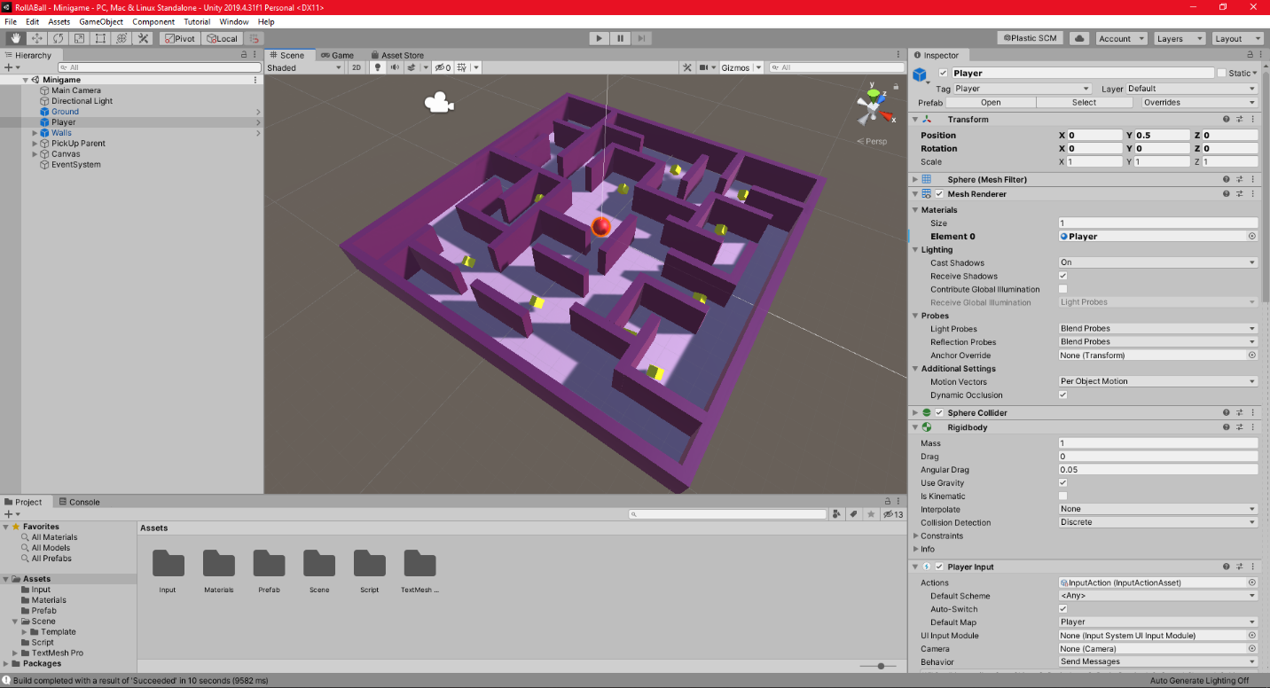
Screenshots
Figure 1. Unity Editor

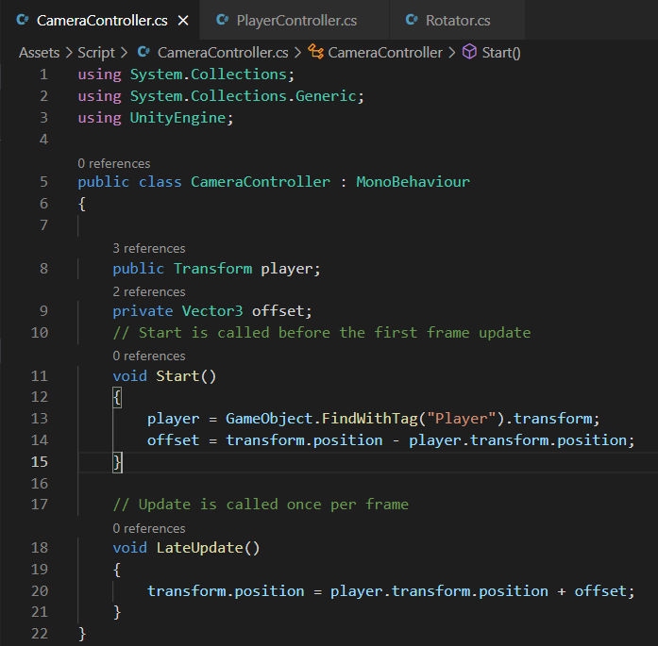

Figure 2. Camera Controller C# code

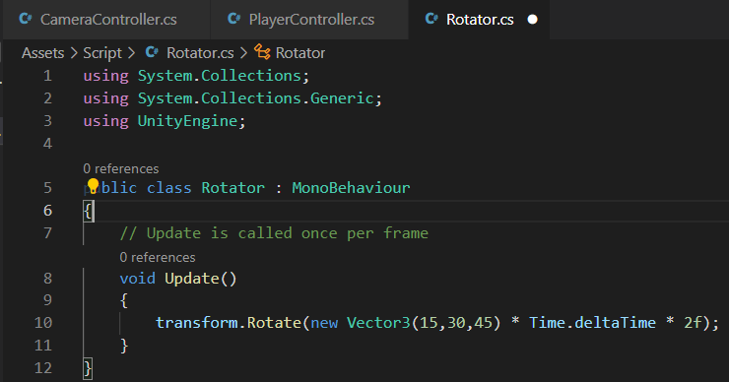

Figure 3. Rotator C# code

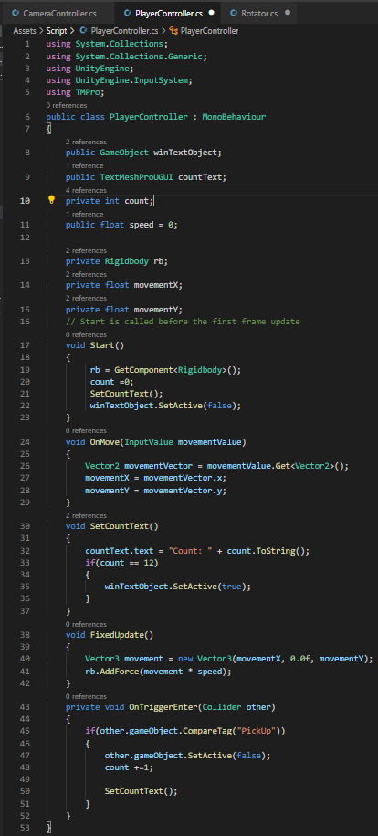

Figure 4. Player Controller C# code

Link of the video
https://drive.google.com/drive/folders/1G6Gsc3I6gCVSOmnfZovbeHuFZhRdVkra?usp=sharing

