
Technological Institute of the Philippines
938 Aurora Boulevard Cubao, Quezon City

Assignment 4.1 Create your Own UI

Name: Buenaventura, Aristotle C.
Section: IS12S2

Reflection

To begin with, the video training provided with the canvas was insufficient to develop this user interface. To make this, I watched various YouTube tutorials. It's simple to set up the text and buttons, but adding a script and codes to them is more complicated. The first thing I did was attach the Play button to the minigame scene so that when the user clicks it, it takes them to the minigame scene. The next button is the Quit button, which has an Application.Quit() code and is used to exit the application. Last but not least, there's the options menu, which was the most challenging portion. I provide audio that the user can control in the option; the user can adjust the volume. I also included a resolution picker so that users may choose the screen size they wish to play the game on. Because I was stuck on the resolution part, it took me a week to finish. I'm not sure why it wasn't working, but thanks to other YouTube lessons, I could fix it. There's something I can't explain; I'm not sure why the minigame scene I built is too dark, although the editor's minigame scene is brightly lit.
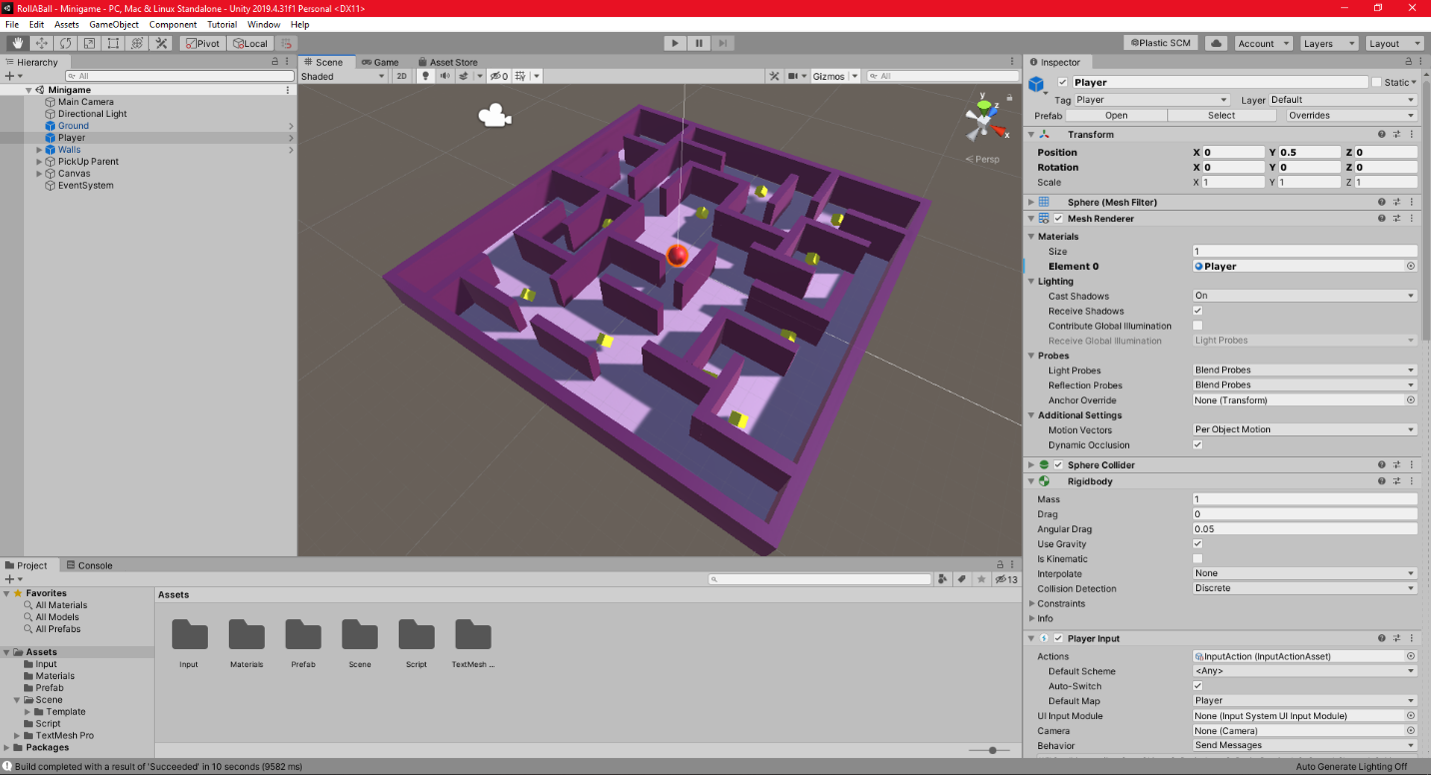
Screenshots
Figure 1. Unity Editor Minigame
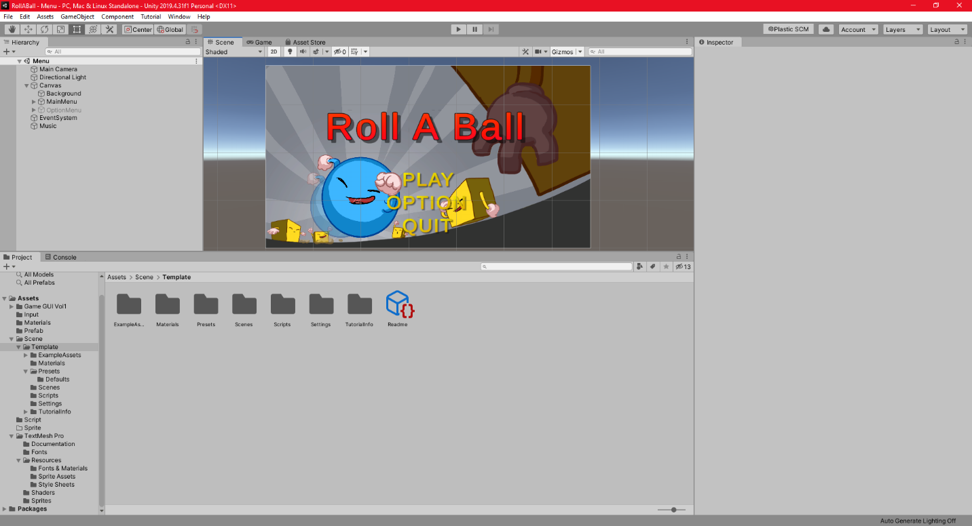
Figure 2. Unity Editor Menu

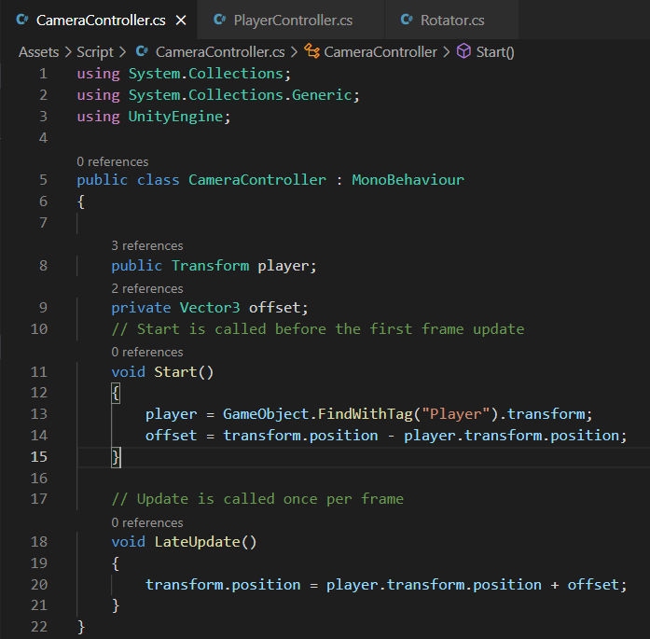

Figure 3. Camera Controller C# code

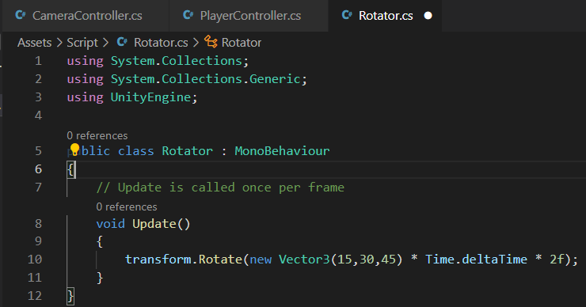

Figure 4. Rotator C# code

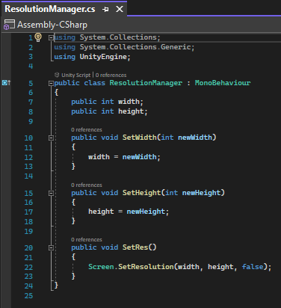

Figure 5. Resolution Manager C# code

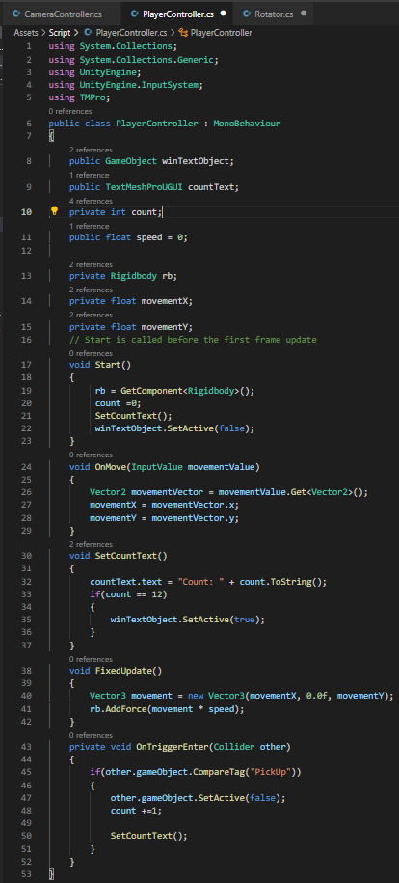

Figure 6. Player Controller C# code

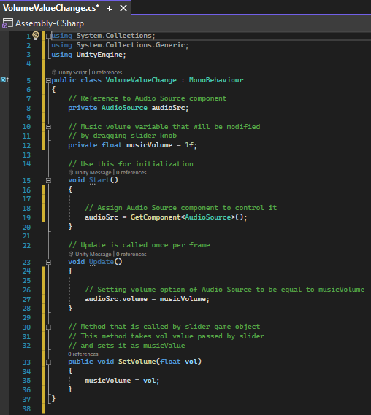

Figure 7. Volume Value Change C# code

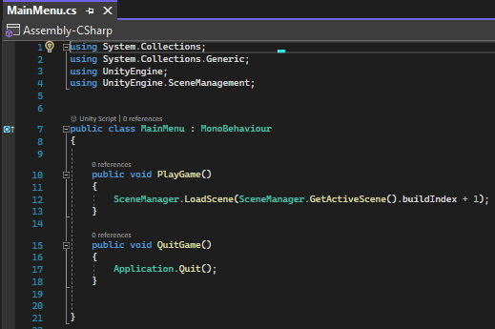

Figure 8. Main Menu C# code

Link of the video
https://drive.google.com/drive/folders/1WZ0kSgWFeHJPPF7cSKwOOzhHroFotuSu?usp=sharing

Honor Pledge:
“I affirm that I shall not give or receive any unauthorized help on this assignment and that all work is my own.”

