
Technological Institute of the Philippines
938 Aurora Boulevard Cubao, Quezon City

ITE 010 – INTRODUCTION TO HUMAN-COMPUTER INTERACTION
Assignment 1.3 – Keypad and Calculator Design

Name: Aristotle Buenaventura
Section: IT12S1

Output:

- Design of a simple android keypad setup.

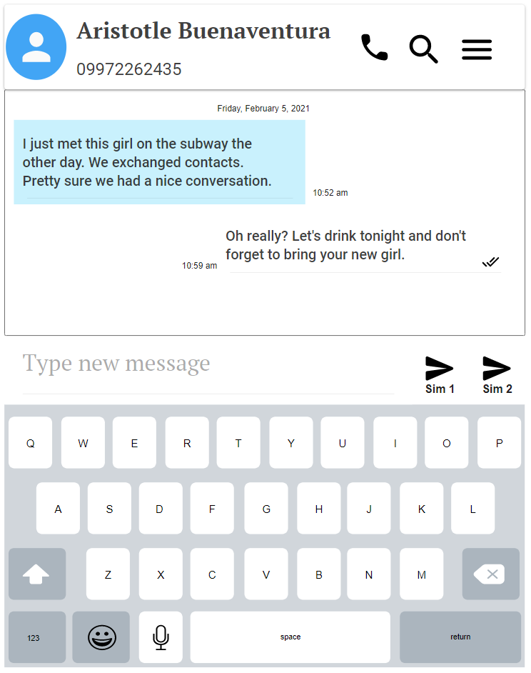

- Design of a simple android calculator setup.

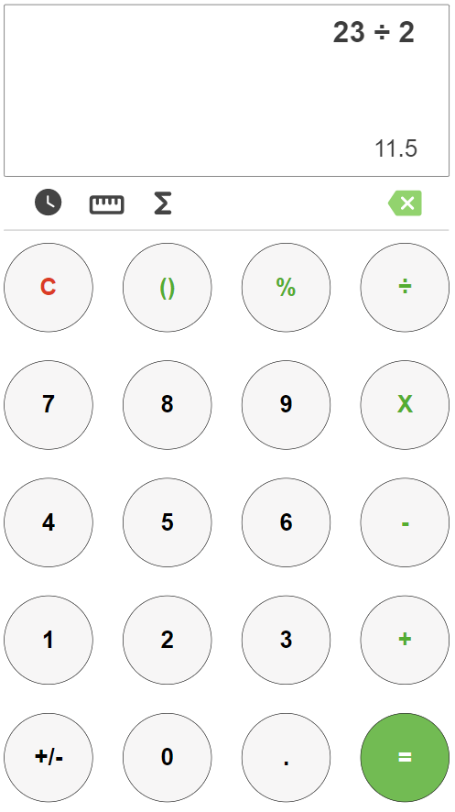

Reflection:

I thought I could not make it because I do not have any skills in terms of designing and using UI designer like pencil and photoshop. I managed to download and install the Pencil application but whenever I use it, it suddenly stops. Maybe because of the specs of my laptop, i5 with 8Gb ram. I tried to look for other UI designers online and I saw Moqups, I used it for this activity. I hope that I can do all the designs activities for this course, I will try to study how to use those UI/UX designer apps for future activities.

