
Technological Institute of the Philippines
938 Aurora Boulevard Cubao, Quezon City

ITE 010 – INTRODUCTION TO HUMAN-COMPUTER INTERACTION
Assignment 2.1 – Computers

Name: Aristotle Buenaventura
Section: IT12S1

- How do you think new, fast, high-density memory devices and quick processors have influenced recent developments in HCI? Do they make systems any easier to us? Do they expand the range of applications of computer systems?
All current PC gadget innovations are in fact restricted by the speed of electron movement. This limit is somewhat central, on the grounds that the quickest conceivable speed for data transmission is obviously the speed of light, and the speed of an electron is now a generous part of this. Where we expect future enhancements isn't such a great amount in the speed of PC gadgets as in the speed of calculation. From the outset, these may seem like something very similar, until you understand that the quantity of PC gadget tasks expected to play out a calculation is controlled by something different - in particular, a calculation.
Furthermore, the PC caused life more to unwind and simpler. PCs give different sorts of games and individuals could appreciate and unwind from the regular. At last, compute helps people solve many complicated problems by software, for example, investment and finance. Along these lines, individuals' life turns out to be more straightforward and convenient.
Fundamentally, having a high clock speed but just only a couple of centers implies your PC will actually want to stack and cooperate with a single application rapidly. On the other hand, having more processor cores, but a slower clock speed implies your PC can work with more applications all at once, yet each may run a little slower.

- What input and output devices would you use for the following systems? For each, compare and contrast alternatives, and if appropriate indicate why the conventional keyboard, mouse, and c.r.t screen may be less suitable. (12 pts.)
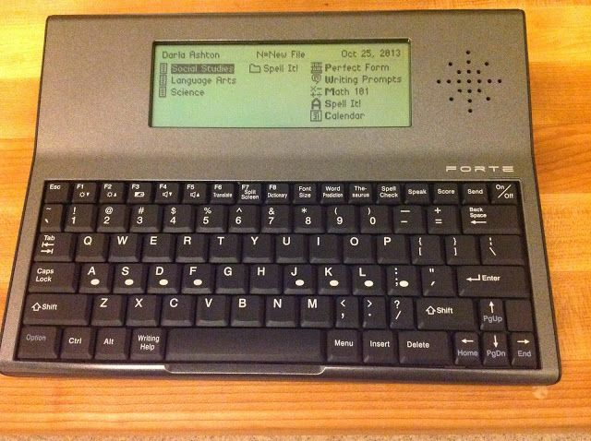
- Portable word processor
A portable word processor is a lightweight gadget that is not difficult to transport. Word processing permits the user to alter and address his/her composed work more effectively than doing as such by hand.
- Keyboard
  - Users can't word process without this gadget, this gadget will assist them to input their content in the portable word processor.
- Touchscreen
  - To effortlessly explore the gadget, it is greatly improved to utilize a touchscreen than utilizing the mouse to control and work the gadget.
- Built-in microphone
  - The gadget has voice recognition for commands inside the gadget.
- Built-in speaker
  - After the user composed his/her content, the gadget can read it to effectively identifying linguistic blunders.

- No mouse
  - This gadget doesn’t need a mouse because of the touchscreen and voice acknowledgment, additionally, it is versatile so it is badly arranged if a mouse is holding tight to that device.
- No CRT monitors
  - Once more, this device is compact, subsequently, a CRT screen isn't suitable for this sort of gadget.

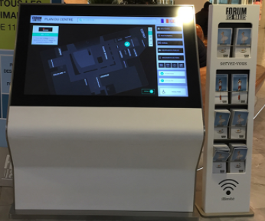
- Tourist information system
A tourist information system is a gadget with programming that causes travelers to find their location, hotel information, transportation, places of interest, and so forth.
- TouchScreen
  - The major device that need for this gadget is a big touchscreen, the useful of that is for users to navigate clearly their places of interest.

- Built-in speaker
  - This device will help the user to know the name of the place and how to pronounce it correctly.
- Built-in microphone
  - The users will simply say their preffered spot and the gadget will tell them the guide on the best way to arrive.
- No keyboard
  - The device is in touchscreen innovation so users can include their content utilizing their finger while tapping the screen, keyboards are superfluous for this sort of contraption.
- No mouse
  - This device needn't bother with a mouse due to the touchscreen and voice affirmation, furthermore, it is adaptable so it is gravely masterminded if a mouse is holding tight to that gadget.
- No CRT monitors
  - This gadget is loaded with touchscreens; appropriately, a CRT screen isn't appropriate for such a contraption.

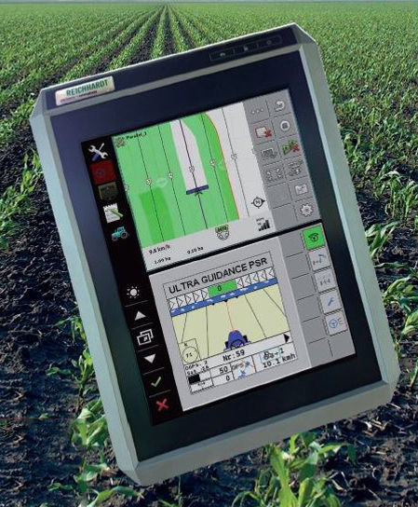
- Tractor-mounted crop-spraying controller
The gadget is utilized to splash a fluid, where sprayers are regularly utilized for projection of water, weed executioners, crop execution materials, bug maintenance chemical, as well as manufacturing and production line ingredients.
- Touchscreen
  - To easily explore the contraption, it is significantly improved to use a touchscreen than using the mouse to control and work the device.
- Camera
  - For the gadget to see the ranch that should be treated.
- Built-in speaker
  - For notification sounds.
- Built-in microphone
  - This gadget likewise furnishes with voice acknowledgment to effectively control the framework.
- No mouse
  - This contraption needn't bother with a mouse since utilizing a mouse needs a mouse cushion or table yet inside the farm hauler, there is no sufficient space for that.
- No CRT monitors
  - This gadget is stacked with touchscreens; properly, a CRT screen isn't fitting for such a contraption.
- No keyboard
  - Once more, this contraption is outfitted with touchscreen innovation, hence, the console is insignificant.

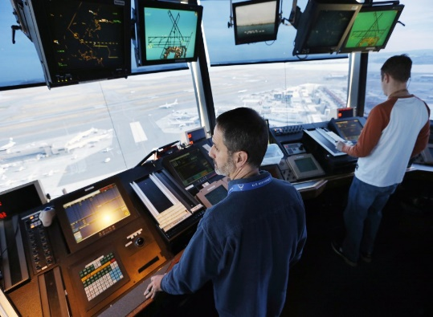
- Air traffic control system
The air traffic control system works inside a framework, planning examples to guarantee airplane keep a protected distance noticeable all around and on the ground. The principle objective of an air traffic control is to guarantee the wellbeing of airplane, pilots, airline stewards, and obviously, the carrier travelers.
- Touchscreen
  - Utilizing the touchscreen is for effectively figure out how to control the entire framework instead of utilizing a CRT screen.
- Camera
  - This device needs a ton of cameras to see the whole air terminal including air and land.
- Microphone/Telephone
  - For correspondence with other air terminal faculty and furthermore the pilot.
- Speaker
  - To hear the reaction of other air terminal personnel and besides the pilot.
- Mouse
  - For faster navigation of the whole computer system.
- CRT monitor
  - Screens that will be put at the highest point of the control room, these screens will show what the camera sees.
- Keyboard
  - For quicker composing all the sources of info that are important for correspondence among pilots and them.

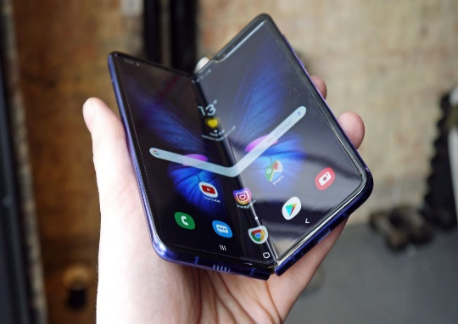
- Worldwide personal communications system
A new generation of wireless-phone technology that introduces a range of features and services surpassing those accessible in simple and advanced mobile phone frameworks.

- Touchscreen
  - Specialized gadgets these days have touchscreen innovation for effectively control the gadget.
- Camera
  - For live gathering and chat to other people.
- Built-in speaker
  - To hear the things their friends and family have said.
- Built-in microphone
  - To say anything, they desire to say to their friends and family.
- Stylus/Pen
  - For writing and drawing.
- No mouse
  - This gadget needn't waste time with a mouse because of the touchscreen and voice certification, additionally, it is adaptable so it is genuinely planned if a mouse is holding tight to that device.
- No CRT monitors
  - Obviously, this contraption needn't bother with a big screen like a CRT screen, this is compact and little.
- No keyboard
  - Again, this contraption is furnished with touchscreen development, thus, the support is inconsequential.

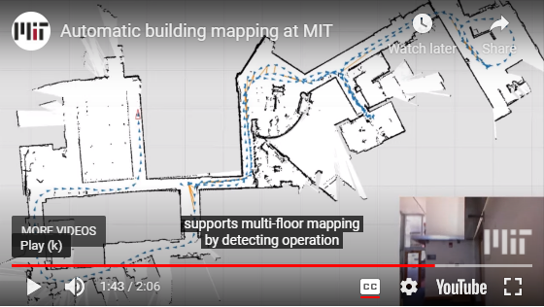
- Digital cartographic system
Digital mapping (likewise called Digital cartographic) is the process by which an assortment of information is arranged and organized into a virtual picture.
- Onboard processing
  - Onboard is a term used to describe a hardware component embedded into a circuit board.
- Kinect depth sensor
  - Kinect's depth-sensing would enable robots to determine the shape and approximate distances to obstacles and maneuver around them.
- Inertial sensor
  - Inertial sensors are sensors based on inertia and relevant measuring principles.
- Laser rangefinder
  - A laser rangefinder, also known as a laser telemeter, is a rangefinder that uses a laser beam to determine the distance to an object.

- No mouse, CRT screens, and keyboard
  - This is independent on the grounds that as the user explores, his movement is resolved utilizing a laser rangefinder and with other info and yield gadgets, along these lines, mouse, CRT, and console are pointless.

