Technological Institute of the Philippines
Quezon City
ITE010 - INTRODUCTION TO HUMAN COMPUTER INTERACTION
Assignment 3.3 BMI Calculator

Name: Aristotle Buenaventura | Date: February 3, 2021
Section: IT12S1

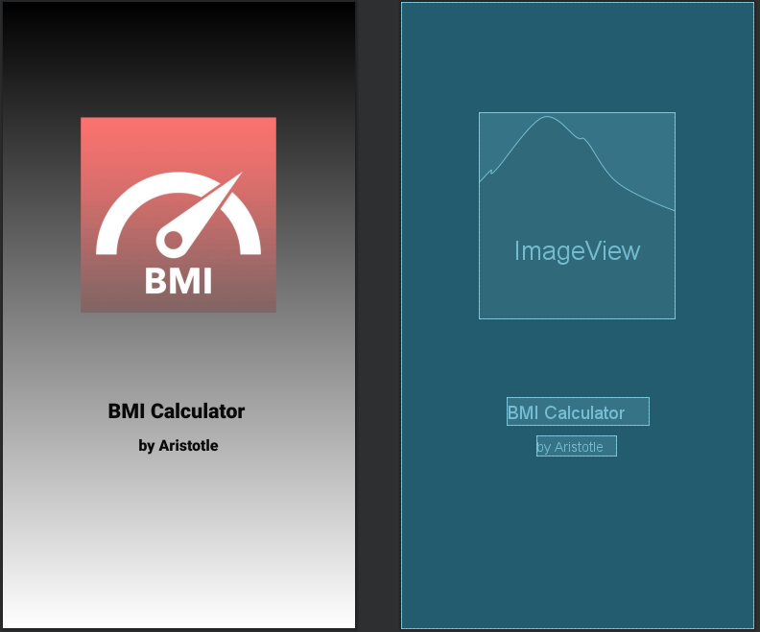
Screenshots

Figure 1. Activity Splash

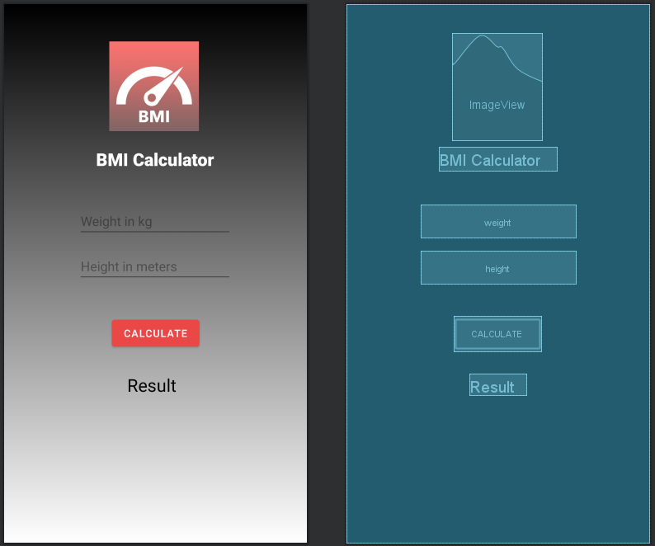

Figure 2. Activity Main


Figure 3. Gradient Background

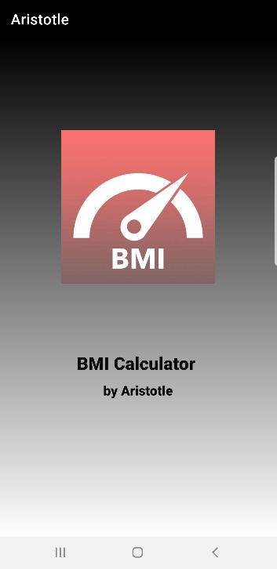

Figure 4. Application’s Screenshot 1
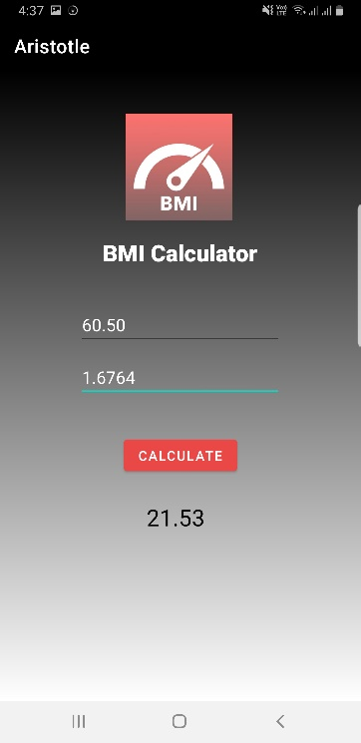

Figure 4. Application’s Screenshot 2

Reflection
It took me five days to complete this simple activity, it wasn't that difficult yet my framework took such a long time to run the android studio. I've noticed that at whatever point I open the emulator my PC abruptly stops. So, thanks to God, I've watched again the conference and I've adapted again how to connect my CP in the Android studio from that point forward the Android studio turns out totally great. I have seen some YouTube instructional exercises on the best way to change the background and textual style tone, it's difficult for me to search for the Android studio Kotlin instructional exercise on the grounds that the majority of the recordings that I have seen are all in Java.

