Technological Institute of the Philippines
Quezon City
ITE010 - INTRODUCTION TO HUMAN COMPUTER INTERACTION
Assignment 4.1 Creating RecyclerView

Name: Aristotle Buenaventura | Date: February 22, 2021
Section: IT12S1

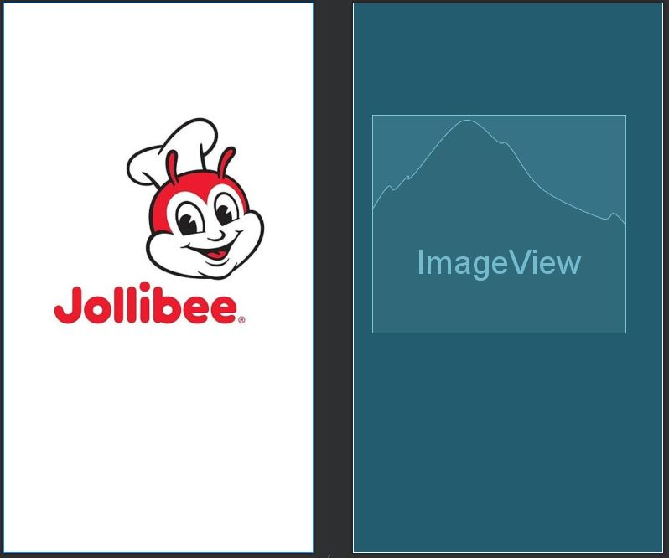
Screenshots

Figure 1. Activity Splash

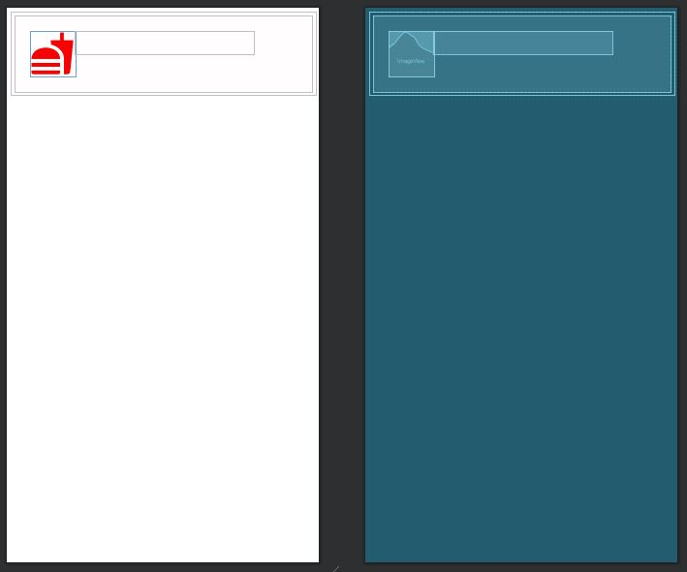

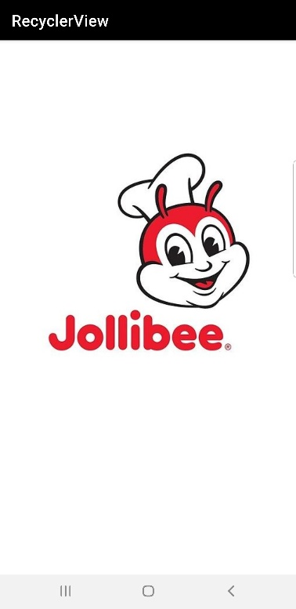
Figure 2. Card Layout

Figure 3. Application’s Screenshot 1

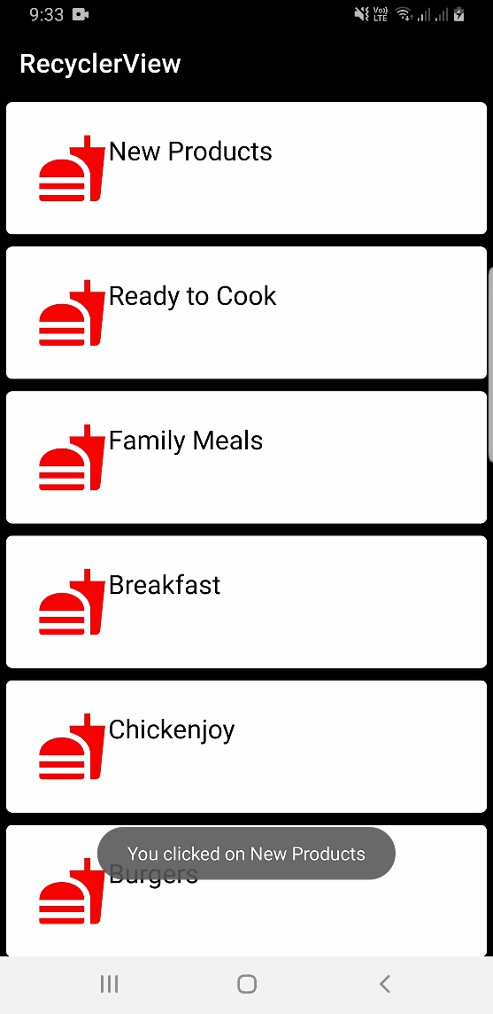

Figure 4. Application’s Screenshot 2

Reflection
I studied the YouTube link that our educator has posted today and I managed to finish it the same day. It's hard and it appears to be that I'm simply copying the code from the video yet I actually give my best to comprehend and break down the codes. I added the splash screen that I have gained from the past module. I completed this task even before the conference lesson since tomorrow, February 23, is my birthday and I don't have a lot of time tomorrow. I hope I will get again an ideal score for this activity and an Uno grade for the last grade.

