
Technological Institute of the Philippines
938 Aurora Boulevard Cubao, Quezon City

ITE 010 – INTRODUCTION TO HUMAN-COMPUTER INTERACTION
Assignment 6.1 – 10 Heuristics for User Interface

Name: Aristotle Buenaventura
Section: IT12S1

Research about 10 Heuristics for User Interface Design by Jakob Nielsen.
- Visibility of system status
The system should always keep users informed about what is going on, through appropriate feedback within reasonable time.

When you do some action or referring to a continuing process, the status should be clearly mentioned until it’s completion. Let’s look in some examples.
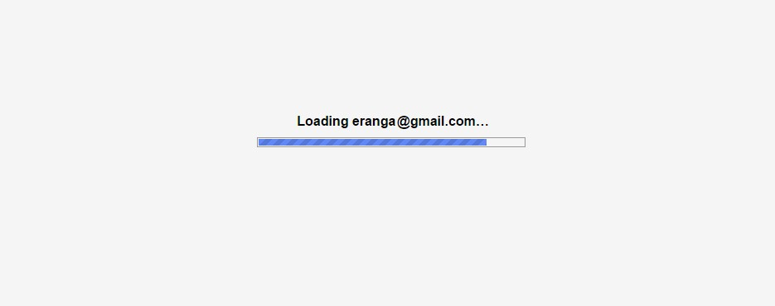

When you have login to Gmail, it shows you what’s happening in the background and the progress.
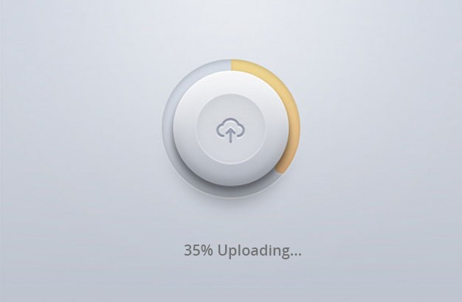

When you upload something, the progress should be clearly visible unless you don’t know what happens in the background and gets confused.

- Match between system and the real world
Is there something on your application that a user may not understand? This is very common to miss since we get associated with the product for over a period of time. It’s also important for the application to speak the language of the target user base.


Neil Patel could very well say “Sign Up” on his landing page. Instead, he chose to say ambitiously — “Yes, I want Neil to teach me how to grow my Business!”. It sets the context and speaks the everyday language.

- User control and freedom
This principle talks about giving the user the freedom to navigate and perform actions. The freedom to undo any accidental actions. This principle can be best illustrated by the Gmail’s flash message with undo action when we accidentally delete an email.

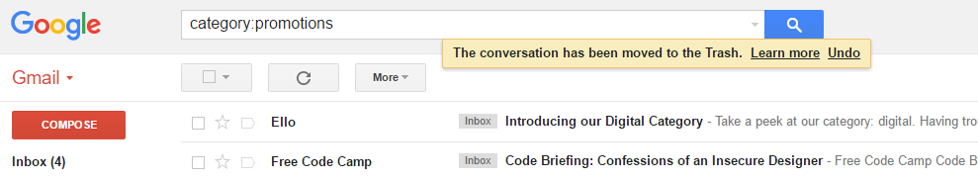
And below is Facebook checking on me if I tapped “Cancel” by mistake.

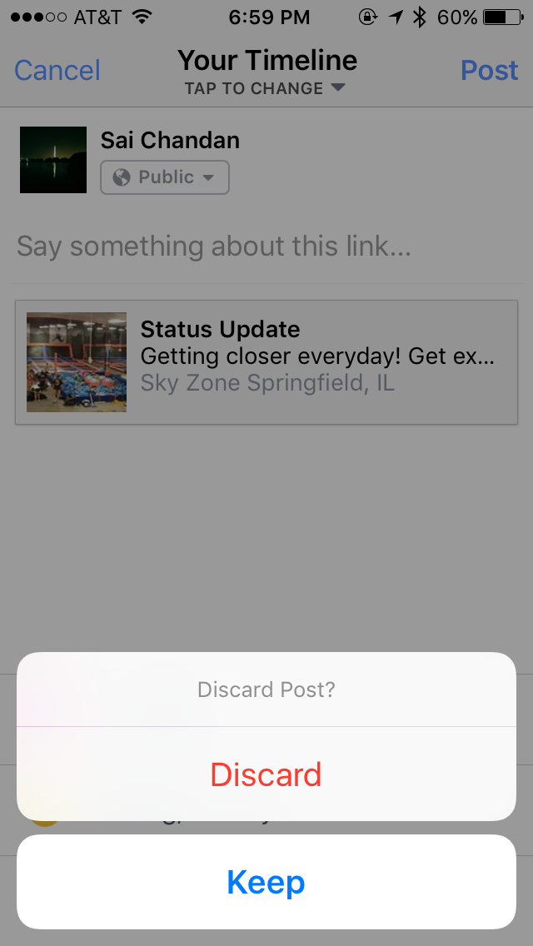

- Consistency and standards
Consistency is the key. A Submit button in one page should look the same across the site on any page. If we show the data in a particular table format on one page, it should look the same the next time data is being shown in tabular format. If the header is displayed in a certain way on the public pages, it should be the same when he/she logs in.



Externally, it’s risk-less to follow the standard conventions. A “How It Works” link invokes similar expectation for a user across sites. Google Plus ambitiously launched “+1” to counter Facebook’s “Like” without much success. Facebook’s “Like” already became a standard and sites like LinkedIn adopted it without contesting.

- Error prevention
How many times did your outlook remind you that there is no attachment in the email while you mentioned that something is attached? Outlook intuitively scans the email for such keywords and alerts the user before sending. This is Error Prevention.

Below is an example of Google Search trying to correct my spelling:
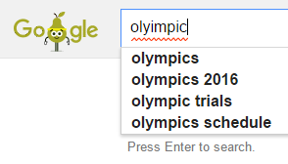

If you have set some rules for the format of user password, try to validate it as the user types rather than waiting for him to click submit.
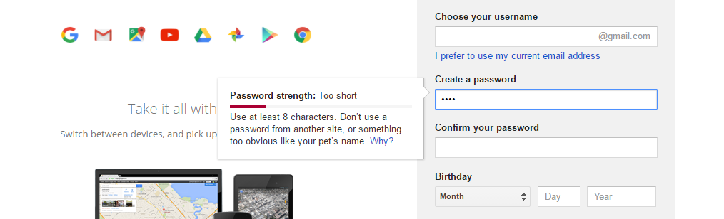

- Recognition rather than recall
It’s always better to suggest the user a set of options than to let him remember and type the whole thing. The goal is to minimize the application of user memory.

Below is an example of Quora suggesting possible questions based on what I am trying to type.
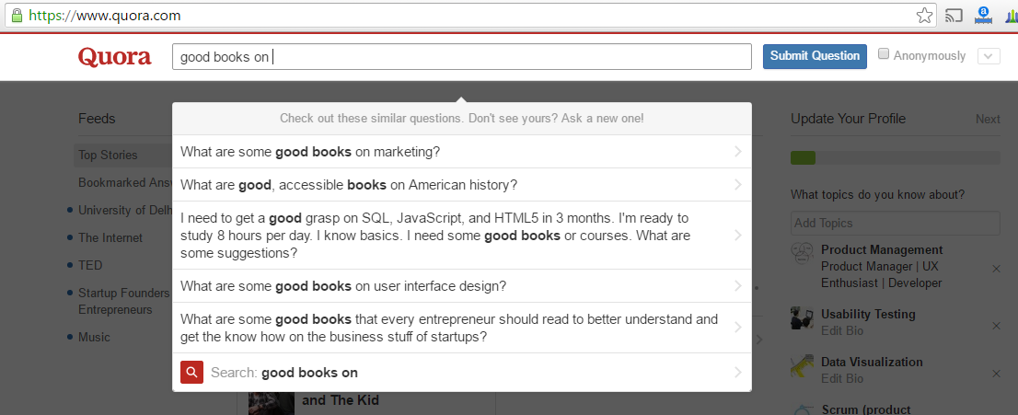

One more example is when Quora lets you pick the topics of interest from a list of options rather than asking you to type all of them which would have been disastrous.

- Flexibility and efficiency of use

The Interface should be flexible transforming itself between a novice user and an advanced user. One frequents this option while installing a new software that asks if the user wants to go ahead with default installation or custom installation. An advanced user chooses a custom installation to cut out the unnecessary services.

Below is an example of setting up Exchange on Android which hides the complex features under Advanced.
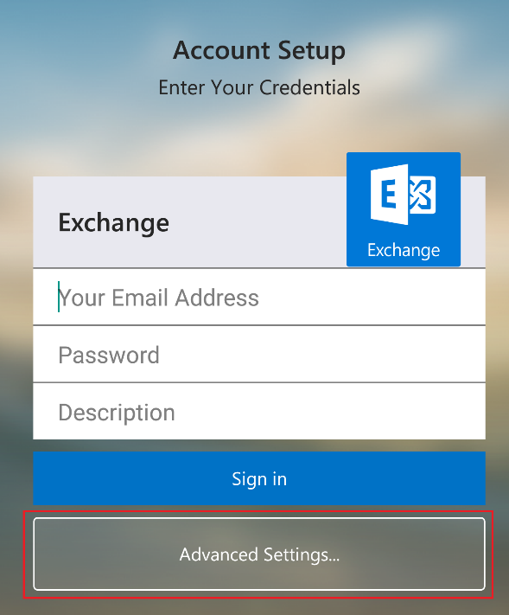

- Aesthetic and minimalist design
Prioritization comes to play when this aspect is being considered. For the designer or the developer, all the information that’s being presented on the page is relevant. The product manager needs to ask the end user if it is so. Is every information displayed on interface necessary and useful?

Google has been resisting the temptation to show more information on their search page for years. This is could be shown as the example of the best possible minimalist design.
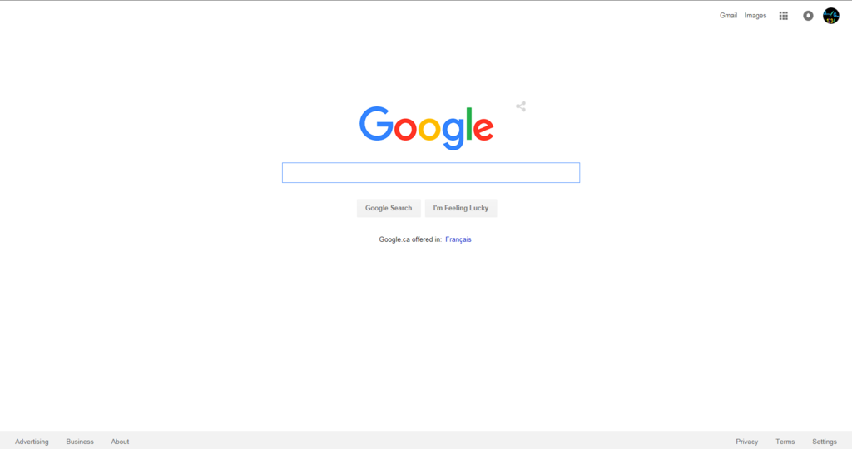

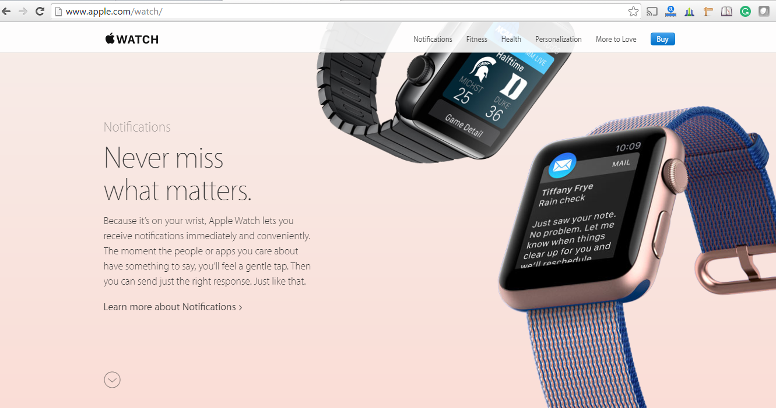
Interfaces need to be cleared of unnecessary elements and content that do not support the page goals and tasks. Apple provides only the basic information of feature hiding additional information under “Learn More”. Check the same product on a retail website to understand the importance of clutter-free experience.

- Help users recognize, diagnose, and recover from errors
Errors are inadvertent in the user journey. A check needs to be made if those errors are being explained to the user in understandable language. In the below example, I have entered a fictitious username and password and the error message I got is either the username or the password is incorrect. Here we are not informing the user if the username is invalid or if the password is wrong.

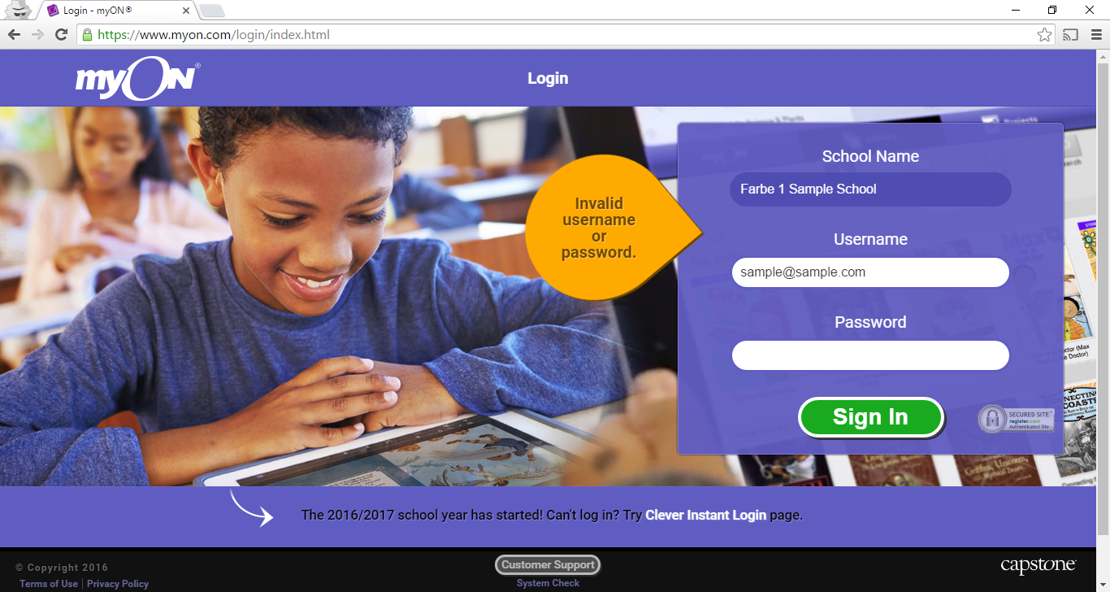

Below is the example of how MailChimp is handling this scenario:
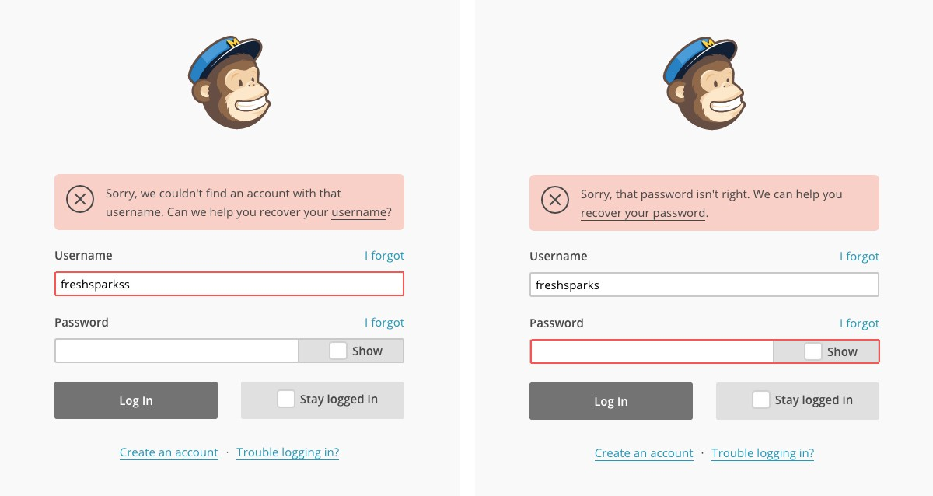

A check needs to be done if exception handling is done across the application so that relevant messages can be shown to the user. Empty state messaging, 404, 500, etc. are some examples. There is no dearth of innovative 404 pages on the web. One example is below:



- Help and documentation

If a user has reached this step, something is not right with the interface. A great user interface lets the user navigate through its features without any documentation or training. But if there is any user who could not make it out, adequate help should be provided within the product.

Below is an example of GoDaddy’s Help page. While there is a search field, there are main categories and frequently asked queries on the same page.
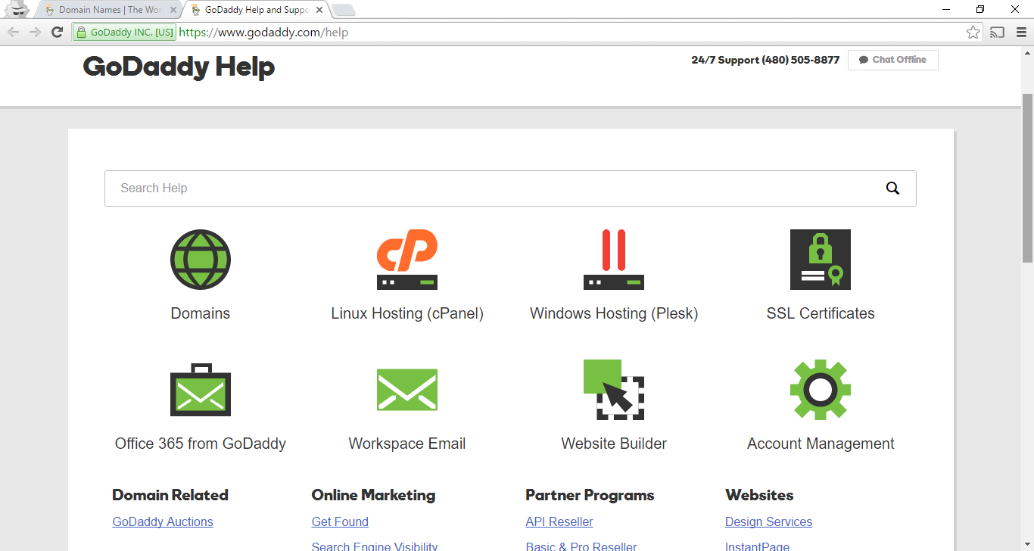

Conclusion
These rules are general dependable guidelines and will for the most part be appropriate to any web and mobile application for certain special cases. Continuously utilize your judgment to implement these standards or some other UX practices by keeping yourself from end user’s perspective.

