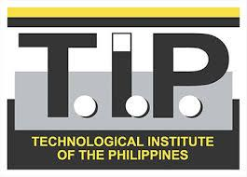
Technological Institute of the Philippines
938 Aurora Boulevard Cubao, Quezon City

ITE 010 – INTRODUCTION TO HUMAN-COMPUTER INTERACTION
Assignment 4.2 – Mobile Learning App Proposal

Members: Section: IT12S1
Buenaventura, Aristotle C.
Naval Jr, Dominador S.A

Project Title
- ChemDroid
Project Description:
- The ChemDroid gives a crucial opportunity for students to learn the core concepts of chemistry and see how those ideas apply to their lives and their general surroundings. It is the best chemistry app accessible on android. This app provides free chemistry topics, definitions, and the periodic table in your pocket. This education application is formatted for college students. Its material design with a clean interface permits students to focus on particular areas in the subject.

Modules/Screens to create:
- Splash
- Menu
- Dashboard
- Study
- Atoms, Molecules, and Ions
- Composition of Substances and Solutions
- Stoichiometry of Chemical Reactions
- Chemical Bonding and Molecular Geometry
- Gases
- Liquid and Solids
- Solutions and Colloids
- Representative Metals, Metalloids, and Nonmetals
- Periodic Table
- Flashcards
- Quizzes
- Help
- Credit
- App version
- Privacy Policy

