
Technological Institute of the Philippines
938 Aurora Boulevard Cubao, Quezon City
College of Information Technology Education

ChemDroid (Chemistry on Android)
ITE010 Final Project

In partial fulfillment for the course
ITE 010 - INTRODUCTION TO HUMAN-COMPUTER INTERACTION

Submitted by:
Buenaventura, Aristotle C.
Naval Jr, Dominador S.A

Submitted to:
Ms. Jean M. Angeles

Date Submitted:
March 11, 2021

Application Description
- The ChemDroid gives a crucial opportunity for students to learn the core concepts of chemistry and see how those ideas apply to their lives and their general surroundings. It is the best chemistry app accessible on android. This app provides free chemistry topics, definitions, exercises, flashcards, quizzes, and video tutorials in your pocket. This education application is formatted for college students. Its material design with a clean interface permits students to focus on particular areas in the subject.
Mobile Features
Flashcard
- As a learning aid, a card containing a small amount of knowledge is kept up for students to see.
Quiz
- A game or match in which you are asked questions to test your knowledge.
Video tutorials
- Computer software lessons, for example, allow for interaction and include a hands-on approach that can help reinforce the details. Instead of hearing or seeing the content, the student may use a keyboard and mouse to respond to prompts and access additional learning features.
Lectures/Lesson contents
- It is a type of oral presentation used to convey knowledge or educate people about a specific topic.
Exercises
- Something that will assist you in testing your knowledge of the subject you want to learn
Usability Principles Applied
Learnability
- The ease with which new users can begin effective interaction and achieve maximal performance
- ou can learn in our app by studying, doing exercises, taking quizzes, and watching video tutorials.
Screenshots and Description (Android)
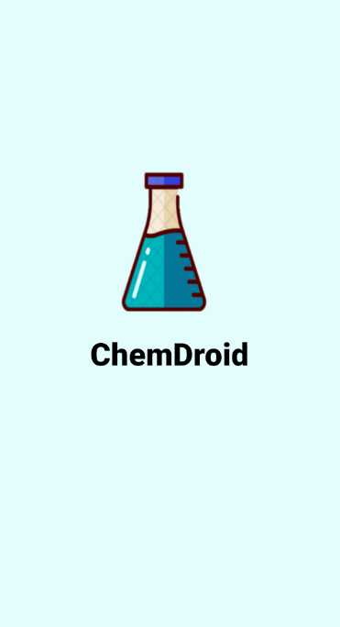
Splash, this is the first image you'll see when you open our app.
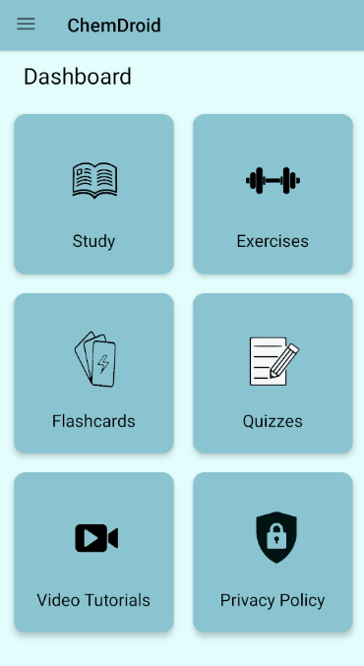
Dashboard, the main content of our mobile application
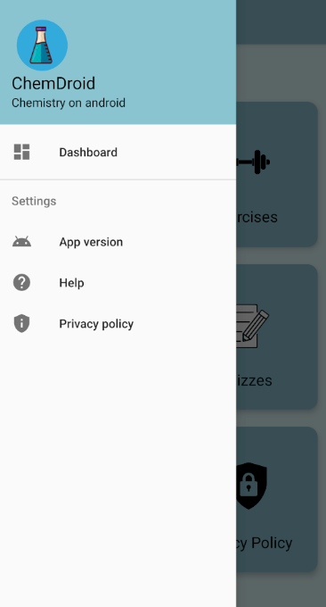
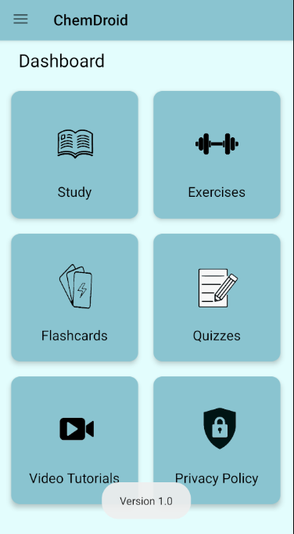
Drawer, this is where you'll find the app's settings and the dashboard menu, which will take you straight to the main content.

If you click the app version in the drawer, this is what you'll see.
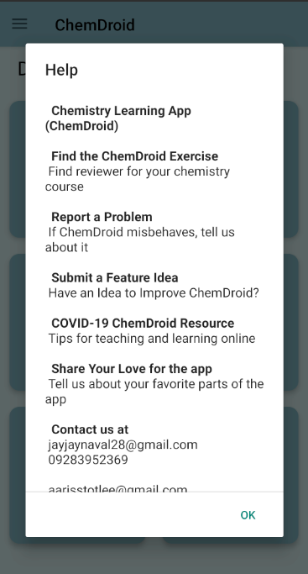
If you choose the help menu, this is what will happen. It will demonstrate the types of things you can say to us and about our app.
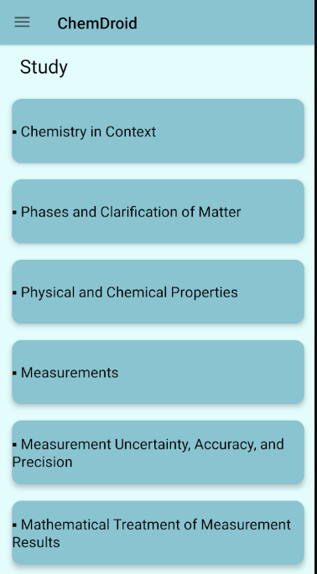

Study content, this is where you'll find the stuff you'll need to learn in order to study chemistry.

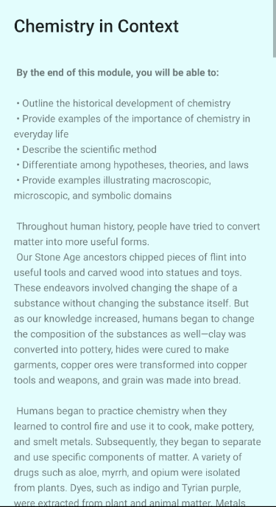
This is what you will see if you click on one of the study's content.
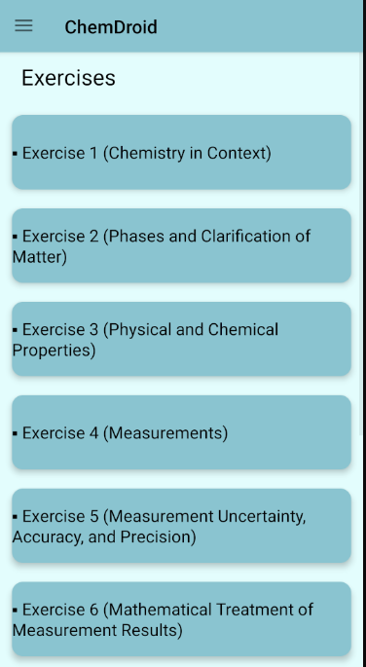
This is where you can practice answering the quiz questions in the exercise content.
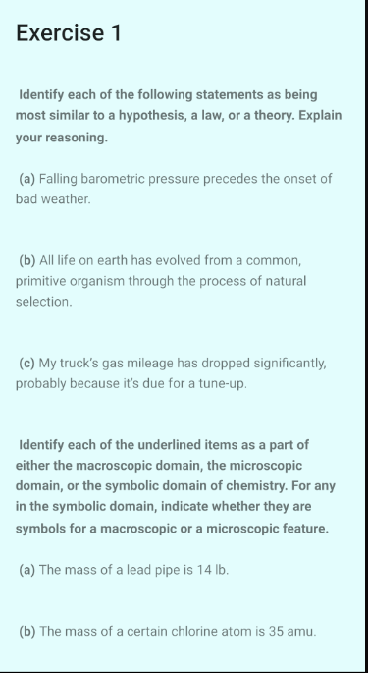
This is what you would see if you click on one of the exercise's content.
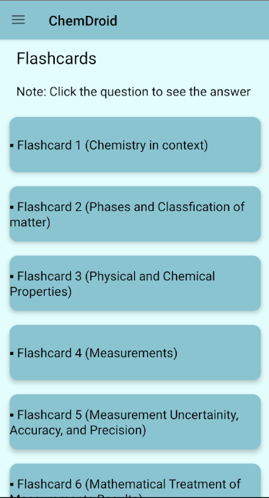
Flashcard content, this is where you can practice your knowledge and also learning the chemistry.
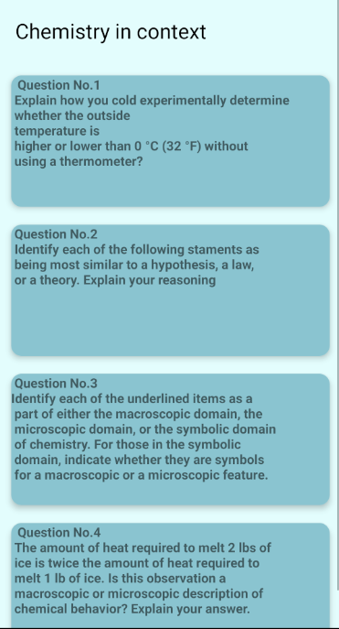
This is where you can practice your expertise while also learning the chemistry through flashcard content
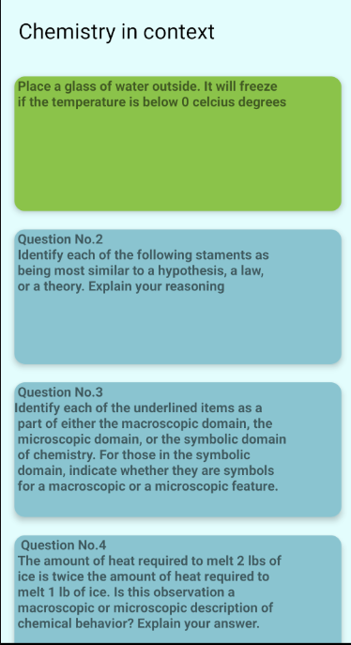
When you press one of the flashcard's questions, it will show the answer or the information you need to classify or the answer you needed.
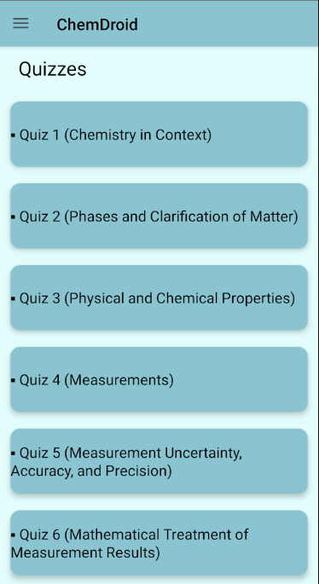
Quiz content allows you to put what you've learned in this app into effect.
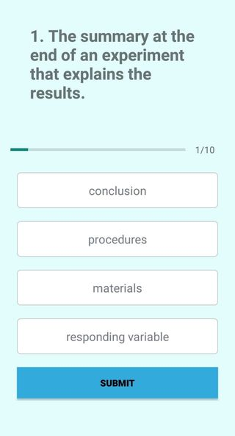
If you press one of the quiz's stuff, this is what you'll see. It will ask you a question to which you may answer.

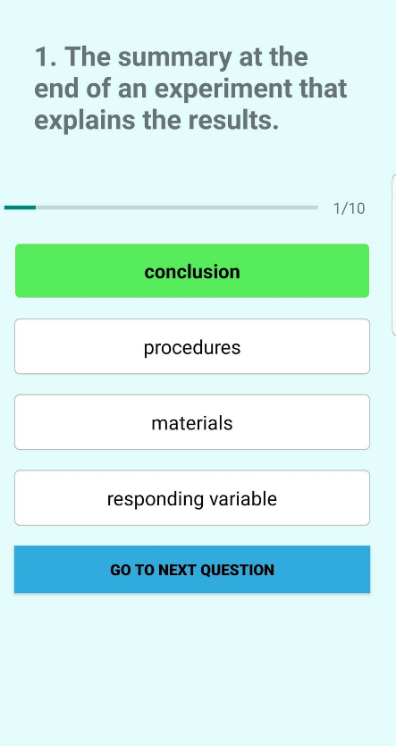
You will quickly move on to the next question if you select the correct answer, but if you select the incorrect option...
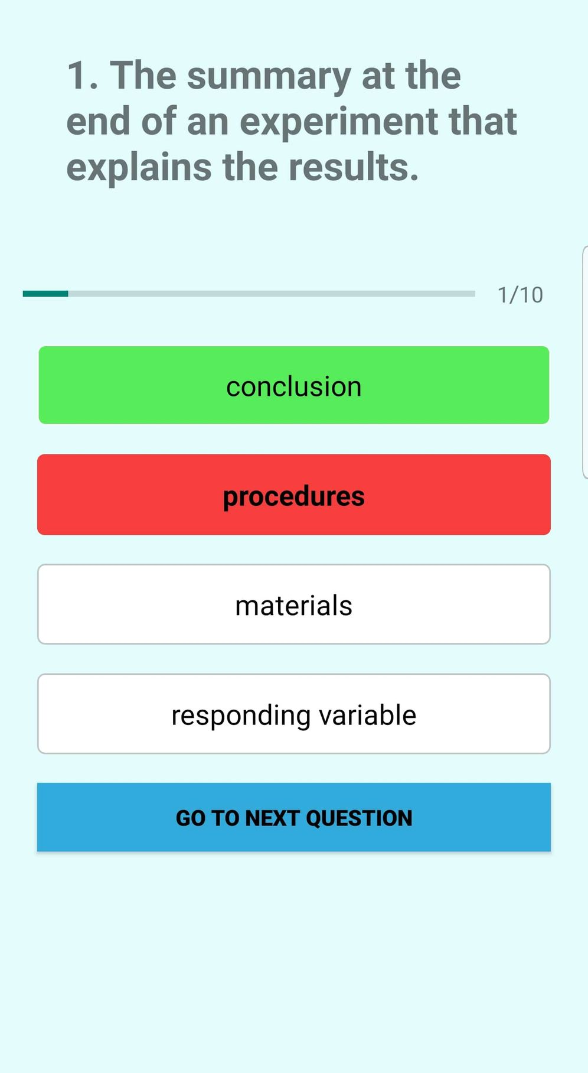
This is what will happen. The right answer will turn green and you can go to the next question.
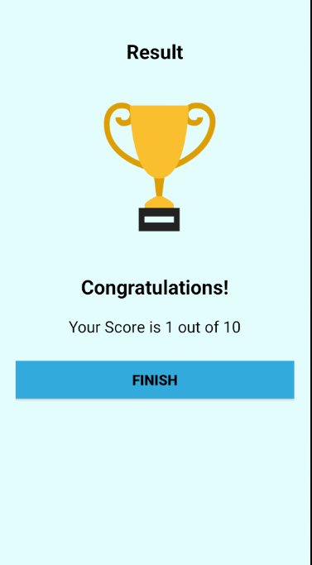
After the quiz, your score will be shown, and if you press finish, you will be returned to the main content.
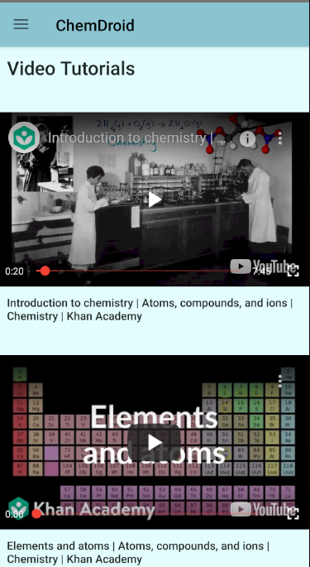

If you click on the video content, it will show a video-tutorials that will assist you in answering the quiz, exercise, and flashcard questions.
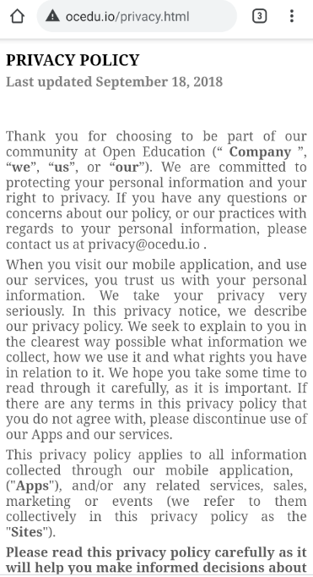

Privacy policy content, This is where you can find our ChemDroid app's privacy policy.

.

Reflection (Individual)
Buenaventura, Aristotle C.
First of all, my partner and I were struggling to find a group because we were new to the section. We’ve tried to ask some of our classmates if they have some slot for us but unfortunately, there was none. A day had passed and we still don’t have a group to join in, so, we have decided to do the project just the two of us. By the way, my partner, Naval, was also my partner way back HTML days which was in modular group one in the first semester. We knew that we can finish this subject even without the help of others. There are lots of references out there on the internet. We have used YouTube, GitHub, Stack Overflow, etc. we have gained our expertise using those sites. Knowledge of codes isn’t enough if we don’t know how to use them or what’s the best features for the users. HCI helps us to know the good and bad designs of a mobile application, we admit that our application is not that good but if we have a huge amount of time, we can add more features to this application. We are hoping that all of our sleepless nights will be paid off, all these hard works will be worth it. Someday, we can create an application better than this, thanks to our professor, Mrs. Angeles, for her unending compassion with us.

Naval Jr, Dominador S.A
- Doing this project from the start, it's making me insane because we have thought yet we don't have the foggiest idea of how to implement it. So we do a ton of research to arrive at our proposition thought. There's so numerous instructional exercise that we confronted yet not every one of them is genuine of the fact that occasionally they're accomplishing something that wrong that giving us a mistake, so we need to do another research once more, everything we do is research, watching instructional exercises to complete this project and fortunately, after struggling we figured out how to complete this task on schedule and we accomplish the recommendation that we passed and the vibe of our application that we need to execute. Because of the Lord, our family, and to you ma'am. For invigorating us, giving knowledge, that we figured out how to complete this project on schedule. After we finish this project it's another knowledge once more, and I know now how to make a mobile application and I'm glancing forward, later on, to have more insight and information, Thank you, all.

