Name: Aristotle Buenaventura  
Student no. 2013752

1.Research and watch a video that is related to latest technology used in any of the following fields:

* + biology;
  + sociology;
  + agriculture/environment;
  + education

1. Share your insights and reflection about the video.
2. Write a brief conclusion.
   * biology;

The latest technology that is related to the study of life is the Artificial Intelligence that helped to facilitate the Covid-19. It helps to track people and the spread of infections all over the world. We all know that we now have roughly 24 million Covid-19 cases, so the AI helps the government to collect all the data and information that will put in the database. AI uses migration maps, which use mobile phones, and social media to collect real-time data on the location of people. With these data, AI were developed to forecast the transmission of Covid-19.   
Sterilizing Robot was made to disinfect the area to avoid the transmission of the virus, they are not susceptible of the virus, and they have installed ultra violet light to kill viruses. They can also deliver foods and medicines.

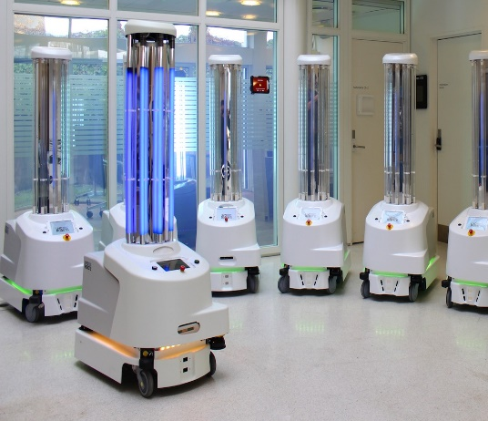I think even if the virus will be gone, we should still use this kind of technology to help our medical “frontliners” and to lessen their exposure to future viruses.

* + sociology;

Prisoners in Colorado, United States of America experienced to use Virtual Reality. They have been imprisoned since 80s and 90s so they have not experienced to use smart phone. Colorado made a program to those prisoners that qualified to early released. When they experienced the virtual reality, they were really amazed and stunned. They have seen the outside world using the virtual reality. Because they have been imprisoned, they do not know what is really happening in outside world. This is the way of Colorado to prepare the prisoners for their life after being inmates.

As a result, we could also do that kind of treatment here in the Philippines. We all know that a lot of prisoners here in the Philippines were sentenced for more than a decade, so they need to know how they will interact to outside world when they released.

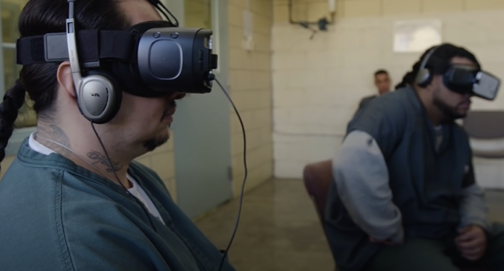

* + agriculture/environment;

Drone technology is an extraordinary innovation in transforming our lives and the way we do business. Farmers seems to accept the fact that they need the technology to help them to grow their crops perfectly. They turn farming into modern farming using drone to spray the plants and monitor the planting processes. Farmers do not need to walk out into the middle of the field just to see if their crops are ready to harvest. Drones can also do mapping and 3d modeling, this is helpful for farmers to check and see how the crops are changing over time.

For this reason, farmers really need to use technology in their farming so that they can compete with other countries in terms of productions. More product to produce, the cheaper the goods. Using of drones is securing the quality of product, and if 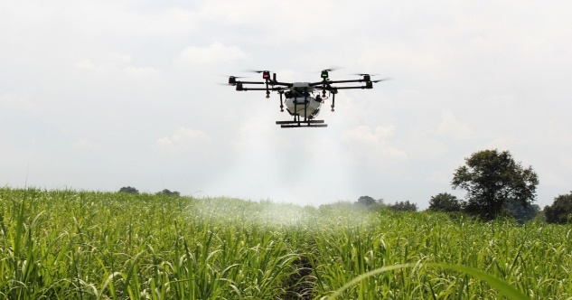the quality is good, more customers will be attracted.

* + education

Covid-19 is ubiquitous that’s why a lot of schools are closed, Virtual education helps students and teachers to cope to this pandemic. Classes take place outside of a physical school building. This method of teaching will help the students to complete courses at home using online content, including videos of instructors in front of an actual class.

As a student who use Virtual education, it really helps me to continue my studies. I can still manage to study even without seeing my teachers and friends personally. The feeling of studying in school and at home is the same, the only difference is I sit in front of a computer for the whole lecture.

# References

ColdFusion. (2020, April 13). COVID-19 - How Tech is Helping. Retrieved from Youtube: https://www.youtube.com/watch?v=KEG_sQrXtzE

Influence, A. (2019, September 10). Why Should You Use a Drone on Your Farm? Retrieved from Youtube: https://www.youtube.com/watch?v=UbtHIUXQoCM

Jazeera, A. (2020, March 16). Coronavirus: Moving to virtual learning exposes deep divide. Retrieved from Youtube: https://www.youtube.com/watch?v=TTndaVo3C0g&t=42s

Vice. (2020, February 1). New VR System Has Prisoners Practicing Life Beyond Bars. Retrieved from Youtube: https://www.youtube.com/watch?v=wpFikLVAlSM