Name: Aristotle C. Buenaventura  
Student no. 2013752  
Program: BSIT

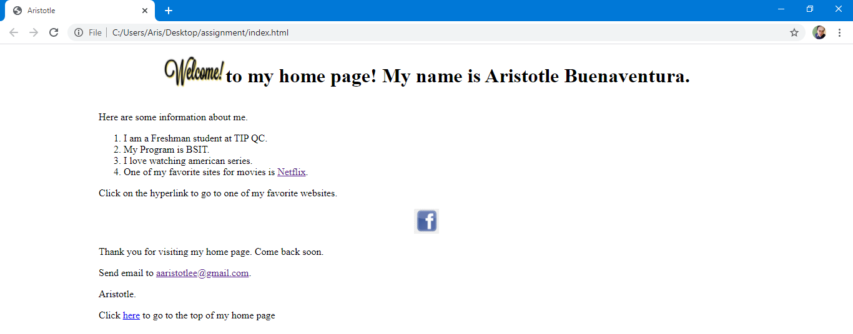Website:

HTML codes

<!DOCTYPE html>

<html>

<head>

<meta charset="utf-8">

<title>Aristotle</title>

<style>

.center {

display: flex;

align-items: center;

justify-content: center;

}

.indent {

padding-left: 150px;

}

</style>

</head>

<body>

<div class="center">

<div>

<img src="welcome.png" alt="Welcome Picture" width="100" height="80">

</div>

<div id="top">

<h1>to my home page! My name is Aristotle Buenaventura.</h1>

</div>

</div>

<div class="indent">

<p> Here are some information about me.</p>

<ol>

<li>I am a Freshman student at TIP QC.</li>

<li>My Program is BSIT.</li>

<li>I love watching american series.</li>

<li>One of my favorite sites for movies is <a href="http://www.netflix.com" target="_blank">Netflix</a>.</li>

</ol>

<p> Click on the hyperlink to go to one of my favorite websites.</p>

</div>

<div class="center">

<a href="http://www.facebook.com" target="_blank"><img src="facebook.jpg" alt="facebook logo" width="40" height="40"></a>

</div>

<div class="indent">

<p>Thank you for visiting my home page. Come back soon.</p>

<p>Send email to <a href="https://mail.google.com/" target="_blank">aaristotlee@gmail.com</a>.</p>

<p>Aristotle.</p>

<p>Click <a href="#top">here</a> to go to the top of my home page</p>

</div>

</body>

</html>