Name: Aristotle Buenaventura  
Student no: 2013752  
Program: BSIT

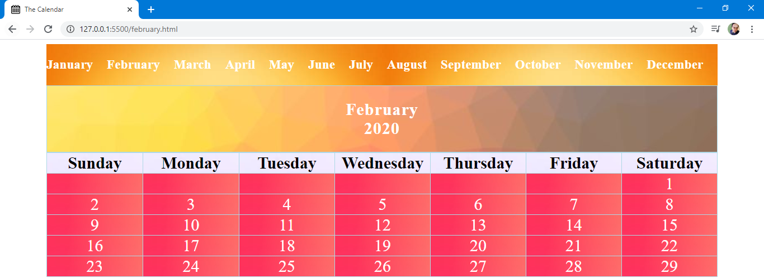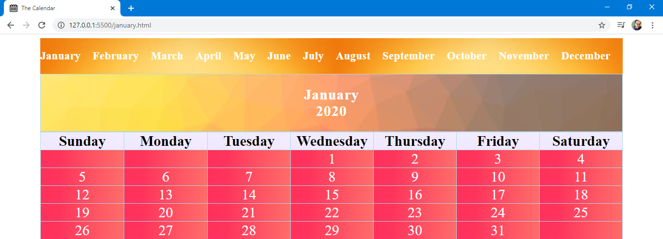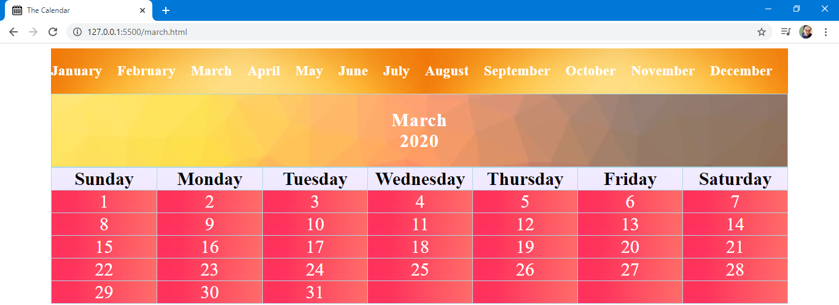**Output**

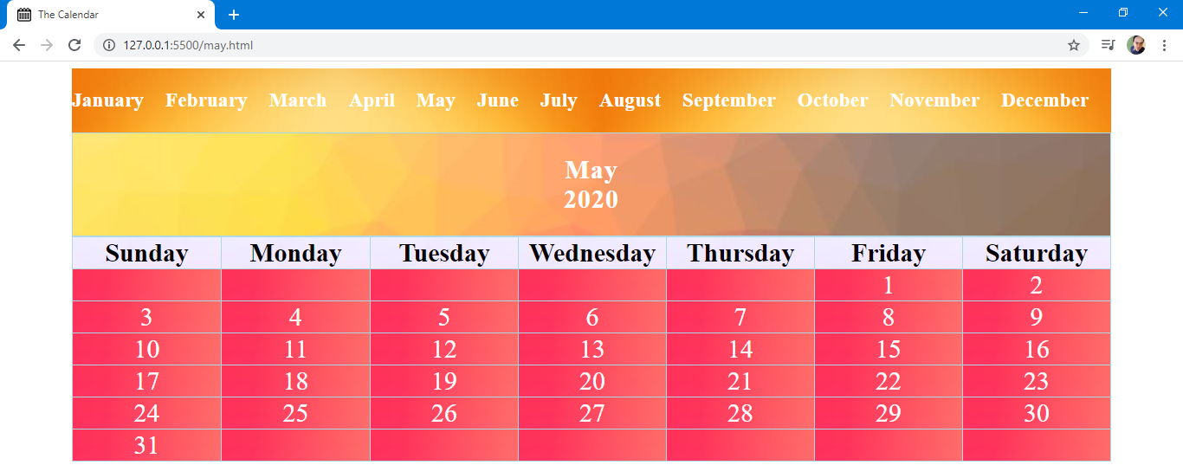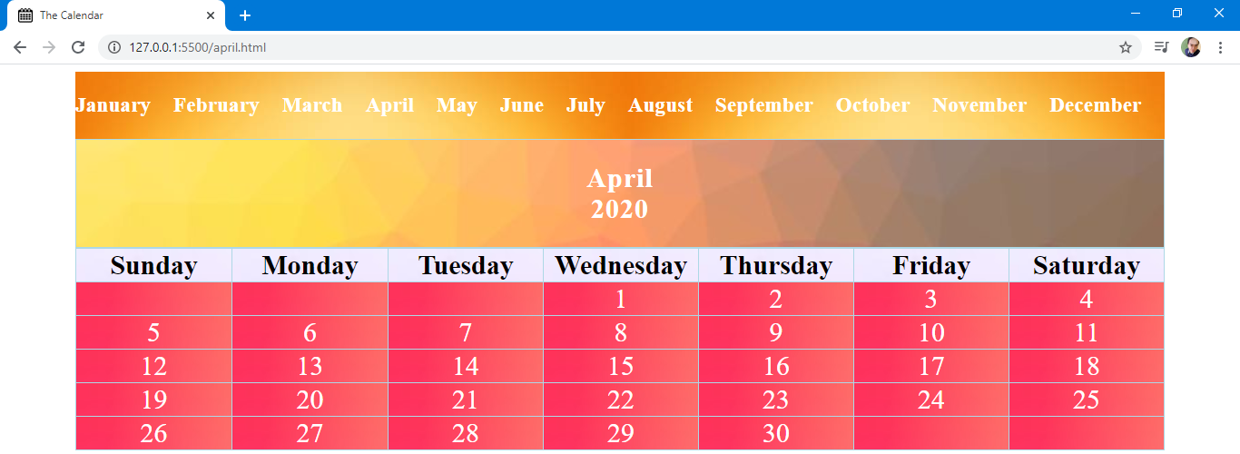

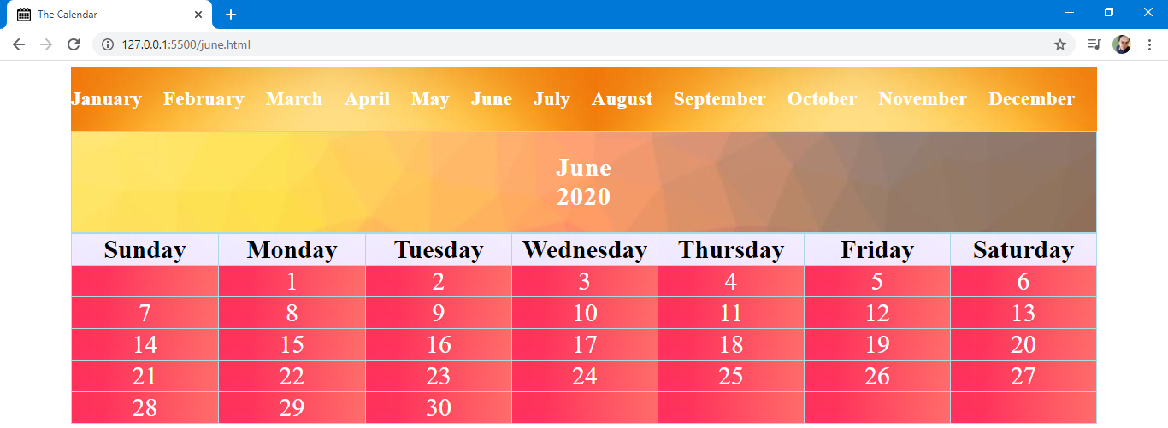

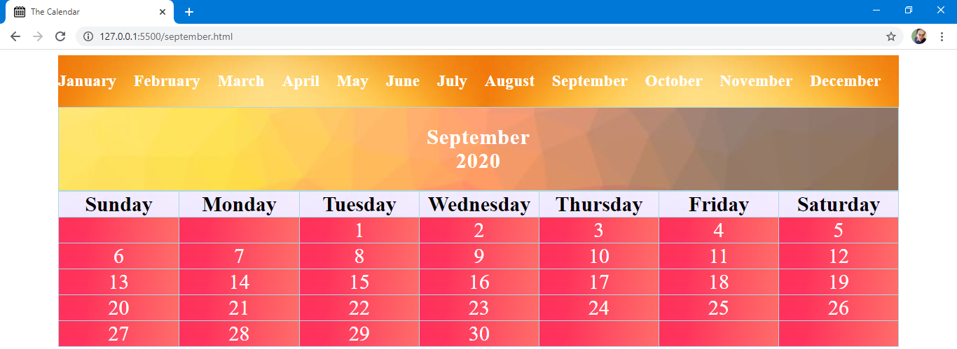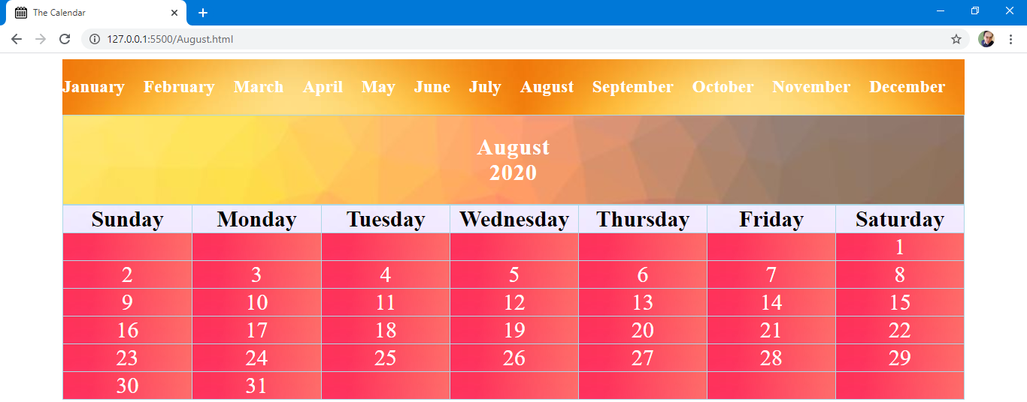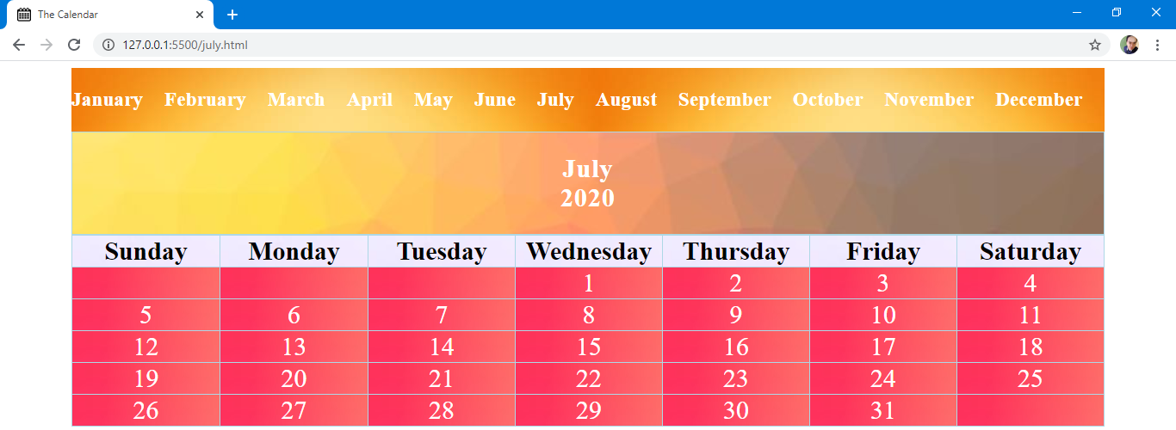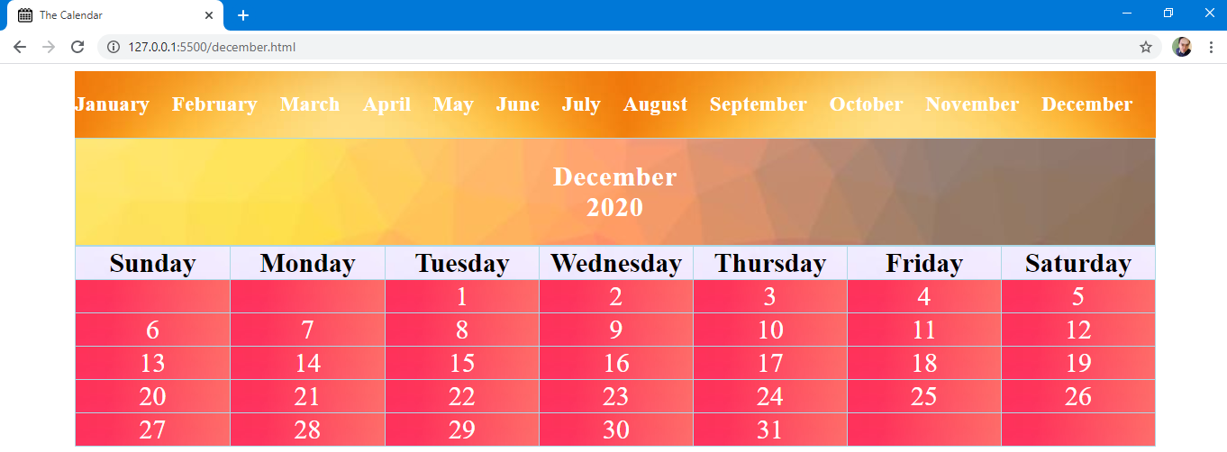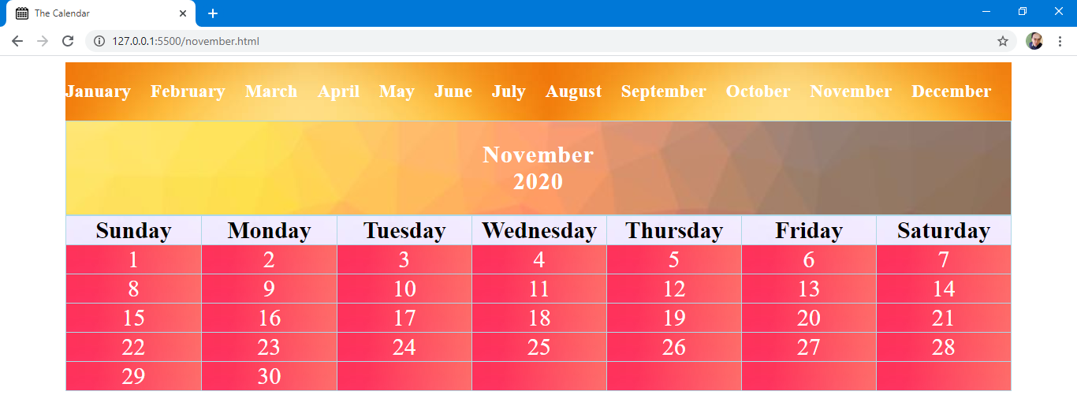  
  
  
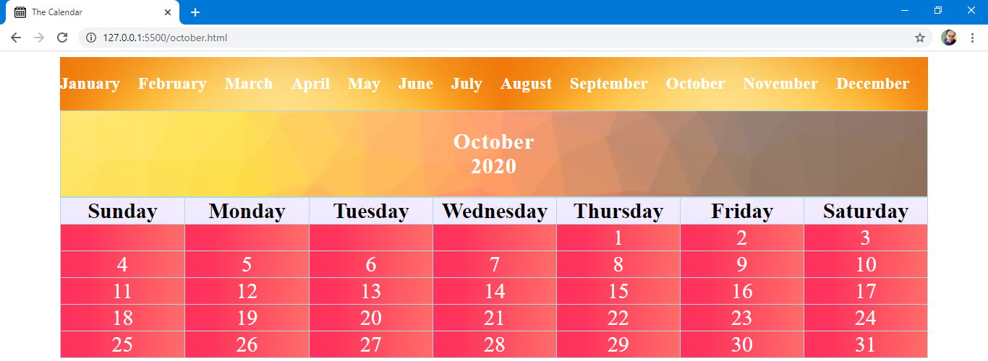

**Codes**

**January**

<!DOCTYPE html>

<html>

    <head>

        <meta charset="utf-8">

        <title>The Calendar</title>

        <meta name="viewport" content="width=device-width,initial-scale=1.0">

        <link rel="icon" href="calendar.jpg" type="image/gif" sizes="16x16">

        <style>

            body {

            background-color: white;

            }

            .container {

                max-width: 1200px;

                margin: auto;

                font-size: 30px;

            }

            .month {

                text-align: center;

                background-image: url(bg.jpeg);

                background-repeat: no-repeat;

                background-size: cover;

                letter-spacing: 1px;

                color: white;

                padding: 25px;

                border: 1px solid lightblue;

            }

            table, th, td {

                width: 100%;

                table-layout: fixed;

                text-align: center;

                border-collapse: collapse;

                border: 1px solid lightblue;

                color:black;

            }

            th {

                background-image: url(bgday.jpg);

            }

            td {

                background-image: url(bgdates.jpg);

                color: white;

            }

            td:hover {

                color: black;

            }

            .navbar {

                display: block;

                max-width: 1200px;

                margin: auto;

                background-image: url(bgmonth.jpg);

            }

            .horizontal-link {

                display: flex;

            }

            .months {

                padding-right: 24.8px;

            }

            a {

                color: white;

                max-width: 1200px;

                text-decoration: none;

                font-size: 20px;

            }

        </style>

    </head>

    <body>

        <div class="navbar">

            <section class="horizontal-link">

                <a href="january.html">

                    <div class="months">

                        <h3>January</h3>

                    </div>

                </a>

                <a href="february.html">

                    <div class="months">

                        <h3>February</h3>

                    </div>

                </a>

                <a href="march.html">

                    <div class="months">

                        <h3>March</h3>

                    </div>

                </a>

                <a href="april.html">

                    <div class="months">

                        <h3>April</h3>

                    </div>

                </a>

                <a href="may.html">

                    <div class="months">

                        <h3>May</h3>

                    </div>

                </a>

                <a href="june.html">

                    <div class="months">

                        <h3>June</h3>

                    </div>

                </a>

                <a href="july.html">

                    <div class="months">

                        <h3>July</h3>

                    </div>

                </a>

                <a href="August.html">

                    <div class="months">

                        <h3>August</h3>

                    </div>

                </a>

                <a href="september.html">

                    <div class="months">

                        <h3>September</h3>

                    </div>

                </a>

                <a href="october.html">

                    <div class="months">

                        <h3>October</h3>

                    </div>

                </a>

                <a href="november.html">

                    <div class="months">

                        <h3>November</h3>

                    </div>

                </a>

                <a href="december.html">

                    <div class="months">

                        <h3>December</h3>

                    </div>

                </a>

            </section>

        <div class="container">

            <div class="month">

                <strong>January</strong>

                <br>

                <strong>2020</strong>

            </div>

                <table>

                    <tr>

                        <th>Sunday</th>

                        <th>Monday</th>

                        <th>Tuesday</th>

                        <th>Wednesday</th>

                        <th>Thursday</th>

                        <th>Friday</th>

                        <th>Saturday</th>

                    </tr>

                    <tr>

                        <td></td>

                        <td></td>

                        <td></td>

                        <td>1</td>

                        <td>2</td>

                        <td>3</td>

                        <td>4</td>

                    </tr>

                    <tr>

                        <td>5</td>

                        <td>6</td>

                        <td>7</td>

                        <td>8</td>

                        <td>9</td>

                        <td>10</td>

                        <td>11</td>

                    </tr>

                    <tr>

                        <td>12</td>

                        <td>13</td>

                        <td>14</td>

                        <td>15</td>

                        <td>16</td>

                        <td>17</td>

                        <td>18</td>

                    </tr>

                    <tr>

                        <td>19</td>

                        <td>20</td>

                        <td>21</td>

                        <td>22</td>

                        <td>23</td>

                        <td>24</td>

                        <td>25</td>

                    </tr>

                    <tr>

                        <td>26</td>

                        <td>27</td>

                        <td>28</td>

                        <td>29</td>

                        <td>30</td>

                        <td>31</td>

                        <td></td>

                    </tr>

                </table>

        </div>

    </body>

</html>

**February**

<!DOCTYPE html>

<html>

    <head>

        <meta charset="utf-8">

        <title>The Calendar</title>

        <meta name="viewport" content="width=device-width,initial-scale=1.0">

        <link rel="icon" href="calendar.jpg" type="image/gif" sizes="16x16">

        <style>

            body {

            background-color: white;

            }

            .container {

                max-width: 1200px;

                margin: auto;

                font-size: 30px;

            }

            .month {

                text-align: center;

                background-image: url(bg.jpeg);

                background-repeat: no-repeat;

                background-size: cover;

                letter-spacing: 1px;

                color: white;

                padding: 25px;

                border: 1px solid lightblue;

            }

            table, th, td {

                width: 100%;

                table-layout: fixed;

                text-align: center;

                border-collapse: collapse;

                border: 1px solid lightblue;

                color:black;

            }

            th {

                background-image: url(bgday.jpg);

            }

            td {

                background-image: url(bgdates.jpg);

                color: white;

            }

            td:hover {

                color: black;

            }

            .navbar {

                display: block;

                max-width: 1200px;

                margin: auto;

                background-image: url(bgmonth.jpg);

            }

            .horizontal-link {

                display: flex;

            }

            .months {

                padding-right: 24.8px;

            }

            a {

                color: white;

                max-width: 1200px;

                text-decoration: none;

                font-size: 20px;

            }

        </style>

    </head>

    <body>

        <div class="navbar">

            <section class="horizontal-link">

                <a href="january.html">

                    <div class="months">

                        <h3>January</h3>

                    </div>

                </a>

                <a href="february.html">

                    <div class="months">

                        <h3>February</h3>

                    </div>

                </a>

                <a href="march.html">

                    <div class="months">

                        <h3>March</h3>

                    </div>

                </a>

                <a href="april.html">

                    <div class="months">

                        <h3>April</h3>

                    </div>

                </a>

                <a href="may.html">

                    <div class="months">

                        <h3>May</h3>

                    </div>

                </a>

                <a href="june.html">

                    <div class="months">

                        <h3>June</h3>

                    </div>

                </a>

                <a href="july.html">

                    <div class="months">

                        <h3>July</h3>

                    </div>

                </a>

                <a href="August.html">

                    <div class="months">

                        <h3>August</h3>

                    </div>

                </a>

                <a href="september.html">

                    <div class="months">

                        <h3>September</h3>

                    </div>

                </a>

                <a href="october.html">

                    <div class="months">

                        <h3>October</h3>

                    </div>

                </a>

                <a href="november.html">

                    <div class="months">

                        <h3>November</h3>

                    </div>

                </a>

                <a href="december.html">

                    <div class="months">

                        <h3>December</h3>

                    </div>

                </a>

            </section>

        <div class="container">

            <div class="month">

                <strong>February</strong>

                <br>

                <strong>2020</strong>

            </div>

                <table>

                    <tr>

                        <th>Sunday</th>

                        <th>Monday</th>

                        <th>Tuesday</th>

                        <th>Wednesday</th>

                        <th>Thursday</th>

                        <th>Friday</th>

                        <th>Saturday</th>

                    </tr>

                    <tr>

                        <td></td>

                        <td></td>

                        <td></td>

                        <td></td>

                        <td></td>

                        <td></td>

                        <td>1</td>

                    </tr>

                    <tr>

                        <td>2</td>

                        <td>3</td>

                        <td>4</td>

                        <td>5</td>

                        <td>6</td>

                        <td>7</td>

                        <td>8</td>

                    </tr>

                    <tr>

                        <td>9</td>

                        <td>10</td>

                        <td>11</td>

                        <td>12</td>

                        <td>13</td>

                        <td>14</td>

                        <td>15</td>

                    </tr>

                    <tr>

                        <td>16</td>

                        <td>17</td>

                        <td>18</td>

                        <td>19</td>

                        <td>20</td>

                        <td>21</td>

                        <td>22</td>

                    </tr>

                    <tr>

                        <td>23</td>

                        <td>24</td>

                        <td>25</td>

                        <td>26</td>

                        <td>27</td>

                        <td>28</td>

                        <td>29</td>

                    </tr>

                </table>

        </div>

    </body>

</html>

**March**

<!DOCTYPE html>

<html>

    <head>

        <meta charset="utf-8">

        <title>The Calendar</title>

        <meta name="viewport" content="width=device-width,initial-scale=1.0">

        <link rel="icon" href="calendar.jpg" type="image/gif" sizes="16x16">

        <style>

            body {

            background-color: white;

            }

            .container {

                max-width: 1200px;

                margin: auto;

                font-size: 30px;

            }

            .month {

                text-align: center;

                background-image: url(bg.jpeg);

                background-repeat: no-repeat;

                background-size: cover;

                letter-spacing: 1px;

                color: white;

                padding: 25px;

                border: 1px solid lightblue;

            }

            table, th, td {

                width: 100%;

                table-layout: fixed;

                text-align: center;

                border-collapse: collapse;

                border: 1px solid lightblue;

                color:black;

            }

            th {

                background-image: url(bgday.jpg);

            }

            td {

                background-image: url(bgdates.jpg);

                color: white;

            }

            td:hover {

                color: black;

            }

            .navbar {

                display: block;

                max-width: 1200px;

                margin: auto;

                background-image: url(bgmonth.jpg);

            }

            .horizontal-link {

                display: flex;

            }

            .months {

                padding-right: 24.8px;

            }

            a {

                color: white;

                max-width: 1200px;

                text-decoration: none;

                font-size: 20px;

            }

        </style>

    </head>

    <body>

        <div class="navbar">

            <section class="horizontal-link">

                <a href="january.html">

                    <div class="months">

                        <h3>January</h3>

                    </div>

                </a>

                <a href="february.html">

                    <div class="months">

                        <h3>February</h3>

                    </div>

                </a>

                <a href="march.html">

                    <div class="months">

                        <h3>March</h3>

                    </div>

                </a>

                <a href="april.html">

                    <div class="months">

                        <h3>April</h3>

                    </div>

                </a>

                <a href="may.html">

                    <div class="months">

                        <h3>May</h3>

                    </div>

                </a>

                <a href="june.html">

                    <div class="months">

                        <h3>June</h3>

                    </div>

                </a>

                <a href="july.html">

                    <div class="months">

                        <h3>July</h3>

                    </div>

                </a>

                <a href="August.html">

                    <div class="months">

                        <h3>August</h3>

                    </div>

                </a>

                <a href="september.html">

                    <div class="months">

                        <h3>September</h3>

                    </div>

                </a>

                <a href="october.html">

                    <div class="months">

                        <h3>October</h3>

                    </div>

                </a>

                <a href="november.html">

                    <div class="months">

                        <h3>November</h3>

                    </div>

                </a>

                <a href="december.html">

                    <div class="months">

                        <h3>December</h3>

                    </div>

                </a>

            </section>

        <div class="container">

            <div class="month">

                <strong>March</strong>

                <br>

                <strong>2020</strong>

            </div>

                <table>

                    <tr>

                        <th>Sunday</th>

                        <th>Monday</th>

                        <th>Tuesday</th>

                        <th>Wednesday</th>

                        <th>Thursday</th>

                        <th>Friday</th>

                        <th>Saturday</th>

                    </tr>

                    <tr>

                        <td>1</td>

                        <td>2</td>

                        <td>3</td>

                        <td>4</td>

                        <td>5</td>

                        <td>6</td>

                        <td>7</td>

                    </tr>

                    <tr>

                        <td>8</td>

                        <td>9</td>

                        <td>10</td>

                        <td>11</td>

                        <td>12</td>

                        <td>13</td>

                        <td>14</td>

                    </tr>

                    <tr>

                        <td>15</td>

                        <td>16</td>

                        <td>17</td>

                        <td>18</td>

                        <td>19</td>

                        <td>20</td>

                        <td>21</td>

                    </tr>

                    <tr>

                        <td>22</td>

                        <td>23</td>

                        <td>24</td>

                        <td>25</td>

                        <td>26</td>

                        <td>27</td>

                        <td>28</td>

                    </tr>

                    <tr>

                        <td>29</td>

                        <td>30</td>

                        <td>31</td>

                        <td></td>

                        <td></td>

                        <td></td>

                        <td></td>

                    </tr>

                </table>

        </div>

    </body>

</html>

**April**

<!DOCTYPE html>

<html>

    <head>

        <meta charset="utf-8">

        <title>The Calendar</title>

        <meta name="viewport" content="width=device-width,initial-scale=1.0">

        <link rel="icon" href="calendar.jpg" type="image/gif" sizes="16x16">

        <style>

            body {

            background-color: white;

            }

            .container {

                max-width: 1200px;

                margin: auto;

                font-size: 30px;

            }

            .month {

                text-align: center;

                background-image: url(bg.jpeg);

                background-repeat: no-repeat;

                background-size: cover;

                letter-spacing: 1px;

                color: white;

                padding: 25px;

                border: 1px solid lightblue;

            }

            table, th, td {

                width: 100%;

                table-layout: fixed;

                text-align: center;

                border-collapse: collapse;

                border: 1px solid lightblue;

                color:black;

            }

            th {

                background-image: url(bgday.jpg);

            }

            td {

                background-image: url(bgdates.jpg);

                color: white;

            }

            td:hover {

                color: black;

            }

            .navbar {

                display: block;

                max-width: 1200px;

                margin: auto;

                background-image: url(bgmonth.jpg);

            }

            .horizontal-link {

                display: flex;

            }

            .months {

                padding-right: 24.8px;

            }

            a {

                color: white;

                max-width: 1200px;

                text-decoration: none;

                font-size: 20px;

            }

        </style>

    </head>

    <body>

        <div class="navbar">

            <section class="horizontal-link">

                <a href="january.html">

                    <div class="months">

                        <h3>January</h3>

                    </div>

                </a>

                <a href="february.html">

                    <div class="months">

                        <h3>February</h3>

                    </div>

                </a>

                <a href="march.html">

                    <div class="months">

                        <h3>March</h3>

                    </div>

                </a>

                <a href="april.html">

                    <div class="months">

                        <h3>April</h3>

                    </div>

                </a>

                <a href="may.html">

                    <div class="months">

                        <h3>May</h3>

                    </div>

                </a>

                <a href="june.html">

                    <div class="months">

                        <h3>June</h3>

                    </div>

                </a>

                <a href="july.html">

                    <div class="months">

                        <h3>July</h3>

                    </div>

                </a>

                <a href="August.html">

                    <div class="months">

                        <h3>August</h3>

                    </div>

                </a>

                <a href="september.html">

                    <div class="months">

                        <h3>September</h3>

                    </div>

                </a>

                <a href="october.html">

                    <div class="months">

                        <h3>October</h3>

                    </div>

                </a>

                <a href="november.html">

                    <div class="months">

                        <h3>November</h3>

                    </div>

                </a>

                <a href="december.html">

                    <div class="months">

                        <h3>December</h3>

                    </div>

                </a>

            </section>

        <div class="container">

            <div class="month">

                <strong>April</strong>

                <br>

                <strong>2020</strong>

            </div>

                <table>

                    <tr>

                        <th>Sunday</th>

                        <th>Monday</th>

                        <th>Tuesday</th>

                        <th>Wednesday</th>

                        <th>Thursday</th>

                        <th>Friday</th>

                        <th>Saturday</th>

                    </tr>

                    <tr>

                        <td></td>

                        <td></td>

                        <td></td>

                        <td>1</td>

                        <td>2</td>

                        <td>3</td>

                        <td>4</td>

                    </tr>

                    <tr>

                        <td>5</td>

                        <td>6</td>

                        <td>7</td>

                        <td>8</td>

                        <td>9</td>

                        <td>10</td>

                        <td>11</td>

                    </tr>

                    <tr>

                        <td>12</td>

                        <td>13</td>

                        <td>14</td>

                        <td>15</td>

                        <td>16</td>

                        <td>17</td>

                        <td>18</td>

                    </tr>

                    <tr>

                        <td>19</td>

                        <td>20</td>

                        <td>21</td>

                        <td>22</td>

                        <td>23</td>

                        <td>24</td>

                        <td>25</td>

                    </tr>

                    <tr>

                        <td>26</td>

                        <td>27</td>

                        <td>28</td>

                        <td>29</td>

                        <td>30</td>

                        <td></td>

                        <td></td>

                    </tr>

                </table>

        </div>

    </body>

</html>

**May**

<!DOCTYPE html>

<html>

    <head>

        <meta charset="utf-8">

        <title>The Calendar</title>

        <meta name="viewport" content="width=device-width,initial-scale=1.0">

        <link rel="icon" href="calendar.jpg" type="image/gif" sizes="16x16">

        <style>

            body {

            background-color: white;

            }

            .container {

                max-width: 1200px;

                margin: auto;

                font-size: 30px;

            }

            .month {

                text-align: center;

                background-image: url(bg.jpeg);

                background-repeat: no-repeat;

                background-size: cover;

                letter-spacing: 1px;

                color: white;

                padding: 25px;

                border: 1px solid lightblue;

            }

            table, th, td {

                width: 100%;

                table-layout: fixed;

                text-align: center;

                border-collapse: collapse;

                border: 1px solid lightblue;

                color:black;

            }

            th {

                background-image: url(bgday.jpg);

            }

            td {

                background-image: url(bgdates.jpg);

                color: white;

            }

            td:hover {

                color: black;

            }

            .navbar {

                display: block;

                max-width: 1200px;

                margin: auto;

                background-image: url(bgmonth.jpg);

            }

            .horizontal-link {

                display: flex;

            }

            .months {

                padding-right: 24.8px;

            }

            a {

                color: white;

                max-width: 1200px;

                text-decoration: none;

                font-size: 20px;

            }

        </style>

    </head>

    <body>

        <div class="navbar">

            <section class="horizontal-link">

                <a href="january.html">

                    <div class="months">

                        <h3>January</h3>

                    </div>

                </a>

                <a href="february.html">

                    <div class="months">

                        <h3>February</h3>

                    </div>

                </a>

                <a href="march.html">

                    <div class="months">

                        <h3>March</h3>

                    </div>

                </a>

                <a href="april.html">

                    <div class="months">

                        <h3>April</h3>

                    </div>

                </a>

                <a href="may.html">

                    <div class="months">

                        <h3>May</h3>

                    </div>

                </a>

                <a href="june.html">

                    <div class="months">

                        <h3>June</h3>

                    </div>

                </a>

                <a href="july.html">

                    <div class="months">

                        <h3>July</h3>

                    </div>

                </a>

                <a href="August.html">

                    <div class="months">

                        <h3>August</h3>

                    </div>

                </a>

                <a href="september.html">

                    <div class="months">

                        <h3>September</h3>

                    </div>

                </a>

                <a href="october.html">

                    <div class="months">

                        <h3>October</h3>

                    </div>

                </a>

                <a href="november.html">

                    <div class="months">

                        <h3>November</h3>

                    </div>

                </a>

                <a href="december.html">

                    <div class="months">

                        <h3>December</h3>

                    </div>

                </a>

            </section>

        <div class="container">

            <div class="month">

                <strong>May</strong>

                <br>

                <strong>2020</strong>

            </div>

                <table>

                    <tr>

                        <th>Sunday</th>

                        <th>Monday</th>

                        <th>Tuesday</th>

                        <th>Wednesday</th>

                        <th>Thursday</th>

                        <th>Friday</th>

                        <th>Saturday</th>

                    </tr>

                    <tr>

                        <td></td>

                        <td></td>

                        <td></td>

                        <td></td>

                        <td></td>

                        <td>1</td>

                        <td>2</td>

                    </tr>

                    <tr>

                        <td>3</td>

                        <td>4</td>

                        <td>5</td>

                        <td>6</td>

                        <td>7</td>

                        <td>8</td>

                        <td>9</td>

                    </tr>

                    <tr>

                        <td>10</td>

                        <td>11</td>

                        <td>12</td>

                        <td>13</td>

                        <td>14</td>

                        <td>15</td>

                        <td>16</td>

                    </tr>

                    <tr>

                        <td>17</td>

                        <td>18</td>

                        <td>19</td>

                        <td>20</td>

                        <td>21</td>

                        <td>22</td>

                        <td>23</td>

                    </tr>

                    <tr>

                        <td>24</td>

                        <td>25</td>

                        <td>26</td>

                        <td>27</td>

                        <td>28</td>

                        <td>29</td>

                        <td>30</td>

                    </tr>

                    <tr>

                        <td>31</td>

                        <td></td>

                        <td></td>

                        <td></td>

                        <td></td>

                        <td></td>

                        <td></td>

                    </tr>

                </table>

        </div>

    </body>

</html>

**June**

<!DOCTYPE html>

<html>

    <head>

        <meta charset="utf-8">

        <title>The Calendar</title>

        <meta name="viewport" content="width=device-width,initial-scale=1.0">

        <link rel="icon" href="calendar.jpg" type="image/gif" sizes="16x16">

        <style>

            body {

            background-color: white;

            }

            .container {

                max-width: 1200px;

                margin: auto;

                font-size: 30px;

            }

            .month {

                text-align: center;

                background-image: url(bg.jpeg);

                background-repeat: no-repeat;

                background-size: cover;

                letter-spacing: 1px;

                color: white;

                padding: 25px;

                border: 1px solid lightblue;

            }

            table, th, td {

                width: 100%;

                table-layout: fixed;

                text-align: center;

                border-collapse: collapse;

                border: 1px solid lightblue;

                color:black;

            }

            th {

                background-image: url(bgday.jpg);

            }

            td {

                background-image: url(bgdates.jpg);

                color: white;

            }

            td:hover {

                color: black;

            }

            .navbar {

                display: block;

                max-width: 1200px;

                margin: auto;

                background-image: url(bgmonth.jpg);

            }

            .horizontal-link {

                display: flex;

            }

            .months {

                padding-right: 24.8px;

            }

            a {

                color: white;

                max-width: 1200px;

                text-decoration: none;

                font-size: 20px;

            }

        </style>

    </head>

    <body>

        <div class="navbar">

            <section class="horizontal-link">

                <a href="january.html">

                    <div class="months">

                        <h3>January</h3>

                    </div>

                </a>

                <a href="february.html">

                    <div class="months">

                        <h3>February</h3>

                    </div>

                </a>

                <a href="march.html">

                    <div class="months">

                        <h3>March</h3>

                    </div>

                </a>

                <a href="april.html">

                    <div class="months">

                        <h3>April</h3>

                    </div>

                </a>

                <a href="may.html">

                    <div class="months">

                        <h3>May</h3>

                    </div>

                </a>

                <a href="june.html">

                    <div class="months">

                        <h3>June</h3>

                    </div>

                </a>

                <a href="july.html">

                    <div class="months">

                        <h3>July</h3>

                    </div>

                </a>

                <a href="August.html">

                    <div class="months">

                        <h3>August</h3>

                    </div>

                </a>

                <a href="september.html">

                    <div class="months">

                        <h3>September</h3>

                    </div>

                </a>

                <a href="october.html">

                    <div class="months">

                        <h3>October</h3>

                    </div>

                </a>

                <a href="november.html">

                    <div class="months">

                        <h3>November</h3>

                    </div>

                </a>

                <a href="december.html">

                    <div class="months">

                        <h3>December</h3>

                    </div>

                </a>

            </section>

        <div class="container">

            <div class="month">

                <strong>June</strong>

                <br>

                <strong>2020</strong>

            </div>

                <table>

                    <tr>

                        <th>Sunday</th>

                        <th>Monday</th>

                        <th>Tuesday</th>

                        <th>Wednesday</th>

                        <th>Thursday</th>

                        <th>Friday</th>

                        <th>Saturday</th>

                    </tr>

                    <tr>

                        <td></td>

                        <td>1</td>

                        <td>2</td>

                        <td>3</td>

                        <td>4</td>

                        <td>5</td>

                        <td>6</td>

                    </tr>

                    <tr>

                        <td>7</td>

                        <td>8</td>

                        <td>9</td>

                        <td>10</td>

                        <td>11</td>

                        <td>12</td>

                        <td>13</td>

                    </tr>

                    <tr>

                        <td>14</td>

                        <td>15</td>

                        <td>16</td>

                        <td>17</td>

                        <td>18</td>

                        <td>19</td>

                        <td>20</td>

                    </tr>

                    <tr>

                        <td>21</td>

                        <td>22</td>

                        <td>23</td>

                        <td>24</td>

                        <td>25</td>

                        <td>26</td>

                        <td>27</td>

                    </tr>

                    <tr>

                        <td>28</td>

                        <td>29</td>

                        <td>30</td>

                        <td></td>

                        <td></td>

                        <td></td>

                        <td></td>

                    </tr>

                </table>

        </div>

    </body>

</html>

**July**

<!DOCTYPE html>

<html>

    <head>

        <meta charset="utf-8">

        <title>The Calendar</title>

        <meta name="viewport" content="width=device-width,initial-scale=1.0">

        <link rel="icon" href="calendar.jpg" type="image/gif" sizes="16x16">

        <style>

            body {

            background-color: white;

            }

            .container {

                max-width: 1200px;

                margin: auto;

                font-size: 30px;

            }

            .month {

                text-align: center;

                background-image: url(bg.jpeg);

                background-repeat: no-repeat;

                background-size: cover;

                letter-spacing: 1px;

                color: white;

                padding: 25px;

                border: 1px solid lightblue;

            }

            table, th, td {

                width: 100%;

                table-layout: fixed;

                text-align: center;

                border-collapse: collapse;

                border: 1px solid lightblue;

                color:black;

            }

            th {

                background-image: url(bgday.jpg);

            }

            td {

                background-image: url(bgdates.jpg);

                color: white;

            }

            td:hover {

                color: black;

            }

            .navbar {

                display: block;

                max-width: 1200px;

                margin: auto;

                background-image: url(bgmonth.jpg);

            }

            .horizontal-link {

                display: flex;

            }

            .months {

                padding-right: 24.8px;

            }

            a {

                color: white;

                max-width: 1200px;

                text-decoration: none;

                font-size: 20px;

            }

        </style>

    </head>

    <body>

        <div class="navbar">

            <section class="horizontal-link">

                <a href="january.html">

                    <div class="months">

                        <h3>January</h3>

                    </div>

                </a>

                <a href="february.html">

                    <div class="months">

                        <h3>February</h3>

                    </div>

                </a>

                <a href="march.html">

                    <div class="months">

                        <h3>March</h3>

                    </div>

                </a>

                <a href="april.html">

                    <div class="months">

                        <h3>April</h3>

                    </div>

                </a>

                <a href="may.html">

                    <div class="months">

                        <h3>May</h3>

                    </div>

                </a>

                <a href="june.html">

                    <div class="months">

                        <h3>June</h3>

                    </div>

                </a>

                <a href="july.html">

                    <div class="months">

                        <h3>July</h3>

                    </div>

                </a>

                <a href="August.html">

                    <div class="months">

                        <h3>August</h3>

                    </div>

                </a>

                <a href="september.html">

                    <div class="months">

                        <h3>September</h3>

                    </div>

                </a>

                <a href="october.html">

                    <div class="months">

                        <h3>October</h3>

                    </div>

                </a>

                <a href="november.html">

                    <div class="months">

                        <h3>November</h3>

                    </div>

                </a>

                <a href="december.html">

                    <div class="months">

                        <h3>December</h3>

                    </div>

                </a>

            </section>

        <div class="container">

            <div class="month">

                <strong>July</strong>

                <br>

                <strong>2020</strong>

            </div>

                <table>

                    <tr>

                        <th>Sunday</th>

                        <th>Monday</th>

                        <th>Tuesday</th>

                        <th>Wednesday</th>

                        <th>Thursday</th>

                        <th>Friday</th>

                        <th>Saturday</th>

                    </tr>

                    <tr>

                        <td></td>

                        <td></td>

                        <td></td>

                        <td>1</td>

                        <td>2</td>

                        <td>3</td>

                        <td>4</td>

                    </tr>

                    <tr>

                        <td>5</td>

                        <td>6</td>

                        <td>7</td>

                        <td>8</td>

                        <td>9</td>

                        <td>10</td>

                        <td>11</td>

                    </tr>

                    <tr>

                        <td>12</td>

                        <td>13</td>

                        <td>14</td>

                        <td>15</td>

                        <td>16</td>

                        <td>17</td>

                        <td>18</td>

                    </tr>

                    <tr>

                        <td>19</td>

                        <td>20</td>

                        <td>21</td>

                        <td>22</td>

                        <td>23</td>

                        <td>24</td>

                        <td>25</td>

                    </tr>

                    <tr>

                        <td>26</td>

                        <td>27</td>

                        <td>28</td>

                        <td>29</td>

                        <td>30</td>

                        <td>31</td>

                        <td></td>

                    </tr>

                </table>

        </div>

    </body>

</html>

**August**

<!DOCTYPE html>

<html>

    <head>

        <meta charset="utf-8">

        <title>The Calendar</title>

        <meta name="viewport" content="width=device-width,initial-scale=1.0">

        <link rel="icon" href="calendar.jpg" type="image/gif" sizes="16x16">

        <style>

            body {

            background-color: white;

            }

            .container {

                max-width: 1200px;

                margin: auto;

                font-size: 30px;

            }

            .month {

                text-align: center;

                background-image: url(bg.jpeg);

                background-repeat: no-repeat;

                background-size: cover;

                letter-spacing: 1px;

                color: white;

                padding: 25px;

                border: 1px solid lightblue;

            }

            table, th, td {

                width: 100%;

                table-layout: fixed;

                text-align: center;

                border-collapse: collapse;

                border: 1px solid lightblue;

                color:black;

            }

            th {

                background-image: url(bgday.jpg);

            }

            td {

                background-image: url(bgdates.jpg);

                color: white;

            }

            td:hover {

                color: black;

            }

            .navbar {

                display: block;

                max-width: 1200px;

                margin: auto;

                background-image: url(bgmonth.jpg);

            }

            .horizontal-link {

                display: flex;

            }

            .months {

                padding-right: 24.8px;

            }

            a {

                color: white;

                max-width: 1200px;

                text-decoration: none;

                font-size: 20px;

            }

        </style>

    </head>

    <body>

        <div class="navbar">

            <section class="horizontal-link">

                <a href="january.html">

                    <div class="months">

                        <h3>January</h3>

                    </div>

                </a>

                <a href="february.html">

                    <div class="months">

                        <h3>February</h3>

                    </div>

                </a>

                <a href="march.html">

                    <div class="months">

                        <h3>March</h3>

                    </div>

                </a>

                <a href="april.html">

                    <div class="months">

                        <h3>April</h3>

                    </div>

                </a>

                <a href="may.html">

                    <div class="months">

                        <h3>May</h3>

                    </div>

                </a>

                <a href="june.html">

                    <div class="months">

                        <h3>June</h3>

                    </div>

                </a>

                <a href="july.html">

                    <div class="months">

                        <h3>July</h3>

                    </div>

                </a>

                <a href="August.html">

                    <div class="months">

                        <h3>August</h3>

                    </div>

                </a>

                <a href="september.html">

                    <div class="months">

                        <h3>September</h3>

                    </div>

                </a>

                <a href="october.html">

                    <div class="months">

                        <h3>October</h3>

                    </div>

                </a>

                <a href="november.html">

                    <div class="months">

                        <h3>November</h3>

                    </div>

                </a>

                <a href="december.html">

                    <div class="months">

                        <h3>December</h3>

                    </div>

                </a>

            </section>

        <div class="container">

            <div class="month">

                <strong>August</strong>

                <br>

                <strong>2020</strong>

            </div>

                <table>

                    <tr>

                        <th>Sunday</th>

                        <th>Monday</th>

                        <th>Tuesday</th>

                        <th>Wednesday</th>

                        <th>Thursday</th>

                        <th>Friday</th>

                        <th>Saturday</th>

                    </tr>

                    <tr>

                        <td></td>

                        <td></td>

                        <td></td>

                        <td></td>

                        <td></td>

                        <td></td>

                        <td>1</td>

                    </tr>

                    <tr>

                        <td>2</td>

                        <td>3</td>

                        <td>4</td>

                        <td>5</td>

                        <td>6</td>

                        <td>7</td>

                        <td>8</td>

                    </tr>

                    <tr>

                        <td>9</td>

                        <td>10</td>

                        <td>11</td>

                        <td>12</td>

                        <td>13</td>

                        <td>14</td>

                        <td>15</td>

                    </tr>

                    <tr>

                        <td>16</td>

                        <td>17</td>

                        <td>18</td>

                        <td>19</td>

                        <td>20</td>

                        <td>21</td>

                        <td>22</td>

                    </tr>

                    <tr>

                        <td>23</td>

                        <td>24</td>

                        <td>25</td>

                        <td>26</td>

                        <td>27</td>

                        <td>28</td>

                        <td>29</td>

                    </tr>

                    <tr>

                        <td>30</td>

                        <td>31</td>

                        <td></td>

                        <td></td>

                        <td></td>

                        <td></td>

                        <td></td>

                    </tr>

                </table>

        </div>

    </body>

</html>

**September**

<!DOCTYPE html>

<html>

    <head>

        <meta charset="utf-8">

        <title>The Calendar</title>

        <meta name="viewport" content="width=device-width,initial-scale=1.0">

        <link rel="icon" href="calendar.jpg" type="image/gif" sizes="16x16">

        <style>

            body {

            background-color: white;

            }

            .container {

                max-width: 1200px;

                margin: auto;

                font-size: 30px;

            }

            .month {

                text-align: center;

                background-image: url(bg.jpeg);

                background-repeat: no-repeat;

                background-size: cover;

                letter-spacing: 1px;

                color: white;

                padding: 25px;

                border: 1px solid lightblue;

            }

            table, th, td {

                width: 100%;

                table-layout: fixed;

                text-align: center;

                border-collapse: collapse;

                border: 1px solid lightblue;

                color:black;

            }

            th {

                background-image: url(bgday.jpg);

            }

            td {

                background-image: url(bgdates.jpg);

                color: white;

            }

            td:hover {

                color: black;

            }

            .navbar {

                display: block;

                max-width: 1200px;

                margin: auto;

                background-image: url(bgmonth.jpg);

            }

            .horizontal-link {

                display: flex;

            }

            .months {

                padding-right: 24.8px;

            }

            a {

                color: white;

                max-width: 1200px;

                text-decoration: none;

                font-size: 20px;

            }

        </style>

    </head>

    <body>

        <div class="navbar">

            <section class="horizontal-link">

                <a href="january.html">

                    <div class="months">

                        <h3>January</h3>

                    </div>

                </a>

                <a href="february.html">

                    <div class="months">

                        <h3>February</h3>

                    </div>

                </a>

                <a href="march.html">

                    <div class="months">

                        <h3>March</h3>

                    </div>

                </a>

                <a href="april.html">

                    <div class="months">

                        <h3>April</h3>

                    </div>

                </a>

                <a href="may.html">

                    <div class="months">

                        <h3>May</h3>

                    </div>

                </a>

                <a href="june.html">

                    <div class="months">

                        <h3>June</h3>

                    </div>

                </a>

                <a href="july.html">

                    <div class="months">

                        <h3>July</h3>

                    </div>

                </a>

                <a href="August.html">

                    <div class="months">

                        <h3>August</h3>

                    </div>

                </a>

                <a href="september.html">

                    <div class="months">

                        <h3>September</h3>

                    </div>

                </a>

                <a href="october.html">

                    <div class="months">

                        <h3>October</h3>

                    </div>

                </a>

                <a href="november.html">

                    <div class="months">

                        <h3>November</h3>

                    </div>

                </a>

                <a href="december.html">

                    <div class="months">

                        <h3>December</h3>

                    </div>

                </a>

            </section>

        <div class="container">

            <div class="month">

                <strong>September</strong>

                <br>

                <strong>2020</strong>

            </div>

                <table>

                    <tr>

                        <th>Sunday</th>

                        <th>Monday</th>

                        <th>Tuesday</th>

                        <th>Wednesday</th>

                        <th>Thursday</th>

                        <th>Friday</th>

                        <th>Saturday</th>

                    </tr>

                    <tr>

                        <td></td>

                        <td></td>

                        <td>1</td>

                        <td>2</td>

                        <td>3</td>

                        <td>4</td>

                        <td>5</td>

                    </tr>

                    <tr>

                        <td>6</td>

                        <td>7</td>

                        <td>8</td>

                        <td>9</td>

                        <td>10</td>

                        <td>11</td>

                        <td>12</td>

                    </tr>

                    <tr>

                        <td>13</td>

                        <td>14</td>

                        <td>15</td>

                        <td>16</td>

                        <td>17</td>

                        <td>18</td>

                        <td>19</td>

                    </tr>

                    <tr>

                        <td>20</td>

                        <td>21</td>

                        <td>22</td>

                        <td>23</td>

                        <td>24</td>

                        <td>25</td>

                        <td>26</td>

                    </tr>

                    <tr>

                        <td>27</td>

                        <td>28</td>

                        <td>29</td>

                        <td>30</td>

                        <td></td>

                        <td></td>

                        <td></td>

                    </tr>

                </table>

        </div>

    </body>

</html>

**October**

<!DOCTYPE html>

<html>

    <head>

        <meta charset="utf-8">

        <title>The Calendar</title>

        <meta name="viewport" content="width=device-width,initial-scale=1.0">

        <link rel="icon" href="calendar.jpg" type="image/gif" sizes="16x16">

        <style>

            body {

            background-color: white;

            }

            .container {

                max-width: 1200px;

                margin: auto;

                font-size: 30px;

            }

            .month {

                text-align: center;

                background-image: url(bg.jpeg);

                background-repeat: no-repeat;

                background-size: cover;

                letter-spacing: 1px;

                color: white;

                padding: 25px;

                border: 1px solid lightblue;

            }

            table, th, td {

                width: 100%;

                table-layout: fixed;

                text-align: center;

                border-collapse: collapse;

                border: 1px solid lightblue;

                color:black;

            }

            th {

                background-image: url(bgday.jpg);

            }

            td {

                background-image: url(bgdates.jpg);

                color: white;

            }

            td:hover {

                color: black;

            }

            .navbar {

                display: block;

                max-width: 1200px;

                margin: auto;

                background-image: url(bgmonth.jpg);

            }

            .horizontal-link {

                display: flex;

            }

            .months {

                padding-right: 24.8px;

            }

            a {

                color: white;

                max-width: 1200px;

                text-decoration: none;

                font-size: 20px;

            }

        </style>

    </head>

    <body>

        <div class="navbar">

            <section class="horizontal-link">

                <a href="january.html">

                    <div class="months">

                        <h3>January</h3>

                    </div>

                </a>

                <a href="february.html">

                    <div class="months">

                        <h3>February</h3>

                    </div>

                </a>

                <a href="march.html">

                    <div class="months">

                        <h3>March</h3>

                    </div>

                </a>

                <a href="april.html">

                    <div class="months">

                        <h3>April</h3>

                    </div>

                </a>

                <a href="may.html">

                    <div class="months">

                        <h3>May</h3>

                    </div>

                </a>

                <a href="june.html">

                    <div class="months">

                        <h3>June</h3>

                    </div>

                </a>

                <a href="july.html">

                    <div class="months">

                        <h3>July</h3>

                    </div>

                </a>

                <a href="August.html">

                    <div class="months">

                        <h3>August</h3>

                    </div>

                </a>

                <a href="september.html">

                    <div class="months">

                        <h3>September</h3>

                    </div>

                </a>

                <a href="october.html">

                    <div class="months">

                        <h3>October</h3>

                    </div>

                </a>

                <a href="november.html">

                    <div class="months">

                        <h3>November</h3>

                    </div>

                </a>

                <a href="december.html">

                    <div class="months">

                        <h3>December</h3>

                    </div>

                </a>

            </section>

        <div class="container">

            <div class="month">

                <strong>October</strong>

                <br>

                <strong>2020</strong>

            </div>

                <table>

                    <tr>

                        <th>Sunday</th>

                        <th>Monday</th>

                        <th>Tuesday</th>

                        <th>Wednesday</th>

                        <th>Thursday</th>

                        <th>Friday</th>

                        <th>Saturday</th>

                    </tr>

                    <tr>

                        <td></td>

                        <td></td>

                        <td></td>

                        <td></td>

                        <td>1</td>

                        <td>2</td>

                        <td>3</td>

                    </tr>

                    <tr>

                        <td>4</td>

                        <td>5</td>

                        <td>6</td>

                        <td>7</td>

                        <td>8</td>

                        <td>9</td>

                        <td>10</td>

                    </tr>

                    <tr>

                        <td>11</td>

                        <td>12</td>

                        <td>13</td>

                        <td>14</td>

                        <td>15</td>

                        <td>16</td>

                        <td>17</td>

                    </tr>

                    <tr>

                        <td>18</td>

                        <td>19</td>

                        <td>20</td>

                        <td>21</td>

                        <td>22</td>

                        <td>23</td>

                        <td>24</td>

                    </tr>

                    <tr>

                        <td>25</td>

                        <td>26</td>

                        <td>27</td>

                        <td>28</td>

                        <td>29</td>

                        <td>30</td>

                        <td>31</td>

                    </tr>

                </table>

        </div>

    </body>

</html>

<!DOCTYPE html>

<html>

    <head>

        <meta charset="utf-8">

        <title>The Calendar</title>

        <meta name="viewport" content="width=device-width,initial-scale=1.0">

        <link rel="icon" href="calendar.jpg" type="image/gif" sizes="16x16">

        <style>

            body {

            background-color: white;

            }

            .container {

                max-width: 1200px;

                margin: auto;

                font-size: 30px;

            }

            .month {

                text-align: center;

                background-image: url(bg.jpeg);

                background-repeat: no-repeat;

                background-size: cover;

                letter-spacing: 1px;

                color: white;

                padding: 25px;

                border: 1px solid lightblue;

            }

            table, th, td {

                width: 100%;

                table-layout: fixed;

                text-align: center;

                border-collapse: collapse;

                border: 1px solid lightblue;

                color:black;

            }

            th {

                background-image: url(bgday.jpg);

            }

            td {

                background-image: url(bgdates.jpg);

                color: white;

            }

            td:hover {

                color: black;

            }

            .navbar {

                display: block;

                max-width: 1200px;

                margin: auto;

                background-image: url(bgmonth.jpg);

            }

            .horizontal-link {

                display: flex;

            }

            .months {

                padding-right: 24.8px;

            }

            a {

                color: white;

                max-width: 1200px;

                text-decoration: none;

                font-size: 20px;

            }

        </style>

    </head>

    <body>

        <div class="navbar">

            <section class="horizontal-link">

                <a href="january.html">

                    <div class="months">

                        <h3>January</h3>

                    </div>

                </a>

                <a href="february.html">

                    <div class="months">

                        <h3>February</h3>

                    </div>

                </a>

                <a href="march.html">

                    <div class="months">

                        <h3>March</h3>

                    </div>

                </a>

                <a href="april.html">

                    <div class="months">

                        <h3>April</h3>

                    </div>

                </a>

                <a href="may.html">

                    <div class="months">

                        <h3>May</h3>

                    </div>

                </a>

                <a href="june.html">

                    <div class="months">

                        <h3>June</h3>

                    </div>

                </a>

                <a href="july.html">

                    <div class="months">

                        <h3>July</h3>

                    </div>

                </a>

                <a href="August.html">

                    <div class="months">

                        <h3>August</h3>

                    </div>

                </a>

                <a href="september.html">

                    <div class="months">

                        <h3>September</h3>

                    </div>

                </a>

                <a href="october.html">

                    <div class="months">

                        <h3>October</h3>

                    </div>

                </a>

                <a href="november.html">

                    <div class="months">

                        <h3>November</h3>

                    </div>

                </a>

                <a href="december.html">

                    <div class="months">

                        <h3>December</h3>

                    </div>

                </a>

            </section>

        <div class="container">

            <div class="month">

                <strong>November</strong>

                <br>

                <strong>2020</strong>

            </div>

                <table>

                    <tr>

                        <th>Sunday</th>

                        <th>Monday</th>

                        <th>Tuesday</th>

                        <th>Wednesday</th>

                        <th>Thursday</th>

                        <th>Friday</th>

                        <th>Saturday</th>

                    </tr>

                    <tr>

                        <td>1</td>

                        <td>2</td>

                        <td>3</td>

                        <td>4</td>

                        <td>5</td>

                        <td>6</td>

                        <td>7</td>

                    </tr>

                    <tr>

                        <td>8</td>

                        <td>9</td>

                        <td>10</td>

                        <td>11</td>

                        <td>12</td>

                        <td>13</td>

                        <td>14</td>

                    </tr>

                    <tr>

                        <td>15</td>

                        <td>16</td>

                        <td>17</td>

                        <td>18</td>

                        <td>19</td>

                        <td>20</td>

                        <td>21</td>

                    </tr>

                    <tr>

                        <td>22</td>

                        <td>23</td>

                        <td>24</td>

                        <td>25</td>

                        <td>26</td>

                        <td>27</td>

                        <td>28</td>

                    </tr>

                    <tr>

                        <td>29</td>

                        <td>30</td>

                        <td></td>

                        <td></td>

                        <td></td>

                        <td></td>

                        <td></td>

                    </tr>

                </table>

        </div>

    </body>

</html>

**December**

<!DOCTYPE html>

<html>

    <head>

        <meta charset="utf-8">

        <title>The Calendar</title>

        <meta name="viewport" content="width=device-width,initial-scale=1.0">

        <link rel="icon" href="calendar.jpg" type="image/gif" sizes="16x16">

        <style>

            body {

            background-color: white;

            }

            .container {

                max-width: 1200px;

                margin: auto;

                font-size: 30px;

            }

            .month {

                text-align: center;

                background-image: url(bg.jpeg);

                background-repeat: no-repeat;

                background-size: cover;

                letter-spacing: 1px;

                color: white;

                padding: 25px;

                border: 1px solid lightblue;

            }

            table, th, td {

                width: 100%;

                table-layout: fixed;

                text-align: center;

                border-collapse: collapse;

                border: 1px solid lightblue;

                color:black;

            }

            th {

                background-image: url(bgday.jpg);

            }

            td {

                background-image: url(bgdates.jpg);

                color: white;

            }

            td:hover {

                color: black;

            }

            .navbar {

                display: block;

                max-width: 1200px;

                margin: auto;

                background-image: url(bgmonth.jpg);

            }

            .horizontal-link {

                display: flex;

            }

            .months {

                padding-right: 24.8px;

            }

            a {

                color: white;

                max-width: 1200px;

                text-decoration: none;

                font-size: 20px;

            }

        </style>

    </head>

    <body>

        <div class="navbar">

            <section class="horizontal-link">

                <a href="january.html">

                    <div class="months">

                        <h3>January</h3>

                    </div>

                </a>

                <a href="february.html">

                    <div class="months">

                        <h3>February</h3>

                    </div>

                </a>

                <a href="march.html">

                    <div class="months">

                        <h3>March</h3>

                    </div>

                </a>

                <a href="april.html">

                    <div class="months">

                        <h3>April</h3>

                    </div>

                </a>

                <a href="may.html">

                    <div class="months">

                        <h3>May</h3>

                    </div>

                </a>

                <a href="june.html">

                    <div class="months">

                        <h3>June</h3>

                    </div>

                </a>

                <a href="july.html">

                    <div class="months">

                        <h3>July</h3>

                    </div>

                </a>

                <a href="August.html">

                    <div class="months">

                        <h3>August</h3>

                    </div>

                </a>

                <a href="september.html">

                    <div class="months">

                        <h3>September</h3>

                    </div>

                </a>

                <a href="october.html">

                    <div class="months">

                        <h3>October</h3>

                    </div>

                </a>

                <a href="november.html">

                    <div class="months">

                        <h3>November</h3>

                    </div>

                </a>

                <a href="december.html">

                    <div class="months">

                        <h3>December</h3>

                    </div>

                </a>

            </section>

        <div class="container">

            <div class="month">

                <strong>December</strong>

                <br>

                <strong>2020</strong>

            </div>

                <table>

                    <tr>

                        <th>Sunday</th>

                        <th>Monday</th>

                        <th>Tuesday</th>

                        <th>Wednesday</th>

                        <th>Thursday</th>

                        <th>Friday</th>

                        <th>Saturday</th>

                    </tr>

                    <tr>

                        <td></td>

                        <td></td>

                        <td>1</td>

                        <td>2</td>

                        <td>3</td>

                        <td>4</td>

                        <td>5</td>

                    </tr>

                    <tr>

                        <td>6</td>

                        <td>7</td>

                        <td>8</td>

                        <td>9</td>

                        <td>10</td>

                        <td>11</td>

                        <td>12</td>

                    </tr>

                    <tr>

                        <td>13</td>

                        <td>14</td>

                        <td>15</td>

                        <td>16</td>

                        <td>17</td>

                        <td>18</td>

                        <td>19</td>

                    </tr>

                    <tr>

                        <td>20</td>

                        <td>21</td>

                        <td>22</td>

                        <td>23</td>

                        <td>24</td>

                        <td>25</td>

                        <td>26</td>

                    </tr>

                    <tr>

                        <td>27</td>

                        <td>28</td>

                        <td>29</td>

                        <td>30</td>

                        <td>31</td>

                        <td></td>

                        <td></td>

                    </tr>

                </table>

        </div>

    </body>

</html>