Name: Aristotle Buenaventura  
Student no: 2013752  
Program: BSIT  
  
1. Research on the following Steps in how to apply the following HTML elements:

**<video>**

The HTML <video> element is used to show a video on a web page.

**<audio>**

The <audio> tag is used to embed sound content in a document, such as music or other audio streams. The <audio> tag contains one or more [<source>](https://www.w3schools.com/tags/tag_source.asp) tags with different audio sources. The browser will choose the first source it supports. The text between the <audio> and </audio> tags will only be displayed in browsers that do not support the <audio> element. There are three supported audio formats in HTML: MP3, WAV, and OGG.

**<source>**

The <source> tag is used to specify multiple media resources for media elements, such as [<video>](https://www.w3schools.com/tags/tag_video.asp), [<audio>](https://www.w3schools.com/tags/tag_audio.asp), and [<picture>](https://www.w3schools.com/tags/tag_picture.asp). The <source> tag allows you to specify alternative video/audio/image files which the browser may choose from, based on browser support or viewport width. The browser will choose the first <source> it supports.

**<svg>**

The HTML <svg> element is a container for SVG graphics. SVG has several methods for drawing paths, boxes, circles, text, and graphic images.

**<mark>**

The <mark> tag defines text that should be marked or highlighted.

**<menu>**

The <menu> tag defines a list/menu of commands. The <menu> tag is used for context menus, toolbars and for listing form controls and commands.

**<time>**

The <time> tag defines a specific time (or datetime). The datetime attribute of this element is used translate the time into a machine-readable format so that browsers can offer to add date reminders through the user's calendar, and search engines can produce smarter search results.

2. Steps in how to apply geolocation.  
  
**Locate the User's Position**

The HTML Geolocation API is used to get the geographical position of a user.

Since this can compromise privacy, the position is not available unless the user approves it.

**Using HTML Geolocation**

The getCurrentPosition() method is used to return the user's position.

The example below returns the latitude and longitude of the user's position:

* Check if Geolocation is supported
* If supported, run the getCurrentPosition() method. If not, display a message to the user
* If the getCurrentPosition() method is successful, it returns a coordinates object to the function specified in the parameter (showPosition)
* The showPosition() function outputs the Latitude and Longitude

3. Create simple website applying the HTML5 elements given above.

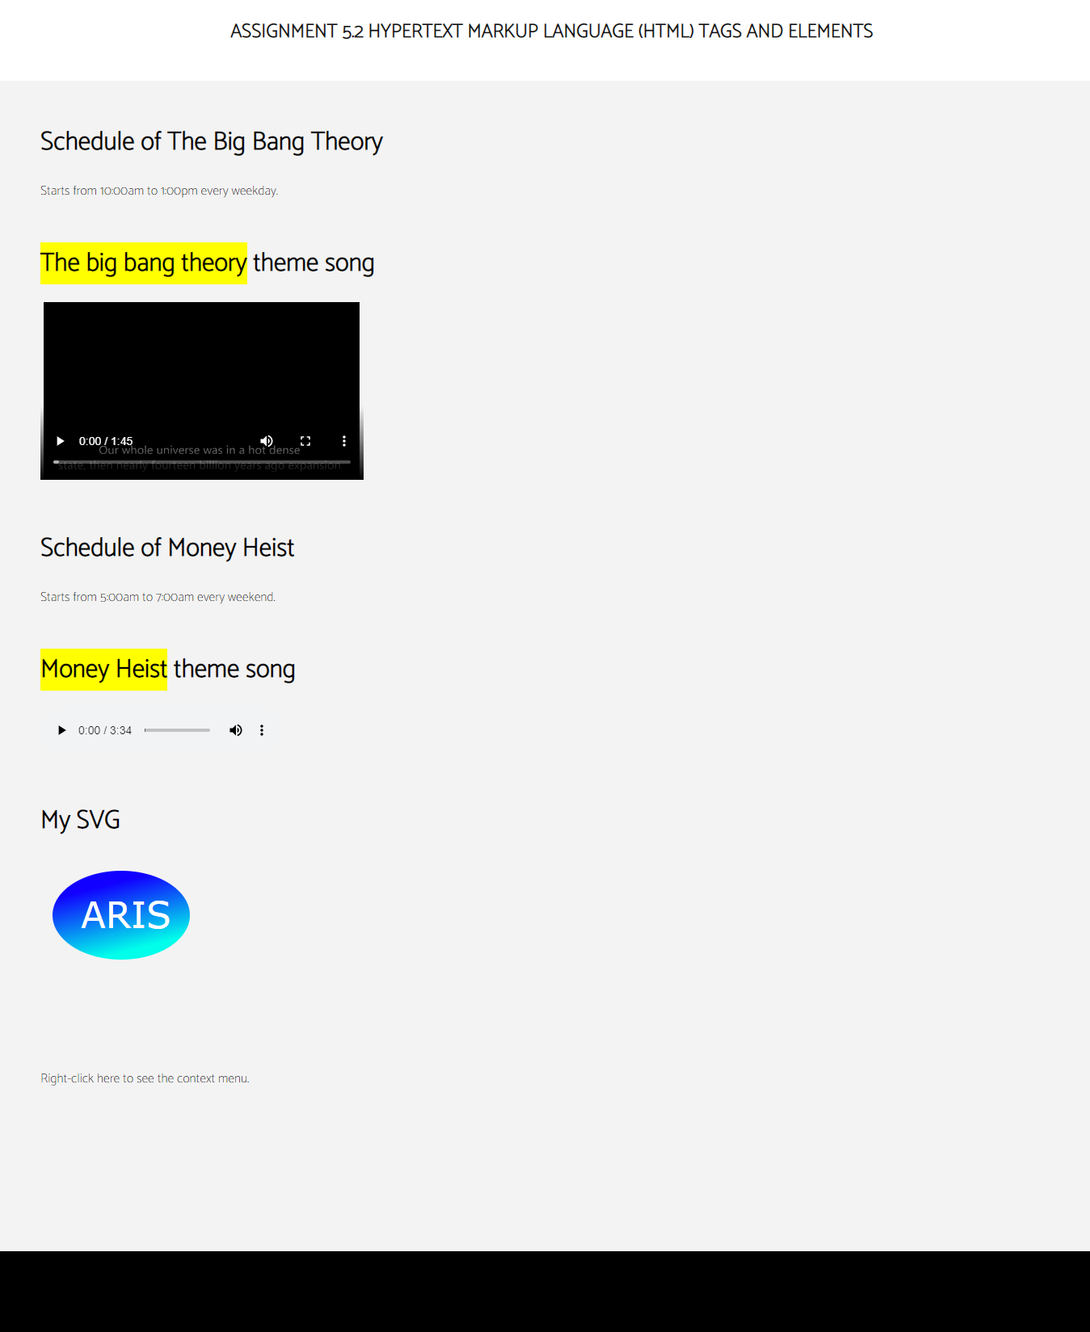

4. Create simple webpage applying geolocation.

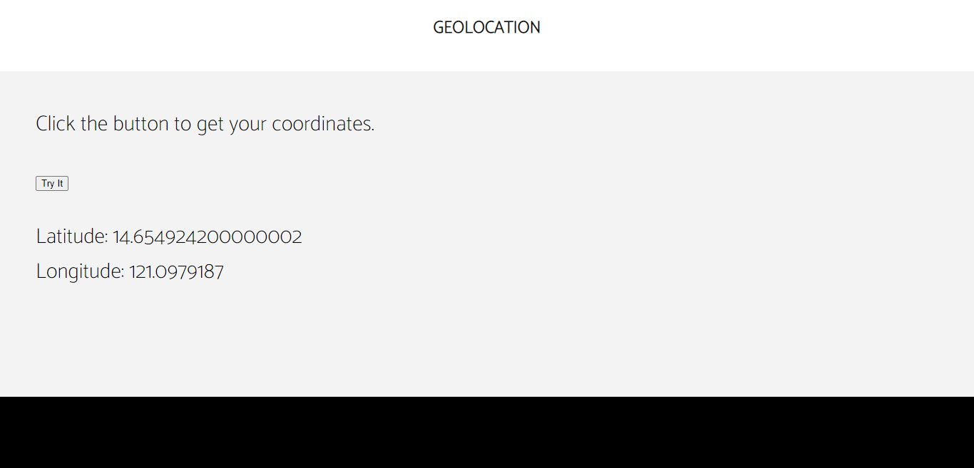

5. Codes for HTML5 Elements

<!DOCTYPE html>

<html>

    <head>

        <meta charset="utf-8">

        <meta name="viewport" content="width=device-width,initial-scale=1.0">

        <title>Assignment 5.2</title>

        <link href="https://fonts.googleapis.com/css2?family=Catamaran:wght@100&display=swap" rel="stylesheet">

        <style>

            body {

                font-family: 'Catamaran', sans-serif;

                background-color: #f3f3f3;

                width: 100%;

                margin: 0;

            }

            header {

                top: 0;

                right: 0;

                left: 0;

                background-color: #fff;

                width: 100%;

                height: 100px;

                z-index: 1;

            }

            header .header-brand {

                font-family: 'Catamaran', sans-serif;

                font-size: 24px;

                font-weight: 900;

                color: #111;

                text-transform: uppercase;

                display: block;

                margin: 0 auto;

                text-align: center;

                padding: 20px 0;

            }

            footer {

                background-color: black;

                width: 100%;

                margin-top: 200px;

                overflow: hidden;

                height: 100px;

            }

            .content {

                margin: 50px;

            }

            menu {

                display: block;

                list-style-type: disc;

                margin-top: 1em;

                margin-bottom: 1em;

                margin-left: 0;

                margin-right: 0;

                padding-left: 40px;

            }

        </style>

    </head>

    <body>

        <header>

            <div class="header-brand">Assignment 5.2 Hypertext Markup Language (HTML) Tags and Elements</div>

        </header>

        <div class="content">

            <h1>Schedule of The Big Bang Theory</h1>

            <p>Starts from <time>10:00am</time> to <time>1:00pm</time> every weekday.</p>

        </div>

        <div class="content">

            <h1><mark>The big bang theory</mark> theme song</h1>

            <video width="400" height="220" controls loop>

                <source src="bigbang.mp4" type="video/mp4">

                Your browser does not support the video tag.

            </video>

        </div>

        <div class="content">

            <h1>Schedule of Money Heist</h1>

            <p>Starts from <time>5:00am</time> to <time>7:00am</time> every weekend.</p>

        </div>

        <div class="content">

            <h1><mark>Money Heist</mark> theme song</h1>

            <audio controls>

                <source src="moneyheist.mp3" type="audio/mp3">

                Your browser does not support the audio tag.

            </audio>

        </div>

        <div class="content">

            <h1>My SVG</h1>

            <svg height="200" width="400">

            <defs>

                <linearGradient id="grad1" x1="3%" y1="30%" x2="30%" y2="100%">

                <stop offset="0%"

                style="stop-color:rgb(17, 0, 255);stop-opacity:1" />

                <stop offset="100%"

                style="stop-color:rgb(0, 255, 234);stop-opacity:1" />

                </linearGradient>

            </defs>

            <ellipse cx="100" cy="70" rx="85" ry="55" fill="url(#grad1)" />

            <text fill="#fefefe" font-size="45" font-family="Verdana"

            x="50" y="86">ARIS</text>

            Sorry, your browser does not support inline SVG.

            </svg>

        </div>

        <div id="box" contextmenu="my_context_menu">

            <p style="margin: 50px;">Right-click here to see the context menu.</p>

        </div>

        <menu type="context" id="my_context_menu">

            <menuitem label="The Big Bang Theory"></menuitem>

            <menuitem label="Money Heist"></menuitem>

        </menu>

        <footer class="footer">

        </footer>

    </body>

</html>

6. Codes for Geolocation.

<!DOCTYPE html>

<html>

    <head>

        <meta charset="utf-8">

        <meta name="viewport" content="width=device-width,initial-scale=1.0">

        <title>GEOLOCATION</title>

        <link href="https://fonts.googleapis.com/css2?family=Catamaran:wght@100&display=swap" rel="stylesheet">

        <style>

            body {

                font-family: 'Catamaran', sans-serif;

                background-color: #f3f3f3;

                width: 100%;

                margin: 0;

            }

            header {

                top: 0;

                right: 0;

                left: 0;

                background-color: #fff;

                width: 100%;

                height: 100px;

                z-index: 1;

            }

            header .header-brand {

                font-family: 'Catamaran', sans-serif;

                font-size: 24px;

                font-weight: 900;

                color: #111;

                text-transform: uppercase;

                display: block;

                margin: 0 auto;

                text-align: center;

                padding: 20px 0;

            }

            .content{

                margin: 50px;

                font-size: 30px;

                font-weight: 400;

            }

            footer {

                background-color: black;

                width: 100%;

                margin-top: 200px;

                overflow: hidden;

                height: 100px;

                position: fixed;

                left: 0;

                bottom: 0;

            }

        </style>

    </head>

    <body>

        <header>

            <div class="header-brand">GEOLOCATION</div>

        </header>

            <div class="content">

                <p>Click the button to get your coordinates.</p>

                <button onclick="getLocation()">Try It</button>

                <p id="demo"></p>

                <script>

                    var x = document.getElementById("demo");

                    function getLocation() {

                    if (navigator.geolocation) {

                        navigator.geolocation.getCurrentPosition(showPosition, showError);

                    } else {

                        x.innerHTML = "Geolocation is not supported by this browser.";

                    }

                    }

                    function showPosition(position) {

                    x.innerHTML = "Latitude: " + position.coords.latitude +

                    "<br>Longitude: " + position.coords.longitude;

                    }

                    function showError(error) {

                    switch(error.code) {

                        case error.PERMISSION_DENIED:

                        x.innerHTML = "User denied the request for Geolocation."

                        break;

                        case error.POSITION_UNAVAILABLE:

                        x.innerHTML = "Location information is unavailable."

                        break;

                        case error.TIMEOUT:

                        x.innerHTML = "The request to get user location timed out."

                        break;

                        case error.UNKNOWN_ERROR:

                        x.innerHTML = "An unknown error occurred."

                        break;

                    }

                    }

                </script>

            </div>

        <footer class="footer">

        </footer>

    </body>

</html>

7. References

<https://www.w3schools.com/html/html5_geolocation.asp>  
<https://www.w3schools.com/html/html5_video.asp>  
<https://www.w3schools.com/html/html5_audio.asp>  
<https://www.w3schools.com/html/html5_svg.asp>  
<https://www.w3schools.com/tags/tag_mark.asp>  
<https://www.w3schools.com/tags/tag_time.asp>  
https://www.w3schools.com/html/html5_geolocation.asp