Member 1: Aristotle Buenaventura  
Member 2: Naval, Dominador

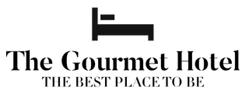Title: The Gourmet Hotel  
Slogan: The best place to be.  
Logo:

Favicon logo:

Description:

Our aim in developing a gourmet hotel was to create a green oasis for guests where the stress and the noise of the big city can be left behind the minute they enter the hotel, completed with relaxation and entertainment possibilities. Our hotel, which blends retreats, parties, private events, and modern design, is unique while reflecting the distinctive style of the hotel chain.

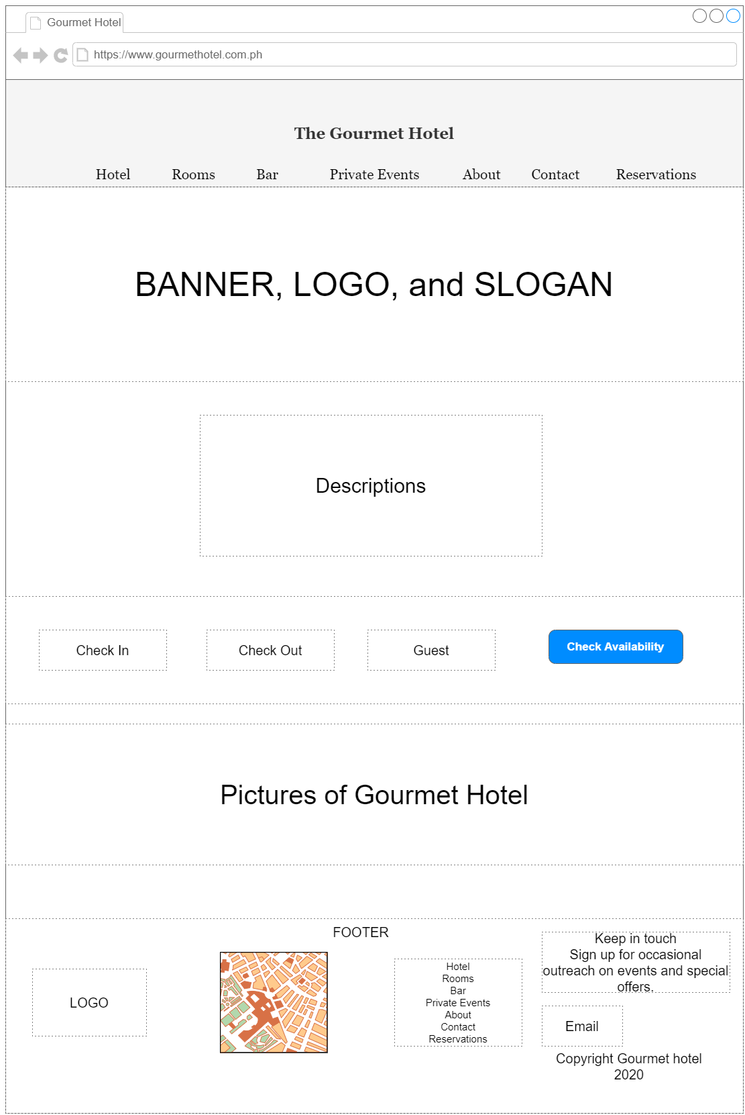Wireframe: