Technological Institute of the Philippines

938 Aurora Blvd. Cubao, Quezon City

College of Information Technology Education

IT 004 – Web Systems and Technologies

Final Period

Installing XAMPP; and Creating File Maintenance using PHP and MySQL

(Insert, Update, and Delete Data from Database using PHP and XAMPP)

|  |  |
| --- | --- |
| Name: BUENAVENTURA, ARISTOTLE C | Date: 11/10/2021 |
| Program / Section: IS12S2 | Instructor: Ms. Roxanne A. Pagaduan |
| Assessment Task: Assignment No 4 | |

**Instructions:**

* Provide screenshots to satisfy the requirements. (note: include screenshot of source code and sample run-time output in every source code and output changes)
* Include your **FULLNAME** in every screenshot.
* You are required to provide the screenshot of your source code for each file like (.html, .css, .js) and a sample output running in the browser.
* Include a brief description in each screenshot.
* Use appropriate filename in saving your files.
* Save your work as **SURNAME_Assign4.DOC** (Ex. PAGADUAN_Assign4.DOC and .PDF)

**Requirements:**

**Part 1: Installing XAMPP**

1. Download the XAMPP Installer. (Note: check the properties of your computer)
2. Install XAMPP in your computer. Follow the steps provided. (Note: see Steps on How to install XAMPP in Windows 10 64bits video) Video Link: <https://youtu.be/votB3vwlhAQ>
3. Provide sample screenshot of installed XAMPP in your computer.

**Part 2: Insert, Update, and Delete Data from Database using PHP and XAMPP**

1. Open XAMPP and start your database server (apache and mysql)
2. Create a database named as php_connection
3. Create table in the database named it as table1 with 5 columns.
4. Create index.php
5. Apply Bootstrap in forms and table needed.
6. Add columns. Named as id, first name, last name, email, contact respectively. Note: set the id as auto-incremented.
7. Add your information.
8. Create php files such connection.php, delete.php, and edit.php as needed.
9. Apply php in manipulating the records.
10. Refer on the provided steps. (see File Maintenance using PHP and MYSQL part1a and part2b videos)

Video Link: Part1a <https://youtu.be/nUTpOSDhxEQ>

Part1b <https://youtu.be/eZQcVrSGR1s>

**ANSWER:**

XAMPP Installed

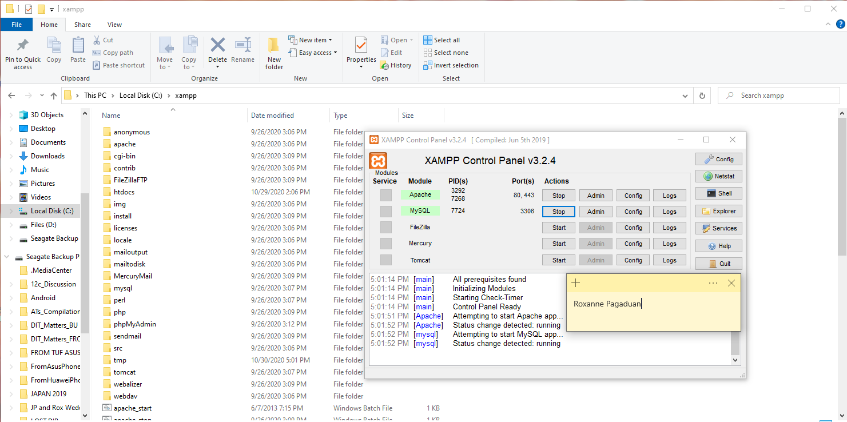

index.php

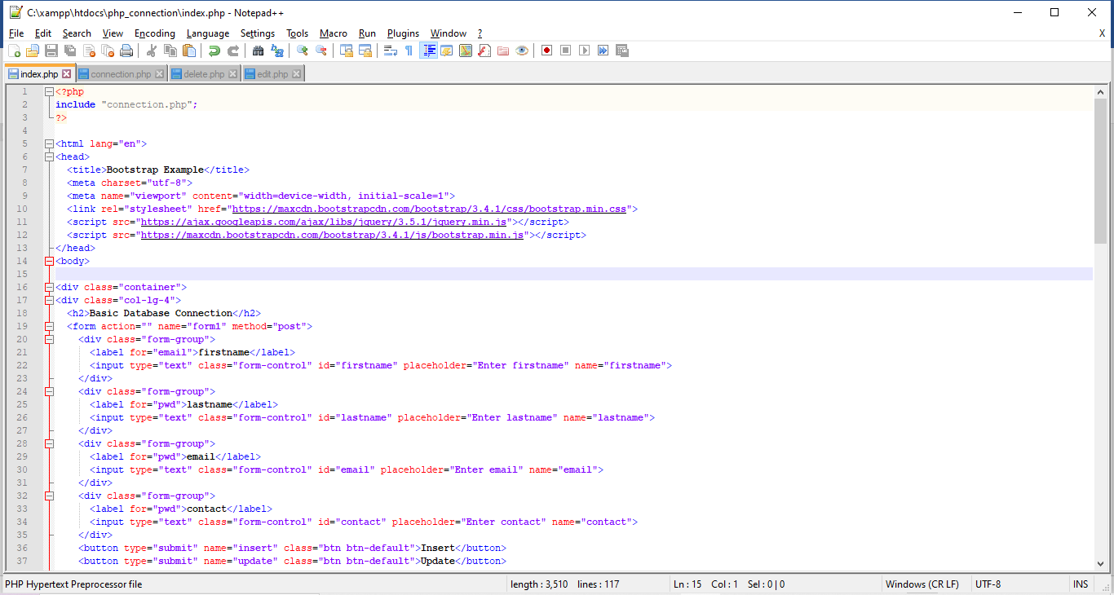

Sample Output:

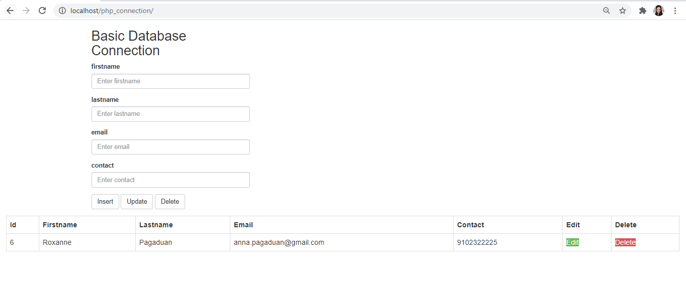

**ANSWER:**

**Part 1: Installing XAMPP**

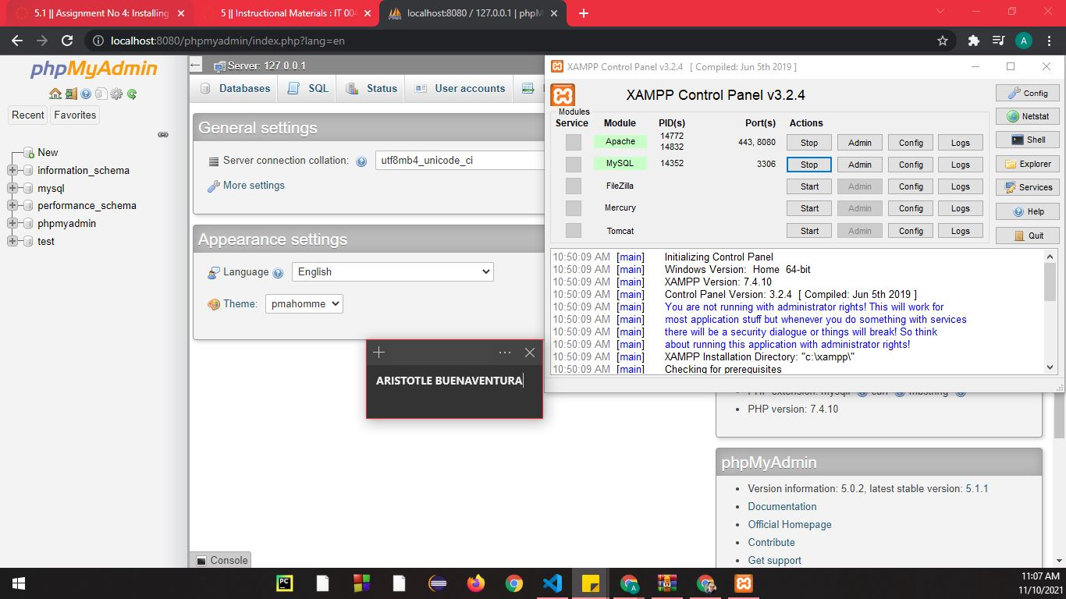XAMPP Installed

*Figure 1. XAMPP installed*

This is the UI of XAMPP; after installing it, the apache and MySQL are both started to connect to the server. XAMPP is a free and open-source cross-platform web server solution stack package developed by Apache Friends, consisting mainly of the Apache HTTP Server, MariaDB database, and interpreters for scripts written in the PHP and Perl programming languages.

**Part 2: Insert, Update, and Delete Data from Database using PHP and XAMPP**

**Source Code:**

***Index.php***

<?php

include "connection.php";

?>

<!DOCTYPE html>

<html lang="en">

<head>

<meta charset="UTF-8">

<meta http-equiv="X-UA-Compatible" content="IE=edge">

<meta name="viewport" content="width=device-width, initial-scale=1.0">

<link rel="stylesheet"href="https://maxcdn.bootstrapcdn.com/bootstrap/3.4.1/css/bootstrap.min.css">

<script src="https://ajax.googleapis.com/ajax/libs/jquery/3.5.1/jquery.min.js"></script>

<script src="https://maxcdn.bootstrapcdn.com/bootstrap/3.4.1/js/bootstrap.min.js"></script>

</head>

<body>

<div class="container">

<div class="col-lg-4">

<h2>Gourmet Hotel Reservation List</h2>

<form action="" name="form1" method="post">

<div class="form-group">

<label for="email">First Name</label>

<input type="text" class="form-control" id="firstname" placeholder="Enter First Name"

name="firstname">

</div>

<div class="form-group">

<label for="pwd">Last Name</label>

<input type="text" class="form-control" id="lastname" placeholder="Enter Last Name"

name="lastname">

</div>

<div class="form-group">

<label for="email">Email Address</label>

<input type="email" class="form-control" id="email" placeholder="Enter Email Address" name="email">

</div>

<div class="form-group">

<label for="pwd">Contact Number</label>

<input type="text" class="form-control" id="contact" placeholder="Enter Contact Number"

name="contact">

</div>

<button type="submit" name="insert" class="btn btn-default">Insert</button>

<button type="submit" name="update" class="btn btn-default">Update</button>

<button type="submit" name="delete" class="btn btn-default">Delete</button>

</form>

</div>

</div>

<div class="col-lg-12">

<table class="table table-bordered">

<thead>

<tr>

<th>ID</th>

<th>First Name</th>

<th>Last Name</th>

<th>Email Address</th>

<th>Contact Number</th>

</tr>

</thead>

<tbody>

<?php

$res=mysqli_query($link,"select * from table1");

while($row=mysqli_fetch_array($res))

{

echo "<tr>";

echo "<td>"; echo $row["id"]; echo "</td>";

echo "<td>"; echo $row["firstname"]; echo "</td>";

echo "<td>"; echo $row["lastname"]; echo "</td>";

echo "<td>"; echo $row["email"]; echo "</td>";

echo "<td>"; echo $row["contact"]; echo "</td>";

echo "<td>"; ?> <a href="edit.php?id=<?php echo $row["id"]; ?>"<button type="button"

class="btn-success">Edit</button></a> <?php echo "</td>";

echo "<td>"; ?> <a href="delete.php?id=<?php echo $row["id"]; ?>"<button type="button"

class="btn-danger">Delete</button></a> <?php echo "</td>";

echo "</tr>";

}

?>

</tbody>

</table>

</div>

</body>

<?php

if(isset($_POST["insert"]))

{

mysqli_query($link,"insert into table1

values(NULL,'$_POST[firstname]','$_POST[lastname]','$_POST[email]','$_POST[contact]')");

?>

<script type="text/javascript">

window.location.href=window.location.href;

</script>

<?php

}

if(isset($_POST["delete"]))

{

mysqli_query($link, "delete from table1 where firstname='$_POST[firstname]'") or

die(mysqli_error($link));

}

if(isset($_POST["update"]))

{

mysqli_query($link, "update table1 set firstname='$_POST[lastname]' where

firstname='$_POST[firstname]'") or die(mysqlii_error($link));

}

?>

</html>

***delete.php***

<?php

include "connection.php";

$id=$_GET["id"];

mysqli_query($link, "delete from table1 where id=$id");

?>

<script type="text/javascript">

window.location="index.php";

</script>

***connection.php***

<?php

$link=mysqli_connect("localhost", "root", "") or die (mysqli_error($link));

mysqli_select_db($link,"php_connection") or die (mysqli_error($link));

?>

***edit.php***

<?php

include "connection.php";

$id=$_GET["id"];

$firstname="";

$lastname="";

$email="";

$contact="";

$res=mysqli_query($link,"select * from table1 where Id=$id");

while($row=mysqli_fetch_array($res))

{

$firstname=$row["firstname"];

$lastname=$row["lastname"];

$email=$row["email"];

$contact=$row["contact"];

}

?>

<!DOCTYPE html>

<html lang="en">

<head>

<meta charset="UTF-8">

<meta http-equiv="X-UA-Compatible" content="IE=edge">

<meta name="viewport" content="width=device-width, initial-scale=1.0">

<link rel="stylesheet"href="https://maxcdn.bootstrapcdn.com/bootstrap/3.4.1/css/bootstrap.min.css">

<script src="https://ajax.googleapis.com/ajax/libs/jquery/3.5.1/jquery.min.js"></script>

<script src="https://maxcdn.bootstrapcdn.com/bootstrap/3.4.1/js/bootstrap.min.js"></script>

</head>

<body>

<div class="container">

<div class="col-lg-4">

<h2>Vertical (basic) form</h2>

<form action="" name="form1" method="post">

<div class="form-group">

<label for="email">firstname</label>

<input type="text" class="form-control" id="firstname" placeholder="Enter firstname"

name="firstname" value="<?php echo $firstname; ?>">

</div>

<div class="form-group">

<label for="pwd">lastname</label>

<input type="text" class="form-control" id="lastname" placeholder="Enter lastname"

name="lastname" value="<?php echo $lastname; ?>">

</div>

<div class="form-group">

<label for="email">email</label>

<input type="email" class="form-control" id="email" placeholder="Enter email" name="email"

value="<?php echo $email; ?>">

</div>

<div class="form-group">

<label for="pwd">contact</label>

<input type="text" class="form-control" id="contact" placeholder="Enter contact"

name="contact" value="<?php echo $contact; ?>">

</div>

<button type="submit" name="update" class="btn btn-default">Update</button>

</form>

</div>

</div>

</body>

<?php

if(isset($_POST["update"]))

{

mysqli_query($link,"update table1 set

firstname='$_POST[firstname]',lastname='$_POST[lastname]',email='$_POST[email]',contact='$_POST

[contact]' where id=$id");

?>

<script type="text/javascript">

window.location="index.php";

</script>

<?php

}

?>

</html>

**Screenshots of Code Source:**

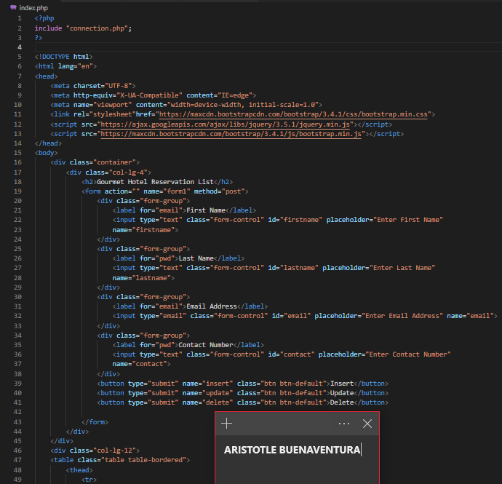

*Figure 2. index.php part 1*

I simply altered several formats and text after copying the code from our professor's tutorial. The user must fill up a form with information such as their first and last names, email address, and contact information. The insert, update, and delete buttons are all located below that.

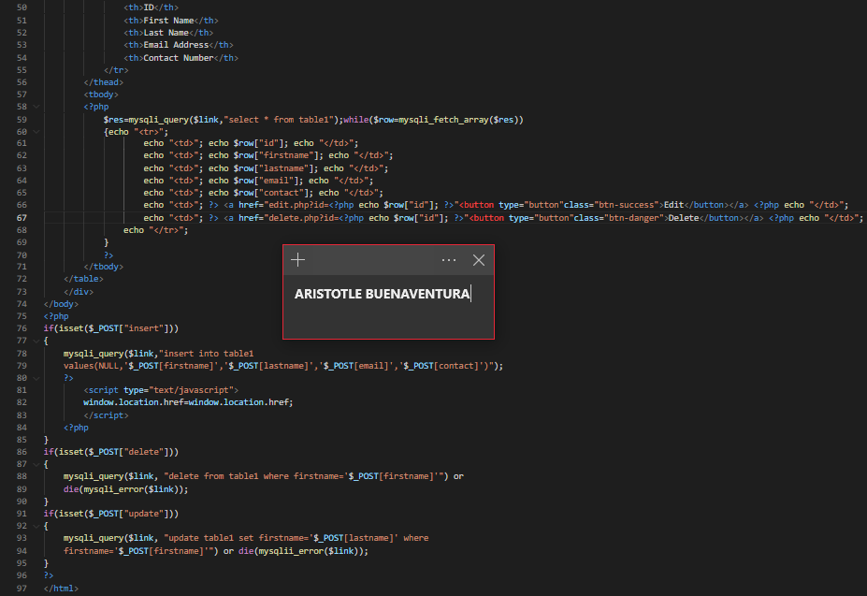

*Figure 2.1. index.php part 2*

This is an extension of the index.php file. First, the code has static values for each variable, but when PHP is used, it becomes dynamic. The values will now be defended based on user input. PHP will just display the values from the database in the website's interface.

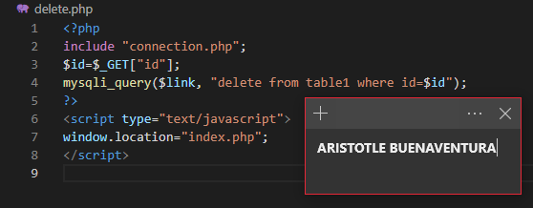

*Figure 3. delete.php*

This is the code for deleting an account in the database that will also reflect on the website.

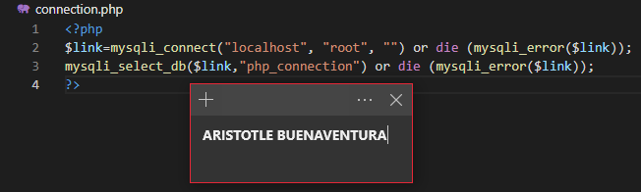

*Figure 4. connection.php*

The goal here is to link the website to the localhost. To introduce the connections, the file connection.php was linked in the index.php file.

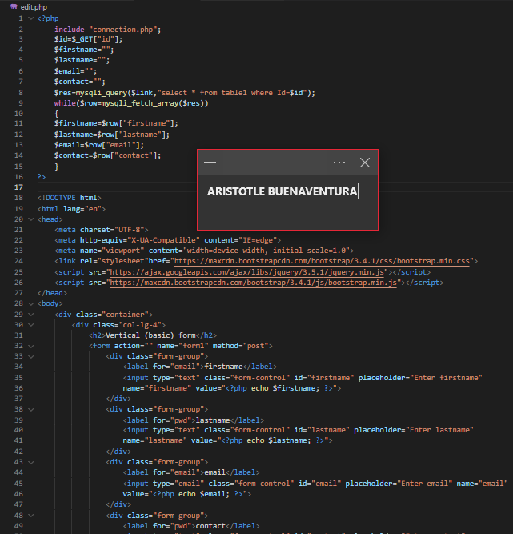

*Figure 5. edit.php part 1*

This is the editing section, where I just duplicated the index.php code block and eliminated some features because this is a new website. When a user hits the Update button, a new page appears, allowing them to edit the account they want to change.

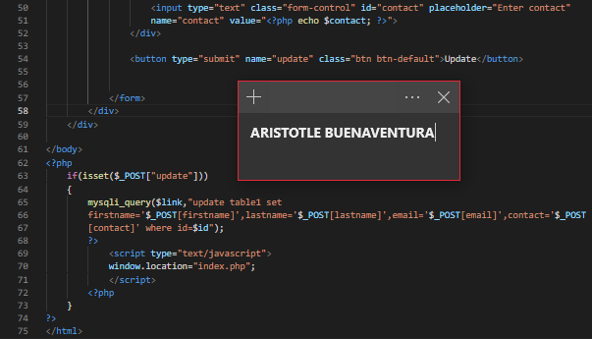

*Figure 5.1. edit.php part 2*

This is the second step of the editing process. The PHP code below is for changing database data, and the revised information will appear on the website so that the user can view the changes.

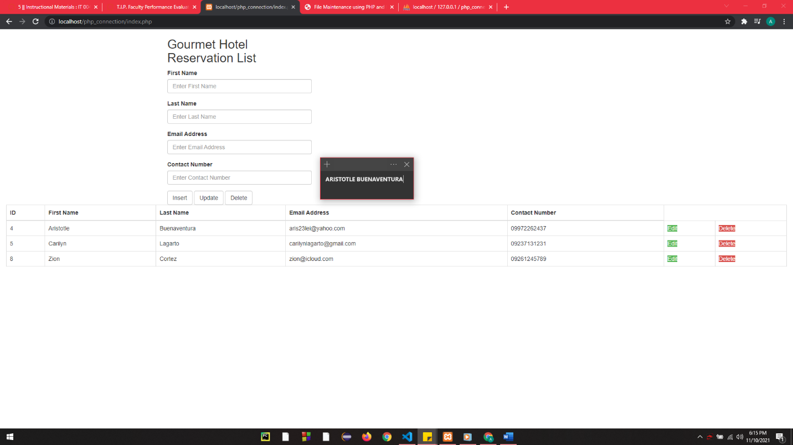**Sample Output:**

*Figure 6. The Final Output*

This is the result of following all of the procedures offered by our professor. In the database, I was able to insert, edit, and delete a specific account.

**Honor Pledge**

“I affirm that I have not given or received any unauthorized help on this assignment, and that this work is my own.”