Technological Institute of the Philippines

938 Aurora Blvd. Cubao, Quezon City

College of Information Technology Education

IT 004 – Web Systems and Technologies

Preliminary Period

|  |  |
| --- | --- |
| Name: BUENAVENTURA, ARISTOTLE C.  MORAGA, KATHLYNNE JOY | Date: 10/23/2021 |
| Program / Section: IT21S1 | Instructor: Ms. Roxanne A. Pagaduan |
| Assessment Task: Practice Set No. 2: JavaScript using HTML Forms and Functions | |

# Instructions:

* Provide screenshots to satisfy the requirements.
* Include your FULL NAME in every screenshot.
* Include a brief description in each screenshot.
* Provide the sample output running in any browser.
* Save your work as **SURNAME1_SURNAME2_PrelimAssign1.DOCX** (Ex. PAGADUAN_ANCHETA_PrelimAssign1.DOCX and .PDF)
* Record your screen while performing the task. Make sure all members contribute and participate in answering the problems. You can use any tools for collaboration like Team Viewer, Google Meet, etc.
* Save your recorded video in .MP4 format and store it inside your google drive using your T.I.P. email account. Note: use appropriate filenames

**Overview:**

A function is a block of code that will be executed when "someone" calls it:

For Example:

<!DOCTYPE html>  
<html>  
<head>  
<script>  
function myFunction()  
{  
alert("Hello World!");  
}  
</script>  
</head>  
  
<body>  
<button onclick="myFunction()">Try it</button>  
</body>  
</html>

JavaScript Function Syntax

A function is written as a code block (inside curly { } braces), preceded by the function keyword:

function functionname()  
{  
some code to be executed  
}

The code inside the function will be executed when "someone" calls the function.

The function can be called directly when an event occurs (like when a user clicks a button), and it can be called from "anywhere" by JavaScript code

**Requirements:**

Satisfy the following requirements using notepad, notepad++ or any available tools. Design your own webpage

1. Create a simple JavaScript calculator

**Sample Output:**

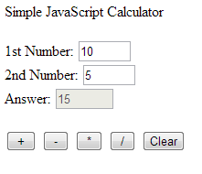

**Note:** save your work as SURNAME1_SURNAME2_PS2a.html

1. Create a JavaScript program that will compute the prelim grade, midterm grade and final grade of a student. Note: provide separate form in each term and result may vary in the sample output provided. Make sure to satisfy the provided formulas.
   1. Consider the following formulas:

CS = 60% Quizzes + 20% Assignments + 20% Laboratory Activities

PG= 50% CS + 50% PE

MG=(1/3*PG)+(2/3*TMG)

FG=(1/3*MG)+(2/3*TFG)

* 1. Allow the user to input Class Standing (CS) components and automatically compute grades.

**Sample Output:**

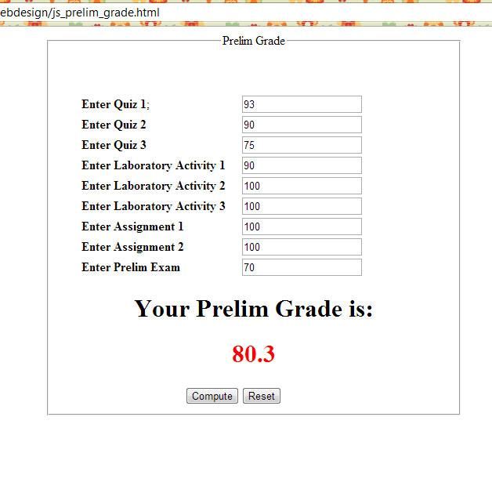

**Note:** save your work as SURNAME_PS2b_Prelim.html

save your work as SURNAME_PS2b_Midterm.html

save your work as SURNAME_PS2b_Finals.html

**Assessment Tool:**

This assessment will be graded using the Rubric for Laboratory Performance in Web Systems and Technologies.

## Answer: (video link)

**Video Link: *<Paste here the link of the video saved in your google drive. Remove restriction of the file for checking purposes>***

**Source Code:**

### PS2a.html

<!--BUENAVENTURA, MORAGA_Assignment 2.1-->

<!DOCTYPE html>

<html>

<head>

<title> JavaScript Calculator </title>

<!--External link for the javascript-->

<script src="scripta.js" type = "text/javascript">

</script>

<!-- Internal Style Sheet -->

<style>

h1{

text-align:center;

position:center;

font-family:Consolas;

}

form{

border:solid;

background-color:white;

position:fixed;

margin-left:330px;

text-align:center;

padding:10px;

}

input{

font-size:30px;

margin-right:20px;

margin-left:20px;

padding-right:50px;

}

p{

font-size:30px;

font-family:Consolas;

}

</style>

</head>

<!-- Start of Body -->

<body style="background-color:#d6bb72;">

<h1> Simple JavaScript Calculator </h1>

<br>

<!--Form-->

<form name = "mainForm">

<p> 1st Number:

<input type = "text" name="num1" /></p>

<p> 2nd Number:

<input type = "text" name="num2" /></p>

<p> Answer:

<input type = "text" name="Answer"

readonly="readonly"/></p>

<br>

<br>

<!--Buttons that has onclick to make it interactive-->

<input type= "button" value="+"

onclick="javascript:add()"/>

&nbsp;

<input type= "button" value="-"

onclick="javascript:minus()"/>

&nbsp;

<input type= "button" value="*"

onclick="javascript:multiply()"/>

&nbsp;

<input type= "button" value="/" style

onclick="javascript:divide()"/>

&nbsp;

<!--Reset Button to clear all values including the answer-->

<input type= "reset" value="CLEAR" style="font-family:Consolas;"/>

</form>

</body>

</html>

### scripta.js

//Here are the functions for the buttons for BUENAVENTURA_MORAGA_PS2a.html. The cancel button was

//already directed in the HTML file

function add(){

value1= parseInt(document.mainForm.num1.value);

value2= parseInt(document.mainForm.num2.value);

sum = value1 + value2;

document.mainForm.Answer.value = sum;

}

function minus(){

value1= parseInt(document.mainForm.num1.value);

value2= parseInt(document.mainForm.num2.value);

sub = value1 - value2;

document.mainForm.Answer.value = sub;

}

function multiply(){

value1= parseInt(document.mainForm.num1.value);

value2= parseInt(document.mainForm.num2.value);

mul = value1 * value2;

document.mainForm.Answer.value = mul;

}

function divide(){

value1= parseInt(document.mainForm.num1.value);

value2= parseInt(document.mainForm.num2.value);

div = value1 / value2;

document.mainForm.Answer.value = div;

}

### PS2b_Prelim.html

<!--BUENAVENTURA, MORAGA_Assignment 2.1-->

<!DOCTYPE html>

<html lang="en">

<head>

<meta charset="UTF-8">

<meta http-equiv="X-UA-Compatible" content="IE=edge">

<meta name="viewport" content="width=device-width, initial-scale=1.0">

<title>Report Card</title>

<!-- External Style Sheet -->

<link rel="stylesheet" href="style.css">

<!--External link for the javascript-->

<script src="scriptb.js" type="text/javascript"></script>

</head>

<body>

<!-- Start of Body -->

<!-- Header Section -->

<div class="header">

<div class="header-brand">REPORT CARD </div>

</div>

<!-- Prelim Grade -->

<section id="container">

<div class="box1">

<div class="grade">

<div class="title">PRELIM GRADE</div>

<form name = "mainForm">

<div class="wrap">

<div class="task">

<p>Assignment:

<p> Quiz:

<p> Laboratory Activities:

<p> Prelim Examination:

<p> Class Standing:

<p> Prelim Grade:

</div>

<!-- Text field where the user inputs their grade or data in each task -->

<div class="textfield">

<input type = "text" id="assignmentPrelim"/></p>

<input type = "text" id="quizPrelim"/></p>

<input type = "text" id="activityPrelim"/></p>

<input type = "text" id="examPrelim"/></p>

<input type = "text" id="standingPrelim"

readonly="readonly"/></p>

<input type = "text" id="gradePrelim"

readonly="readonly"/></p>

</div>

</div>

<!-- Buttons Section -->

<div class="buttons">

<!-- Computes the prelim grade -->

<input class="button1" type= "button" value="Compute"

onclick="computePrelim()" />

<!-- Reset or clear the inputted data in each text field -->

<input class="button1" type= "reset" value="Reset"

onclick="deleteLocalPrelim()"/>

</div>

<!-- Button with link to proceed to midterm web page -->

<a href="BUENAVENTURA_MORAGA_PS2b_Midterm.html"><button type="button" name="button" class="animated-button">Proceed to Midterm</button></a>

</form>

</div>

</div>

</section>

</body>

</html>

### PS2b_Midterm.html

<!--BUENAVENTURA, MORAGA_Assignment 2.1-->

<!DOCTYPE html>

<html lang="en">

<head>

<meta charset="UTF-8">

<meta http-equiv="X-UA-Compatible" content="IE=edge">

<meta name="viewport" content="width=device-width, initial-scale=1.0">

<title>Report Card</title>

<!-- External Style Sheet -->

<link rel="stylesheet" href="style.css">

<!--External link for the javascript-->

<script src="scriptb.js" type="text/javascript"></script>

</head>

<body>

<!-- Start of Body -->

<!-- Header Section -->

<div class="header">

<div class="header-brand">REPORT CARD </div>

</div>

<!-- Midterm Grade -->

<section id="container">

<div class="box1">

<div class="grade">

<div class="title">MIDTERM GRADE</div>

<form name = "mainForm">

<div class="wrap">

<div class="task">

<p>Assignment:

<p> Quiz:

<p> Laboratory Activities:

<p> Midterm Examination:

<p> Class Standing:

<p> Midterm Grade:

</div>

<!-- Text field where the user inputs their grade or data in each task -->

<div class="textfield">

<input type = "text" id="assignmentMidterm"/></p>

<input type = "text" id="quizMidterm"/></p>

<input type = "text" id="activityMidterm"/></p>

<input type = "text" id="examMidterm"/></p>

<input type = "text" id="standingMidterm"

readonly="readonly"/></p>

<input type = "text" id="gradeMidterm"

readonly="readonly"/></p>

</div>

</div>

<!-- Buttons Section -->

<div class="buttons">

<!-- Computes the midterm grade -->

<input class="button1" type= "button" value="Compute"

onclick="computeMidterm()"/>

<!-- Reset or clear the inputted data in each text field -->

<input class="button1" type= "reset" value="Reset"

onclick="deleteLocalMid()"/>

</div>

<!-- Button with link to proceed to final web page -->

<a href="BUENAVENTURA_MORAGA_PS2b_Finals.html"><button type="button" name="button" class="animated-button">Proceed to Finals</button></a>

</form>

</div>

</div>

</section>

</body>

</html>

### PS2b_Finals.html

<!--BUENAVENTURA, MORAGA_Assignment 2.1-->

<!DOCTYPE html>

<html lang="en">

<head>

<meta charset="UTF-8">

<meta http-equiv="X-UA-Compatible" content="IE=edge">

<meta name="viewport" content="width=device-width, initial-scale=1.0">

<title>Report Card</title>

<!-- External Style Sheet -->

<link rel="stylesheet" href="style.css">

<!--External link for the javascript-->

<script src="scriptb.js" type="text/javascript"></script>

</head>

<body>

<!-- Start of Body -->

<!-- Header Section -->

<div class="header">

<div class="header-brand">REPORT CARD </div>

</div>

<!-- Final Grade -->

<section id="container">

<div class="box1">

<div class="grade">

<div class="title">FINAL GRADE</div>

<form name = "mainForm">

<div class="wrap">

<div class="task">

<p> Assignment:

<p> Quiz:

<p> Laboratory Activities:

<p> Final Examination:

<p> Class Standing:

<p> Final Grade:

</div>

<!-- Text field where the user inputs their grade or data in each task -->

<div class="textfield">

<input type = "text" id="assignmentFinal"/></p>

<input type = "text" id="quizFinal"/></p>

<input type = "text" id="activityFinal"/></p>

<input type = "text" id="examFinal"/></p>

<input type = "text" id="standingFinal"

readonly="readonly"/></p>

<input type = "text" id="gradeFinal"

readonly="readonly"/></p>

</div>

</div>

<!-- Buttons Section -->

<div class="buttons">

<!-- Computes the final grade -->

<input class="button1" type= "button" value="Compute"

onclick="computeFinal()"/>

<!-- Reset or clear the inputted data in each text field -->

<input class="button1" type= "reset" value="Reset"

onclick=""/>

</div>

<!-- Button with link to go back to prelim web page -->

<a href="BUENAVENTURA_MORAGA_PS2b_Prelim.html"><button type="button" name="button" class="animated-button">Proceed to Prelims</button></a>

</form>

</div>

</div>

</section>

</body>

</html>

### scriptb.js

function computePrelim(){

if(document.getElementById("assignmentPrelim").value=="" || document.getElementById("quizPrelim").value=="" ||// if the textfield are empty there will be an alert that the user must input all necessary data

document.getElementById("activityPrelim").value=="" || document.getElementById("examPrelim").value==""){

alert("Input all necessary data");

} else{ // else if all the text fields have inputted data

// passing the value in text field into a variable

value1= parseInt(document.getElementById("assignmentPrelim").value);

value2= parseInt(document.getElementById("quizPrelim").value);

value3= parseInt(document.getElementById("activityPrelim").value);

value4= parseInt(document.getElementById("examPrelim").value);

// formulas

quizValue = value2 * 0.6;

assignmentValue = value1 * 0.2;

activityValue = value3 * 0.2;

examValue = value4 * 0.5;

CS = (quizValue + assignmentValue + activityValue);

PG = (CS * 0.5) + examValue;

document.getElementById("standingPrelim").value = CS;

document.getElementById("gradePrelim").value = PG;

// storing the prelim grade in the local storage

localStorage.setItem("keyPrelim",PG)

// printing the prelim grade in the console

console.log("Prelim Grade: "+localStorage.getItem("keyPrelim"));

}

}

function computeMidterm(){

if(localStorage.getItem("keyPrelim")==undefined){ // if the user did not compute his/her prelim grade, the system will not compute the midterm grade.

alert("Compute your Prelim Grade first!");

} else if (document.getElementById("assignmentMidterm").value =="" || document.getElementById("quizMidterm").value=="" || // if the textfield are empty there will be an alert that the user must input all necessary data

document.getElementById("activityMidterm").value =="" || document.getElementById("examMidterm").value==""){

alert("Input all necessary data");

} else{// else if all the text fields have inputted data

// passing the value in text field into a variable

value1= parseInt(document.getElementById("assignmentMidterm").value);

value2= parseInt(document.getElementById("quizMidterm").value);

value3= parseInt(document.getElementById("activityMidterm").value);

value4= parseInt(document.getElementById("examMidterm").value);

// formulas

quizValue = value2 * 0.6;

assignmentValue = value1 * 0.2;

activityValue = value3 * 0.2;

examValue = value4 * 0.5;

prelimGrade = localStorage.getItem("keyPrelim");

CS = (quizValue + assignmentValue + activityValue);

TMG = (CS * 0.5) + examValue;

MG = (1/3 * prelimGrade) + (2/3 * TMG);

document.getElementById("standingMidterm").value = CS;

document.getElementById("gradeMidterm").value = MG;

// storing the midterm grade in the local storage

localStorage.setItem("keyMidterm",MG)

// printing the prelim grade and midterm grade in the console

console.log("Prelim Grade: "+localStorage.getItem("keyPrelim"));

console.log("Midterm Grade: " + localStorage.getItem("keyMidterm"));

}

}

function computeFinal(){

if(localStorage.getItem("keyPrelim")==undefined){ // if the user did not compute his/her prelim grade, the system will not compute the final grade.

alert("Compute your Prelim Grade first!");

} else if(localStorage.getItem("keyMidterm")==undefined){ // if the user did not compute his/her midterm grade, the system will not compute the final grade.

alert("Compute your Midterm Grade first!");

} else if (document.getElementById("assignmentFinal").value=="" || document.getElementById("quizFinal").value=="" || // if the textfield are empty there will be an alert that the user must input all necessary data

document.getElementById("activityFinal").value=="" || document.getElementById("examFinal").value==""){

alert("Input all necessary data");

} else{// else if all the text fields have inputted data

// passing the value in text field into a variable

value1= parseInt(document.getElementById("assignmentFinal").value);

value2= parseInt(document.getElementById("quizFinal").value);

value3= parseInt(document.getElementById("activityFinal").value);

value4= parseInt(document.getElementById("examFinal").value);

// formulas

quizValue = value2 * 0.6;

assignmentValue = value1 * 0.2;

activityValue = value3 * 0.2;

examValue = value4 * 0.5;

midtermGrade=localStorage.getItem("keyMidterm");

CS = (quizValue + assignmentValue + activityValue);

TFG = (CS * 0.5) + examValue;

FG = (1/3 * midtermGrade) + (2/3 * TFG);

document.getElementById("standingFinal").value = CS;

document.getElementById("gradeFinal").value = FG;

// printing the prelim grade,midterm grade, final grade in the console

console.log("Prelim Grade: " + localStorage.getItem("keyPrelim"));

console.log("Midterm Grade: " + localStorage.getItem("keyMidterm"));

console.log("Final Grade: " + FG);

}

}

function deleteLocalPrelim(){

localStorage.removeItem("keyPrelim"); // when the user click the reset button in the prelim web page, the datas of that page will be deleted in the local storage.

}

function deleteLocalMid(){

localStorage.removeItem("keyMidterm"); // when the user click the reset button in the midterm web page, the datas of that page will be deleted in the local storage.

}

### style.css

/* CSS style for the BUENAVENTURA_MORAGA_PS2b_Prelim.html, BUENAVENTURA_MORAGA_PS2b_Midterm, and BUENAVENTURA_MORAGA_PS2b_Finals */

body{

background: #aa5b21;

font-family:Consolas;

font-size: large;

min-width: 960px;

margin: 0 auto;

}

.header{

position: fixed;

top: 0;

right: 0;

left: 0;

background-color: #f5ddcb;

width: 100%;

height: 100px;

z-index: 1;

padding: 34px 0;

padding-top: 0;

}

.header .header-brand {

font-family:Consolas;

font-size: 35px;

font-weight: 1000;

color: #111;

display: block;

margin: 0 auto;

text-align: center;

padding: 50px 0;

text-decoration: none;

}

#container{

display: grid;

grid-template-columns: repeat(5,1fr);

grid-template-rows: repeat(2,1fr);

grid-gap: 50px;

margin-top: 100px;

padding: 80px;

width: auto;

min-width: 960px;

}

.title{

padding: 10px;

font-size: 20px;

font-weight: 1000;

display: flex;

justify-content: center;

align-items: center;

}

.box1{

min-width: 500px;

border:solid;

grid-row: 1/3;

grid-column: 2/5;

background: white;

padding-bottom: 50px;

}

form{

margin-left: 50px;

margin-bottom: 20px;

font-size: 20px;

display: flex;

justify-content: center;

align-items: center;

position: relative;

}

.buttons {

position: absolute;

justify-content: center;

align-items: center;

top: 300px;

}

.button1{

margin-right: 20px ;

font-size: 18px;

}

.wrap{

display: flex;

margin: auto;

}

.textfield{

margin-top: 15px;

margin-left: 20px;

flex-grow: 1;

}

.animated-button {

position: fixed;

display: inline-block;

padding: 20px 40px;

font-size: 1.4rem;

background-color: #323333;

background-size: 20px 20px;

border: 1px solid #555;

color: white;

transition: all 0.3s ease;

cursor: pointer;

}

.animated-button:after {

position: absolute;

top: 50%;

right: 0.6em;

-webkit-transform: translate(0, -50%);

transform: translate(0, -50%);

content: "»";

opacity: 0;

transition: all 0.3s ease;

}

.animated-button:hover {

padding: 20px 60px 20px 20px;

}

.animated-button:hover:after {

right: 1.2em;

opacity: 1;

}

@-webkit-keyframes loading-button-animation {

from {

background-position: 0 0;

}

to {

background-position: 40px 0;

}

}

@keyframes loading-button-animation {

from {

background-position: 0 0;

}

to {

background-position: 40px 0;

}

}

Screenshots of Codes (provide name.png in every screenshot then des to each file – NOT FINISH

**Prelim Grade HTML code**

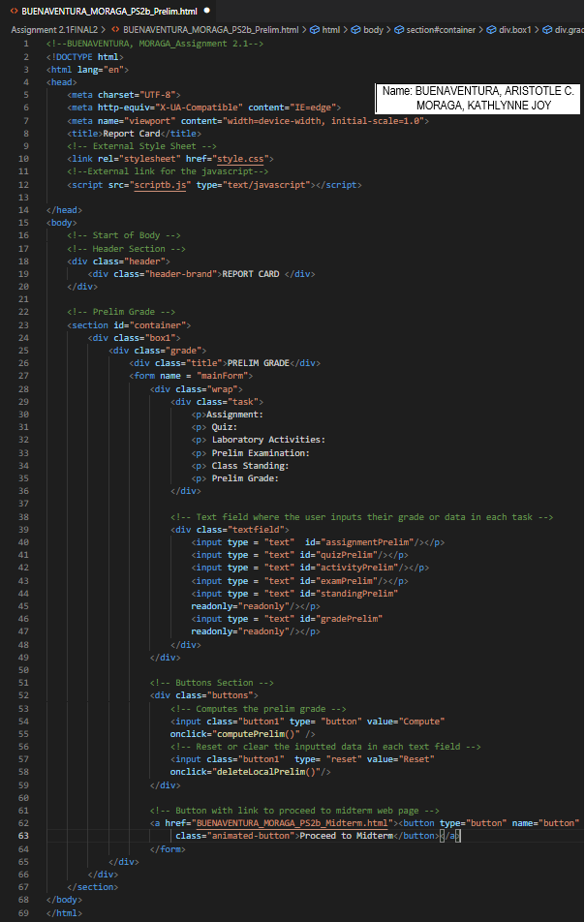

**Midterm Grade HTML code**

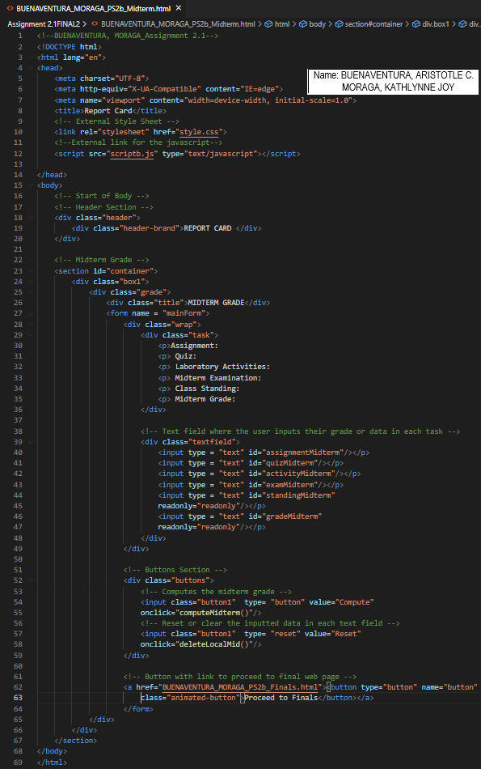

## Final Grade HTML code

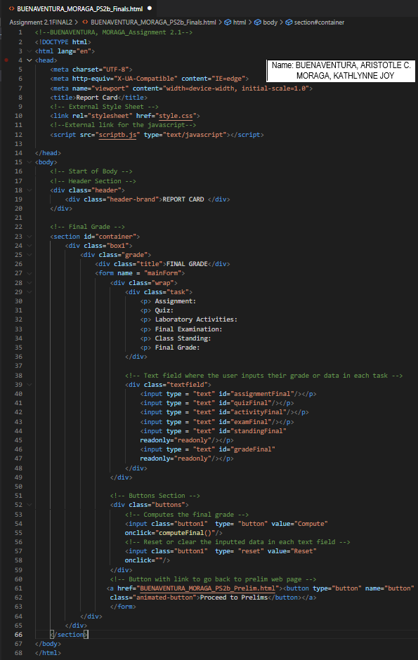

## Descriptions for Prelim, Midterm, and Final Grade HTML codes

The programmers created three separate HTML files for the prelim, midterm, and finals web page. All of them have the same title, which is Report Card. The CSS and JavaScript are linked inside the head tag for easy reading. The class header is for the banner of the page where the Report Card is placed. The class container contains the form and the buttons where the users will input their grades in each text field.

## Style Sheet for Prelim, Midterm, and Final Grade

## 

## 

The programmers used an external style sheet for the report card web pages. They used CSS for designing the web by manipulating the attributes like font, colors, and layouts. First, they put a header on the page with the title and set a background color. Second, they select a different background color for the body to match the header's color and the container. Third, they use a display grid and flex to arrange the items inside the container. Lastly, they implement some animation to the proceed button beside the container.

## JavaScript for Prelim, Midterm, and Final Grade

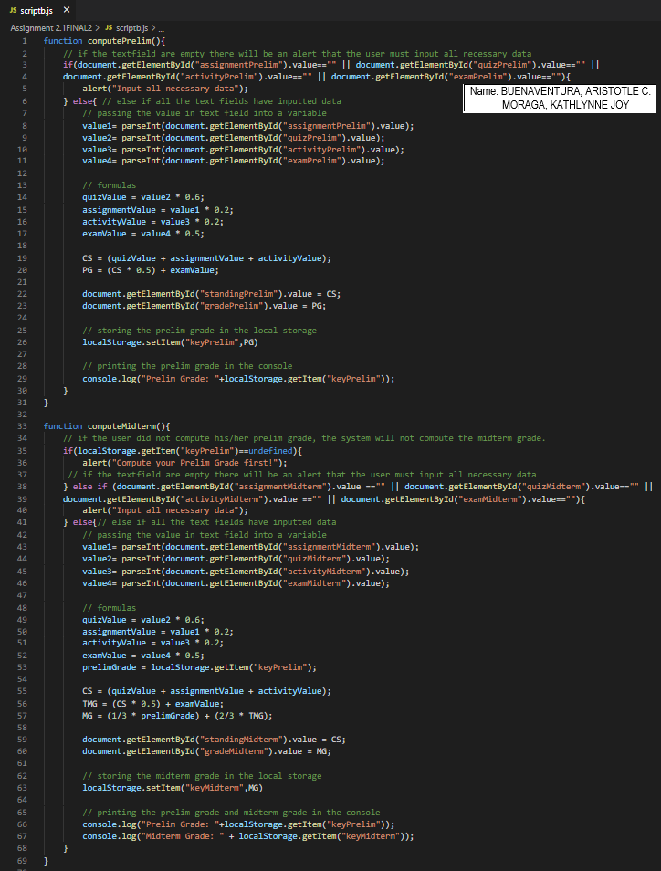

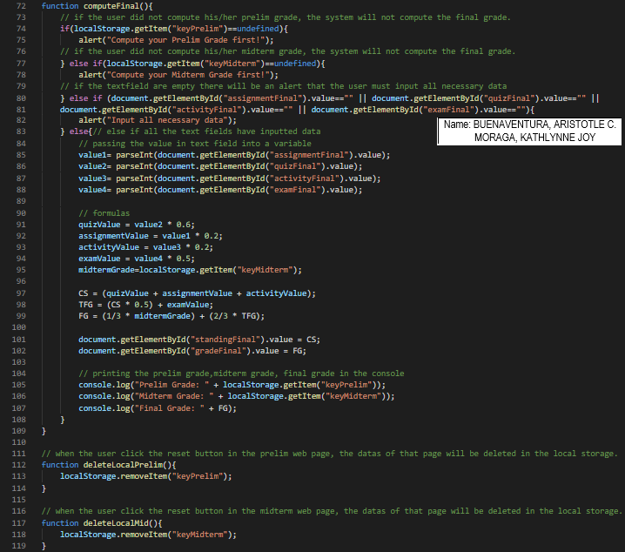

The programmers created an external link for the JavaScript. Inside the JavaScript file has five functions; the three of them, The computePrelim(), computeMidterm(), and computeFinal(), are mainly for computing the grades in each grading period. While the purpose of deleteLocalPrelim() and deleteLocalMid() is when the users click the reset button on the web page, the system will delete that page's data in the local storage.

## Sample Output:

### 1) BUENAVENTURA_MORAGA_PS2a.html

### A) Operators

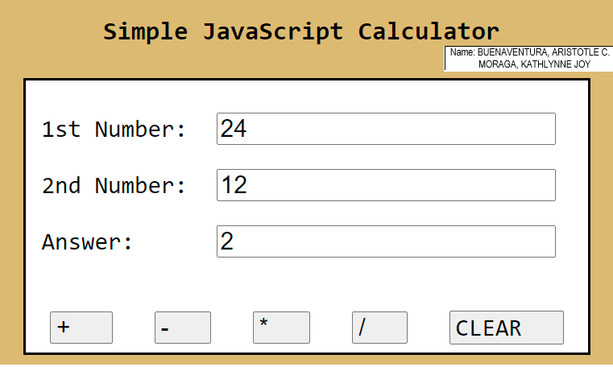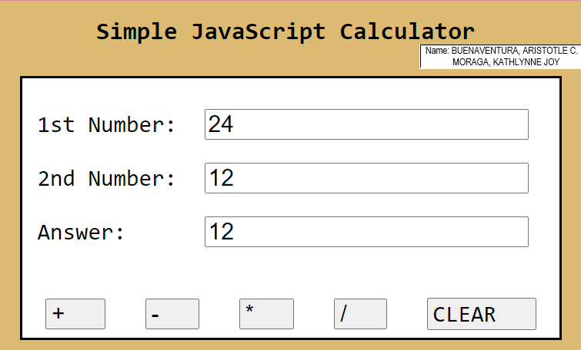

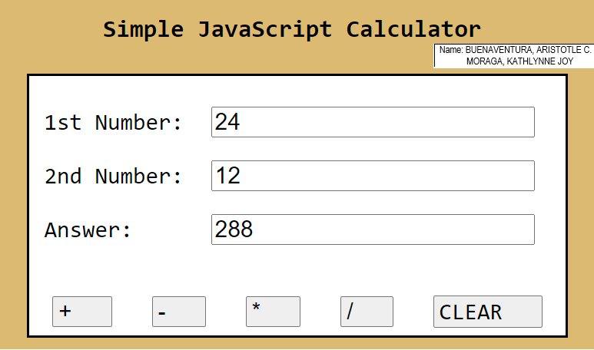

In the first part of the practice set, we are instructed to make a simple JavaScript calculator. The calculator has 4 operators and a reset button that is named as “CLEAR”. The user can interactively use the website and compute fundamental mathematics. This is possible because of the external JavaScript, “scripta.js” which has the function called in the html to perform actions.

### B) Clear

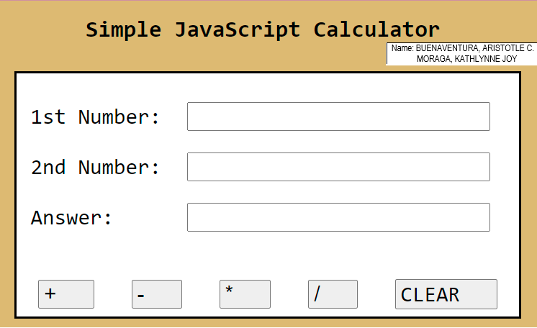

However, since the instructions did not specify if the “Clear” button is a function, I researched a certain case in which you use reset as an input type to delete data easily. We also add an internal CSS to style the calculator.

### 2) BUENAVENTURA_MORAGA_PS2b

#### A) Preliminary

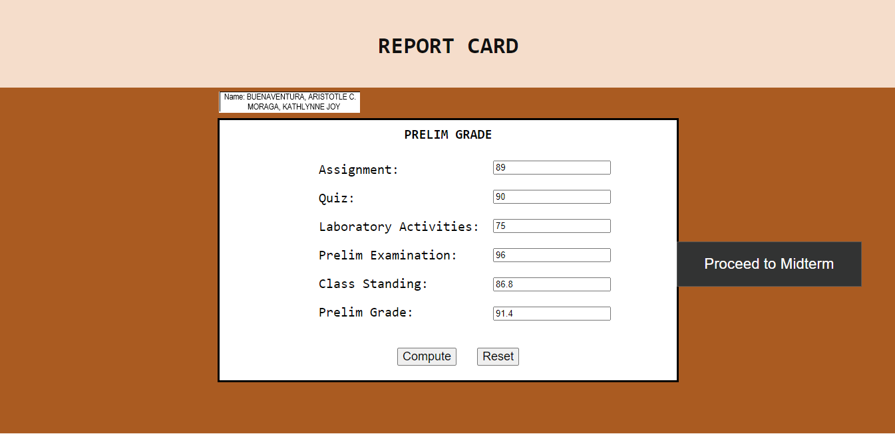 On the prelim page, the user will input their grades on each text field. If the user proceeds to midterm or finals without computing the prelim grade, the system will alert the users to calculate their prelim grade first. Using Local Storage, the Class Standing and Prelim Grade can be accessed later to compute for the midterm grade. Reset will remove value from Local Storage.

#### B) Midterm

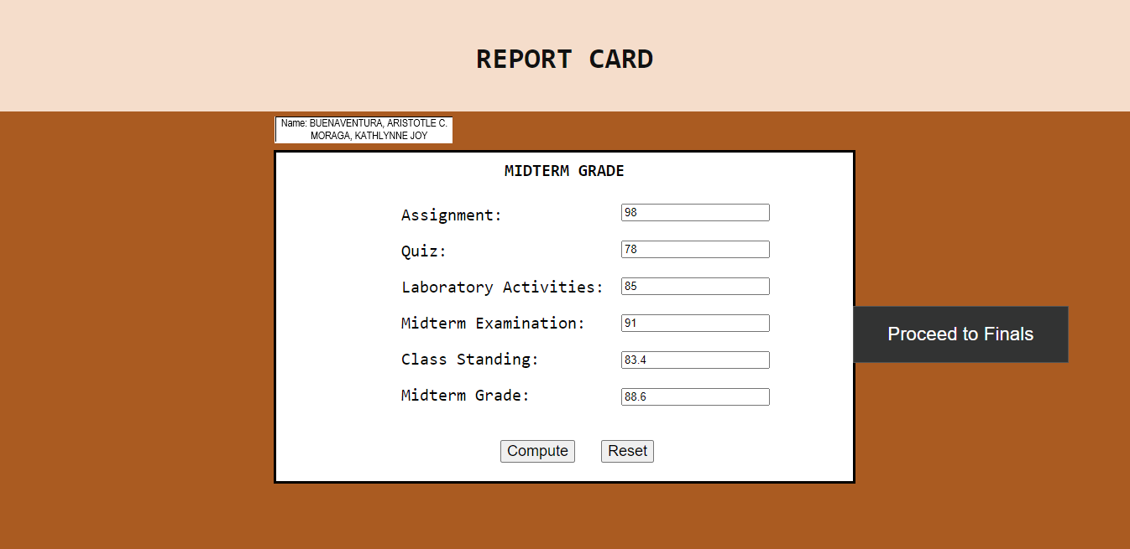

After the user have calculated their prelim grade, they can now proceed and calculate their midterm grade. The same with the prelim grade; if the users move to finals without calculating their midterm grade, the system will tell them through an alert that they need to compute their midterm grade first. Using Local Storage, the Class Standing and Midterm Grade can be accessed later to compute for the final grade. Reset will remove value from Local Storage.

#### C) Final

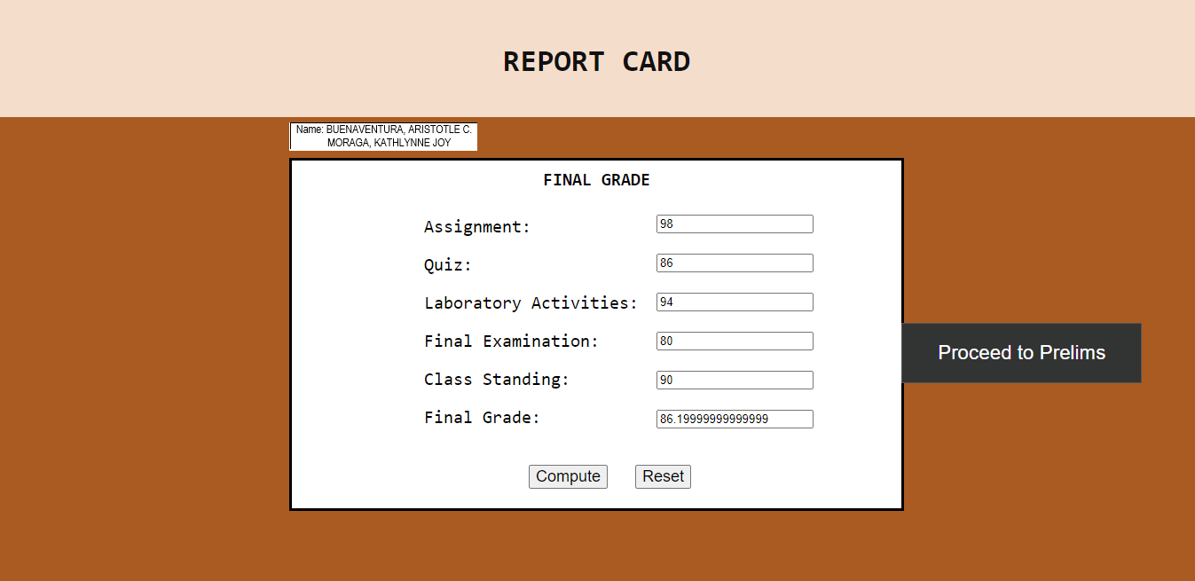

Lastly, when users successfully computed their prelim and midterm grades, they can now proceed to finals and calculate their final grades.

**Honor Pledge:** "We affirm that we have not given or received any unauthorized help on this assignment, and that this work is our own"