Technological Institute of the Philippines

938 Aurora Blvd. Cubao, Quezon City

College of Information Technology Education

IT 004– Web Systems and Technologies

Final Period

Altering Table Structures; and

Adding Image File in the Table Records

|  |  |
| --- | --- |
| Name: BUENAVENTURA, ARISTOTLE C. | Date: 11/21/2021 |
| Program / Section: IT12S21 | Instructor: Ms. Roxanne A. Pagaduan |
| Assessment Task: Quiz No 6 | |

**Instructions:**

* Provide screenshots to satisfy the requirements. (note: include screenshot of source code and sample run-time output in every source code and output changes)
* Include your **FULLNAME** in every screenshot.
* You are required to provide the screenshot of your source code for each file like (.html, .css, .js, .php) and a sample output running in the browser.
* Include a brief description in each screenshot.
* Use appropriate filename in saving your files.
* Save your work as **SURNAME_Quiz6.DOCX** (Ex. PAGADUAN_Quiz6.DOCX and .PDF)

**Requirements:**

1. Open and modify your php_connection database created from previous activity to satisfy the requirements.
2. Start up your server and database using php and mysql respectively.
3. Using myphpAdmin, alter the table structure and add a new column (image file type).
4. Provide the complete step-by-step procedure in adding a new image file column in the table. Include description as possible in each screenshot. Also, label each image number and include a brief description in each image.
5. Provide the final source code of all scripts (index.php, connection.php, edit.php, delete.php, etc).
6. Provide screenshot of all scripts and myphpAdmin (table structure).
7. Display the final output at running in any browser.

Note: Refer on the provided steps. (see File Maintenance using PHP and MYSQL part1a and part2b videos)

Video Link: <https://www.youtube.com/watch?v=1IbXtIPWM3s>

**ANSWER:**

**Source Code:**

***index.php***

<?php

include "connection.php";

?>

<!DOCTYPE html>

<html lang="en">

<head>

<meta charset="UTF-8">

<meta http-equiv="X-UA-Compatible" content="IE=edge">

<meta name="viewport" content="width=device-width, initial-scale=1.0">

<link rel="stylesheet"href="https://maxcdn.bootstrapcdn.com/bootstrap/3.4.1/css/bootstrap.min.css">

<script src="https://ajax.googleapis.com/ajax/libs/jquery/3.5.1/jquery.min.js"></script>

<script src="https://maxcdn.bootstrapcdn.com/bootstrap/3.4.1/js/bootstrap.min.js"></script>

</head>

<body>

<div class="container">

<div class="col-lg-4">

<h2>Gourmet Hotel Reservation List</h2>

<form action="" name="form1" method="post" enctype="multipart/form-data">

<div class="form-group">

<label for="image">Image</label>

<input type="file" class="form-control" name="f1">

</div>

<div class="form-group">

<label for="email">First Name</label>

<input type="text" class="form-control" id="firstname" placeholder="Enter First Name"

name="firstname">

</div>

<div class="form-group">

<label for="pwd">Last Name</label>

<input type="text" class="form-control" id="lastname" placeholder="Enter Last Name"

name="lastname">

</div>

<div class="form-group">

<label for="email">Email Address</label>

<input type="email" class="form-control" id="email" placeholder="Enter Email Address" name="email">

</div>

<div class="form-group">

<label for="pwd">Contact Number</label>

<input type="text" class="form-control" id="contact" placeholder="Enter Contact Number"

name="contact">

</div>

<button type="submit" name="insert" class="btn btn-default">Insert</button>

<button type="submit" name="update" class="btn btn-default">Update</button>

<button type="submit" name="delete" class="btn btn-default">Delete</button>

</form>

</div>

</div>

<div class="col-lg-12">

<table class="table table-bordered">

<thead>

<tr>

<th>ID</th>

<th>Image</th>

<th>First Name</th>

<th>Last Name</th>

<th>Email Address</th>

<th>Contact Number</th>

</tr>

</thead>

<tbody>

<?php $res=mysqli_query($link,"select * from table1");while($row=mysqli_fetch_array($res))

{echo "<tr>";

echo "<td>"; echo $row["id"]; echo "</td>";

echo "<td>"; ?> <img src="<?php echo $row["image"]; ?>" height="100" width="100"> <?php echo"</td>";

echo "<td>"; echo $row["firstname"]; echo "</td>";

echo "<td>"; echo $row["lastname"]; echo "</td>";

echo "<td>"; echo $row["email"]; echo "</td>";

echo "<td>"; echo $row["contact"]; echo "</td>";

echo "<td>"; ?> <a href="edit.php?id=<?php echo $row["id"]; ?>"<button type="button"class="btn-success">Edit</button></a> <?php echo "</td>";

echo "<td>"; ?> <a href="delete.php?id=<?php echo $row["id"]; ?>"<button type="button"class="btn-danger">Delete</button></a> <?php echo "</td>";

echo "</tr>";

}

?>

</tbody>

</table>

</div>

</body>

<?php

if(isset($_POST["insert"]))

{

$tm=md5(time());

$fnm=$_FILES["f1"]["name"];

$dst="./images/".$tm.$fnm;

$dst1="images/".$tm.$fnm;

move_uploaded_file($_FILES["f1"]["tmp_name"],$dst);

mysqli_query($link,"insert into table1

values(NULL,'$dst1','$_POST[firstname]','$_POST[lastname]','$_POST[email]','$_POST[contact]')");

?>

<script type="text/javascript">

window.location.href=window.location.href;

</script>

<?php

}

if(isset($_POST["delete"]))

{

mysqli_query($link, "delete from table1 where firstname='$_POST[firstname]'") or

die(mysqli_error($link));

}

if(isset($_POST["update"]))

{

mysqli_query($link, "update table1 set firstname='$_POST[lastname]' where

firstname='$_POST[firstname]'") or die(mysqlii_error($link));

}

?>

</html>

***edit.php***

<?php

include "connection.php";

$id=$_GET["id"];

$firstname="";

$lastname="";

$email="";

$contact="";

$image="";

$res=mysqli_query($link,"select * from table1 where Id=$id");

while($row=mysqli_fetch_array($res))

{

$firstname=$row["firstname"];

$lastname=$row["lastname"];

$email=$row["email"];

$contact=$row["contact"];

$image=$row["image"];

}

?>

<!DOCTYPE html>

<html lang="en">

<head>

<meta charset="UTF-8">

<meta http-equiv="X-UA-Compatible" content="IE=edge">

<meta name="viewport" content="width=device-width, initial-scale=1.0">

<link rel="stylesheet"href="https://maxcdn.bootstrapcdn.com/bootstrap/3.4.1/css/bootstrap.min.css">

<script src="https://ajax.googleapis.com/ajax/libs/jquery/3.5.1/jquery.min.js"></script>

<script src="https://maxcdn.bootstrapcdn.com/bootstrap/3.4.1/js/bootstrap.min.js"></script>

</head>

<body>

<div class="container">

<div class="col-lg-4">

<h2>Vertical (basic) form</h2>

<form action="" name="form1" method="post" enctype="multipart/form-data">

<img src="<?php echo $image; ?>" height="100" width="100">

<div class="form-group">

<label for="image">Image</label>

<input type="file" class="form-control" name="f1">

</div>

<div class="form-group">

<label for="email">firstname</label>

<input type="text" class="form-control" id="firstname" placeholder="Enter firstname"

name="firstname" value="<?php echo $firstname; ?>">

</div>

<div class="form-group">

<label for="pwd">lastname</label>

<input type="text" class="form-control" id="lastname" placeholder="Enter lastname"

name="lastname" value="<?php echo $lastname; ?>">

</div>

<div class="form-group">

<label for="email">email</label>

<input type="email" class="form-control" id="email" placeholder="Enter email" name="email"

value="<?php echo $email; ?>">

</div>

<div class="form-group">

<label for="pwd">contact</label>

<input type="text" class="form-control" id="contact" placeholder="Enter contact"

name="contact" value="<?php echo $contact; ?>">

</div>

<button type="submit" name="update" class="btn btn-default">Update</button>

</form>

</div>

</div>

</body>

<?php

if(isset($_POST["update"]))

{

$tm=md5(time());

$fnm=$_FILES["f1"]["name"];

if($fnm=="")

{

mysqli_query($link,"update table1 set

firstname='$_POST[firstname]',lastname='$_POST[lastname]',email='$_POST[email]',contact='$_POST

[contact]' where id=$id");

}

else

{

$dst="./images/".$tm.$fnm;

$dst1="images/".$tm.$fnm;

move_uploaded_file($_FILES["f1"]["tmp_name"],$dst);

mysqli_query($link,"update table1 set

image='$dst1',firstname='$_POST[firstname]',lastname='$_POST[lastname]',email='$_POST[email]',contact='$_POST

[contact]' where id=$id");

}

?>

<script type="text/javascript">

window.location="index.php";

</script>

<?php

}

?>

</html>

***delete.php***

<?php

include "connection.php";

$id=$_GET["id"];

mysqli_query($link, "delete from table1 where id=$id");

?>

<script type="text/javascript">

window.location="index.php";

</script>

***connection.php***

<?php

$link=mysqli_connect("localhost", "root", "") or die (mysqli_error($link));

mysqli_select_db($link,"php_connection") or die (mysqli_error($link));

?>

**Screenshots of Code Source:**

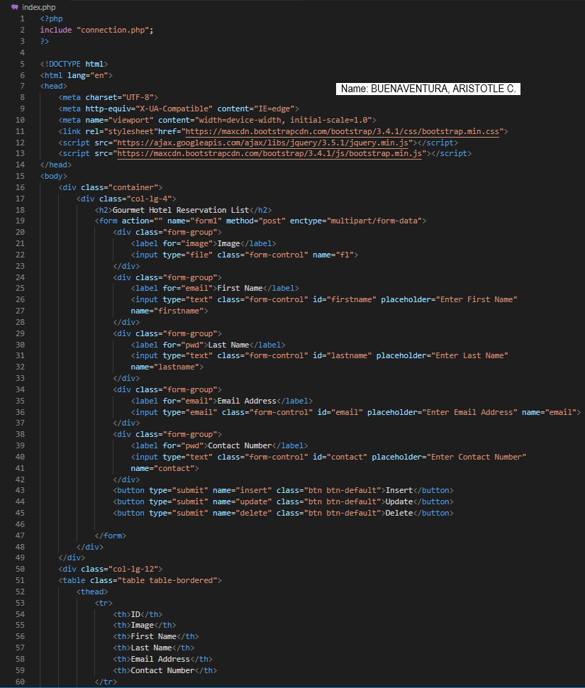

*Figure 1. index.php part 1*

I simply altered several formats and text after copying the code from our professor's tutorial. The user must fill up a form with information such as their image, first and last names, email address, and contact information. The insert, update, and delete buttons are all located below that.

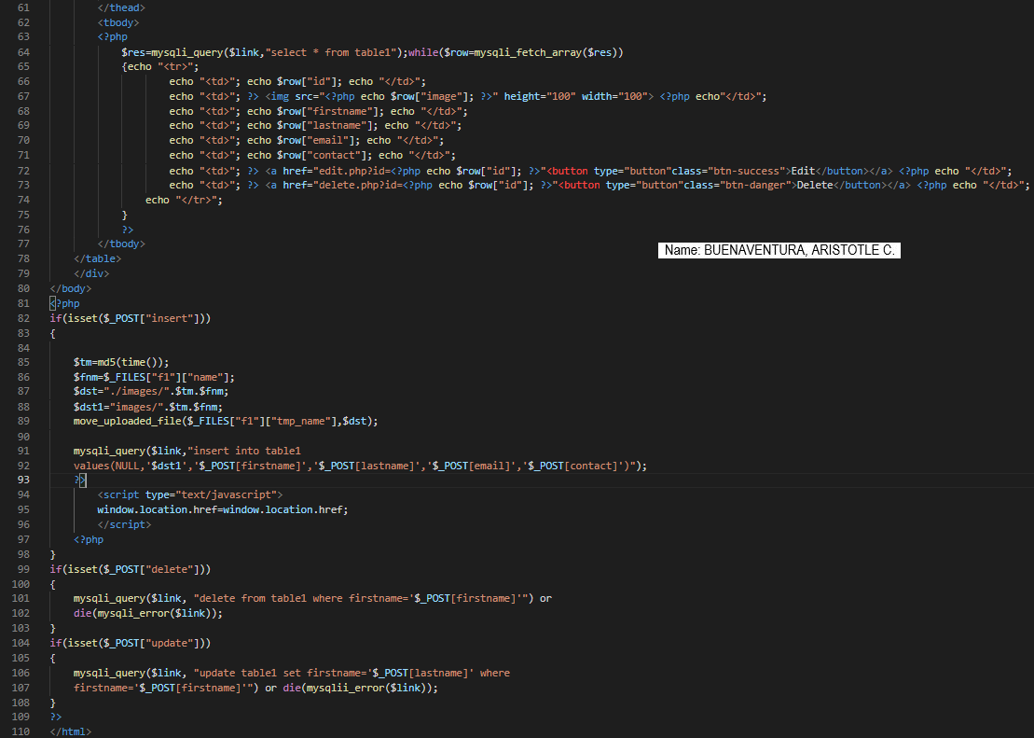

*Figure 1.1 index.php part 2*

This is an extension of the index.php file. First, the code has static values for each variable, but when PHP is used, it becomes dynamic. The values will now be defended based on user input. PHP will just display the values from the database in the website's interface.

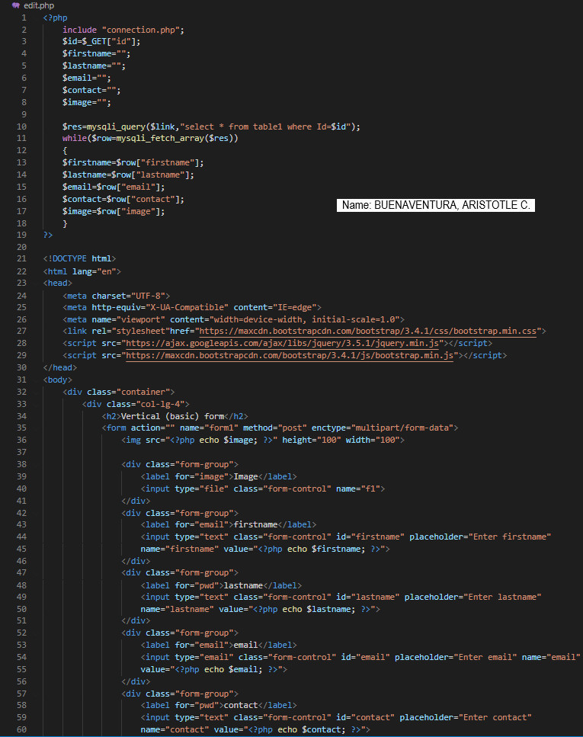

*Figure 2. edit.php part 1*

This is the editing section, where I just duplicated the index.php code block and eliminated some features because this is a new website. When a user hits the Update button, a new page appears, allowing them to edit the account they want to change.

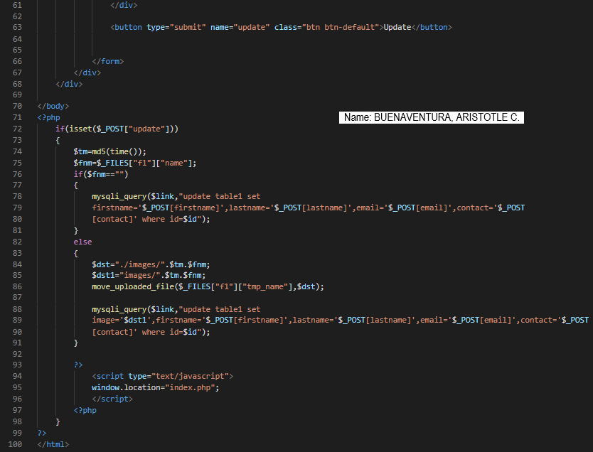

*Figure 2.1. edit.php part 2*

This is the second step of the editing process. The PHP code below is for changing database data, and the revised information will appear on the website so that the user can view the changes.

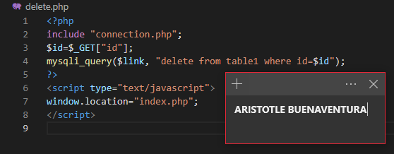

*Figure 3. delete.php*

This is the code for deleting an account in the database that will also reflect on the website.

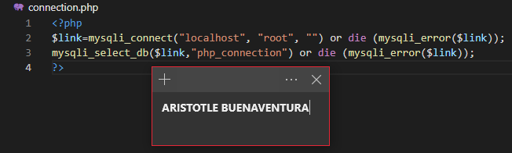

*Figure 4. connection.php*

The goal here is to link the website to the localhost. To introduce the connections, the file connection.php was linked in the index.php file.

**Sample Output Running in Web Browser:**

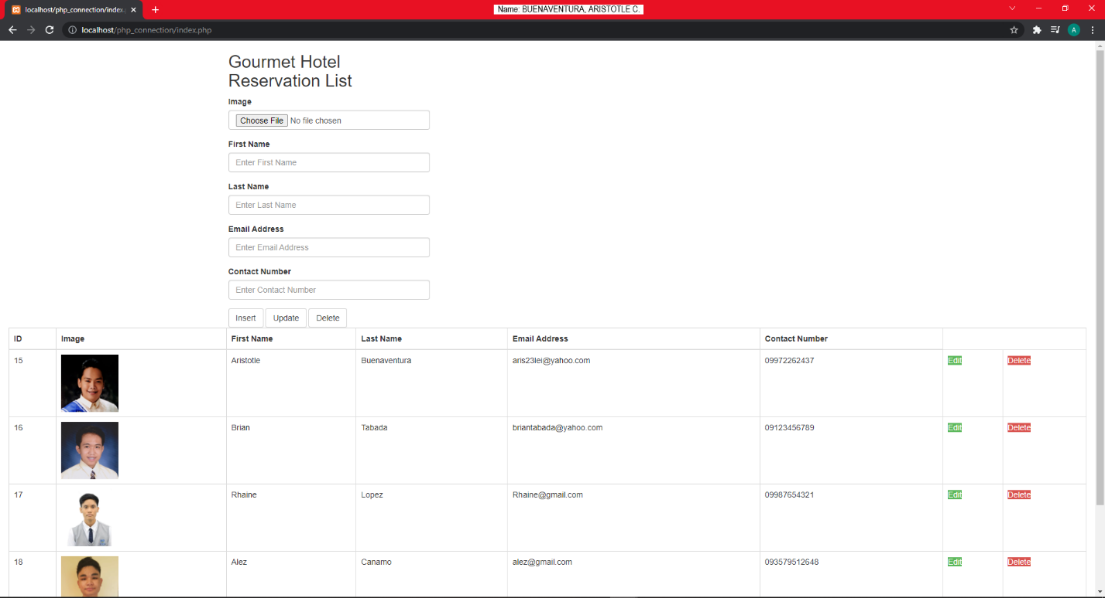

*Figure 5. List of Users*

This is identical to the prior work, except that the image is now included in the table. When creating an account, you must provide your first and last names, email address, phone number, and photo. A specific account can be added, updated, or deleted by the Admin.

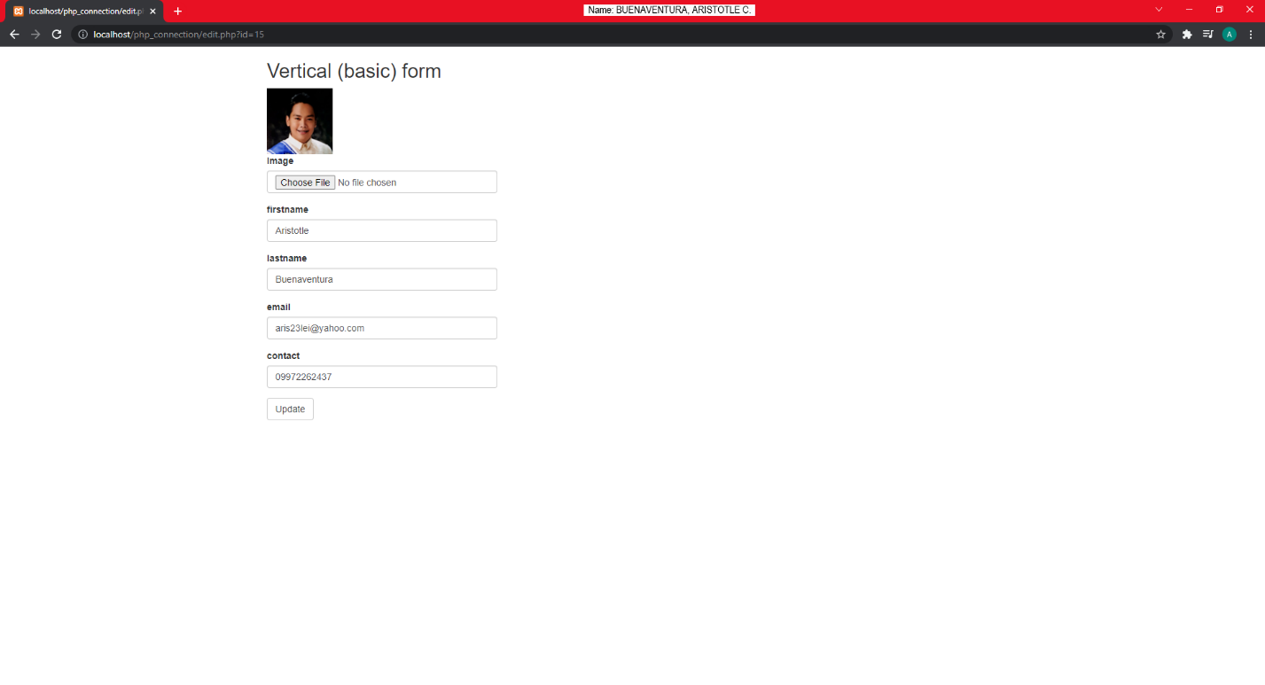

*Figure 5.1 Update Information*

By simply clicking the Select file button, the admin can change the image of a certain account; a pop-up folder will appear, from which the admin can select an image. The administrator must then click the update button.

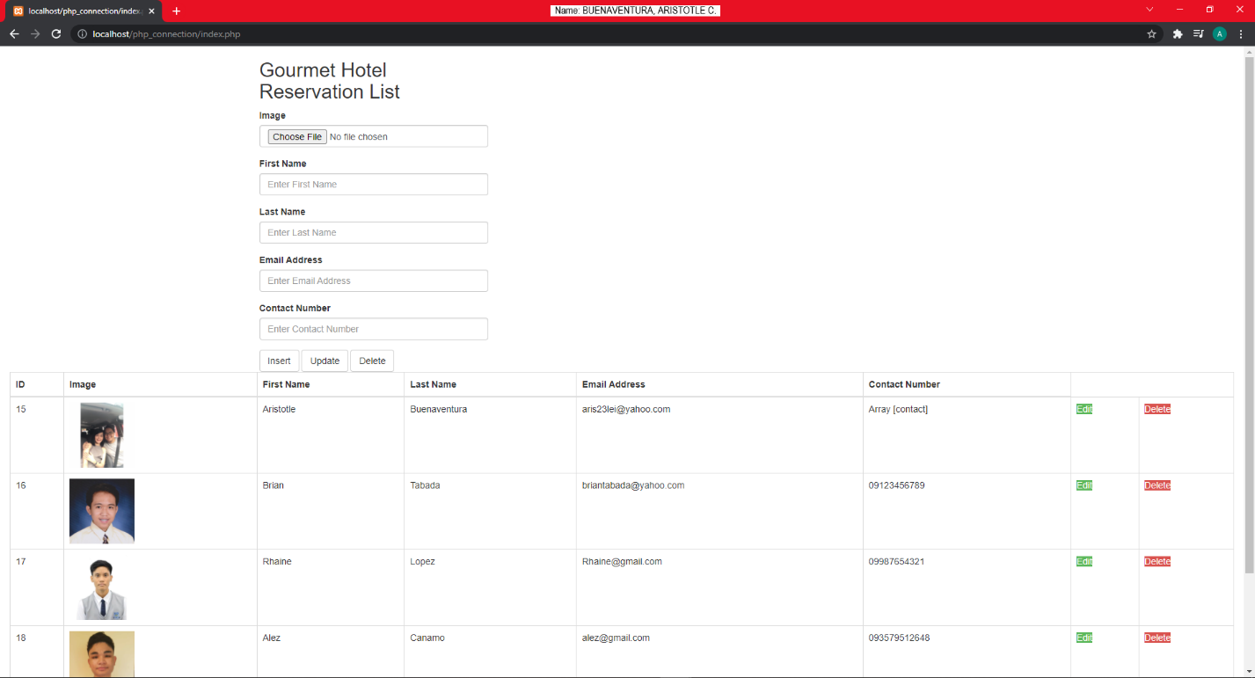

*Figure 5.1 Updated Information*

The new information for the specific account will appear in the table after the admin clicks the update button. As you can see, Aristotle's photograph has changed from the previous one.

**Honor Pledge**

“I affirm that I have not given or received any unauthorized help on this assignment, and that this work is my own.”