**Web Page 3: Wedding Events**

**Source Code:**

***wedding.html***

 <!DOCTYPE html>

<html lang="en">

<head>

<meta charset="UTF-8">

<meta http-equiv="X-UA-Compatible" content="IE=edge">

<meta name="viewport" content="width=device-width, initial-scale=1.0">

<!-- Link for bootstrap -->

<link rel="stylesheet" href="https://stackpath.bootstrapcdn.com/bootstrap/4.1.3/css/bootstrap.min.css"

integrity="sha384-MCw98/SFnGE8fJT3GXwEOngsV7Zt27NXFoaoApmYm81iuXoPkFOJwJ8ERdknLPMO"

crossorigin="anonymous">

<title>Wedding Events - Gourmet Hotel</title>

<link rel="stylesheet" href="csscustom.css">

<link rel="stylesheet" href="https://cdnjs.cloudflare.com/ajax/libs/font-awesome/4.7.0/css/font-awesome.min.css">

</head>

<body>

<header class="header container-fluid "id="event-wedding">

<nav class="navbar fixed-top navbar-expand-lg navbar-dark scrolling-navbar">

<a class="navbar-brand px-4 py-4" href="#">Gourmet Hotel</a>

<button class="navbar-toggler" type="button" data-toggle="collapse" data-target="#navbarH">

<span class="navbar-toggler-icon"></span>

</button>

<div class="collapse navbar-collapse" id="navbarH">

<ul class="navbar-nav ml-auto">

<li class="nav-item active">

<a class="nav-link" href="#">Home</a>

</li>

<div class="nav-item dropdown">

<button class="nav-link dropdown-toggle" type="button" id="dropdownMenuLink" data-toggle="dropdown">

Rooms

</button>

<div class="dropdown-menu">

<div class="row">

<div class="col-md-3">

<a class="dropdown-item" href="rooms/Alpha.html">Alpha Room</a>

<a class="dropdown-item" href="rooms/Bravo.html">Bravo Room</a>

<a class="dropdown-item" href="rooms/Charlie.html">Charlie Room</a>

<a class="dropdown-item" href="rooms/Delta.html">Delta Room</a>

</div>

</div>

</div>

</div>

<div class="nav-item dropdown">

<button class="nav-link dropdown-toggle" type="button" id="dropdownMenuLink" data-toggle="dropdown">

Events

</button>

<div class="dropdown-menu">

<div class="row">

<div class="col-md-3">

<a class="dropdown-item" href="wedding.html">Wedding</a>

<a class="dropdown-item" href="corporate.html">Corporate</a>

</div>

</div>

</div>

</div>

<li class="nav-item">

<a class="nav-link" href="#">Inquiries</a>

</li>

<li class="nav-item">

<a class="nav-link" href="#">About</a>

</li>

</ul>

</div>

</nav>

<div class="description">

<h1>Wedding Events</h1>

<button class="btn btn-outline-secondary btn-lg">Inquire now</button>

</div>

<div class="overlay"></div>

</header>

<div class="container features">

<div class="row content-text">

<div class="col">

<h3 class="feature-title">Where the adventure begins</h3>

<div class="container">

<p>Ready to start a relationship with our historical and cultural

auditorium all over again. We have a variety of stunning wedding

venues to choose from, ranging from big to small. We have the ideal

atmosphere for your special occasion in a range of styles. The same

exceptional service also accompanies the historic venues that our

landmark hotel is recognized for.

</p>

<p>

Large wedding celebrations have taken place at the Gourmet Hotel.

With its ambiance of classical beauty, the great dame is the epitome

of elegance and luxury and is known for its legendary service and Filipino

friendliness. The hotel's staff's warmth and service excellence will exceed

your expectations and ensure the success of your reception.

</p>

<p>

Appreciate an award-winning culinary team's wedding meal, evening snacks,

and a variety of special extras. Our popular all-inclusive packages offer

a cost-effective option without sacrificing quality. We have a variety of

amenities to make your wedding particularly unique, as well as tasty cuisine

options.

</p>

<p>

We invite you to share your special day with us since we have a wealth of

experience and a reputation for style. Our spectacular hotel, located in the

center of Manila, allows you to construct the wedding day of your dreams with

the freedom and originality you desire.

</p>

</div>

</div>

<div class="col">

<div id="accordion">

<div class="card">

<div class="card-header" id="headingOne">

<h5 class="mb-0">

<button class="btn btn-link" data-toggle="collapse" data-target="#collapseOne" aria-expanded="true" aria-controls="collapseOne">

Details

</button>

</h5>

</div>

<div id="collapseOne" class="collapse show" aria-labelledby="headingOne" data-parent="#accordion">

<div class="card-body">

Capacity: Up to 1,250 guests<br>

Area: 1, 072 square meters

</div>

</div>

</div>

<div class="card">

<div class="card-header" id="headingTwo">

<h5 class="mb-0">

<button class="btn btn-link collapsed" data-toggle="collapse" data-target="#collapseTwo" aria-expanded="false" aria-controls="collapseTwo">

Request for Proposal

</button>

</h5>

</div>

<div id="collapseTwo" class="collapse" aria-labelledby="headingTwo" data-parent="#accordion">

<div class="card-body">

If you require any further information or wish to guarantee your place

please call us at Cookie Eater Team at +639 972 262 437

or +02 847 738 48.

</div>

<div class="card-body">Request for Proposal.</div>

</div>

</div>

<div class="card">

<div class="card-header" id="headingThree">

<h5 class="mb-0">

<button class="btn btn-link collapsed" data-toggle="collapse" data-target="#collapseThree" aria-expanded="false" aria-controls="collapseThree">

We will contact you

</button>

</h5>

</div>

<div id="collapseThree" class="collapse" aria-labelledby="headingThree" data-parent="#accordion">

<div class="card-body">

<form class="needs-validation" novalidate>

<div class="form-row">

<div class="col-md-6 mb-3">

<label for="validationCustom01">First name</label>

<input type="text" class="form-control" id="validationCustom01" placeholder="First name" required>

<div class="valid-feedback">

Looks good!

</div>

</div>

<div class="col-md-6 mb-3">

<label for="validationCustom02">Last name</label>

<input type="text" class="form-control" id="validationCustom02" placeholder="Last name" required>

<div class="valid-feedback">

Looks good!

</div>

</div>

</div>

<div class="form-row">

<div class="col-md-6 mb-3">

<label for="validationCustom03">City</label>

<input type="text" class="form-control" id="validationCustom03" placeholder="City" required>

<div class="invalid-feedback">

Please provide a valid city.

</div>

</div>

<div class="col-md-6 mb-3">

<label for="validationCustom02">Email</label>

<input type="text" class="form-control" id="validationCustom02" placeholder="Email" required>

<div class="valid-feedback">

Looks good!

</div>

</div>

</div>

<div class="form-group">

<div class="form-check">

<input class="form-check-input" type="checkbox" value="" id="invalidCheck" required>

<label class="form-check-label" for="invalidCheck">

Agree to terms and conditions

</label>

<div class="invalid-feedback">

You must agree before submitting.

</div>

</div>

</div>

<button class="btn btn-primary" type="submit">Submit form</button>

</form>

</div>

</div>

</div>

</div>

</div>

</div>

</div>

<div id="carouselExampleIndicators" class="carousel slide" data-ride="carousel">

<ol class="carousel-indicators">

<li data-target="#carouselExampleIndicators" data-slide-to="0" class="active"></li>

<li data-target="#carouselExampleIndicators" data-slide-to="1"></li>

<li data-target="#carouselExampleIndicators" data-slide-to="2"></li>

<li data-target="#carouselExampleIndicators" data-slide-to="3"></li>

<li data-target="#carouselExampleIndicators" data-slide-to="4"></li>

<li data-target="#carouselExampleIndicators" data-slide-to="5"></li>

<li data-target="#carouselExampleIndicators" data-slide-to="6"></li>

<li data-target="#carouselExampleIndicators" data-slide-to="7"></li>

</ol>

<div class="carousel-inner">

<div class="carousel-item active">

<img class="d-block w-100" src="images/black.jpg" alt="First slide">

</div>

<div class="carousel-item">

<img class="d-block w-100" src="images/event2.jpg" alt="Second slide">

</div>

<div class="carousel-item">

<img class="d-block w-100" src="images/elegant.jpg" alt="Third slide">

</div>

<div class="carousel-item">

<img class="d-block w-100" src="images/pink.jpg" alt="Third slide">

</div>

<div class="carousel-item">

<img class="d-block w-100" src="images/violet.jpg" alt="Third slide">

</div>

<div class="carousel-item">

<img class="d-block w-100" src="images/wedding.jpg" alt="Third slide">

</div>

<div class="carousel-item">

<img class="d-block w-100" src="images/wedding2.jpg" alt="Third slide">

</div>

<div class="carousel-item">

<img class="d-block w-100" src="images/yellow.jpg" alt="Third slide">

</div>

</div>

<a class="carousel-control-prev" href="#carouselExampleIndicators" role="button" data-slide="prev">

<span class="carousel-control-prev-icon" aria-hidden="true"></span>

<span class="sr-only">Previous</span>

</a>

<a class="carousel-control-next" href="#carouselExampleIndicators" role="button" data-slide="next">

<span class="carousel-control-next-icon" aria-hidden="true"></span>

<span class="sr-only">Next</span>

</a>

</div>

<div class="container features">

<div class="row content-text">

<div class="col">

<h3 class="feature-title">Request for Proposal</h3>

<div class="container">

<p>If you require any further information or wish to guarantee your place

please call us at Cookie Eater Team at +639 972 262 437

or +02 847 738 48.</p>

<button class="btn btn-outline-secondary btn-lg">Inquire now</button>

</div>

</div>

<div class="col">

<div class="container">

<div class="map-responsive">

<iframe src="https://www.google.com/maps/embed?pb=!1m14!1m12!1m3!1d2729.818297825859!2d121.05931872638772!3d14.624916157068517!2m3!1f0!2f0!3f0!3m2!1i1024!2i768!4f13.1!5e0!3m2!1sen!2sph!4v1635818164516!5m2!1sen!2sph"

style="border:0;" allowfullscreen="" loading="lazy"></iframe>

</div>

</div>

</div>

</div>

</div>

<footer class="text-center text-lg-start bg-light text-muted">

<section class="d-flex justify-content-center justify-content-lg-between p-4 border-bottom">

</section>

<section class="footlinks">

<div class="container text-center text-md-start mt-5">

<div class="row mt-3">

<div class="col-md-3 col-lg-4 col-xl-3 mx-auto mb-4">

<h6 class="text-uppercase fw-bold mb-4">

<i class="fas fa-gem me-3"></i> Follow us on:

</h6>

<p>

<a href="#" class="fa fa-facebook"></a>

<a href="#" class="fa fa-twitter"></a>

<a href="#" class="fa fa-instagram"></a>

</p>

</div>

<div class="col-md-3 col-lg-2 col-xl-2 mx-auto mb-4">

<h6 class="text-uppercase fw-bold mb-4">

About Us

</h6>

<p>

<a href="#!" class="text-reset">Who We Are</a>

</p>

<p>

<a href="#!" class="text-reset">What We Do</a>

</p>

<p>

<a href="#!" class="text-reset">Why Us</a>

</p>

</div>

<div class="col-md-4 col-lg-3 col-xl-3 mx-auto mb-md-0 mb-4">

<h6 class="text-uppercase fw-bold mb-4">

Contact

</h6>

<p> Marikina, NCR 1800, PH</p>

<p>gourmetHotel@grhotel.com.ph</p>

<p>+639 972 262 437</p>

<p>+02 847 738 48</p>

</div>

</div>

</div>

</section>

<div class="text-center p-4" style="background-color: rgba(0, 0, 0, 0.05);">

© 2021 Copyright:

<a class="text-reset fw-bold" href="PS3.html">Cookie Eaters Inc.</a>

</div>

</footer>

<!-- Jquery -->

<script src="https://code.jquery.com/jquery-3.3.1.slim.min.js"

integrity="sha384-q8i/X+965DzO0rT7abK41JStQIAqVgRVzpbzo5smXKp4YfRvH+8abtTE1Pi6jizo"

crossorigin="anonymous"></script>

<!-- Bootstrap -->

<script src="https://stackpath.bootstrapcdn.com/bootstrap/4.1.3/js/bootstrap.min.js"

integrity="sha384-ChfqqxuZUCnJSK3+MXmPNIyE6ZbWh2IMqE241rYiqJxyMiZ6OW/JmZQ5stwEULTy"

crossorigin="anonymous"></script>

<script src="javasc.js"></script>

</body>

</html>

**csscustom.css**

/* EVENTS CODES OVERRIDES */

#event-corporate {

background-position: bottom;

height: 800px;

background-image: url('images/event1.jpg');

}

.features {

margin: 4em auto;

padding: 1em;

position: relative;

}

.feature-title {

color: #333;

font-size: 1.3rem;

font-weight: 800;

margin-bottom: 20px;

text-transform: uppercase;

}

.features img {

-webkit-box-shadow: 1px 1px 4px rgba(0, 0, 0, 0.4);

-moz-box-shadow: 1px 1px 4px rgba(0, 0, 0, 0.4);

box-shadow: 1px 1px 4px rgba(0, 0, 0, 0.4);

margin-bottom: 16px;

}

.content{

max-width: 1000px;

margin-bottom: 100px;

}

.content p{

text-indent: 50px;

font-weight: 600;

}

.bottom{

margin-bottom: 0;

}

.row{

max-width: 1000px;

margin: 0;

}

.description{

color: white;

z-index: 1;

position: absolute;

bottom: 150px;

left: 100px;

}

.btn{

background-color: #333;

color: white;

}

.carousel-item{

height: 32rem;

background-size: cover;

}

.fix{

display: flex;

}

.carousel-item img {

height: 100%;

object-fit: cover;

}

.container {

padding: 0;

}

.btn{

background-color: rgb(185, 184, 185);

color: black;

}

.btn-link:hover {

color: black;

text-decoration: none;

}

.btn-link.focus, .btn-link:focus {

text-decoration: none;

}

.map-responsive{

overflow:hidden;

padding-bottom:56.25%;

position:relative;

height:0;

}

.map-responsive iframe{

left:0;

top:0;

height:100%;

width:100%;

position:absolute;

}

@media(max-width: 770px) {

.map-responsive{

margin-top: 40px;

}

.content-text .col {

flex-basis: unset;

}

}

/* Wedding */

#event-wedding {

background-position: bottom;

height: 800px;

background-image: url('images/couple.jpg');

}

**javasc.sc**

$(window).scroll(function() {

if($(window).scrollTop()) {

$("nav").addClass("black");

}

else {

$("nav").removeClass("black");

}

});

(function($) { "use strict";

$('body').on('mouseenter mouseleave','.nav-item',function(e){

if ($(window).width() > 750) {

var _d=$(e.target).closest('.nav-item');_d.addClass('show');

setTimeout(function(){

_d[_d.is(':hover')?'addClass':'removeClass']('show');

},1);

}

});

})(jQuery);

// Example starter JavaScript for disabling form submissions if there are invalid fields

(function() {

'use strict';

window.addEventListener('load', function() {

// Fetch all the forms we want to apply custom Bootstrap validation styles to

var forms = document.getElementsByClassName('needs-validation');

// Loop over them and prevent submission

var validation = Array.prototype.filter.call(forms, function(form) {

form.addEventListener('submit', function(event) {

if (form.checkValidity() === false) {

event.preventDefault();

event.stopPropagation();

}

form.classList.add('was-validated');

}, false);

});

}, false);

})();

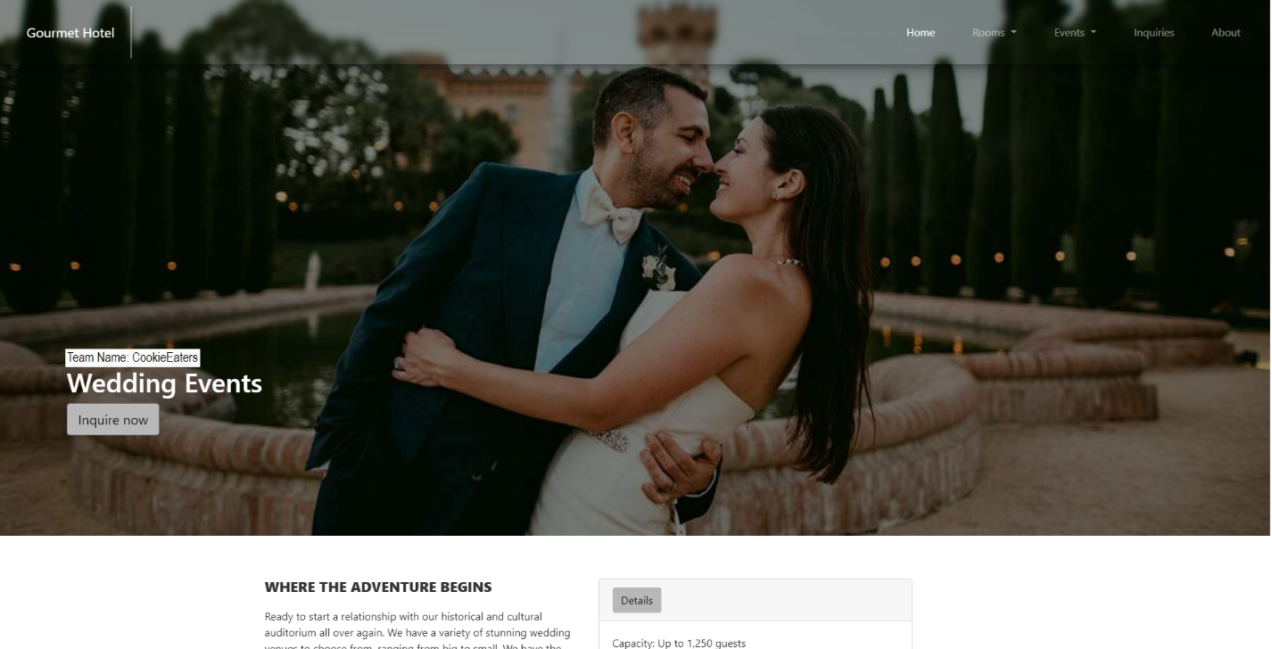**Output:**

*Figure 1. Wedding Event Page Part 1*

This is the web website for the wedding event; in the top, there is an image of a couple who symbolizes marriage. The web page's name is also displayed in the header's lower left corner. Users can utilize the inquire button to ask questions regarding the wedding event proposal.

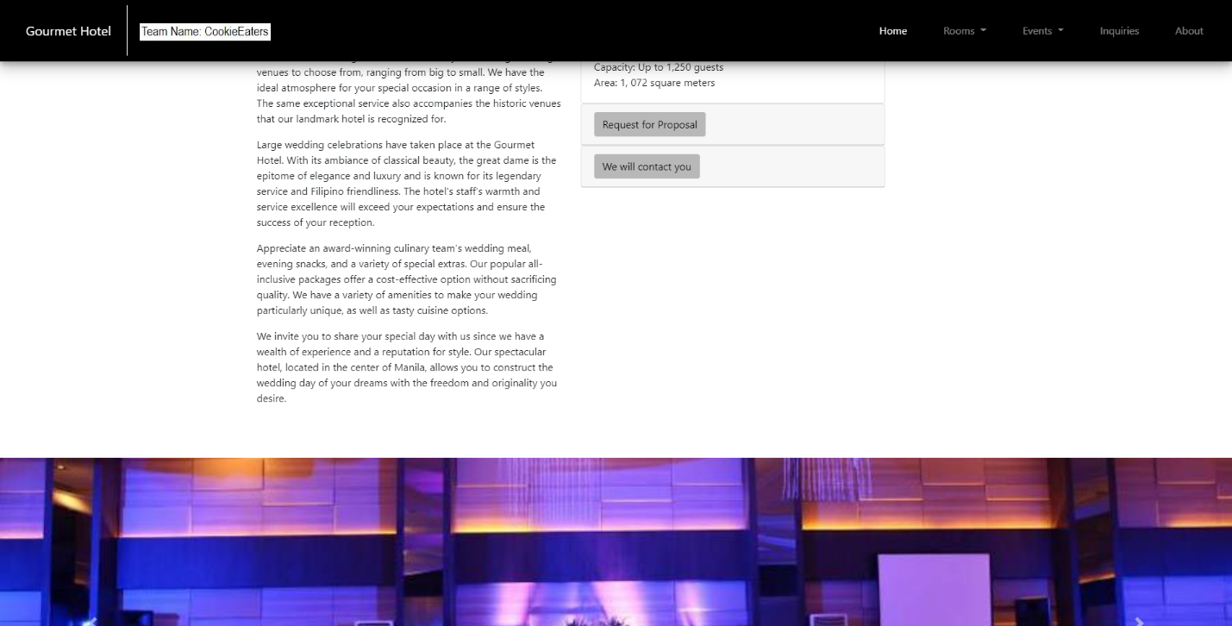

*Figure 2. Wedding Event Page Part 2*

The Gourmet Hotel's wedding events are described in detail on the second section of the wedding event web page. The kinds of experiences that clients might have. The details of the wedding room are located on the right side of it. There's also a page for requesting a proposal and another for entering contact information. The hotel will contact the users when they have filled out the form with their information.

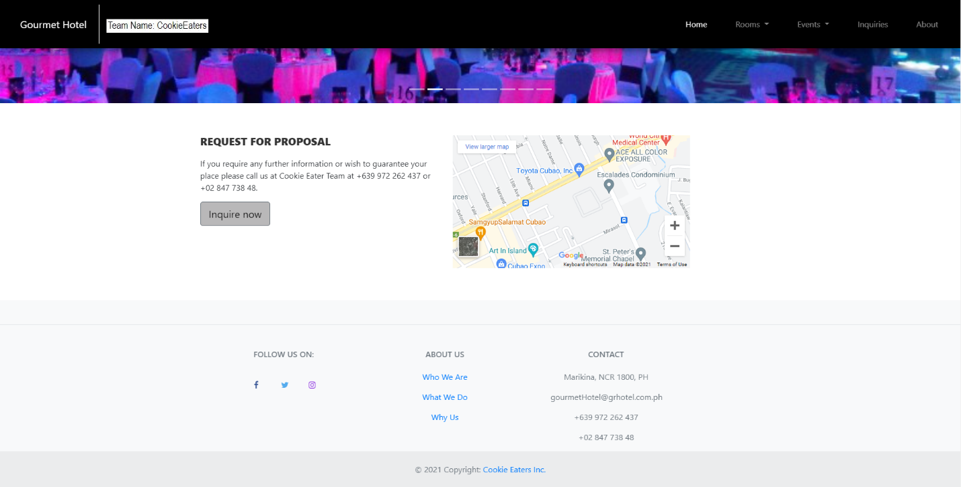 *Figure 3. Wedding Event Page Part 3*

The call for proposal is published again at the bottom of the wedding event web page. The Gourmet Hotel's location is shown on the right side of the map. The Gourmet Hotel's information is found in the footer.

**Web Page 4: Corporate Events**

**Source Code:**

<!DOCTYPE html>

<html lang="en">

<head>

<meta charset="UTF-8">

<meta http-equiv="X-UA-Compatible" content="IE=edge">

<meta name="viewport" content="width=device-width, initial-scale=1.0">

<!-- Link for bootstrap -->

<link rel="stylesheet" href="https://stackpath.bootstrapcdn.com/bootstrap/4.1.3/css/bootstrap.min.css"

integrity="sha384-MCw98/SFnGE8fJT3GXwEOngsV7Zt27NXFoaoApmYm81iuXoPkFOJwJ8ERdknLPMO"

crossorigin="anonymous">

<title>Corporate Events - Gourmet Hotel</title>

<link rel="stylesheet" href="csscustom.css">

<link rel="stylesheet" href="https://cdnjs.cloudflare.com/ajax/libs/font-awesome/4.7.0/css/font-awesome.min.css">

</head>

<body>

<header class="header container-fluid "id="event-corporate">

<nav class="navbar fixed-top navbar-expand-lg navbar-dark scrolling-navbar">

<a class="navbar-brand px-4 py-4" href="#">Gourmet Hotel</a>

<button class="navbar-toggler" type="button" data-toggle="collapse" data-target="#navbarH">

<span class="navbar-toggler-icon"></span>

</button>

<div class="collapse navbar-collapse" id="navbarH">

<ul class="navbar-nav ml-auto">

<li class="nav-item active">

<a class="nav-link" href="#">Home</a>

</li>

<div class="nav-item dropdown">

<button class="nav-link dropdown-toggle" type="button" id="dropdownMenuLink" data-toggle="dropdown">

Rooms

</button>

<div class="dropdown-menu">

<div class="row">

<div class="col-md-3">

<a class="dropdown-item" href="rooms/Alpha.html">Alpha Room</a>

<a class="dropdown-item" href="rooms/Bravo.html">Bravo Room</a>

<a class="dropdown-item" href="rooms/Charlie.html">Charlie Room</a>

<a class="dropdown-item" href="rooms/Delta.html">Delta Room</a>

</div>

</div>

</div>

</div>

<div class="nav-item dropdown">

<button class="nav-link dropdown-toggle" type="button" id="dropdownMenuLink" data-toggle="dropdown">

Events

</button>

<div class="dropdown-menu">

<div class="row">

<div class="col-md-3">

<a class="dropdown-item" href="wedding.html">Wedding</a>

<a class="dropdown-item" href="corporate.html">Corporate</a>

</div>

</div>

</div>

</div>

<li class="nav-item">

<a class="nav-link" href="#">Inquiries</a>

</li>

<li class="nav-item">

<a class="nav-link" href="#">About</a>

</li>

</ul>

</div>

</nav>

<div class="description">

<h1>Corporate Events</h1>

<button class="btn btn-outline-secondary btn-lg">Inquire now</button>

</div>

<div class="overlay"></div>

</header>

<div class="container features">

<div class="row content-text">

<div class="col">

<h3 class="feature-title">For your needs, we provide

a variety of meeting and event facilities.</h3>

<div class="container">

<p>Our ballrooms provide the ideal venue for your

most critical milestones, allowing you to celebrate

extraordinary moments with people who matter.

</p>

<p>

The Gourmet Hotel features a variety of flexible facilities to

fit your needs, whether it's a presentation, a launch event, or

a grand ball. Air-conditioned meeting rooms, Wi-Fi, and in-house

AV equipment provide everything you need for a comfortable and successful

conference or meeting. In addition, the crew can offer a comprehensive

range of catering services to meet your needs. Your professional conference

coordinator will guarantee that your day runs successfully with the support

of an experienced and helpful crew.

</p>

<p>

From beautiful wedding celebrations to significant business conventions,

the Gourmet Hotel's attractively designed ballrooms and banquet function

rooms provide more than enough space and state-of-the-art facilities.

</p>

<p>

The Gourmet Hotel, located in the city's cosmopolitan commercial and economic

district, provides suitable spaces for your corporate gatherings. Our distinctive

ballroom, function, and conference rooms are the perfect place for business

functions, product launches, and social events with a sophisticated visual

system. Our devoted staff of service professionals is always available to assist

you with your event's requirements.

</p>

<p>

You are invited to meet and more at the Gourmet Hotel. Whether you need a ballroom

or a boardroom, our hotel has a variety of meeting spaces that may be customized to

fit your specific needs.

</p>

<p>

The Gourmet Hotel has a whole team committed to making your stay as pleasant as possible.

</p>

</div>

</div>

<div class="col">

<div id="accordion">

<div class="card">

<div class="card-header" id="headingOne">

<h5 class="mb-0">

<button class="btn btn-link" data-toggle="collapse" data-target="#collapseOne" aria-expanded="true" aria-controls="collapseOne">

Details

</button>

</h5>

</div>

<div id="collapseOne" class="collapse show" aria-labelledby="headingOne" data-parent="#accordion">

<div class="card-body">

Capacity: Up to 750 guests<br>

Area: 980 square meters

</div>

</div>

</div>

<div class="card">

<div class="card-header" id="headingTwo">

<h5 class="mb-0">

<button class="btn btn-link collapsed" data-toggle="collapse" data-target="#collapseTwo" aria-expanded="false" aria-controls="collapseTwo">

Request for Proposal

</button>

</h5>

</div>

<div id="collapseTwo" class="collapse" aria-labelledby="headingTwo" data-parent="#accordion">

<div class="card-body">

If you require any further information or wish to guarantee your place

please call us at Cookie Eater Team at +639 972 262 437

or +02 847 738 48.

</div>

<div class="card-body">Request for Proposal.</div>

</div>

</div>

<div class="card">

<div class="card-header" id="headingThree">

<h5 class="mb-0">

<button class="btn btn-link collapsed" data-toggle="collapse" data-target="#collapseThree" aria-expanded="false" aria-controls="collapseThree">

We will contact you

</button>

</h5>

</div>

<div id="collapseThree" class="collapse" aria-labelledby="headingThree" data-parent="#accordion">

<div class="card-body">

<form class="needs-validation" novalidate>

<div class="form-row">

<div class="col-md-6 mb-3">

<label for="validationCustom01">First name</label>

<input type="text" class="form-control" id="validationCustom01" placeholder="First name" required>

<div class="valid-feedback">

Looks good!

</div>

</div>

<div class="col-md-6 mb-3">

<label for="validationCustom02">Last name</label>

<input type="text" class="form-control" id="validationCustom02" placeholder="Last name" required>

<div class="valid-feedback">

Looks good!

</div>

</div>

</div>

<div class="form-row">

<div class="col-md-6 mb-3">

<label for="validationCustom03">City</label>

<input type="text" class="form-control" id="validationCustom03" placeholder="City" required>

<div class="invalid-feedback">

Please provide a valid city.

</div>

</div>

<div class="col-md-6 mb-3">

<label for="validationCustom02">Email</label>

<input type="text" class="form-control" id="validationCustom02" placeholder="Email" required>

<div class="valid-feedback">

Looks good!

</div>

</div>

</div>

<div class="form-group">

<div class="form-check">

<input class="form-check-input" type="checkbox" value="" id="invalidCheck" required>

<label class="form-check-label" for="invalidCheck">

Agree to terms and conditions

</label>

<div class="invalid-feedback">

You must agree before submitting.

</div>

</div>

</div>

<button class="btn btn-primary" type="submit">Submit form</button>

</form>

</div>

</div>

</div>

</div>

</div>

</div>

</div>

<div id="carouselExampleIndicators" class="carousel slide" data-ride="carousel">

<ol class="carousel-indicators">

<li data-target="#carouselExampleIndicators" data-slide-to="0" class="active"></li>

<li data-target="#carouselExampleIndicators" data-slide-to="1"></li>

<li data-target="#carouselExampleIndicators" data-slide-to="2"></li>

<li data-target="#carouselExampleIndicators" data-slide-to="3"></li>

<li data-target="#carouselExampleIndicators" data-slide-to="4"></li>

<li data-target="#carouselExampleIndicators" data-slide-to="5"></li>

<li data-target="#carouselExampleIndicators" data-slide-to="6"></li>

<li data-target="#carouselExampleIndicators" data-slide-to="7"></li>

</ol>

<div class="carousel-inner">

<div class="carousel-item active">

<img class="d-block w-100" src="images/black.jpg" alt="First slide">

</div>

<div class="carousel-item">

<img class="d-block w-100" src="images/event2.jpg" alt="Second slide">

</div>

<div class="carousel-item">

<img class="d-block w-100" src="images/elegant.jpg" alt="Third slide">

</div>

<div class="carousel-item">

<img class="d-block w-100" src="images/pink.jpg" alt="Third slide">

</div>

<div class="carousel-item">

<img class="d-block w-100" src="images/violet.jpg" alt="Third slide">

</div>

<div class="carousel-item">

<img class="d-block w-100" src="images/wedding.jpg" alt="Third slide">

</div>

<div class="carousel-item">

<img class="d-block w-100" src="images/wedding2.jpg" alt="Third slide">

</div>

<div class="carousel-item">

<img class="d-block w-100" src="images/yellow.jpg" alt="Third slide">

</div>

</div>

<a class="carousel-control-prev" href="#carouselExampleIndicators" role="button" data-slide="prev">

<span class="carousel-control-prev-icon" aria-hidden="true"></span>

<span class="sr-only">Previous</span>

</a>

<a class="carousel-control-next" href="#carouselExampleIndicators" role="button" data-slide="next">

<span class="carousel-control-next-icon" aria-hidden="true"></span>

<span class="sr-only">Next</span>

</a>

</div>

<div class="container features">

<div class="row content-text">

<div class="col">

<h3 class="feature-title">Request for Proposal</h3>

<div class="container">

<p>If you require any further information or wish to guarantee your place

please call us at Cookie Eater Team at +639 972 262 437

or +02 847 738 48.</p>

<button class="btn btn-outline-secondary btn-lg">Inquire now</button>

</div>

</div>

<div class="col">

<div class="container">

<div class="map-responsive">

<iframe src="https://www.google.com/maps/embed?pb=!1m14!1m12!1m3!1d2729.818297825859!2d121.05931872638772!3d14.624916157068517!2m3!1f0!2f0!3f0!3m2!1i1024!2i768!4f13.1!5e0!3m2!1sen!2sph!4v1635818164516!5m2!1sen!2sph"

style="border:0;" allowfullscreen="" loading="lazy"></iframe>

</div>

</div>

</div>

</div>

</div>

<!-- Footer -->

<footer class="text-center text-lg-start bg-light text-muted">

<section class="d-flex justify-content-center justify-content-lg-between p-4 border-bottom">

</section>

<section class="footlinks">

<div class="container text-center text-md-start mt-5">

<div class="row mt-3">

<div class="col-md-3 col-lg-4 col-xl-3 mx-auto mb-4">

<h6 class="text-uppercase fw-bold mb-4">

<i class="fas fa-gem me-3"></i> Follow us on:

</h6>

<p>

<a href="#" class="fa fa-facebook"></a>

<a href="#" class="fa fa-twitter"></a>

<a href="#" class="fa fa-instagram"></a>

</p>

</div>

<div class="col-md-3 col-lg-2 col-xl-2 mx-auto mb-4">

<h6 class="text-uppercase fw-bold mb-4">

About Us

</h6>

<p>

<a href="#!" class="text-reset">Who We Are</a>

</p>

<p>

<a href="#!" class="text-reset">What We Do</a>

</p>

<p>

<a href="#!" class="text-reset">Why Us</a>

</p>

</div>

<div class="col-md-4 col-lg-3 col-xl-3 mx-auto mb-md-0 mb-4">

<h6 class="text-uppercase fw-bold mb-4">

Contact

</h6>

<p> Marikina, NCR 1800, PH</p>

<p>gourmetHotel@grhotel.com.ph</p>

<p>+639 972 262 437</p>

<p>+02 847 738 48</p>

</div>

</div>

</div>

</section>

<div class="text-center p-4" style="background-color: rgba(0, 0, 0, 0.05);">

© 2021 Copyright:

<a class="text-reset fw-bold" href="PS3.html">Cookie Eaters Inc.</a>

</div>

</footer>

<!-- Jquery -->

<script src="https://code.jquery.com/jquery-3.3.1.slim.min.js"

integrity="sha384-q8i/X+965DzO0rT7abK41JStQIAqVgRVzpbzo5smXKp4YfRvH+8abtTE1Pi6jizo"

crossorigin="anonymous"></script>

<!-- Bootstrap -->

<script src="https://stackpath.bootstrapcdn.com/bootstrap/4.1.3/js/bootstrap.min.js"

integrity="sha384-ChfqqxuZUCnJSK3+MXmPNIyE6ZbWh2IMqE241rYiqJxyMiZ6OW/JmZQ5stwEULTy"

crossorigin="anonymous"></script>

<script src="javasc.js"></script>

</body>

</html>

**csscustom.css**

/* EVENTS CODES OVERRIDES */

#event-corporate {

background-position: bottom;

height: 800px;

background-image: url('images/event1.jpg');

}

.features {

margin: 4em auto;

padding: 1em;

position: relative;

}

.feature-title {

color: #333;

font-size: 1.3rem;

font-weight: 800;

margin-bottom: 20px;

text-transform: uppercase;

}

.features img {

-webkit-box-shadow: 1px 1px 4px rgba(0, 0, 0, 0.4);

-moz-box-shadow: 1px 1px 4px rgba(0, 0, 0, 0.4);

box-shadow: 1px 1px 4px rgba(0, 0, 0, 0.4);

margin-bottom: 16px;

}

.content{

max-width: 1000px;

margin-bottom: 100px;

}

.content p{

text-indent: 50px;

font-weight: 600;

}

.bottom{

margin-bottom: 0;

}

.row{

max-width: 1000px;

margin: 0;

}

.description{

color: white;

z-index: 1;

position: absolute;

bottom: 150px;

left: 100px;

}

.btn{

background-color: #333;

color: white;

}

.carousel-item{

height: 32rem;

background-size: cover;

}

.fix{

display: flex;

}

.carousel-item img {

height: 100%;

object-fit: cover;

}

.container {

padding: 0;

}

.btn{

background-color: rgb(185, 184, 185);

color: black;

}

.btn-link:hover {

color: black;

text-decoration: none;

}

.btn-link.focus, .btn-link:focus {

text-decoration: none;

}

.map-responsive{

overflow:hidden;

padding-bottom:56.25%;

position:relative;

height:0;

}

.map-responsive iframe{

left:0;

top:0;

height:100%;

width:100%;

position:absolute;

}

@media(max-width: 770px) {

.map-responsive{

margin-top: 40px;

}

.content-text .col {

flex-basis: unset;

}

}

/* Wedding */

#event-wedding {

background-position: bottom;

height: 800px;

background-image: url('images/couple.jpg');

}

**javasc.sc**

$(window).scroll(function() {

if($(window).scrollTop()) {

$("nav").addClass("black");

}

else {

$("nav").removeClass("black");

}

});

(function($) { "use strict";

$('body').on('mouseenter mouseleave','.nav-item',function(e){

if ($(window).width() > 750) {

var _d=$(e.target).closest('.nav-item');_d.addClass('show');

setTimeout(function(){

_d[_d.is(':hover')?'addClass':'removeClass']('show');

},1);

}

});

})(jQuery);

// Example starter JavaScript for disabling form submissions if there are invalid fields

(function() {

'use strict';

window.addEventListener('load', function() {

// Fetch all the forms we want to apply custom Bootstrap validation styles to

var forms = document.getElementsByClassName('needs-validation');

// Loop over them and prevent submission

var validation = Array.prototype.filter.call(forms, function(form) {

form.addEventListener('submit', function(event) {

if (form.checkValidity() === false) {

event.preventDefault();

event.stopPropagation();

}

form.classList.add('was-validated');

}, false);

});

}, false);

})();

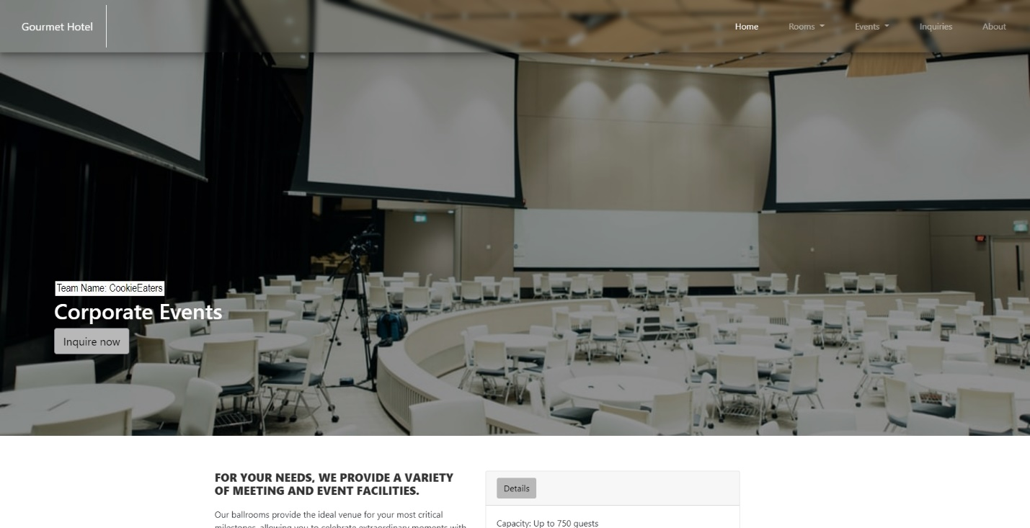**Output:**

*Figure 1. Corporate Event Page Part 1*

This is the corporate event webpage, including a photograph of the corporate room in the Gourmet Hotel at the top. The name of the web page is also shown in the lower left corner of the header. The inquiry button allows users to ask inquiries about the wedding event proposal.

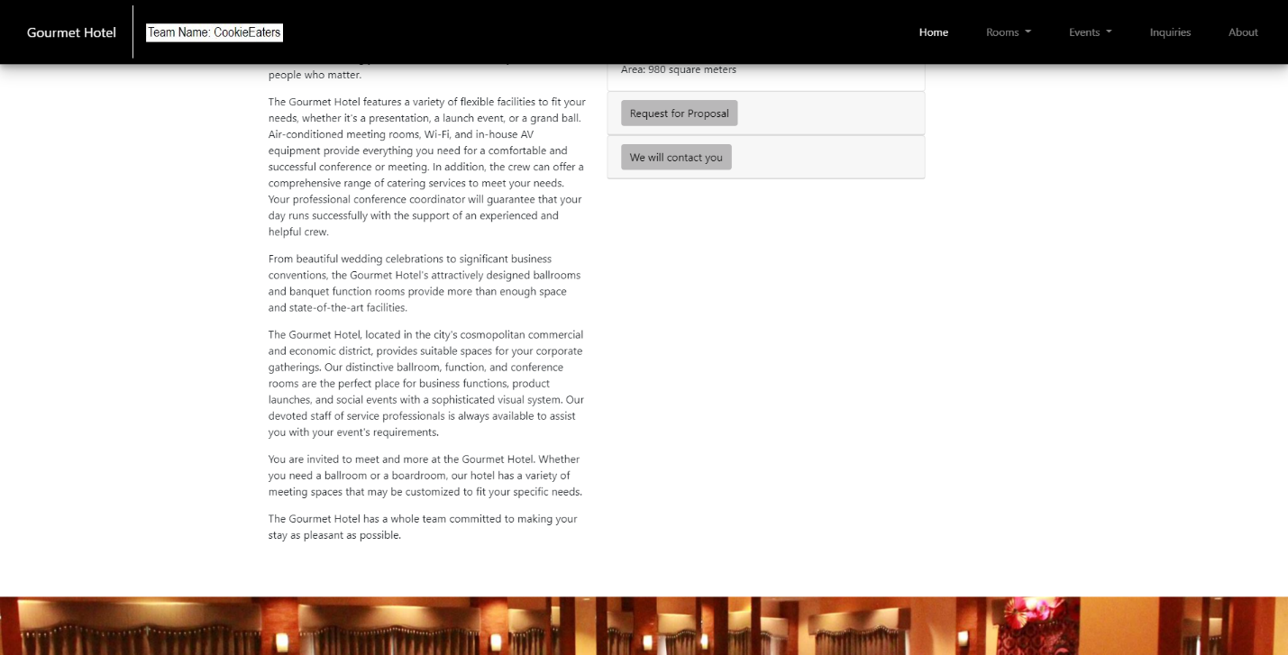*Figure 1. Wedding Event Page Part 1*

On the second portion of the corporate event web page, the Gourmet Hotel's corporate events are detailed. The kind of experiences that customers may have. The corporate room's information can be found on the right side. A page for requesting a proposal and another for inputting contact information are also available. When the users have completed the form and submitted their information, the hotel will contact them.

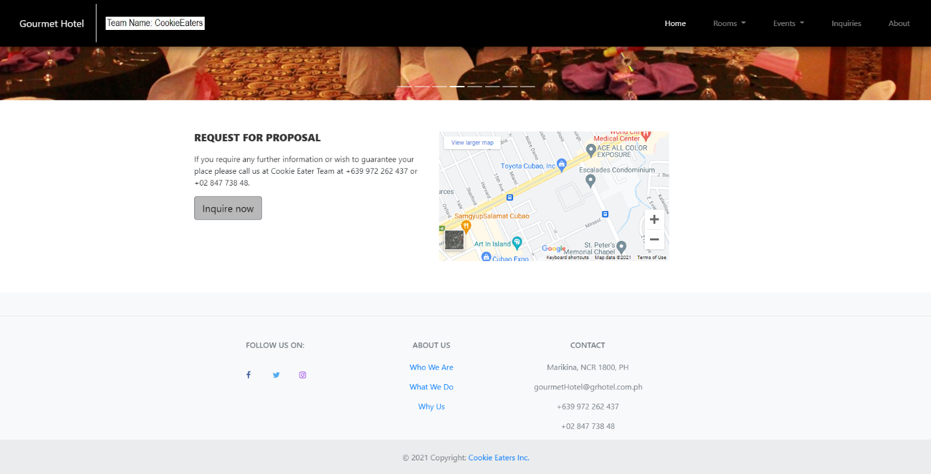*Figure 1. Wedding Event Page Part 1*

The request for proposals is posted at the bottom of the corporate event web page once more. The location of the Gourmet Hotel is given on the right side of the map. The information for the Gourmet Hotel can be found in the footer.