Technological Institute of the Philippines

938 Aurora Blvd. Cubao, Quezon City

College of Information Technology Education

IT 004 – Web Systems and Technologies

Midterm Period

Designing Landing Page Using Bootstrap

|  |  |
| --- | --- |
| Name: BUENAVENTURA, ARISTOTLE C. | Date: 10/28/2021 |
| Program / Section: IS12S2 | Instructor: Ms. Roxanne A. Pagaduan |
| Assessment Task: Assignment No. 2 | |

**Instructions:**

* Provide screenshots to satisfy the requirements.
* Include your FULLNAME in every screenshot.
* Include brief description in each screenshot.
* Save your work as **SURNAME_Assign2.DOC** (Ex. PAGADUAN_Assign2.DOC and .PDF)

**Requirements:**

After performing the steps provided in module 3 entitled “Interactive Web Design using Bootstrap, provide the following requirements:

1. Screenshot of all the html, css, and other files used.
   1. File Name: xxxx.html

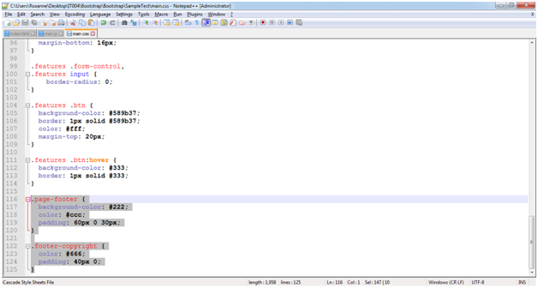

* 1. File Name: xxxx.css

*<provide the screenshot>*

***Note:*** *provide all the screenshot of your source code*

1. Sample Final Output Running in the Browser.

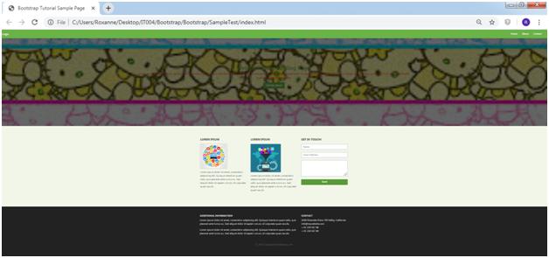

**Assessment Tool:**

This assessment will be graded using the Rubric for Laboratory Performance in Web Systems and Technologies.

Source Code:

***bootstrap.html***

<!DOCTYPE html>

<html lang="en">

<head>

<link rel="stylesheet" href="https://stackpath.bootstrapcdn.com/bootstrap/4.1.3/css/bootstrap.min.css"

integrity="sha384-MCw98/SFnGE8fJT3GXwEOngsV7Zt27NXFoaoApmYm81iuXoPkFOJwJ8ERdknLPMO" crossorigin="anonymous">

<link rel="stylesheet" href="bootstrap/css/bootstrap.min.css">

<link rel="stylesheet" type="text/css" href="main.css">

<title>Bootstrap Tutorial Sample Page</title>

<meta charset="utf-8">

<meta name="viewport" content="width=device-width, initial-scale=1">

</head>

<body>

<nav class="navbar navbar-expand-md">

<a class="navbar-brand" href="#">Logo</a>

<button class="navbar-toggler navbar-dark" type="button" data-toggle="collapse" data-target="#main-navigation">

<span class="navbar-toggler-icon"></span>

</button>

<div class="collapse navbar-collapse" id="main-navigation">

<ul class="navbar-nav">

<li class="nav-item">

<a class="nav-link" href="#">Home</a>

</li>

<li class="nav-item">

<a class="nav-link" href="#">About</a>

</li>

<li class="nav-item">

<a class="nav-link" href="#">Contact</a>

</li>

</ul>

</div>

</nav>

<header class="header">

<div class="description">

<h1>Welcome to the Landing Page!</h1>

<p>Lorem ipsum dolor sit amet, consectetur adipiscing elit. Quisque interdum quam odio,

quis placerat ante luctus eu. Sed aliquet dolor id sapien rutrum, id vulputate quam iaculis.

Suspendisse consectetur mi id libero fringilla, in pharetra sem ullamcorper.</p>

<button class="btn btn-outline-secondary btn-lg">Tell Me More!</button>

</div>

<div class="overlay"></div>

</header>

<div class="container features">

<div class="row">

<div class="col-lg-4 col-md-4 col-sm-12">

<h3 class="feature-title">Lorem ipsum</h3>

<img src="pythonLogo.jpeg" class="img-fluid" >

<p>Lorem ipsum dolor sit amet, consectetur adipiscing elit. Quisque interdum quam odio,

quis placerat ante luctus eu. Sed aliquet dolor id sapien rutrum, id vulputate quam iaculis.</p>

</div>

<div class="col-lg-4 col-md-4 col-sm-12">

<h3 class="feature-title">Lorem ipsum</h3>

<img src="pythonLOGO2.jpg" class="img-fluid">

<p>Lorem ipsum dolor sit amet, consectetur adipiscing elit. Quisque interdum quam odio,

quis placerat ante luctus eu. Sed aliquet dolor id sapien rutrum, id vulputate quam iaculis.</p>

</div>

<div class="col-lg-4 col-md-4 col-sm-12">

<h3 class="feature-title">Get in Touch!</h3>

<div class="form-group">

<input type="text" class="form-control" placeholder="Name" name="">

</div>

<div class="form-group">

<input type="email" class="form-control" placeholder="Email Address" name="email">

</div>

<div class="form-group">

<textarea class="form-control" rows="4"></textarea>

</div>

<input type="submit" class="btn btn-secondary btn-block" value="Send" name="">

</div>

</div>

</div>

<footer class="page-footer">

<div class="container">

<div class="row">

<div class="col-lg-8 col-md-8 col-sm-12">

<h6 class="text-uppercase font-weight-bold">Additional Information</h6>

<p>Lorem ipsum dolor sit amet, consectetur adipiscing elit. Quisque interdum quam odio,

quis placerat ante luctus eu. Sed aliquet dolor id sapien rutrum, id vulputate quam iaculis.</p>

<p>Lorem ipsum dolor sit amet, consectetur adipiscing elit. Quisque interdum quam odio,

quis placerat ante luctus eu. Sed aliquet dolor id sapien rutrum, id vulputate quam iaculis.</p>

</div>

<div class="col-lg-4 col-md-4 col-sm-12">

<h6 class="text-uppercase font-weight-bold">Contact</h6>

<p>1640 Riverside Drive, Hill Valley, California

<br/>info@mywebsite.com

<br/>+ 01 234 567 88

<br/>+ 01 234 567 89</p>

</div>

</div>

<div class="footer-copyright text-center">© 2019 Copyright: MyWebsite.com</div>

</footer>

<script src="https://code.jquery.com/jquery-3.3.1.slim.min.js"

integrity="sha384-q8i/X+965DzO0rT7abK41JStQIAqVgRVzpbzo5smXKp4YfRvH+8abtTE1Pi6jizo"

crossorigin="anonymous"></script>

<script src="https://stackpath.bootstrapcdn.com/bootstrap/4.1.3/js/bootstrap.min.js"

integrity="sha384-ChfqqxuZUCnJSK3+MXmPNIyE6ZbWh2IMqE241rYiqJxyMiZ6OW/JmZQ5stwEULTy"

crossorigin="anonymous"></script>

<script src="main.js"></script>

</body>

</html>

***main.css***

body {

padding: 0;

margin: 0;

background: #f2f6e9;

}

.navbar {

background:#6ab446;

}

.nav-link,.navbar-brand {

color: #fff;

cursor: pointer;

}

.nav-link {

margin-right: 1em !important;

}

.nav-link:hover {

color: #000;

}

.navbar-collapse {

justify-content: flex-end;

}

.header {

background-image: url('bg.jpg');

background-size: cover;

background-position: center;

position: relative;

}

.header.style {

height: 400px;

}

.overlay {

position: absolute;

min-height: 100%;

min-width: 100%;

left: 0;

top: 0;

background: rgba(0, 0, 0, 0.6);

}

.description {

left: 50%;

position: absolute;

top: 45%;

transform: translate(-50%, -50%);

text-align: center;

}

.description h1 {

color: #6ab446;

}

.description p {

color: #fff;

font-size: 1.3rem;

line-height: 1.5;

}

.description button {

border:1px solid #6ab446;

background:#6ab446;

border-radius: 0;

color:#fff;

}

.description button:hover {

border:1px solid #fff;

background:#fff;

color:#000;

}

.features {

margin: 4em auto;

padding: 1em;

position: relative;

}

.feature-title {

color: #333;

font-size: 1.3rem;

font-weight: 700;

margin-bottom: 20px;

text-transform: uppercase;

}

.features img {

-webkit-box-shadow: 1px 1px 4px rgba(0, 0, 0, 0.4);

-moz-box-shadow: 1px 1px 4px rgba(0, 0, 0, 0.4);

box-shadow: 1px 1px 4px rgba(0, 0, 0, 0.4);

margin-bottom: 16px;

}

.features .form-control, .features input {

border-radius: 0;

}

.features .btn {

background-color: #589b37;

border: 1px solid #589b37;

color: #fff;

margin-top: 20px;

}

.features .btn:hover {

background-color: #333;

border: 1px solid #333;

}

.page-footer {

background-color: #222;

color: #ccc;

padding: 20px 0 20px;

}

.footer-copyright {

color: #666;

padding: 20px 0;

}

@media (max-width: 575.98px) {

.description {

left: 0;

padding: 0 15px;

position: absolute;

top: 10%;

transform: none;

text-align: center;

}

.description h1 {

font-size: 2em;

}

.description p {

font-size: 1.2rem;

}

.features {

margin: 0;

}

}

***main.js***

$(document).ready(function(){

$('.header').height($(window).height());

})

1. Screenshot of all the html, css, and other files used.
   1. 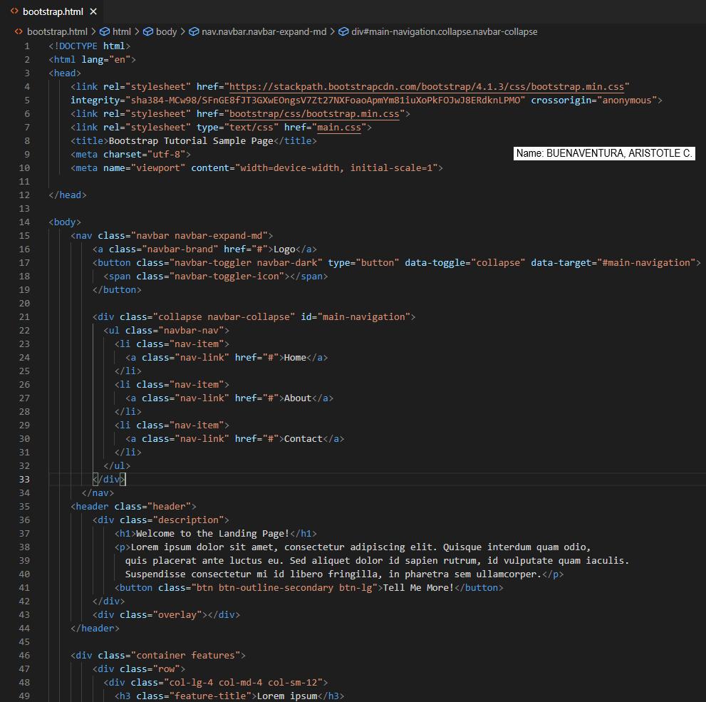File Name: bootstrap.html

*Figure 1. bootstrap.html page 1*

The bootstrap is referenced on the head tag in the first part of the HTML. It also has the external CSS tied to it. The logo, home, about, and contact links are all hyperlinks in the navigation. A welcome greeting and a brief summary are included in the header.

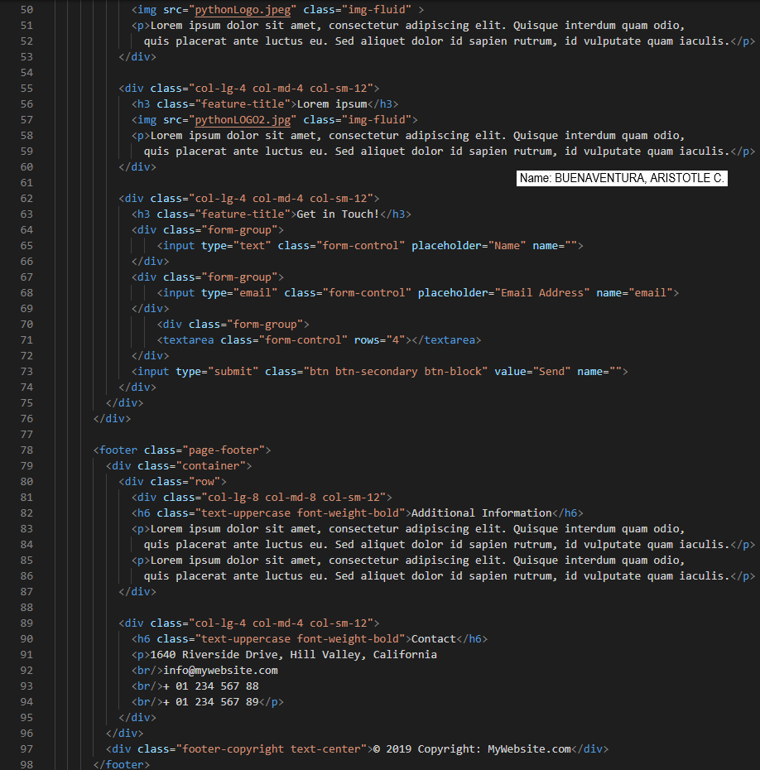

*Figure 1.1. bootstrap.html page 2*

The three divs are contained in a container on the second half of the HTML. The logo and description are on the first and second container, respectively, while the form is on the third page. The footer contains the webpage's supplementary information as well as the developer's contact information and address. The copyright is located at the bottom of the page.

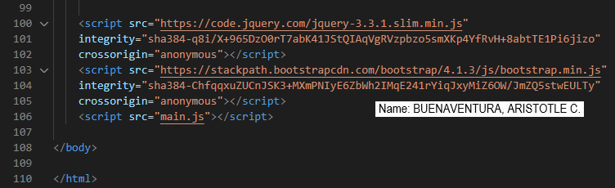

*Figure 1.2. bootstrap.html page 3*

The last portion of the HTML has the jquery, bootstrap, and CSS links.

* 1. File Name: main.css

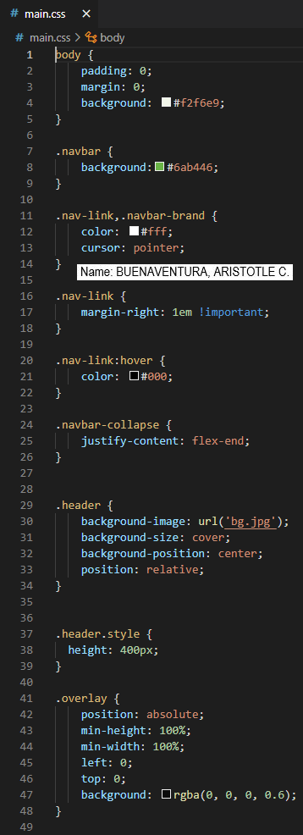

*Figure 2 main.css page 1*

Padding and margin for the entire page are set to 0 in the initial part of the CSS. For the navigation bar, I used a green background. The hyperlinks in the navigation area have a hover effect. I used an image for the header and placed it in the middle of the page, underneath the navigation bar.

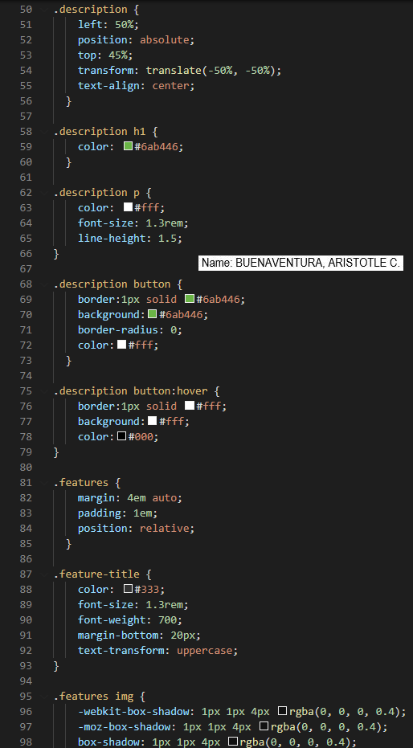

*Figure 2.2 main.css page 2*

The description inside the header is aligned at the center in the second half of the CSS. For contrast, the h1 and p have different hues. A button with a hover effect is located beneath the explanation.

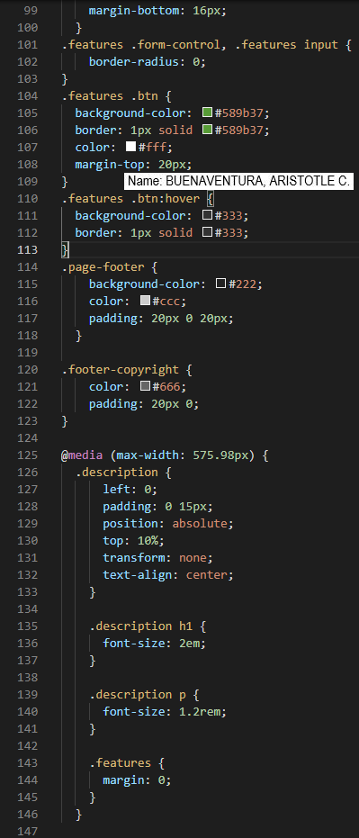

*Figure 2.3 main.css page 3*

The footer's background color is set to black in the final CSS section. The responsiveness of the web page is determined by a media query; when the user shrinks the browser, the page adjusts its elements to fit the screen size.

* 1. File Name: main.js

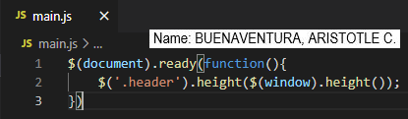

*Figure 3 main.js*

This JavaScript function is used to make the header more responsive. The content inside the header will not overflow when the user minimizes the browser.

1. 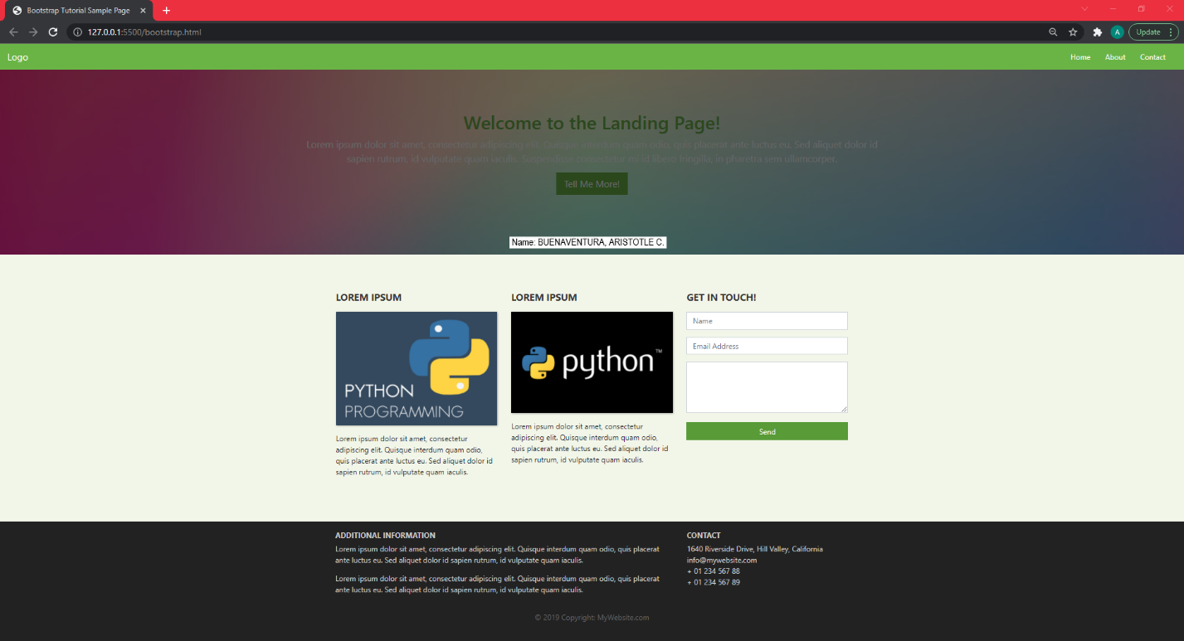Sample Final Output Running in the Browser.

*Figure 4 The Final Output*

This is the final result after integrating all of the HTML, JavaScript, and CSS. Because of the bootstrap implementation, the pieces are well-placed.

**Honor Pledge:**

“I affirm that I have not given or received any unauthorized help on this assignment, and that this work is my own.”