
Department of Computer Science & Engineering
Budge Budge Institute of Technology (BBIT)
Mini Project Report
Project Title: Integrated Python Helpdesk & Data Processing Suite
Team Members:
ALI AFREEN (27600125039)
ARIT CHAKRABORTY (27600125040)
ANURAG SHANKAR SHAW (27600125041)
SRIJON GHORUI (27600125042)
Guide/Faculty: Prof. Mrs. Mousumi Ojha
Semester/Class: 3rd Semester, CSE
Academic Year: 2026-2027


Certificate
This is to certify that the mini project entitled “Integrated Python Helpdesk & Data Processing Suite” has been successfully completed by:
• ALI AFREEN (27600125039)
• ARIT CHAKRABORTY (27600125040)
• ANURAG SHANKAR SHAW (27600125041)
• SRIJON GHORUI (27600125042)
under the guidance of Prof. Mrs. Mousumi Ojha at Department of Computer Science & Engineering, Budge Budge Institute of Technology, Kolkata.
Guide/Faculty Name & Signature: __________________________
Head of Department: __________________________
Date: ______________ Seal: ______________

Acknowledgement
We would like to express our heartfelt gratitude to our guide Yusuf sir for their valuable guidance and support in completing this project. We are also thankful to the Department of Computer Science & Engineering, Budge Budge Institute of Technology, for providing us with the facilities to carry out this work.
Signature of Team Members:
1. ________________________________________ (ALI AFREEN (27600125039))
2. ________________________________________ (ARIT CHAKRABORTY (27600125040))
3. ________________________________________ (ANURAG SHANKAR SHAW (27600125041))
4. ________________________________________ (SRIJON GHORUI (27600125042))

Abstract
The Integrated Python Helpdesk & Data Processing Suite is a menu-driven console application designed to manage two essential operational workflows within small organizations, college laboratories, and support offices: IT helpdesk ticket management and automated tabular data processing. Tracking support requests manually or across scattered spreadsheets frequently leads to unresolved tickets, missed priority escalations, duplicate entries, and inconsistent summary metrics. This project addresses these challenges through a lightweight, beginner-friendly command-line program developed in Python.
The Helpdesk Module allows users and technicians to log new support tickets with unique ticket IDs, issue categories, priority levels (Low, Medium, High, Critical), and status flags (Open, In-Progress, Resolved), as well as view, search, update, and delete existing tickets. The Data Processing Module enables operators to add structured operational records, validate numeric entries, compute summary statistics (total valid records, sum, average, minimum, and maximum values), and export processed summary reports.
The system is implemented in Python 3 using core programming constructs including functions, loops, conditional statements, lists, dictionaries, exception handling, and built-in standard library modules (csv and os). Helpdesk tickets and processed data logs are stored persistently in local CSV files so that all records remain intact across sessions without requiring an external database server or paid software. The application serves as a practical educational prototype demonstrating structured file handling, input validation, and modular software design.

Table of Contents
Nos. | Title | Page Nos.
1 | Introduction | 1
2 | Problem Statement | 2
3 | Objectives | 3
4 | Literature Survey / Existing System | 4
5 | System Requirements | 5
6 | System Design | 6
7 | Implementation | 7
8 | Results & Discussion | 8
9 | Conclusion | 10
10 | References | 11
11 | Appendix | 12

1. Introduction
Service desk logging and routine data processing are foundational tasks across educational institutions, computer laboratories, small businesses, and administrative offices. A helpdesk ticketing system keeps user-reported issues, hardware faults, and software requests organized in one central register, while a data processing utility enables operators to validate, clean, and summarize tabular records quickly. When these activities are handled through paper registers or unvalidated spreadsheets, searching for open issues and computing reliable operational metrics becomes slow and error-prone.
The Integrated Python Helpdesk & Data Processing Suite combines both workflows into a unified, menu-driven console application. Through an intuitive numbered menu, users can log support tickets, track resolution progress, search by ticket ID or priority, and run batch data processing routines on CSV files. Designed specifically for an IT Workshop (Python) curriculum, the project emphasizes clean procedural design using standard Python data structures and persistent flat-file storage.
Scope
• Store and manage IT helpdesk support ticket records locally.
• Store and manage operational data records locally.
• Search tickets by ticket ID, requester name, or priority level.
• Update ticket status (Open, In-Progress, Resolved) and delete closed or invalid tickets.
• Compute summary statistics (count, sum, average, minimum, and maximum) and export summary reports to CSV.
Limitations of Scope
The application is designed as a single-user local command-line tool. It does not include role-based network authentication, real-time cloud synchronization, automated email notifications, or concurrent multi-user database locking.

2. Problem Statement
Manual tracking of technical support requests and ad-hoc handling of raw CSV files frequently result in duplicated ticket numbers, overlooked high-priority incidents, inconsistent status updates, and calculation mistakes during report generation. Furthermore, switching between separate tools to manage support logs and analyze operational datasets introduces unnecessary friction for laboratory assistants and office operators. The core problem is to build a unified, zero-cost Python application that streamlines helpdesk ticket lifecycle management and automates tabular data validation and aggregation without requiring an external database server.
Proposed Solution
A menu-driven Python program will provide separate helpdesk ticket and data processing operations. Data will be stored persistently in tickets.csv, data_records.csv, and processed_summary.csv. Basic validation will reject missing required fields, duplicate ticket IDs or record IDs, invalid priority/status options, and negative or non-numeric values.
Key Functional Highlights
• Unique Primary Keys: Enforces uniqueness on ticket_id and record_id before saving.
• Lifecycle Status Transitions: Allows controlled updates between Open, In-Progress, and Resolved.
• Instant Keyword Search: Quickly locates tickets by ID, requester name, or priority level.
• Numeric Data Validation: Rejects negative numbers and malformed strings during data entry.
• Automated Summary Export: Computes count, sum, average, min, and max values and writes them to CSV.

3. Objectives
1. To create a simple helpdesk ticket directory and data processing suite using Python.
2. To add, display, search, update, and delete helpdesk support ticket records.
3. To maintain ticket IDs, requester names, categories, priority levels, and resolution statuses.
4. To store and view operational data records containing record IDs, departments, metrics, and numeric values.
5. To calculate descriptive statistics (count, sum, average, minimum, and maximum) across valid data records.
6. To export computed summary metrics automatically to a persistent CSV summary file.
7. To demonstrate functions, loops, conditional statements, collections, input validation, and CSV file handling.

4. Literature Survey / Existing System
Common approaches to helpdesk ticket tracking and data summarization include paper registers, spreadsheet files, and dedicated enterprise ticketing platforms. Paper registers are easy to start with, but searching, filtering, and updating records manually can be slow and error-prone. Spreadsheets offer flexible tables and formulas, but users must manage input validation and workflows themselves. Full-scale enterprise applications provide extensive features, but they are unnecessarily complex for a small educational exercise.
The proposed project takes a middle approach: it uses a simple command-line interface and local CSV files. It is easier to understand and modify than a large web application, while offering structured records, automatic statistical calculation, and basic input validation. This project is designed as an educational prototype rather than a replacement for a commercial multi-user service desk system.
Comparison with Existing Approaches
Feature | Paper Registers | Manual Spreadsheets | Proposed Python Suite
Search & Filtering | Slow manual scan | Manual filter setup | Instant CLI search by ID/Priority
Input Validation | None | Weak / Easily bypassed | Strict programmatic validation
Data Aggregation | Manual calculation | Formula-dependent | Automated single-pass metrics

5. System Requirements
Hardware Requirements
• Minimum: Computer or laptop with a dual-core processor, 2 GB RAM, and approximately 100 MB free disk space.
• Recommended: Dual-core or better processor, 4 GB RAM or more, and a keyboard/display suitable for terminal use.
• No internet connection is required for normal program execution.
Software Requirements
• Operating system: Windows, Linux, or macOS.
• Programming language: Python 3.10 or later (uses standard-library features).
• Editor/IDE: Visual Studio Code, IDLE, PyCharm, or any text editor.
• Storage: CSV files managed with Python's built-in csv module.
• Modules: csv and os (included with Python standard library).
Functional Requirements
• Add, view, search, update status, and delete helpdesk tickets.
• Add and view operational data records.
• Validate required fields, priority/status options, and numeric inputs.
• Compute summary metrics (Count, Sum, Average, Minimum, Maximum) and save data to CSV files.
Non-functional Requirements
• Usability: Clear numbered menu and understandable console messages.
• Reliability: Records are written to CSV files immediately after successful changes.
• Portability: Uses Python's standard library and runs across common operating systems.
• Maintainability: Operations are separated cleanly into modular functions.

6. System Design
System Architecture
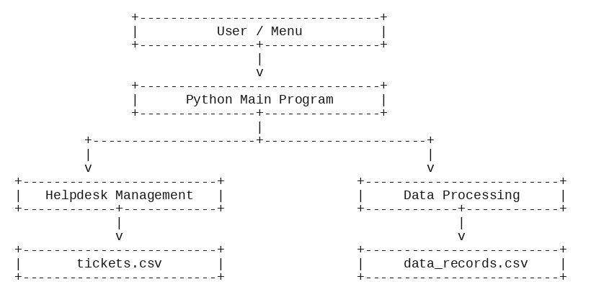
Use Case Description
The system has two actors — Helpdesk User (performs ticket directory operations) and Data Operator (manages data records and summary reports). The User can Add, View, Search, Update, and Delete Helpdesk Tickets. The Operator can Add Data Records, View Data Records, and Process Data & Export Summary Reports.
Data Design
The system persists data in flat CSV files — tickets.csv, data_records.csv, and processed_summary.csv — using Python's csv.DictReader and csv.DictWriter.
• tickets.csv fields: ticket_id, requester, category, priority, status — ticket_id is the unique key.
• data_records.csv fields: record_id, department, metric_name, numeric_value — record_id is the unique key; numeric_value is cast to float during summary processing.
Every mutation follows a read-modify-write cycle: load the file, modify in memory, and rewrite to disk.
Main Algorithm
1. Start the program and display the main menu.
2. Read the user's menu choice.
3. Call the selected helpdesk or data processing function.
4. Load the relevant CSV file, perform validation, and process the requested operation.
5. Save changes to the relevant CSV file.
6. Display the result and return to the menu.
7. Repeat until the user selects Exit (0).

7. Implementation
Coding
The program is written in Python 3 using only the standard library (csv and os) — no external dependencies. It follows a modular, layered design: main() is the menu dispatcher that routes user choices to action functions via an if/elif/else control structure; the Helpdesk Module (add_ticket, view_tickets, search_ticket, update_ticket, delete_ticket) and Data Processing Module (add_data_record, view_data_records, process_data_summary) handle business logic; and shared helpers read_csv() and write_csv() handle CSV file persistence. Each action function follows the same pattern: read file -> validate input -> modify in memory -> rewrite file -> print result. Input validation wraps numeric input() in a try/except ValueError block and rejects negative numbers.
Algorithms Used
• Linear Search (search_ticket) — O(n) substring match against ticket_id, requester, or priority, case-insensitive. Appropriate for the small data volumes of a CLI app.
• Filter-and-Rewrite (delete_ticket) — O(n) list comprehension excluding the target ticket_id, then length comparison to detect 'Ticket not found'.
• Uniqueness Check (add_ticket, add_data_record) — O(n) loop scan checking whether the entered ID already exists in the loaded list.
• Primary-Key Lookup (update_ticket) — O(n) traversal matching ticket_id to update status in memory before rewriting the CSV file.
• Aggregate Computation (process_data_summary) — Single-pass O(n) numeric extraction computing Count, Sum, Average, Minimum, and Maximum values.
• Read-Modify-Write (every mutation) — O(n) read + O(n) rewrite; acts as atomic persistence for a single-user console application.

8. Results & Discussion
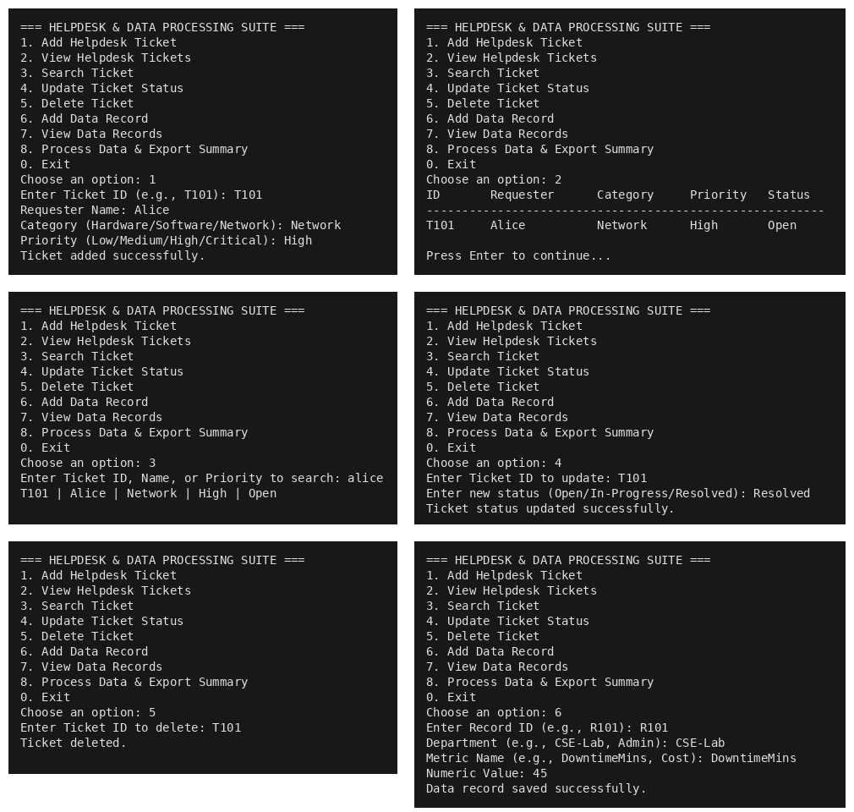

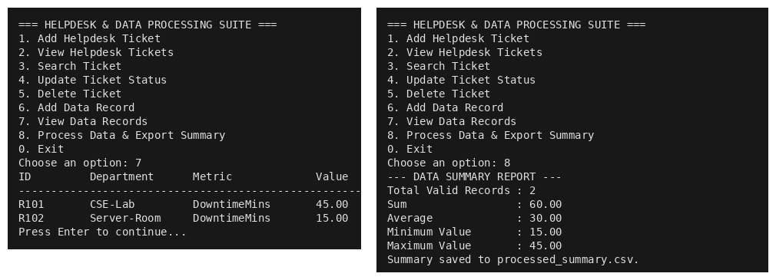
Performance
All operations run in O(n) time, where n is the number of rows in the CSV file (typically a few hundred for the target use case), so every menu action completes in milliseconds. process_data_summary computes Count, Sum, Average, Minimum, and Maximum in a single pass — no nested loops or separate aggregation queries. The read-modify-write cycle loads the whole file once per mutation, avoiding repeated disk I/O. No external libraries are imported, so startup time is under 100 ms.
Advantages
• Simple menu-based interaction for beginners.
• Persistent storage without an external database.
• Basic checks reduce duplicate ticket/record IDs and invalid numeric inputs.
• Statistical summary metrics (Sum, Average, Min, Max) are calculated and exported automatically.
• Modular functions make the program easier to understand and extend.

9. Conclusion
Achievements
The Integrated Python Helpdesk & Data Processing Suite demonstrates how Python can be used to solve a small, practical record-management and data analysis problem. It combines helpdesk ticket tracking and tabular data summarization in one menu-driven application, with CSV file handling for persistence. The program uses fundamental concepts such as functions, loops, conditionals, lists, dictionaries, input validation, and exception handling.
Limitations
• Data is stored locally and is not encrypted.
• The program is intended for one user at a time.
• Data record editing and deletion are not included in this version.
• CSV files do not provide the transaction safety and concurrency controls of a database.
Future Enhancements
The current version meets its basic educational objectives, but it is not intended for sensitive or large-scale enterprise data. Future improvements could include editing and deleting data records, ticket escalation history, graphical charts, a graphical user interface (Tkinter), SQLite database storage, login authentication, and automated backup.

10. References
1. Python Software Foundation, "The Python Tutorial," Python 3 Documentation. Available: https://docs.python.org/3/tutorial/
2. Python Software Foundation, "csv — CSV File Reading and Writing," Python 3 Documentation. Available: https://docs.python.org/3/library/csv.html
3. Python Software Foundation, "os — Miscellaneous operating system interfaces," Python 3 Documentation. Available: https://docs.python.org/3/library/os.html
Accessed for the concepts and standard-library interfaces used in this educational project.

11. Appendix
import csv
import os

TICKETS_FILE = "tickets.csv"
DATA_FILE = "data_records.csv"
SUMMARY_FILE = "processed_summary.csv"

TICKET_FIELDS = ["ticket_id", "requester", "category", "priority", "status"]
DATA_FIELDS = ["record_id", "department", "metric_name", "numeric_value"]
SUMMARY_FIELDS = ["metric", "value"]

def read_csv(filename):
if not os.path.exists(filename):
return []
with open(filename, "r", newline="", encoding="utf-8") as file:
return list(csv.DictReader(file))

def write_csv(filename, fields, rows):
with open(filename, "w", newline="", encoding="utf-8") as file:
writer = csv.DictWriter(file, fieldnames=fields)
writer.writeheader()
writer.writerows(rows)

def pause():
try:
input("\nPress Enter to continue...")
except EOFError:
print()

def add_ticket():
tickets = read_csv(TICKETS_FILE)
ticket_id = input("Enter Ticket ID (e.g., T101): ").strip().upper()
if not ticket_id:
print("Ticket ID is required.")
return

for t in tickets:
if t["ticket_id"] == ticket_id:
print("A ticket with this ID already exists.")
return

requester = input("Requester Name: ").strip()
category = input("Category (Hardware/Software/Network): ").strip()
priority = input("Priority (Low/Medium/High/Critical): ").strip().capitalize()

if not requester or not category:
print("Requester Name and Category are required.")
return

if priority not in ["Low", "Medium", "High", "Critical"]:
print("Invalid priority! Choose Low, Medium, High, or Critical.")
return

tickets.append({
"ticket_id": ticket_id,
"requester": requester,
"category": category,
"priority": priority,
"status": "Open"
})
write_csv(TICKETS_FILE, TICKET_FIELDS, tickets)
print("Ticket added successfully.")

def view_tickets():
tickets = read_csv(TICKETS_FILE)
if not tickets:
print("No tickets found.")
return

print(f"\n{'ID':8} {'Requester':14} {'Category':12} {'Priority':10} {'Status'}")
print("-" * 56)
for t in tickets:
print(
f"{t['ticket_id']:8} {t['requester']:14} "
f"{t['category']:12} {t['priority']:10} {t['status']}"
)
pause()

def search_ticket():
query = input("Enter Ticket ID, Name, or Priority to search: ").strip().lower()
if not query:
print("Please enter something to search for.")
return

tickets = read_csv(TICKETS_FILE)
found = False
for t in tickets:
if (query in t["ticket_id"].lower() or
query in t["requester"].lower() or
query in t["priority"].lower()):
print(
f"{t['ticket_id']} | {t['requester']} | "
f"{t['category']} | {t['priority']} | {t['status']}"
)
found = True

if not found:
print("No matching ticket found.")

def update_ticket():
tickets = read_csv(TICKETS_FILE)
ticket_id = input("Enter Ticket ID to update: ").strip().upper()

for t in tickets:
if t["ticket_id"] == ticket_id:
new_status = input(
"Enter new status (Open/In-Progress/Resolved): "
).strip().title()
if new_status not in ["Open", "In-Progress", "Resolved"]:
print("Invalid status.")
return
t["status"] = new_status
write_csv(TICKETS_FILE, TICKET_FIELDS, tickets)
print("Ticket status updated successfully.")
return

print("Ticket ID not found.")

def delete_ticket():
tickets = read_csv(TICKETS_FILE)
ticket_id = input("Enter Ticket ID to delete: ").strip().upper()
if not ticket_id:
print("No Ticket ID entered.")
return

new_tickets = [t for t in tickets if t["ticket_id"] != ticket_id]
if len(new_tickets) == len(tickets):
print("Ticket not found.")
else:
write_csv(TICKETS_FILE, TICKET_FIELDS, new_tickets)
print("Ticket deleted.")

def add_data_record():
records = read_csv(DATA_FILE)
record_id = input("Enter Record ID (e.g., R101): ").strip().upper()
if not record_id:
print("Record ID is required.")
return

for r in records:
if r["record_id"] == record_id:
print("Record ID already exists.")
return

department = input("Department (e.g., CSE-Lab, Admin): ").strip()
metric_name = input("Metric Name (e.g., DowntimeMins, Cost): ").strip()
if not department or not metric_name:
print("Department and Metric Name are required.")
return

try:
value = float(input("Numeric Value: "))
if value < 0:
raise ValueError
except ValueError:
print("Enter a valid non-negative number.")
return

records.append({
"record_id": record_id,
"department": department,
"metric_name": metric_name,
"numeric_value": f"{value:.2f}"
})
write_csv(DATA_FILE, DATA_FIELDS, records)
print("Data record saved successfully.")

def view_data_records():
records = read_csv(DATA_FILE)
if not records:
print("No data records found.")
return

print(f"\n{'ID':10} {'Department':15} {'Metric':18} {'Value'}")
print("-" * 53)
for r in records:
print(
f"{r['record_id']:10} {r['department']:15} "
f"{r['metric_name']:18} {r['numeric_value']}"
)
pause()

def process_data_summary():
records = read_csv(DATA_FILE)
if not records:
print("No data records to process.")
return

values = []
for r in records:
try:
values.append(float(r["numeric_value"]))
except ValueError:
pass

if not values:
print("No valid numeric values found.")
return

count = len(values)
total = sum(values)
average = total / count
minimum = min(values)
maximum = max(values)

print("--- DATA SUMMARY REPORT ---")
print(f"Total Valid Records : {count}")
print(f"Sum : {total:.2f}")
print(f"Average : {average:.2f}")
print(f"Minimum Value : {minimum:.2f}")
print(f"Maximum Value : {maximum:.2f}")

summary_rows = [
{"metric": "Total Valid Records", "value": count},
{"metric": "Sum", "value": f"{total:.2f}"},
{"metric": "Average", "value": f"{average:.2f}"},
{"metric": "Minimum", "value": f"{minimum:.2f}"},
{"metric": "Maximum", "value": f"{maximum:.2f}"}
]
write_csv(SUMMARY_FILE, SUMMARY_FIELDS, summary_rows)
print(f"Summary saved to {SUMMARY_FILE}.")

def main():
while True:
print("\n=== HELPDESK & DATA PROCESSING SUITE ===")
print("1. Add Helpdesk Ticket")
print("2. View Helpdesk Tickets")
print("3. Search Ticket")
print("4. Update Ticket Status")
print("5. Delete Ticket")
print("6. Add Data Record")
print("7. View Data Records")
print("8. Process Data & Export Summary")
print("0. Exit")

choice = input("Choose an option: ").strip()

if choice == "1":
add_ticket()
elif choice == "2":
view_tickets()
elif choice == "3":
search_ticket()
elif choice == "4":
update_ticket()
elif choice == "5":
delete_ticket()
elif choice == "6":
add_data_record()
elif choice == "7":
view_data_records()
elif choice == "8":
process_data_summary()
elif choice == "0":
print("Thank you for using the system.")
break
else:
print("Invalid choice. Please select a listed option.")

if __name__ == "__main__":
main()
User Manual
1. Start the program using Python (python helpdesk_suite.py).
2. Select option 1 to add a helpdesk ticket; enter a unique Ticket ID, requester name, category, and priority.
3. Use option 2 to view all tickets, option 3 to search by ID/name/priority, option 4 to update ticket status, and option 5 to delete a ticket by ID.
4. Select option 6 to add a data record; enter a unique Record ID, department name, metric name, and numeric value.
5. Use option 7 to view all stored operational data records.
6. Use option 8 to calculate Total Valid Records, Sum, Average, Minimum, and Maximum values and export the report to processed_summary.csv.
7. Select option 0 to exit. Saved data remains persistently in the CSV files.

