20-Oct-99, 1:00 am EST

Bayesian Modelling of Visual Perception

Pascal Mamassian¹, Michael S. Landy² and Laurence T. Maloney²

(1) Psychology Department, University of Glasgow
(2) Department of Psychology, Center for Neural Science, New York University

Keywords
Bayesian modelling; Three-dimensional perception; Likelihood; Prior assumptions; Visual constraints; Decision rule; Shape from shading; Shape from contour.

Abstract
We review the fundamentals of Bayesian modelling with special emphasis on three-dimensional visual perception. We first discuss three basic components of any Bayesian model: the likelihood function, the prior, and the gain function. Likelihood functions are used to model how visual sensors encode sensory information. This sensory information is typically consistent with not one but many possible scenes, and priors provide a principled way of formulating constraints on possible scenes that lead to unambiguous visual perception. Gain functions are important in accounting for task-dependent performance. We illustrate how Bayesian models can be investigated experimentally, and conclude with a discussion of the advantages and disadvantages of the Bayesian approach.

Submitted to: Statistical Theories of the Brain, R. Rao, B. Olshausen and M. Lewicki (Eds), Cambridge, MA: MIT Press. Please do not cite without permission.
I. Introduction

I.1. Motivation

Through perception, an organism arrives at decisions about the external world, decisions based on both current sensory information and prior knowledge concerning the environment. Unfortunately, the study of perceptual decision-making is distributed across sub-disciplines within psychology and neuroscience. Perceptual psychologists and neuroscientists focus on the information available in stimuli, developmental researchers focus on how prior knowledge about the environment is acquired, researchers interested in memory study how this prior knowledge is encoded, and, last of all, cognitive psychologists might be primarily interested in the decision mechanisms. Any perceptual task evidently involves all three components and, at first glance, it would seem that any theory of a perceptual decision making must draw on heterogeneous models and results from all of these areas of psychology.
Knill & Richards (1996) proposed an alternative. They suggested that Bayesian Decision Theory (BDT) is a convenient and natural framework that allows researchers to study all aspects of a perceptual decision in a unified manner. In this chapter, we summarise the key points that make the Bayesian framework attractive as a framework for the study of perception and we illustrate how to develop models of visual function based on BDT.
We emphasise the role played by prior knowledge about the environment in the interpretation of images, and describe how this prior knowledge is represented as prior distributions in BDT. For the sake of terminological variety, we will occasionally refer to prior knowledge as ‘prior beliefs’ or ‘prior constraints’, but it is important to be aware that this prior knowledge is not something the observer need be aware of. Yet, as we shall see, these implicit assumptions can be revealed through psychophysical experimentation.

To introduce the Bayesian approach, we illustrate how to model a simplified problem of three-dimensional perception. This model is unrealistic and our intent in presenting it is to introduce the terminology, concepts, and methods of Bayesian modeling.We next consider how the framework can be used to model more realistic problems concerning the perception of shape from shading and from contours. We conclude with a general discussion of the advantages and disadvantages of the Bayesian approach. Other tutorials on Bayesian modelling of visual perception with more technical details include Knill et al. (1996), Yuille & Buelthoff (1996), and Maloney (in press) .
Before introducing Bayesian modelling however, we first remind the reader what it is about three-dimensional perception that is difficult to model.

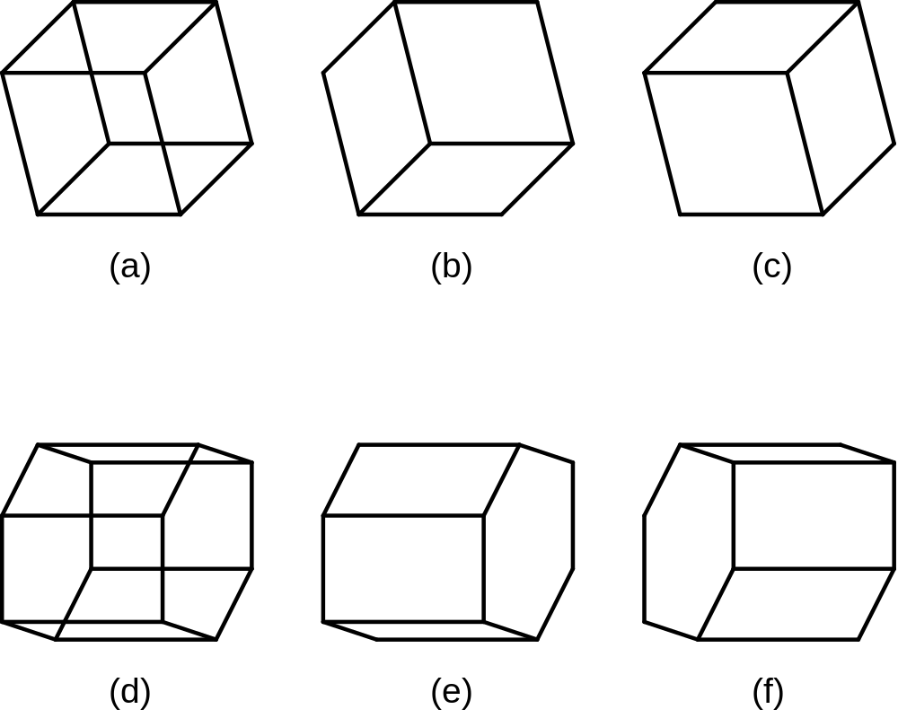

Figure 1: Multistable figures. Figures A and D typically engender one of two interpretations (B or C for A), and E or F for D). When viewed long enough, the interpretation will alternate between B and C and between D and F. The interpretation might vary when the figure is repeatedly presented or when the observer blinks or changes fixation.

I.2. Visual Perception as an Ill-posed Problem

Consider for instance the line drawing in Figure 1A. Even though this line drawing is consistent with an infinite number of polyhedra, human observers usually report only two distinct interpretations, illustrated in Figures 1B and 1C. Similarly, Figure 1D is usually interpreted as shown in Figures 1E or in 1F. If Figure 1A is viewed long enough, the observer will usually experience alternation between the interpretations suggested in Figures 1B and 1C, but only one interpretation is seen at any point in time.
Two questions arise: (1) Why are only two of an infinite number of possible interpretations seen? (2) And why do we see only one interpretation at a time rather than, say, a superposition of all of the possible interpretations?
A proper answer to the first question requires that we explain why the visual system ‘favors’ certain interpretations over others a priori. Within the Bayesian framework, this mechanism will prove to be the prior distribution. An answer to the second question will lead us to consider how perceptual decisions are made within the Bayesian framework.
Because space perception is ill-posed with many possible scenes consistent with the available sensory information, Bayesian modelling will prove to be particularly appropriate (for a recent review of visual space perception, see Hershenson, 1999).

II. A Simple Example: 3D Angle Perception
In this section we introduce the key concepts of Bayesian modelling by means of a simple example. We will not attempt to model the interpretation of the simple line drawings in Fig. 1. That would requires too much investment in mathematical notation (to represent figures made out of lines in space) and would serve to obscure rather than display the elements of Bayesian modelling. Instead, we consider a perceptual task that is extremely simple, highly unrealistic, but plausibly related to perceptual interpetation of the figures in Fig. 1: estimation of the angle formed by two intersecting lines in space given only the projection of the lines onto a single retina.

II.1. Task

The problem is illustrated in Figure 2: Given two intersecting lines in an image, what is the angle between the two lines in three-dimensional space? Just as for the figures in Fig. 1, the observer looks at a two-dimensional image and has to make an inference about some three-dimensional property of the scene.

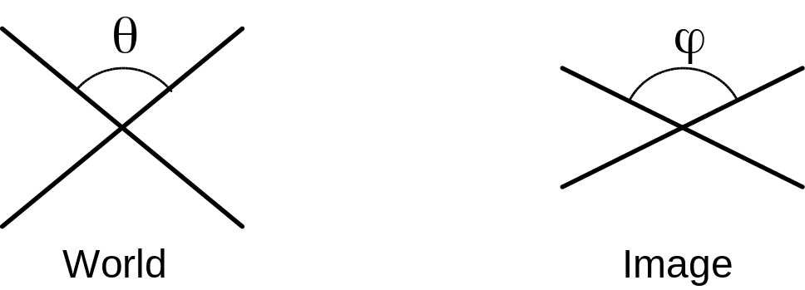

Figure 2: Perception of 3D angles. The angle (theta) between two line segments in 3D space projects as an angle (phi) in the image. The task of the observer is to infer (theta) given (phi).

At the outset, our problem appears impossible. We do not even know whether the two lines even intersect in space! Even if we somehow knew that they did, we still don’t know how to go from knowledge of (phi) to knowledge of (theta). Clearly there can be no deterministic rule that takes us from (phi) to (theta), for there are many values of (theta) that all lead to the same value (phi). But perhaps we can, given (phi), rank the possible values of (theta) as candidates by some measure of plausibility.
To do so, we need to understand consider how the scene was generated. Let’s imagine that the scene was generated by a Demon who first draws the angle on a transparent sheet of acrylic (Fig. 2, ‘World’), perpendicular to the line of sight of the observer, and then gleefully`spins’ the sheet of acrylic about a horizontal axis (Fig. XX Pascal, do you do demons?). The spin is so forceful that we can assume that the acrylic sheet ends up at any angle (gamma) as likely as any other. While the angle was drawn and the sheet spun, the observer waited patiently with his eyes closed. The angle that the Demon drew is symmetric around the vertical axis before and after the spin as illustrated in Fig. 2.
At the Demon’s command, he opens his eyes and, challenged by the Demon, must specify the true angle (theta) give that he can only see the projection (phi).
Given this generating model, we can say quite a lot about the relation between (phi) and the possible (theta)s that might have given rise to it.As the acrylic sheet gets more slanted relative to the line-of-sight, the projected angle (phi) in Fig. 2 increases to 180 (when the sheet is horizontal) and then decreases back to the true value, when the acrylic sheet is upside down. The projected angle (phi) is always greater than or equal to the true angle (theta). We can say more than this, though. We can, given what we know about the generating model, compute the probability that any particular value of the unknown (theta) was the angle that the Demon drew, given the known value of (phi). This probability distribution is the first element of Bayesian modeling that we introduce and it is the likelihood function.

II.2. Likelihood Function

Let us assume that the angle (phi) between the two lines in the image is measured to be 135 degrees. What is the likelihood that any given world angle (theta), say, 95 degrees, was the angle that the Demon chose to draw? To answer this question, we can imagine the following simulation. We take our own acrylic sheet with two lines painted on it separated by 95 degrees and we then spin it ourselves, repeatedly, simulating what the Demon did, over and over. Following each simulation of the Demon’s spin, we measure the resulting angle (phi)’. If the projected angle is approximately the angle (phi) that we measured (say, 135 degrees plus or minus 5 degrees), we decide that the simulation is a “hit”, otherwise it is a “miss”. Repeating this procedure 1000 times, we end up with 5 hits and 995 misses. We conclude that the probability of obtaining an image angle of approximately 135 degrees given a world angle of 95 degrees is about 0.005.

If we repeat our simulation experiment for all possible values of the world angle, we obtain a histogram approximation of the “likelihood function” (Figure 4). The likelihood is a function of both the known image angle (phi) and the unknown world angle (theta).

Note that (theta) is a random variable whereas (phi) is considered as a fixed parameter (cf. Berger, 1985). For this reason, we prefer to think the likelihood function as a function of (theta) indexed by (phi). The likelihood function is not a probability distribution function since the integral over all values of (theta) need not be 1 (it is the integral over all values of the stimulus variable that must equals 1). We introduce the following notation for the likelihood function:
likelihood(theta|phi) = p(phi | theta) .

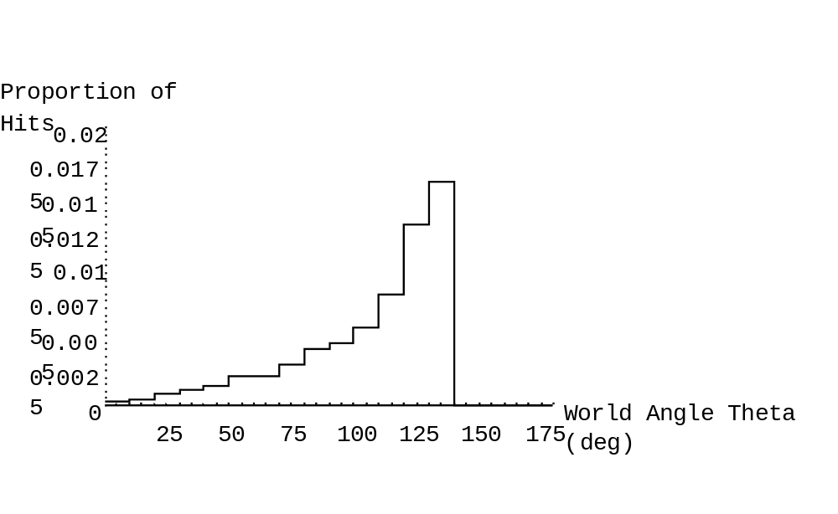
Figure 3: The likelihood function. The likelihood characterises the chances that a particular world angle projects as a given image angle. For this example, the image angle was 135 degrees.

The Demon is still waiting for a response. It’s plausible that, given the likelihood function in Fig. 3, it would be foolish to guess that the Demon drew an angle as small as, say, 10 degrees. The likelihood that a world angle of 10 degrees would lead to the observed value of (phi) (135 degrees) is very small relative to larger angles. The likelihood increases for world angles up to 135 degrees at which point the likelihood drops to zero. (Recall that the reason for the zero values above 135 degrees is that the projected angle is always larger than the world angle so it is impossible for a world angle larger than 135 degrees to produce an image angle of 135 degrees. The largest likelihood is therefore reached for a world angle equal to 135 degrees.) The world angle that is most likely to have given rise to the observed (phi) is 135 degrees.
If we choose this angle as our estimate of the response variable, we follow the strategy called Maximum Likelihood Estimation (MLE) (statistics reference, Berger?). We choose, as our response, the world angle that had the highest probability of generating the observed sensory information. This decision rule is close in spirit to the Likelihood Principle proposed by Helmholtz (**need ref**).

The likelihood function captures all of the sensory information we have. What happens if we have extra knowledge or beliefs beyond the simple geometrical knowledge included in the likelihood function? Suppose that we know that our Demon has a marked bias toward angles near 90 degrees and an aversion toward smaller or larger angles (especially 666 degrees).

II.3. Prior Distributions
We represent our knowledge about the Demon’s bias toward some angles and away from others as a prior distribution, a probability distribution function on the response variable:
prior(theta) = p(theta) .

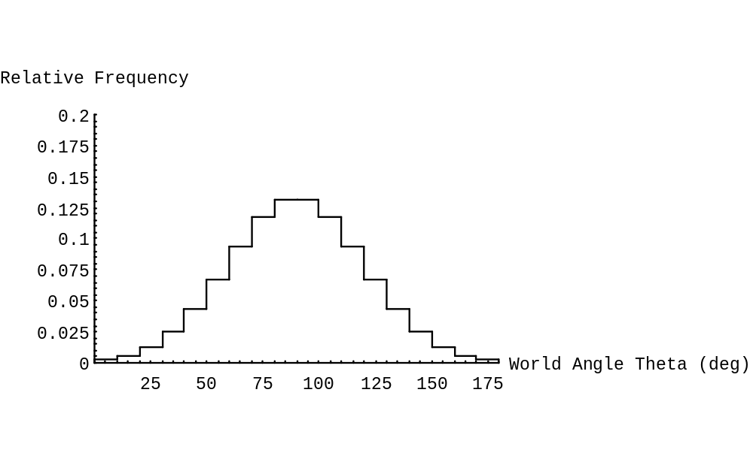
Figure 5: Prior distribution (discretized Normal distribution with a mean of 90 deg and a standard deviation of 30 deg). The prior distribution represents the prior belief of the observer as the frequency of occurrence of various world angles.

The Demon’s bias can be represented by a prior distribution such as the one in Fig. 5, a Gaussian with a mean of 90 degrees and a standard deviation of 30 degrees. The value of standard deviation in effect represents how strong the Demon’s bias toward 90 is. If the standard deviation is very small, the resulting Guassian will be almost a `spike’ at 90. If this distribution accurately captured the Demon’s behavior, then we’d know the Demon almost always picked an angle of 90 degrees or very close to it. Even without the sensory information and the likelihood, we’d expect to be able to make a very good estimate of the world angle. If, on the other hand, the standard devation is very large, then the Demon’s bias toward 90 is very slight and knowledge of the prior is not helping us much in our estimation task. We’ll assume that our Demon’s bias is well captured by a standard deviation of 30 degrees as shown in in Fig. 5: the bias toward 90 is obvious but not so obvious as to tempt us to ignore the sensory information embodied in the likelihood function.
So far, we have encountered two elements found in any Bayesian model: the likelihood function and the prior. The former represents everything we know about the process that turns the state of the world into sensory information. The latter describes what we know about the relative plausibility of different states of the world. Both represent knowledge in probabilistic terms, permitting us to combine sensory information and prior knowledge about the world using the probability calculus.

II.4. Bayes’ Rule and the Posterior Distribution

The Demon is still waiting for an answer. We next need to combine likelihood and prior to compute a posterior distribution, our estimate of the probability of different states of the world (here (theta)) giving everything we know. The following formula describes how to compute the posterior distribution:
posterior(theta) = C * likelihood(theta) * prior(theta) ,

where (C) is a constant chosen so that the posterior is indeed a probability distribution function (i.e., the integral over all possible values of (theta) is one). This formula is derived from Bayes’ Theorem, a simple mathematical result concerning computations with conditional probabilities:
p(theta | phi) = p(phi | theta) * p(theta) / p(phi) .
The left-hand side is the posterior, p(phi|theta), the likelihood, and p(theta), the prior.
Evidently, (C) equals the inverse of p(phi), but it is easy to avoid computing it (or even thinking about it) since (1) it is the constant needed to make the posterior distribution a distribution, and (2) given the uses to which the posterior is put, it often turns out that the normalization by ( C) is not necessary. We’ll return to this point in discussing the decision rule.
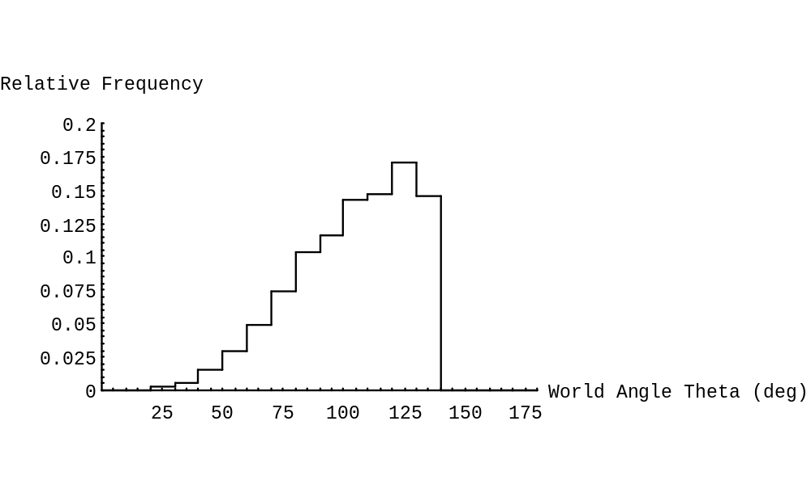
Figure 5: Posterior distribution. The posterior distribution represents the likelihood of occurrence of the response variable weighted by prior beliefs.

The posterior distribution represents the overall belief in the frequency of occurrence of the response variable when both the geometrical knowledge and the prior beliefs are taken into account. Figure 5 shows the posterior distribution when the likelihood function was computed as in section II.2 and the prior probability was chosen as in section II.3. Note that the peak of the posterior distribution is located in between the peaks of the likelihood function (Figure 3) and the prior distribution (Figure 4).
In effect, the two sources of information we have are being pooled. The likelihood function would lead us to pick large values of (theta), near (phi)=135 as our maximum likelihood guess, the prior would lead us to favor a guess nearer 90 degrees, reflecting the our knowledge of the Demon’s bias toward 90. The two pieces of information average out to a posterior whose peak falls around 125 degrees, about 22% of the way from the likelihood peak to the prior peak.
We could imagine redoing this example with different values of the standard deviation o the prior. When the standard deviation is smaller, the peak of the posterior moves toward 90, the peak of the prior, when it is larger, the peak of the posterior moves toward the peak of the liklihood function. This standard deviation is effectively controlling the relative important of prior and sensory information. When the Demon's bias toward 90 is known to be very strong, we should favor our prior knowledge and downweight confliciting sensory data. We should favor the sensory data when the prior is weak.
Intelligent selection of the distributional form for the prior is an important part of modeling. The prior is how we encode, in the language of probability, all that we know about the state of the world, independently of the current sensory input.
Still, the Demon is becoming impatient. The posterior distribution is what we have, but what we need is an estimate of (theta), a `best guess’. That’s what the Demon wants from us.

II.5. Gain, Loss, and the Decision Rule

The decision rule links the posterior distribution with the action taken by the observer. The action can be an explicit motor act, such as transporting the hand to the vicinity of an object, or an estimate of some aspect of the world such as the angle (theta). One possible criterion for choosing an estimate to pick the mode of the posterior distribution, the most probable value of (theta) according to the posterior distribution. If we used such a Maximum a Posteriori (MAP) Rule, our response to the Demon’s challenge would be ‘125 degrees’. This rule is widely used in the Bayesian literature and it is a plausible choice of deicsion rule. Within the full framework of Bayesian Decision Theory the choice of decision rule is remarkably simple and principled. It beings by assuming that for every action we might take there are consequences: a numerical gain or loss, where a loss is merely a negative gain. In the example we’ve been pursuing, we’ve neglected to describe the consequences of our actions. Let’s remedy the deifciency now.
Suppose that, if we guess the Demon’s angle (theta) to within say 5 degrees, he goes away (+100, a gain). If we miss by more than 5 degrees, he draws a new angle spins the acrylic sheet anew, and continues to torment us (-50, aloss). With this specificiation of gain/loss, we can then choose the action that maximizes our expected gain. The Bayes decision rule is precisely the choice of action (alpha) that, given the posterior, maximizes expected gain:
expected_gain(alpha) = integral_over_(theta) posterior(theta) * gain(alpha, theta)
In the case of the example, with the gains and losses just described, it turns out that the Bayes decision rule is precisely the MAP rule. If we wish to be rid of the Demon as quickly as possible, we should pick the most probable value of (theta) according to the posterior distribution. Any other choice prolongs, on average, our encounter with the Demon.
But suppose that the gains and losses are different from those just specified? What is the Demon appears with his acrylic sheet and announces that, today, he will force the observer to pay him, in dollars, the square of the difference in degrees between his estimate and the true value of (theta). A five degree error costs $25, a 10 degree error, $100. This gain/loss function is the least-square loss function, a very commonly used
loss criterion in statistical estimation.
The Observer’s immediate question is likely to be, Is the MAP still the best rule to use? The answer turns out to be no. The rule which minimizes his expected loss is to pick the mean of the posterior distribution, not the mode. The Bayes rule, with this new gain/loss function is now the mean. The mean of the posterior distribution in Fig. 5 is XXX.X, slightly less than the MAP which was 125.
Evidently there is no one computation applied to the posterior distribution that is the Bayes rule. Rather, the rule varies as the gains and losses vary. The ‘Bayes rule’ is always: do whatever you must to maximize expected gain.
The Bayesian framework allows us to model the consequences of gains and losses on behavior and to represent performance in different tasks in a common framework so long as the effect of a change of task can be modeled as a change in possible gains and losses.
See Berger (1985) or Maloney (in press) contains a more detailed discussion.

While the MAP rule and its correpsonding gain function is appealing for its simplicity, it has been argued that it is prone to favour unstable interpretations, i.e. scenes viewed from accidental viewpoints (Freeman, 1996; Yuille & Buelthoff, 1996).

One important property of the decision rules in our example is that the same action will be chosen whenever the same stimulus (phi) is seen. We have neglected to model photon noise or noise noise and introduction of these as contributors to the likelihood component of a Bayesian model would introduce variability into human responses to identical stimuli.
Mamassian & Landy (1998) obtained good results with what they termed a “non-committing” rule. According to this non-deterministic rule, an action is chosen with a probability that matches its posterior probability. Actions with high posterior probabilities will be selected more often than those with low posterior probabilities, but any action may potentially be chosen. This decision is more commonly known as probability matching and is very common observed in human and animal choice behavior when the gain function is the first gain function described above, that led to the MAP Rule. Even though the MAP Rule is optimal, humans and other animals persist in probability matching to a remarkable degree. It is important to note that this rule is not optimal (the MAP rule always leads to higher gain).

II.6. Discussion

In this section, we have defined the three fundamental steps in Bayesian modelling of visual perception (Figure 8). The first step is to define the prior distributions to represent what we know about the probability of encountered different states of the world. The second step is to compute the likelihood function by determining all the ways the stimuli could have been generated and their frequency of occurrence. Using Bayes’ rule, likelihood and priors can be combined to produce a posterior distribution, i.e., the best estimate of the probability of each possible state of the world given the sensory data and the prior distribution. The third and last step is to settle on a decision rule that transforms the posterior distribution into an action.

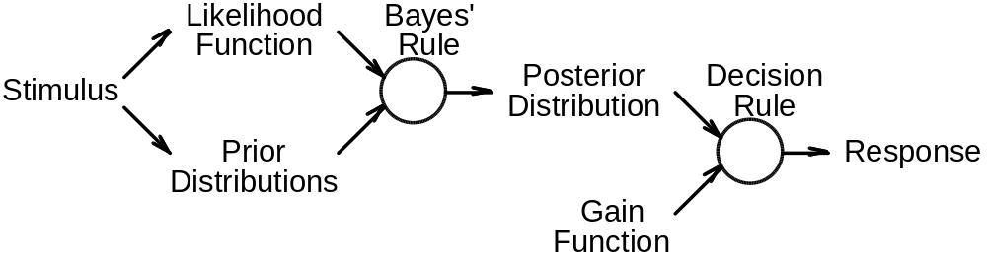

Figure 8: Flowchart of the steps involved in Bayesian modelling.

III. The Study of Human Priors: Perception of Embossed Surfaces

III.1. Issues

In the previous part of the chapter, we have provided a model of perceptual decision making based on sensory information and a priori knowledge.
What are the characteristics of prior assumptions? In the simple cases discussed here, prior distributions are characterised by two fundamental properties: (1) a bias and (2) a confidence (or belief) in this bias. If the prior is modelled by a normal distribution, the bias corresponds to the mean of the distribution, and the confidence is inversely related to the standard deviation. Therefore, we shall address two questions: What are the biases inherent in the visual system? And what are the confidence levels for these biases? The first question is the easiest since biases can often be read directly out of psychophysical measurements. The issue of how confident we are in using our prior assumptions is more difficult and will necessitate the full power of Bayesian modelling. As an auxiliary question, we shall look for stimulus properties that can affect these confidence levels.

These issues can be addressed using simple ambiguous 3D patterns. In previous work, we have used as stimuli shaded embossed surfaces with parallel contours (Mamassian & Landy, 1997, 1998, in preparation). We summarise this work in the following sections.

III.2. Assumption of Illumination from Above-Left

Light sources are usually located above our head. In an attempt to quantify the corresponding bias of the visual system, we found a preference for an above-left illumination (Mamassian & Landy, 1997). We can model this preference with a simple Bayesian model.

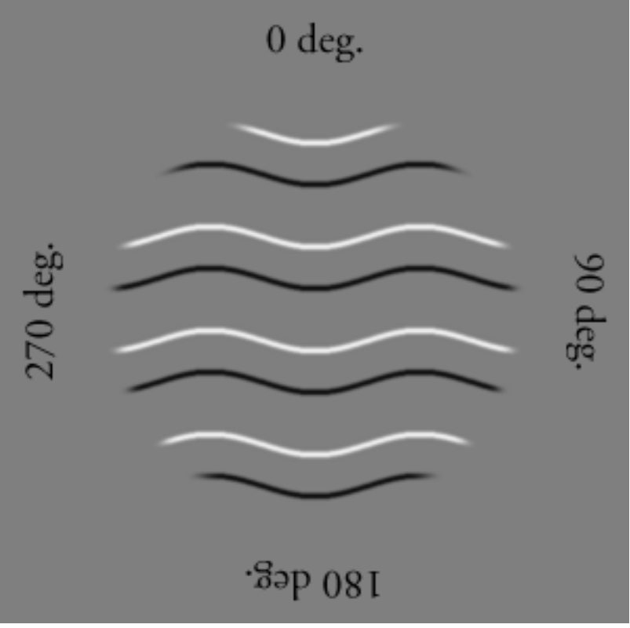

Figure 9: Stimulus used in the illumination experiment. This figure was presented at different orientations in the image plane. Observers indicated whether they perceived the thick or thin strips in relief.

Stimuli were shaded embossed surfaces as shown in Figure 9. These stimuli can be interpreted as surfaces with narrow or wide strips in relief. Figure 10 shows the proportion of times the stimulus was interpreted as formed by narrow strips in relief as a function of the orientation of the figure in the image plane.

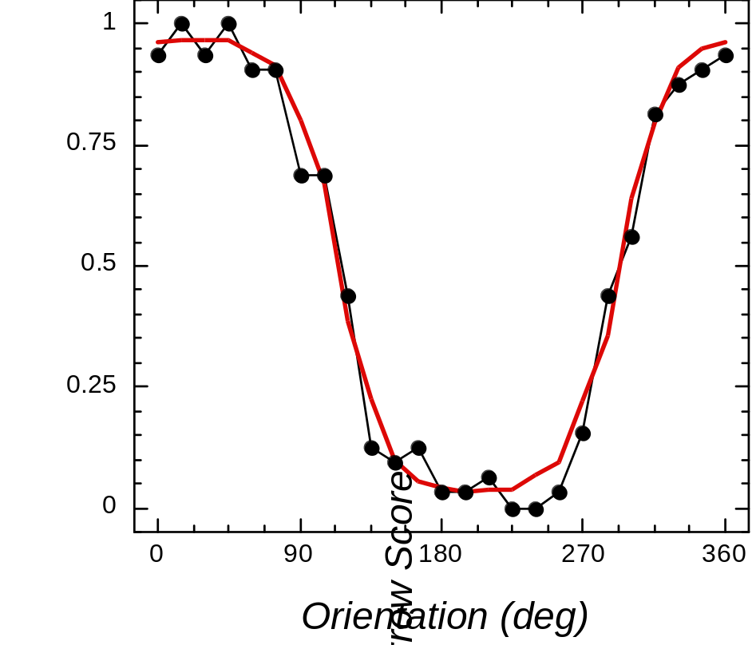

Figure 10: Results for the illumination experiment. The dots indicate the performance of one single observer and the solid line shows the performance of the model.

The smooth curve in Figure 10 shows the best fit of the Bayesian model to the human data. We found a bias for the light source to be located 23.3 degrees to the left of vertical. (XXX OMIT THIS AS YOU CAN’T EASILY EXPLAIN IT: to the left for the light source position equal to 23.3 degrees (Light_kappa = 1.978; Surface_kappa = 1.337 XXX). This fit also provided estimates of the confidence level for this bias (the standard deviation of the prior distribution). In addition, there was a very slight bias to prefer narrow rather than wide strips in relief (XXX OMIT OR EXPLAIN: bias = 0.514 XXX).

III.3. Assumption of Viewpoint from Above

Using the line drawing shown in Figure 11, we showed that observers have a bias to interpret contour drawings as if the observer were located above the object (Mamassian & Landy, 1998). In this experiment, observers reported whether the line drawing appeared to be the projection of a surface patch whose shape was egg-shaped or saddle-shaped. Again, these images were shown at various orientations in the image plane, and observers indicated whether they perceived the object as egg- or saddle-shaped. (XXX: THE FOLLOWING SEEMS WRONG, SINCE THE FIGURES HAVE NO CURVED CONTOURS, PLEASE EXPLAIN: This preference for above viewpoint is also responsible for the fact that observers prefer interpretation shown in Figure 1B over 1C when they are looking at Figure 1A. XXX)

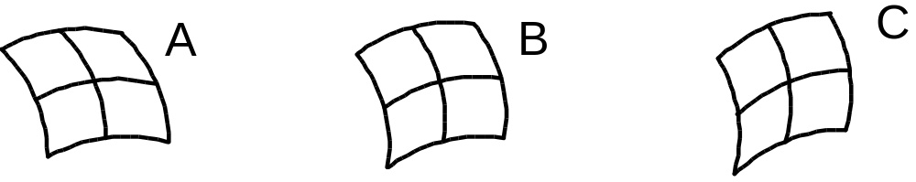

Figure 11: Stimuli used in the viewpoint experiment. The line drawing shown in B can be interpreted as an egg-shaped patch or saddle-shaped patch depending on its orientation in the frontal plane. Figure A tends to be seen as egg-shaped more often, whereas C is more often seen as saddle-shaped.

The preference for a viewpoint located above the scene can be modelled as a preference for the normal to the surface to point upwards. This preference can therefore be modelled as a bias on the tilt of the surface normal, with the preferred tilt equal to 90 degrees.
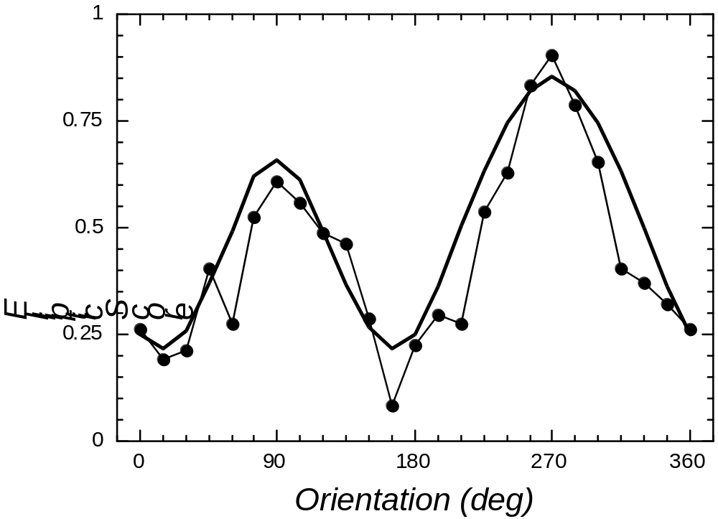

Figure 12: Results for the viewpoint experiment. The proportion of times observers indicated Figure 10B was egg-shaped (for 7 observers) is shown as a function of the orientation in the image plane. The best fit of the Bayesian model is shown as a solid line.

From the best fit of a Bayesian model that included this prior constraint, we estimated the standard deviation of the prior distribution on surface tilt orientation to be 31.5 degrees. In addition, two other constraints were necessary to fully account for the human data. First, there was a bias to prefer contours to be interpreted as convex in 3D (by a factor of 1.75). Second, there was a bias to assume that the contours were aligned with the lines of principal curvature on the surface (the standard deviation of this bias was estimated to be 7.44 degrees).

III.4. Interaction of Prior Assumptions

In the last two sections, we have seen that the interpretation of ambiguous figures benefits from two assumptions: a preference for the illumination to be located above (and to the left) of the object and a similar preference to have the viewpoint located above the scene. In this section, we look at stimuli for which both of these assumptions can be used to disambiguate the figure. An example stimulus is shown in Figure 13 (Mamassian & Landy, in preparation).

Figure 13: Stimuli used for the interaction of priors experiment. Depending on its orientation in the frontal plane, this figure can be interpreted as an embossed surface with narrow or wide strips in relief. Both shading and contour cues to shape are present in the stimulus.

These stimuli can be perceived as embossed surfaces with either narrow or wide strips in relief. The interpretation changed as the figure was rotated in the frontal plane (Figure 14).

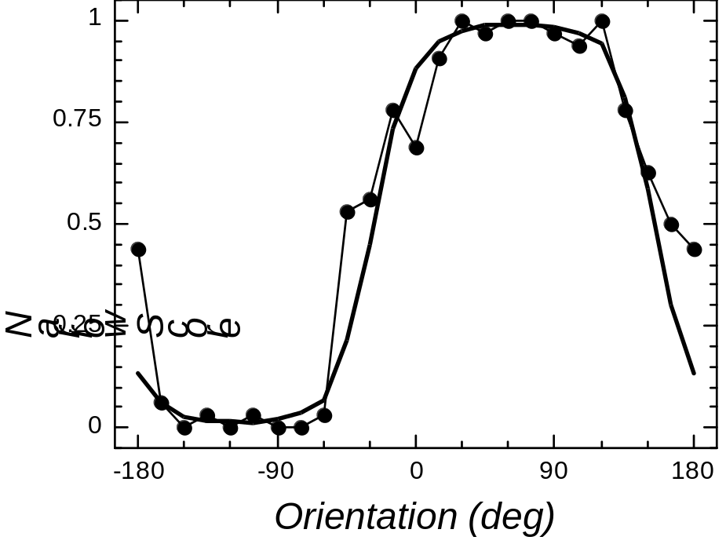

Figure 14: Results for the interaction of priors experiment. The figure gives the proportion of trials observers indicated that the narrow strips were seen in relief as a function of the image plane orientation of the stimulus.

The human performance was well modelled by a Bayesian model that included both the illumination and the viewpoint priors described in the previous sections. The best fit of the model allowed us to extract the parameters of the prior distributions. The light position bias was 10.3 degrees to the left of the vertical. The standard deviation of the illumination prior was 38.4 degrees, whereas the standard deviation of the viewpoint prior was 77.9 degrees. In addition, there was a very slight bias to prefer narrow over wide strips in relief (bias = 0.52).

In the first part of this chapter, we argued that the standard deviation of a prior distribution is inversely related to the confidence in this prior. We tested whether this confidence could be affected by changing the properties of the stimulus. We found that increasing the shading contrast decreased the standard deviation of the illumination prior, and similarly, increasing the contour contrast decreased the standard deviation of the viewpoint prior. These results are consistent with our predictions. It is important to realise what these results imply: prior distributions are not fixed, but instead depend on the apparent reliability of the depth cue that utilises the prior. This reliability can be estimated from ancillary measures extracted from the stimulus (e.g., the contrast of the shading or contour edges in our example).

III.5. Discussion

In this part of the chapter, we have summarised three studies that looked at the 3D perception of ambiguous images. We used the Bayesian framework developed in the previous part of the chapter to focus on the prior assumptions used by the visual system. We found a preference for the illumination to come from above-left and for the viewpoint to be located above the scene. The Bayesian models allowed us to explain quantitatively human performance.

We also looked at a situation in which the consequences of two prior assumptions must be combined. We found that the same Bayesian framework was still applicable in predicting human performance, but only if we allowed the prior distributions to be affected by the stimulus properties. Specifically, we found that the prior confidence value as measured by the variance of the prior distribution was inversely related to the contrast of the stimulus attributes relevant for this prior. This finding is important because it forces us to reconsider the common belief that prior constraints are pieces of knowledge that are independent of the stimuli and of the task with which observers are confronted.

IV. General Discussion

In this chapter, we have described a general framework to study the ambiguities inherent in three-dimensional perception and have described a few applications. The framework is Bayesian in the sense that it emphasises the role played by prior assumptions. In this last part of the chapter, we discuss some of the issues that are inherent in this Bayesian framework.

The first issue deals with the benefits of using a framework as general as the one outlined here. Indeed, it has been shown that other frameworks such as regularization were just special cases of the Bayesian framework (Yuille & Buelthoff, 1996). The advantage is therefore to bring together different ideas that have been used in the past to compare them. One apparent disadvantage is the difficulty to falsify (in the Popperian sense) such a general framework. Nevertheless, some general principles apply. For instance, Yuille & Buelthoff (1996) point out that the more “structured” the likelihood, the smaller the influence of the priors. Likewise, Knill et al. (1996) describe how the influence of the priors increases with stimulus noise (???). In addition, more specific models can be described within the framework and these models can be tested experimentally (VAGUE; VERY VAGUE).

What is the meaning of prior constraints? We have seen how prior constraints can bias the interpretation of ambiguous images. It is important to distinguish the bias from the confidence in this bias. While the bias can reasonably be assumed to be stable under different experimental conditions, the confidence in the bias would be determined directly from the image. For example, in the experiment we described above, the confidence in the light source position was dependent on the contrast of the shading boundaries.

The introduction of the notion of prior confidence leads us to wonder how stable prior biases are? Even though biases can be considered constant over a short time, is it possible to update these priors when the environmental conditions change? This question assumes that biases reflect statistical regularities of the environment in the first place. It also assumes that the visual system has been able to sample an extremely large number of scenes to build the prior distribution. It would therefore make sense to attempt building “sub-optimal” priors that might affect the likelihood functions in possibly wrong ways. These questions need to be addressed in future research. In particular, one way to update the priors might be through the use of the marginal distribution (cf. section 3.5, p. 94, Berger, 1985). (ELABORATE ON THIS)

One important detail to remember about prior assumptions is that they are not all contained in the prior distribution term of the Bayesian framework. We have seen that some variables that participate in the construction of the likelihood function have their own prior distributions. Some other assumptions about the “context” (cf. Yuille & Buelthoff, 1996) are also contained in the likelihood, such as the assumption that surfaces have a Lambertian reflectance. This remark grants us the choice of two different types of tasks to study the prior distributions used by the visual system. To come back to our example, we can ask the observer to estimate either the world angle (explicit task) or instead the slant of the plane containing the two segments (implicit task). Explicit and implicit tasks are equally legitimate for studying the observer’s prior for world angle.

For even the simplest problem, the computational time to simulate a Bayesian model can be very large. This is because the Bayesian observer has to consider all the possible scenes that can give rise to the observed image. Reduced sampling of the world will lead to poorly approximated likelihood functions, which might in turn lead to misinterpretations of the image. One way to circumvent this problem could be to choose an appropriate gain function (HUH? VAGUE).

A related problem is the meaning of a distribution that is close to zero over an interval. Do we really want to pretend that such values for the prior, likelihood or posterior can never occur? One possible answer to this question is the effect of noise In our discussion in this chapter, we have neglected the effect of noise (e.g. Pelli, 1990). Noise is another factor that will increase the uncertainty in the likelihood function.

To conclude, we have reviewed the main principles underlying Bayesian modelling of three-dimensional perception. The framework entails the derivation of the likelihood function, the description of prior assumptions and the choice of a decision rule. We believe that this framework provides a powerful tool to study the mechanisms involved in human visual perception and that it can have important generalisations in others areas of cognitive neuroscience.

Acknowledgements
Funding was partially provided by the Human Frontier Science Program, the AFOSR, and NIH grant EY08266.

References
Berger, J. O. (1985). Statistical Decision Theory and Bayesian Analysis (Second Edition). New York, NY: Springer-Verlag.
Clark, J. J. & Yuille, A. L. (1990). Data Fusion for Sensory Information Processing Systems. Boston, MA: Kluwer Academic Publishers.
Freeman (1996)
Von Helmholtz …
Hershenson, M. (1999). Visual Space Perception: A Primer. Cambridge, MA: MIT Press.
Knill, Kersten & Yuille (1996). In Knill & Richards.
Knill & Richards (1996).
Maloney, L. T. (in press). Statistical decision theory and biological vision. In Perception and the Physical World. D. Heyer & R. Mausfeld (Eds.). Chichester, UK: Wiley.
Mamassian, P. & Landy, M. S. (1997). Illuminant and viewpoint biases from embossed surfaces. Perception, 26 Supp., 51.
Mamassian, P. & Landy, M. S. (1998). Observer biases in the 3D interpretation of line drawings. Vision Research, 38, 2817-2832.
Mamassian, P. & Landy, M. S. (in preparation). Interaction of visual prior constraints.
Pelli, D. (1990).
Rock, I. (1983). The Logic of Perception. Cambridge, MA: MIT Press.
Yuille, A. & Buelthoff, H. H. (1996). In Knill & Richards.

Note that angle is a continuous variable, so we are dealing with a continuous distribution. The probability of any particular value (e.g. an image angle of precisely 135 degrees) is zero. Such distribution functions are not easily estimated using Monte Carlo simulations without approximating them as discrete distributions (e.g. binning the angles into bins of width 10 degrees).

