02458 Cognitive modelling E19

Exam 12-12-2019

Arianna Taormina ([arita@fysik.dtu.dk](mailto:arita@fysik.dtu.dk))

# Problem 1

Hp:

* Strong fusion model
* Observer responses are normally distributed
* Observer doesn’t zoom out
* Gaussian Visual noise and Gaussian Auditory noise are independent
* the observer as no prior knowledge of the location of the stimulus

Given:

* S = true angle of the stimulus
* x_A = internal representation of the true angle
* R = observer response is the estimate of S given x_A

We know that

* With only auditory stimulus:

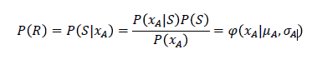

Equation

* Similar with x_V with only Visual stimulus (x_V instead of x_A).
* And with both A and V:

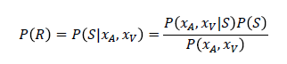

Equation

The means and sigmas are therefore related as:

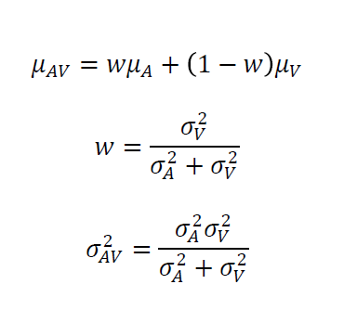

Equation

In our case we have two experiments:

1. EXPERIMENT AUDIO AND VISUAL (AV)

Audio from three angles S1,S2, S3 .

N_obs for each S = 100.

Visual (flash of light) is kept constant

1. EXPERIMENT ONLY VISUAL (V)

We start by calculating the real means and sigmas for AV and V.

We want to estimate the distribution of the observer’s responses when there is not visual stimulus, so when its only AUDIO (A) for each of the three sound locations, meaning that we have to estimate the two parameters of the 3 gaussianS: m_a (mean of Audio response distribution) and s_a (standard deviation of Audio response distribution) for the 3 cases, starting from the fusion model.

We invert the Equation 3 to calculate sigma_a and mu_a

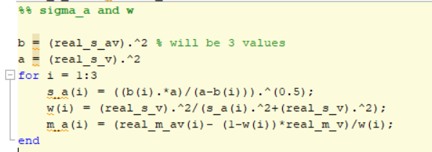

Figure 1 snip of Matlab code

Getting the parameters of the 3 Gaussians:

audio from location number 1

standard deviation: 6.1804

mean: 7.5996

----------------------------------

audio from location number 2

standard deviation: 7.4278

mean: 16.7696

----------------------------------

audio from location number 3

standard deviation: 7.2575

mean: 20.6594

----------------------------------

We can see that the estimated location of the Audio stimuli changes a lot in the 3 cases and the one having lowest deviation is the first.

# Problem 2

|  |  |  |  |  |
| --- | --- | --- | --- | --- |
|  | NO | YES-MAYBE | YES | TOT OBS |
| **NOISE** | **15** | **6** | **29** | 50 |
| **SIGNAL** | **27** | **4** | **19** | 50 |
| TOT OBS | 42 | 10 | 48 |  |

Table 1 Summary table of CR,FA,M and H

We can see the 3 answers as a three level confidence ratings, which can be model using a signal detection model w ith2 criteria dividing the line into 3 ordered response categories.

LAMBDA_1 = between NO and YES-MAYBE

LAMBDA_2 = between YES-MAYBE and YES

For LAMBDA_1:

FA = 6+29/50

H =4+19/50

For LAMBDA_2:

FA = 29/50

H = 19/50

In vectors:

P_FA =

0.7000 0.5800

P_H =

0.4600 0.3800

Standardizing:

Z_FA =

0.5244 0.2019

Z_H =

-0.1004 -0.3055

d_prime =

-0.6248 -0.5074

The receiver operating characteristics is a straight line in Gaussian coordinates so:

Φ-1 (P_H) = (1/ σ) Φ-1 (P_FA) + (μ/σ)

By fitting a straight line to the P_H / P_FA for each of the two criteria we get:

sigma_SN_approx = 1.5728

mu_SN_approx = -0.6824

Overall we can see there are many more FA then hits, moreover d_prime is negative for both criterions: the observer is not able to distinguish S from N.

# Problem 3

We know that :

d_prime = Φ-1 (P_H) - Φ-1 (P_FA)

d_prime= Z_H-Z_FA;

criterion or bias = Φ-1(P_CR)

P_CR = 1- P_FA

We are given:

d_prime =1.1;

x = 5;

There fore we can calculate:

The sound level is 5 cd/m^3

The standard deviation is 4.5455 cd/m^3

We don’t know anything about the bias or criterion of the observer, so we can examine the 3 cases: lax criterion, moderate and conservative.

criterion = [-0.5 0.55 1.5];

Assuming Gaussian noise the psychometric function is a cumulative Gaussian Φ((x-x0)/σ) where x is the intensity of the stimuli in cd/m^3 ,x0 is the 50% threshold and σ is the standard deviation.

The sensitivity d’ is measured in standard deviations on the unit-less internal representation.

There fore we calculate σ and x0:

The sound level x is 5 (cd/m^3)

The standard deviation σ is 4.5455 (cd/m^3)

The 50% of threshold is -2.2727,2.5, 6.8182 (cd/m^3) for lax, moderate and conservative criterion.

The threshold tells us how likely is the observer to say “Yes” when there is no stimulus. In case of negative threshold he would say yes more then 50% of the time.

# Problem 4

QUESTION 1) AND 2)

Running PCA on the S matrix we can see how the first 54 Principal components are enough to capture 90% of the variance.

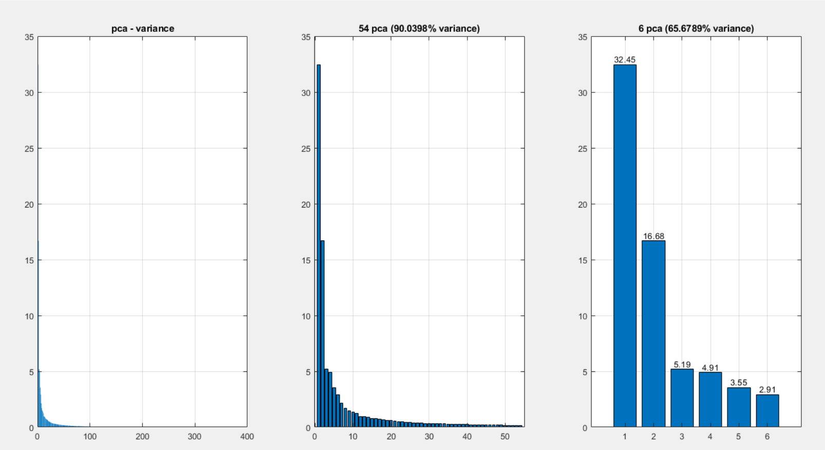

Figure PC54 and PC6

QUESTION 3)

Coefficients of Linear Model

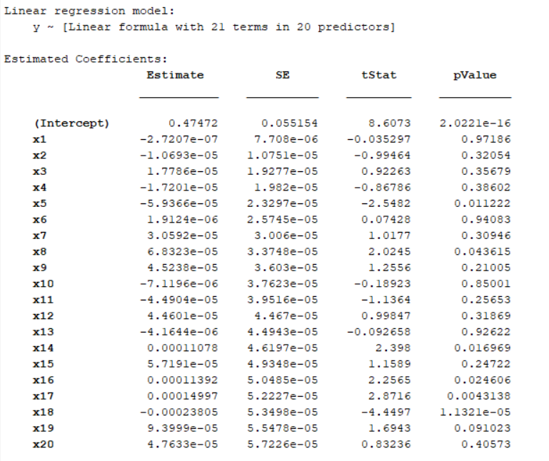

Figure

QUESTION 4)

We use forward sequential feature selection to find important features. The feature selection procedure performs a sequential search using the MSE of the learning algorithm on each candidate feature subset as the performance indicator for that subset.

I had started by using all W, but it was taking way to long and I then re-select among only the first 20 components.

The selected features are not the one which have in general more variance, but the ones that better capture the sliminess of the image (eg features like shape of the mouth, position of the eyes..)

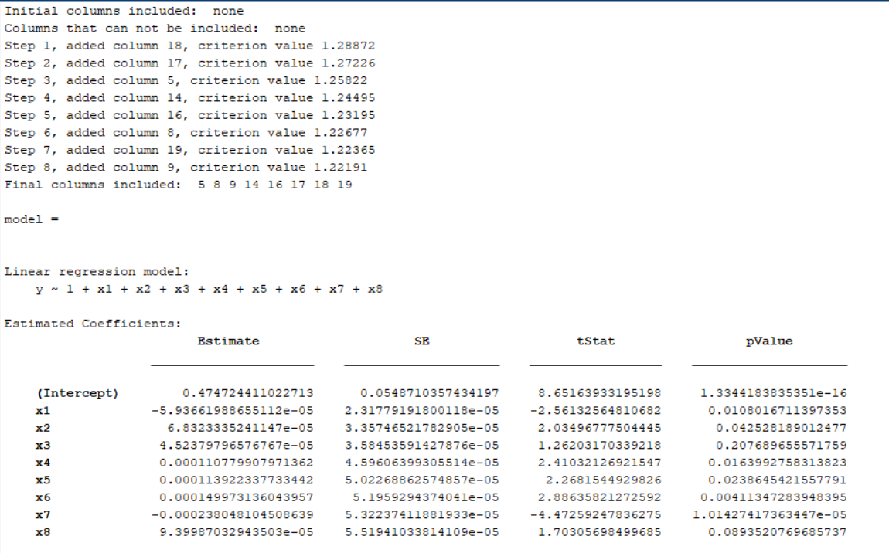

Figure Selected features

QUESTION 5)

show the linear model output for smiley intensity level y0 -1 to +1 from the code

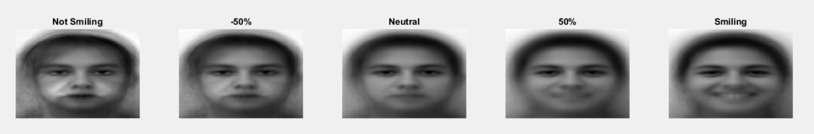

Figure New Faces!