STRATEGIC REPOSITIONING OF ARQON SNEAKERS: BALANCING SUSTAINABILITY, COMPETITIVENESS, AND GROWTH

Table of Contents
Slide 1 – Company Overview & Market Snapshot 3
Slide 2 – Competitive Position & Strategy 4
Slide 3 – Internal Analysis & SWOT Insights 5
Slide 4 – Strategic Growth Opportunities (Ansoff) 7
Slide 5 – Sustainability, CSR & Carroll’s Pyramid 8
Slide 5 – Reference 10
Slide 6 - Thank You 10

Slide 1 – Company Overview & Market Snapshot
Bullets:
- The core of Arqon's corporate vision is about producing sustainable, innovative, and inclusive sneakers;
- the company's corporate mission is to provide high-quality shoes at affordable prices while promoting social responsibility and ethical practices;
- its core values are integrity, performance and its commitment to sustainability;
- the strategic objective will promote sustainable growth for the long term and benefit all stakeholders;
- it is based on an assessment of innovation, competitive activity, economic, and environmental influences.
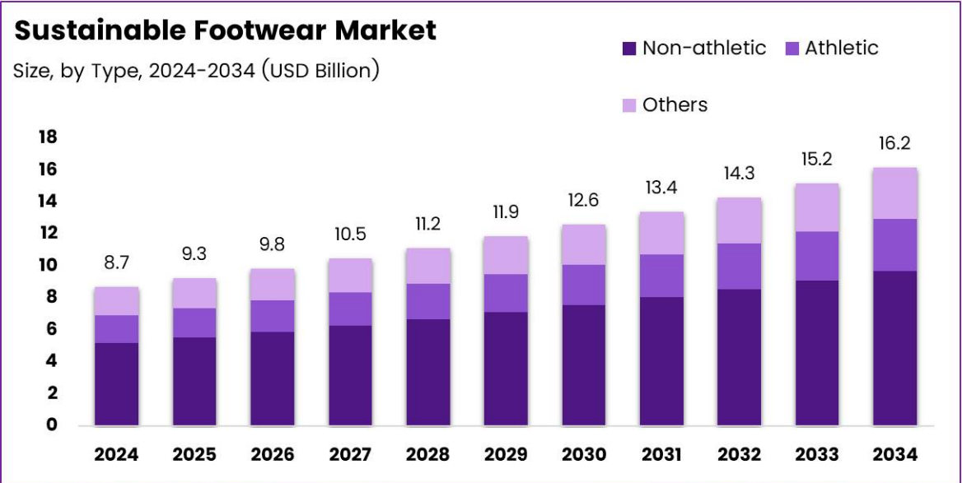
Speaker Note
Sneakers Inc. has a goal to be an innovative and sustainable shoe manufacturer operating globally under the Arqon brand. Sneakers Inc.'s strategic objectives are to produce high-quality, affordable, ethically-produced shoes that have minimal environmental impact while including everyone regardless of income or geographical area. This includes focusing on performance while maintaining a commitment to customers as well as the environment. These goals are supported by core values (transparency, integrity, customer commitment) which will help build trust and loyalty with customers while establishing the company's commitment to its mission. Post the 2008 crisis, the current leadership believes there is an opportunity for Sneakers Inc. to increase competitiveness using digital branding and sourcing greener materials. A PESTLE analysis shows several drivers affecting the industry: increasing technological innovation; increasing consumer awareness of sustainability; post-pandemic economic recovery; tighter environmental regulations.

Slide 2 – Competitive Position & Strategy
Bullets:
- The company will follow an approach of a differentiation strategy based on moderate costs, a moderate level of competition, as well as maintaining a sustainable niche focus.
- Supplier efficiency is also important to the company; however, it has a major concern regarding the carbon footprint of suppliers. The company focuses on an inclusive, responsible image of the brand (Albers, 2023).
- Porter's analysis will help the company develop a strategy that will allow it to sustain a competitive advantage.
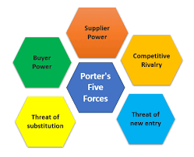
Speaker Note
Arqon implements an overall differentiation strategy. The differentiation strategy emphasizes innovation and sustainability (green) while also emphasizing affordability. Competition intensity will remain very high in part due to other global sneaker manufacturers and changing consumer preferences, thus buyer power is high. Customers are demanding that sneakers be made from eco-friendly materials but at affordable prices, which has increased supplier power. The company was forced to replace its green supplier LTC for Zwolawski & Zwolawski and El Dutch Supplier to address a stock out crisis. The replacement of suppliers did improve the time it takes to get products from the manufacturer to the retailer but it also increased the carbon footprint of the company; and demonstrates how operational dependability may need to be sacrificed for ethical considerations regarding sustainability. To mitigate this Arqon can enhance transparency of their operations and communicate corrective actions.

Slide 3 – Internal Analysis & SWOT Insights
Bullets:
• Strengths of the organization are: innovative, highly committed workforce, high-quality ethics.
• Limitations or weakness of the firm is: low volume manufacturing; dependence on suppliers.
• Opportunities for the firm include development of new environmentally friendly products & entry to developing economies.
• Some threats for the organization are: uncertainty of the economy, large scale of competition.
• The VRIO model supports an explanation for why the organization has a sustainable competitive advantage through differentiation.
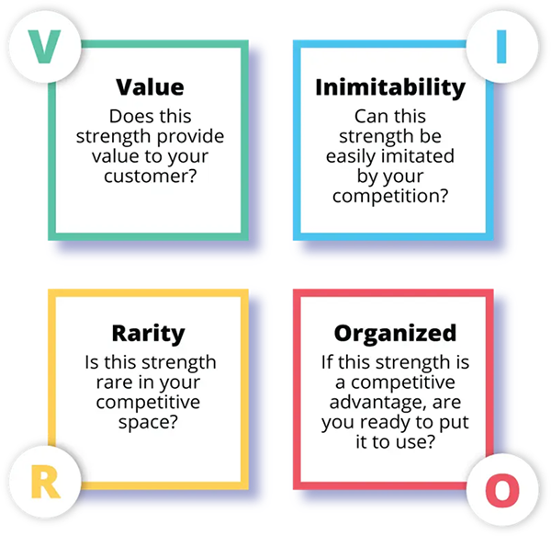
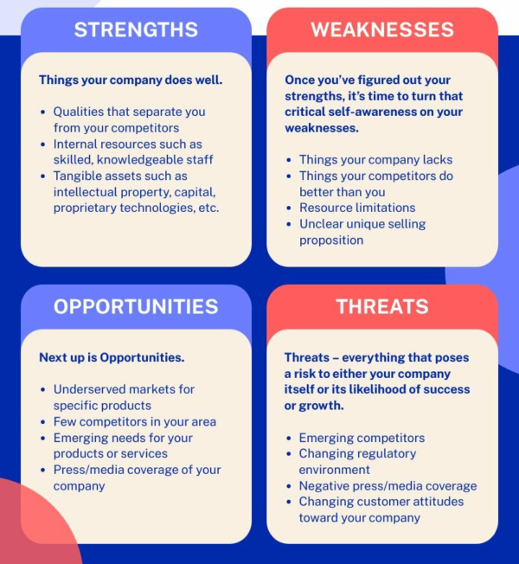
Speaker Note
Arqon's strength as a provider of innovative designs combined with their strong human resource capabilities (dedicated staff) provide the basis for a "competitive core" based upon Valuable, Rare, and Hard-to-Imitate Resources (VRIO). These strengths consist of having an authentic and high-quality product (due to the skill of designers), authentic branding and authentic and ethical leadership. The weaknesses of Arqon are limited capacity for production and limited number of suppliers. Arqon has also shown vulnerability in managing supplies (as evident in the recent stock shortages in the United States). Arqon may also have opportunities to expand into Asian countries which are seeking to create new, green or environmentally friendly footwear products. Another opportunity for Arqon is to transition into using biodegradable materials within their footwear products. Arqon faces many threats including an economic downturn, larger competitors who can take advantage of economy of scales, etc. The VRIO analysis indicates that Arqon has developed a sustainable/eco-friendly brand identity that will be difficult to replicate and therefore provides the basis for long term competitive advantage. Arqon will need to strengthen their internal operating systems by implementing digital forecasting technology to monitor supply chain needs and implement multi-sourcing to ensure product availability while maintaining their ethical commitments.

Slide 4 – Strategic Growth Opportunities (Ansoff)
Bullets:
• Covertly expanding through powerful social media branding to penetrate the market.
• Focusing on developing products that are part of its Eco-Friendly Collections.
• Specifically, its expansion into new markets will be focused on new markets in Asia and Europe (Dia, Islam and Islam, 2025).
• Diversifying by adding Accessories & Apparel Line.
• Achieving a 15% revenue growth rate for the year.
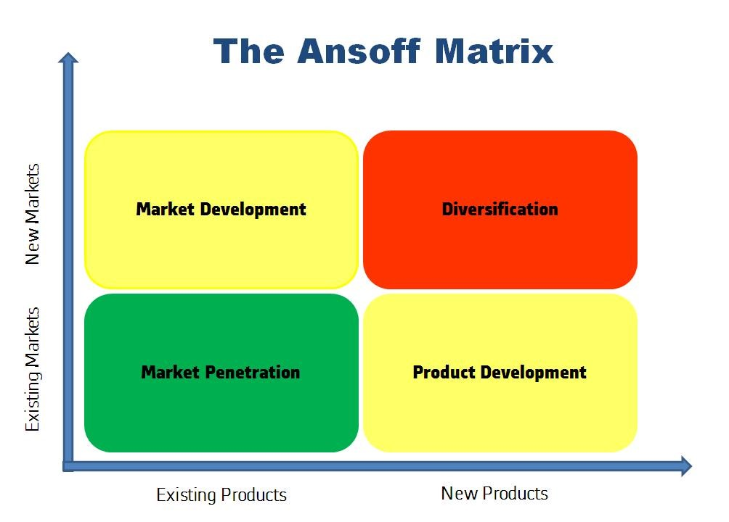
Speaker Note
Arqon is going to apply Ansoff's Growth Matrix for it's future growth strategy with a focus on sustainable development. To gain market share (market penetration) it will focus on collaboration with social media influencers and targeted online advertising to further increase the level of customer interaction and loyalty to the brand. The product development component will provide the opportunity for new products produced from recycled materials and/or using plant based soles, which will be learned from the experience with suppliers. For its market development component, Arqon will target eco-friendly fashion consumers in Asia and Europe through E-Commerce and partnership with local companies. Its diversification component will include lifestyle accessories that further build on the brand identity of Arqon. Arqon's short-term goals are for a 15% yearly revenue growth rate as well as an additional 10% in the level of awareness or "brand recall" over the next 2 years. Arqon will invest primarily in research and development and modernising their logistics to enable them to quickly source their raw materials while also ensuring they can do this in a responsible manner.

Slide 5 – Sustainability, CSR & Carroll’s Pyramid
Bullets:
• The Company has Ethical Sourcing Practices that are in line with Carroll's CSR Model.
• Environmentally the company is working towards reducing its Emissions and Recycling Waste.
• Philanthropically the company conducts Community Shoe Donation Drives.
• Legally the company works to ensure its Suppliers comply with Fair Labor Standards (Ghalambor & Firozpour, 2025).
• Economically the company will continue to work towards Achieving Long-Term Profitability for All Stakeholders.
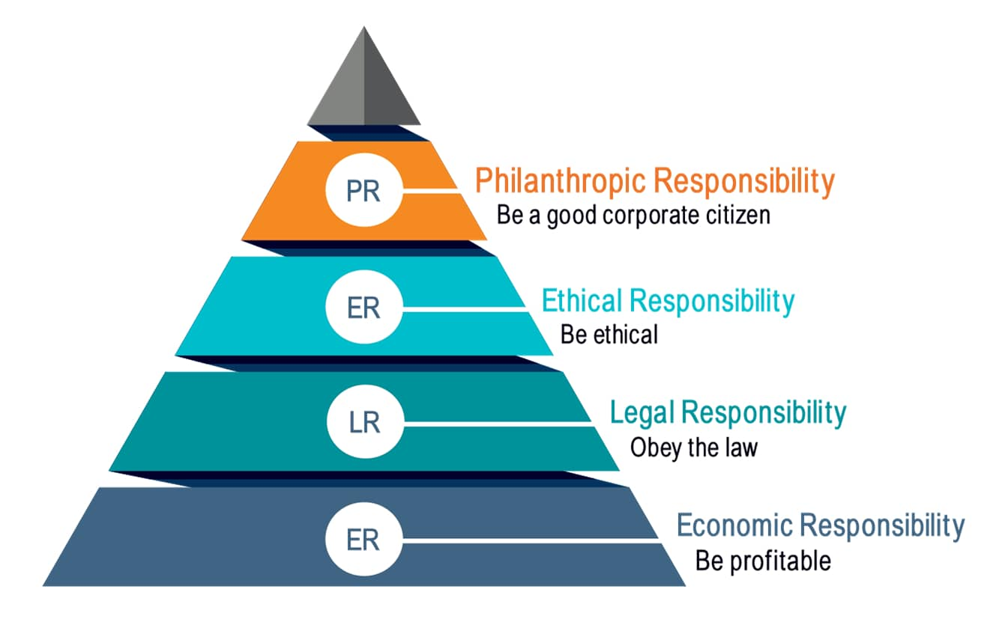

Speaker Note
Arqon uses Carroll's CSR Pyramid as a tool in which it combines its pursuit of sustainability with profitability by integrating sustainability into each of the four layers of Carroll's pyramid; Economic Layer - Cost effective procurement is used to sustain shareholder returns, Legal Layer - Arqon will ensure that all suppliers comply with labor and environmental standards to prevent past carbon footprint problems, Ethical Layer - Fair trade materials are being used, transparent reporting is occurring, and consumers are having their confidence restored as a result of the replacement of LTC, Philanthropic Layer - Social impact is being reinforced by means of "Walk for Earth" donation programs and providing sneakers to underprivileged youth.
Stakeholders include customers, employees, NGOs and regulatory bodies, all of which have an interest in Arqon's sustainable reform process, and therefore can be identified using stakeholder mapping.

Slide 5 – Reference
Albers, J., 2023. The Gen-Z Sneakerhead Paradox: Balancing Sustainability and Streetwear in the World of Nike: Nike Case Study (Master's thesis, Universidade NOVA de Lisboa (Portugal)).
Caré-Famchon, A. and Roy, P., 2024. A sustainable business model in the fashion industry. In Business Model Innovation in Creative and Cultural Industries (pp. 48-68). Routledge.
Dia, R.R., Islam, Q.T. and Islam, Q.T., 2025. Green Steps: The Evolution of Thaely in the Sneaker World. SAGE Publications: SAGE Business Cases Originals.
Ghalambor, M.A. and Firozpour, A., 2025. Future-proofing footwear: Scenario-based sustainable innovation for SDG alignment in Iranian MSMEs within the textile industry. Journal of the International Council for Small Business, pp.1-25.

Slide 6 - Thank You

