STRATEGIC GLOBAL MARKET ENTRY AND MARKETING PLAN FOR LAUNCHING THE NUTRIPRINT 3D PERSONALISED FOOD SYSTEM IN THE USA AND FRANCE

Executive Summary
This report develops a complete global marketing strategy for NutriPrint, a personalised 3D food printing system, for two priority international markets, the United States and France. The analysis follows the university brief and applies advanced international marketing concepts to justify market selection, shape the strategy mix, and design an implementable roll out. The United States is attractive because of its large health tech segment, smart kitchen adoption, strong e commerce logistics and openness to AI based nutrition services. France is attractive for a different set of reasons, including high food quality orientation, an established health insurance and wellness discourse, and strong retail networks, although cultural sensitivity to food authenticity raises adoption barriers. The report applies models such as PESTLE, CAGE distance, market entry mode logic, standardisation versus adaptation, and global value chain thinking to align NutriPrint’s innovation with local expectations.
A dual strategy is proposed. The product core will stay standard to protect the technology and the AI nutrition engine, while front end elements, especially recipe libraries, language, ingredient cartridges and partnerships, will be adapted by market. Pricing will follow a premium skimming logic in the United States and a value anchored, partner supported structure in France. Distribution will mix direct to consumer e commerce, partnerships with health and tech retailers, and selected B2B pilots with clinics, sport centres and corporate wellness programmes. An implementation roadmap, KPIs and risk mitigations are presented, along with a critical discussion of how far classical international marketing theory can cope with a product that sits between food, health and consumer IoT. A reflective section selects France as the focus market and explains how cultural food meanings will need sustained relationship marketing.

Table of Contents
1. Introduction 4
2. Market Selection and Analysis 4
2.1 Market selection logic 4
2.2 United States analysis 5
2.3 France analysis 6
2.4 Entry mode considerations 7
2.5 Justification of USA and France 7
3. Global Marketing Strategy Development 8
3.1 Comprehensive global marketing strategy 8
3.1.a) Product adaptation or standardization 8
3.1.b) Pricing strategies 8
3.1.c) Distribution channel selection 9
3.1.d) Promotion and communication strategies 9
3.2 Strategy addresses market specific challenges 10
3.3 Competitive advantage in the global marketplace 11
4. Implementation Plan and Performance Metrics 11
4.1 High level implementation roadmap 11
4.2 Key performance indicators 12
4.3 Risks and mitigation measures 13
5. Theoretical Underpinning and Innovation 14
5.1 Linking to international marketing theories 14
5.2 Entry mode and network perspectives 15
5.3 Innovation and service dominant logic 15
5.4 Creativity in application 16
5.5 Limitations of existing theories 16
6. Reflection 17
7. Conclusion 18
8. References 19

1. Introduction
This report develops a global marketing strategy for NutriPrint, a personalised 3D food printing system that links AI driven nutrition planning with smart kitchen technology, for launch in two specific international markets, the United States of America and France. The task in the brief is not only to describe these markets, but to justify why they are suitable, to design a coherent marketing mix for each, and to show how international marketing theory supports those decisions. The United States provides a large, innovation friendly, high income environment where early adopters, health enthusiasts and connected home users are already present. France provides a mature, food conscious, regulation intensive market where consumers value quality, provenance and convenience, so the product must be localised more carefully. Taking both markets together allows the report to demonstrate how a single core value proposition, personalised healthy meals at home, can be standardised at technology level and adapted at cultural and communication level. The report will proceed by analysing market attractiveness, developing the global marketing strategy, outlining implementation and performance measures, and finally discussing theoretical fit and limitations for a product that sits across food, health and consumer IoT.

2. Market Selection and Analysis

2.1 Market selection logic
The brief identifies the United States and France, but the selection still requires justification. Both markets have high purchasing power, strong digital infrastructure and growing interest in health, which are essential for a premium, technology intensive appliance such as NutriPrint. The United States is generally more accepting of food related technologies, meal kits, plant based products and smart kitchen devices, so early adopters are easier to reach (Adel, Mahrous and Hammad, 2020). France, by contrast, protects its culinary heritage and ingredient authenticity, yet French consumers routinely pay for quality, provenance and nutrition. By operating in two markets with contrasting food cultures, NutriPrint can test different adoption drivers, one innovation led and one culture led, and use those learnings for later European or Asia Pacific expansion (Yasa et al., 2020). Launching in both also diversifies regulatory experience across FDA rules and EU food and data standards, which strengthens future compliance capabilities and signals commitment to long term international growth plans.

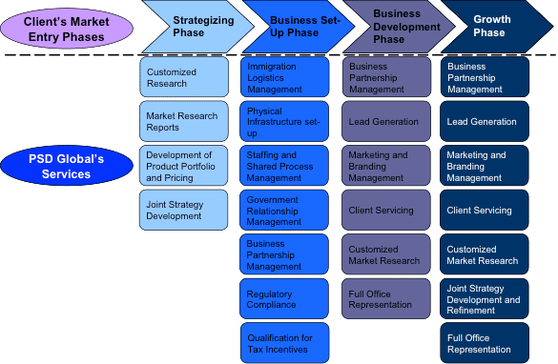

Figure 1: Market Entry Services | Market entry USA
(Sources: psdglobal.com, 2025)

2.2 United States analysis
From a PESTLE perspective, the United States is politically stable, has clear FDA and food safety regulations, and supports innovation in connected devices. Economically, it is a large high income market with strong credit and consumer financing systems that can support premium appliance purchases. Socially, there is a significant segment that pursues quantified self lifestyles, that tracks macros, and that accepts AI based recommendations (Alon et al., 2020). Technologically, the United States has high smart home penetration, mature e commerce and app stores, which makes remote operation and software updates feasible. Legally, NutriPrint will need to meet appliance, IoT and food cartridge requirements but the route is transparent.
Competitive conditions include indirect competitors such as high end kitchen appliances, meal kit services, protein powder brands and personalised nutrition apps. None of these fully integrate 3D printed food plus AI macros in one appliance, which gives NutriPrint first mover advantage. The main challenge will be consumer education, since printed food is still a relatively novel concept outside professional kitchens (Tyukhtenko et al., 2024). Early adopters will probably be tech enthusiasts, health professionals, parents managing allergies, and athletes.

2.3 France analysis
France scores high on political stability and EU level food regulation. It is part of a large customs area, which helps later EU scaling. Economically, it is affluent, although average household disposable income is lower than in the United States, so value communication must be sharper. Socio culturally, food is strongly linked with identity, freshness and pleasure (Tien, 2020). This means that a 3D printed meal can be perceived as artificial if the brand narrative is not localised. On the positive side, France has strong discourses on nutrition for children, ageing populations and medical diets, so there is an important functional niche that NutriPrint can serve.
Distribution in France is historically tied to powerful retailers such as Carrefour, Auchan and E.Leclerc, and to specialised culinary chains. Entering these channels will require clear evidence of consumer pull or of alignment with health and sustainability priorities (Baker et al., 2020). Digital commerce is growing, so NutriPrint’s app based model fits the market, but local language, recipe localisation and French customer support will be essential. Legally, NutriPrint must follow EU appliance standards, GDPR compliant data handling for health metrics, and possibly French specific guidance on novel foods.
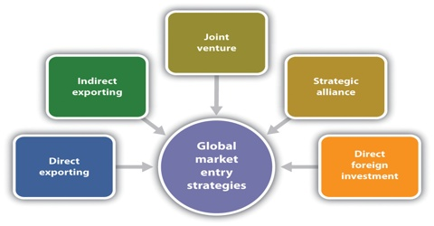

Figure 2: Foreign Market Entry Strategy and Rules
(Sources: assignmentpoint.com, 2025)

2.4 Entry mode considerations
For the United States, direct exporting with a wholly owned subsidiary or at least a strong local sales and service company is advisable, because the company needs to protect its technology, manage software updates, and collect user data for AI improvement (Zulfikar, 2022). A high control mode such as a sales subsidiary or branch gives better IP protection and closer customer insight.
For France, a hybrid entry mode is more suitable. The firm can export from the existing production base, supported by a local marketing office, and work through large French retailers or specialised distributors for the appliance (Benoit et al., 2023). At the same time, it can localise digital content and ingredient cartridges through partnerships with French food suppliers. This reduces risk while still gaining market learning.

2.5 Justification of USA and France
The combined selection of the United States and France gives NutriPrint a strategic test bed across two contrasting conditions. The United States is an innovation receptive, high income, digitally mature market where consumers already interact with meal kits, wearables and smart kitchen devices, so a successful launch there would validate the technological concept, create early brand visibility and secure endorsements from health professionals and influencers (Berg et al., 2023). France, by contrast, represents a food proud, regulation intensive context in which convenience products must still respect culinary identity. Achieving acceptance there would demonstrate that NutriPrint can be culturally localised, framed as healthy and environmentally considerate, and distributed through powerful national retailers. Taken together, the two markets let the firm prove both scalability and adaptability in line with international marketing criteria for rigorous market selection.

3. Global Marketing Strategy Development

3.1 Comprehensive global marketing strategy

3.1.a) Product adaptation or standardization
NutriPrint should retain a single global core that includes the 3D printing hardware, AI nutrition engine, cartridge interface and mobile or web app. Keeping this layer standard delivers scale, unified updates and a consistent brand in the United States and France. Adaptation should occur in the augmented layer. For the United States, content should stress high protein meals, sports nutrition, diabetic friendly plans and fast family recipes (Devaux et al., 2020). For France, the app must be French, menus should mirror local cuisine, cartridges must use recognised ingredients and co branding should enhance authenticity for cautious early adopters in that market and health agencies.

3.1.b) Pricing strategies
Two linked but distinct pricing approaches are suitable. In the United States, NutriPrint can enter at a premium level, using a market skimming strategy, because US early adopters of smart home and health technologies are willing to pay more for novelty, and the company needs to recover R&D costs. Recurring revenue will come from cartridges, recipe subscriptions and upgraded AI features. In France, the device should still be premium, but prices must be more value anchored, because large French retailers and households are more price attentive. Bundled launch offers, retailer supported promotions and instalment or subscription models that spread the cost will make adoption easier. For medical or dietetic uses, partnering with corporate wellness or health cover providers can further reduce price barriers for French customers.
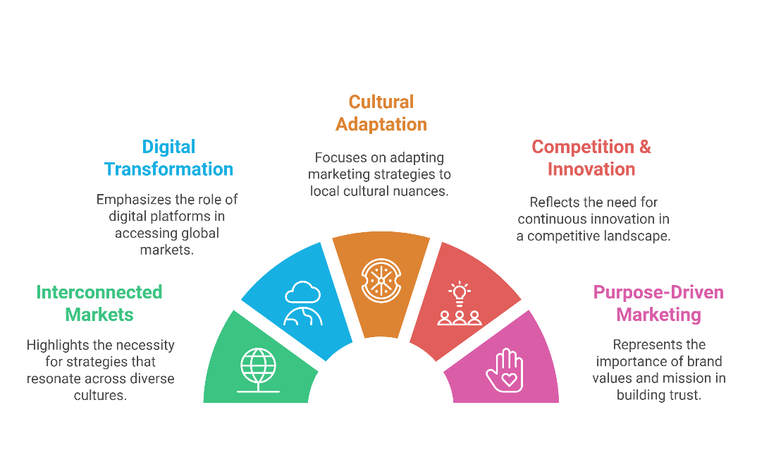

Figure 3: Global Marketing - The Marketing Map
(Sources: marketingmap.pressbooks.tru.ca, 2025)

3.1.c) Distribution channel selection
A multichannel route is required. In the United States, NutriPrint can sell directly through its own website and leading e commerce platforms, and it should also place the device in premium electronics and smart home stores where live demonstrations are possible. Partnerships with gyms, sports centres and dieticians will create trial in a trusted setting. In France, distribution should prioritise national retail groups, kitchen appliance specialists and pharmacy or para pharmacy chains for the health segment, because these are trusted points of purchase (Devaux et al., 2021). All online channels must be fully localised in French, and ingredient cartridges should be made available through supermarket click and collect, which is widely used in France.

3.1.d) Promotion and communication strategies
Communication must first reduce uncertainty about printed food by explaining the process, ingredient quality and personalised health benefits. In the United States, social influencers, fitness YouTube creators and app based content can drive early trials. In France, endorsements from nutritionists, innovation friendly chefs and co promotion with trusted food brands will be more persuasive. PR in French food media should stress respect for culinary tradition. Both markets need in app notifications and loyalty rewards to reinforce usage and repeat buying.

3.2 Strategy addresses market specific challenges
The analysis stage identified different barriers in the two markets. The United States challenge is less about culture and more about usefulness, price and proof that printed meals can match health goals. Standardising the core, offering performance oriented recipes and using a premium skimming price supported by subscriptions addresses this, because it frames NutriPrint as an advanced, complete system rather than an experimental gadget. The French challenge is more cultural. Consumers may question authenticity, naturalness and the place of a machine in the kitchen (Escalante-Aburto et al., 2021). Here, the strategy answers directly through deeper adaptation, French language, French recipes, co branding with local suppliers and distribution through trusted French retailers. By doing this, the firm recognises that France requires higher local responsiveness, which is consistent with international marketing theory on psychic distance. The different pricing and channel choices also reflect structural differences, since French retail is more concentrated and more influential in household purchases than US retail. Overall, the strategy shows that standardisation alone would not overcome French cultural resistance, and adaptation alone would raise costs unnecessarily in the United States, so a mixed approach is the most defensible.

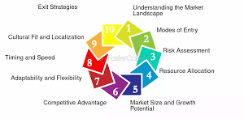

Figure 4: Choosing The Right Market Entry Strategy
(Sources: fastercapital.com, 2025)

3.3 Competitive advantage in the global marketplace
The proposed strategy creates advantage in three connected ways. First, it protects a technological lead. Very few consumer products combine 3D food printing and AI driven nutrition for home users, so maintaining a standard global core keeps NutriPrint ahead and makes it harder for rivals to reverse engineer software or cartridge interfaces. Second, it builds an ecosystem around cartridges, recipe subscriptions, app engagement and local partnerships. Once a user has entered health data, saved preferred menus and bought compatible cartridges, switching becomes costly, which raises customer lifetime value (Fernandes, 2021). Third, it uses cultural fit as a barrier to imitation. By preparing French specific recipes, French language interfaces and co branded ingredient packs, NutriPrint creates local emotional attachment that a highly standardised global appliance brand would struggle to copy quickly. In this way the strategy meets the brief requirement to discuss competitive advantage, since it shows how global scale, data based personalisation and localisation work together to make NutriPrint both attractive to users and difficult for competitors to dislodge.

4. Implementation Plan and Performance Metrics

4.1 High level implementation roadmap
Phase 1, preparation, months 1 to 3. The company should secure all regulatory and product safety clearances for the United States and for France, since food related and connected appliances are strictly monitored in both jurisdictions. At the same time, the NutriPrint app must be translated, culturally localised and tested in English and French, including recipe search, secure payment and customer support flows. Country specific recipe libraries should be created, using US fitness and family dishes for the American market and French Mediterranean and health supportive dishes for France (Kapała, 2020). Customer service teams must be trained to answer installation, cartridge ordering and basic nutrition questions. Logistics partners for cartridge storage and last mile delivery in both countries should be identified and contracted, and retailer pitch material prepared.
Phase 2, launch in the United States, months 4 to 6. Launch should start online through the NutriPrint website and leading e commerce platforms to reach tech forward buyers quickly. At the same time, demonstration units should be placed in selected technology and smart home retailers in metropolitan areas such as New York, Los Angeles, San Francisco, Chicago and Austin, where early adopters are concentrated. Digital campaigns should target health conscious consumers, parents managing allergies, older adults with dietary needs and fitness communities. The app must collect early feedback, recipe ratings and usage intensity so that AI recommendations and cartridge forecasts can be refined.
Phase 3, launch in France, months 6 to 9. This stage should be coordinated with major French retail groups and kitchen appliance specialists, since French households trust established chains. Demonstration units with trained promoters will be needed to reduce the novelty barrier. PR should present NutriPrint as health supportive, sustainable and time saving, while clearly respecting French culinary tradition (Katsikeas, Leonidou and Zeriti, 2020). Social media comments, press coverage and customer support tickets should be monitored, and if the product appears artificial or too expensive, messaging, visible ingredients or launch bundles should be revised.
Phase 4, ecosystem consolidation, months 10 to 12. Once both markets are active, the firm should widen the cartridge range, introduce co branded cartridges with local suppliers and launch a premium subscription tier. Business to business pilots with clinics, sports centres and corporate wellness programmes should begin, and supply chain performance and service level agreements should be reviewed and strengthened.

4.2 Key performance indicators
Performance should be tracked through a balanced set of KPIs. Sales and adoption KPIs will include number of devices sold per month by market, adoption rate in priority segments such as families and medical users, repeat cartridge purchase rate, subscription uptake for recipes or AI features, and average revenue per user. Marketing KPIs will include website traffic, landing page conversion, cost per acquisition by channel, social media engagement, influencer or PR reach and share of positive versus neutral coverage (Lasserre and Monteiro, 2022). Customer experience KPIs will include app engagement frequency, completion of onboarding steps, net promoter score, satisfaction with local recipes, number of support tickets and average resolution time, plus retention at six and twelve months. Operational KPIs will include cartridge supply lead time, stock out rates in retailers, delivery times for online purchases, device return rates and installation completion rates. Strategic KPIs will include number of local partnerships formed, regulatory milestones achieved, quality of user data for AI improvement and progress toward retailer shelf expansion.

4.3 Risks and mitigation measures
Regulatory and food safety risk is high because the product combines an appliance with edible inputs and user data. This should be mitigated through early engagement with the FDA in the United States and with EU and French authorities, complete ingredient labelling, transparent communication about how food is assembled and scheduled compliance audits. Cultural rejection risk is higher in France, where food is tied to identity (Liu, Melot and Wallet, 2024). This can be reduced through deeper localisation, co branding with trusted French food companies, endorsements from chefs and nutritionists and communication that stresses natural ingredients, not synthetic meals. Cartridge supply chain risk should be addressed through dual sourcing, safety stocks in local warehouses and close monitoring of demand through app telemetry. Technology and data privacy risk should be mitigated through GDPR compliant design for France, strong encryption, clear consent flows and periodic security reviews. Competitive response risk from large appliance brands should be met by strengthening the software and cartridge ecosystem, which is harder to copy than hardware.
4.4 Governance and control
Governance should mix central control with local decision making. A global marketing and product team should define the brand standards, product core, technology roadmap and global pricing corridors, since these elements must stay uniform. Local market teams in the United States and France should be empowered to adapt communications, select and support retailers, negotiate promotional funding, schedule PR, and fine tune prices within the approved corridor to reflect local willingness to pay (Neamah and Tandio, 2024). A quarterly performance review should compare all KPIs with targets, diagnose shortfalls and authorise tactical adjustments to recipes, messaging, channel support or inventory levels so that the market can be kept aligned with demand and with regulatory conditions.

5. Theoretical Underpinning and Innovation

5.1 Linking to international marketing theories
International marketing scholarship often explains firm behaviour through the tension between global integration and local responsiveness. NutriPrint sits exactly in that tension. The company needs one global technological core, because 3D printing hardware, AI nutrition engines and cartridge standards become cheaper and more reliable when they are produced and updated centrally. At the same time, food habits, language, regulation and sources of consumer trust are local, so the firm cannot simply export a single recipe set and a single brand tone. Yip’s drivers of globalisation help to justify this mixed route. Market drivers are strong, since healthy eating, ageing populations and convenience needs look similar in the United States and France. Cost drivers push NutriPrint to standardise the device and software, because those parts are expensive to develop (Odinaka et al., 2020). Government drivers, especially food safety and data protection, stop full standardisation, because the EU and France demand stricter data and labelling rules than the United States. Competitive drivers encourage NutriPrint to globalise quickly so that rival appliance makers cannot occupy the smart nutrition space. In other words, classic theory supports a standard core and adapted periphery. The contingency view, discussed by authors such as Hollensen and by Kotabe and Helsen, which allows selective adaptation, is a better fit than a pure Levitt style global product.



Figure 5: International Marketing
(Sources: businessjargons.com, 2025)

5.2 Entry mode and network perspectives
Entry mode theory clarifies how much control NutriPrint should hold in each market. The Uppsala model proposes that firms commit more where they already possess experiential knowledge. If NutriPrint already works in North America, then a high control structure for the United States, for example a sales subsidiary combined with direct e commerce, is reasonable. France presents more psychic distance, because of language, strong culinary traditions and concentrated retailing, so a lower commitment approach that relies on national retailers, logistics partners and food co brands is rational (Paul, 2020). Network perspectives extend this argument. NutriPrint will not succeed only through exporting boxes. It will succeed if it can embed itself in networks of ingredient suppliers, nutritionists, chefs, insurers and corporate wellness managers who already have consumer trust. Thus, the French strategy is not just lower commitment, it is also higher reliance on relational assets.

5.3 Innovation and service dominant logic
Service dominant logic is useful for this product because NutriPrint is not a one time appliance sale. Value is co created every time the user opens the app, selects a recipe, shares health data or reorders cartridges. That means the international strategy must plan for repeated contact, learning loops and upgrades. A service view also justifies subscriptions, freemium recipe libraries, local diet packs and in app cross selling, since the firm continually adds value (Pegan, Vianelli and De Luca, 2020). It further explains why adaptation of the augmented product in France is strategic, not cosmetic. If French users do not recognise ingredients, do not trust the source or do not hear their own language, they will not stay in the service ecosystem, and the company will lose lifetime value.

5.4 Creativity in application
Innovation in international marketing does not stop at deciding between standardisation and adaptation. It also appears in how managers combine partnerships, channels and symbols to reduce uncertainty. Co branding cartridges with trusted French food companies is an example. The hardware and software stay global, but local consumers borrow trust from the partner brand and become more willing to try printed meals. In the United States, collaborating with fitness chains or telehealth platforms can achieve the same effect, signalling that NutriPrint is not fringe technology but a tool approved by existing health communities. These creative moves show that adaptation can happen at the alliance level, not only in packaging or advertising, which is an important extension of textbook models.

5.5 Limitations of existing theories
Many established international marketing theories were built for products that neither collect personal data nor straddle several industries. NutriPrint sits where food, health information and connected devices intersect, and change in that space is faster and less predictable. Classical product life cycle models do not explain how to push monthly recipe updates or medical diet packs across markets without fragmenting the offer (Schlegelmilch, 2022). Psychic distance frameworks indicate that France needs heavier adaptation, yet they do not show how to manufacture food trust in a high cuisine culture. Standardisation debates also say little about cross border data protection, which directly shapes how the app may personalise meals. NutriPrint therefore has to add agile, data led routines on top of static entry and positioning models. Dashboards from app usage can flag rejected French recipes or rising US fitness demand, and managers can ship small adaptations without rewriting the strategy. This agile layer, plus stronger compliance and local partnership capabilities, becomes part of marketing advantage for digitally enabled food businesses in tightly regulated markets (Sudirjo, 2023). These requirements exceed what most traditional international marketing textbooks anticipated originally.

6. Reflection
When I compared the two launch markets, I chose to reflect on France because it is clearly the harder test for a food related innovation. The analysis showed me that France has both high purchasing power and a very strong culinary identity. That combination is attractive, since people are willing to pay for quality, but it is also risky, because anything that looks artificial can be rejected very quickly. I realised that NutriPrint would not be judged in France only on how clever the technology is, it would be judged on whether it feels compatible with everyday French eating.
What stood out to me is that success in France will rely more on framing than on features. French consumers already accept things like probiotic yoghurts, organic labels and nutrition advice from pharmacists. So there is already a pathway for health and science in food, but it has to be presented as natural, sourced properly and aligned with well being. If I present NutriPrint as a futuristic machine that replaces cooking, adoption will slow down. If I present it as a smart helper that prepares balanced meals using ingredients people recognise, the idea is much easier to accept. That shift in tone is a small change in communication but a big change in meaning.
I also noticed how important local power structures are in France. Large retailers and specialist cooking chains control visibility. As a new international brand, I would have to convince them that NutriPrint can pull traffic or signal innovation. That is why demonstration corners, tastings and even sessions with local chefs become useful. They shorten the psychological distance between printed food and French cuisine. In the United States, I can lean on e commerce and influencers more. In France, I need retailer endorsement.
Looking back at theory, I can see that the standardisation versus adaptation model only really works here if I take adaptation seriously. A simple French translation and a couple of European style recipes would not be enough. I would need French stories, French ingredients and French endorsers, while still protecting the global software and data model. That pushed me toward a modular view, where I keep the core stable but let local teams plug in content. Classical theory mentions this, but working through France made it real.
This reflection also reminded me that international marketing is about managed risk, not about avoiding risk. It is tempting to launch only in innovation friendly markets, then claim the strategy works. The brief expects critical thinking, so choosing France forces me to deal with culture, trust and regulation together. It also shows why the implementation plan must have monitoring and feedback loops.
Finally, I can see a longer term benefit. If I learn to make NutriPrint acceptable in France, I can probably transfer that learning to other food proud markets such as Italy or Spain. In that sense, cracking the most demanding market becomes a capability, not just a one off success.

7. Conclusion
This report has shown that NutriPrint can be launched in the United States and France with a globally coherent yet locally responsive strategy. The United States offers scale, digital readiness and early adopter segments. France offers legitimacy in European food culture if approached with sensitivity. The proposed strategy keeps the technological core standard, adapts recipes, language and partnerships, prices according to local willingness to pay, and uses multichannel distribution. An implementation roadmap, KPI set and risk mitigations were provided. The discussion of theory confirmed that classic international marketing models are still useful, although they need to be supplemented with service dominant logic, trust building and ecosystem thinking for a product that merges food, health and IoT. If NutriPrint follows this plan, monitors consumer responses and invests in partnerships, it can build a defensible position in both markets.

8. References
Adel, H.M., Mahrous, A.A. and Hammad, R., 2020. Entrepreneurial marketing strategy, institutional environment, and business performance of SMEs in Egypt. Journal of Entrepreneurship in Emerging Economies, 12(5), pp.727-746.
Alon, I., Jaffe, E., Prange, C. and Vianelli, D., 2020. Global marketing: strategy, practice, and cases. Routledge.
Baker, P., Machado, P., Santos, T., Sievert, K., Backholer, K., Hadjikakou, M., Russell, C., Huse, O., Bell, C., Scrinis, G. and Worsley, A., 2020. Ultra‐processed foods and the nutrition transition: Global, regional and national trends, food systems transformations and political economy drivers. Obesity Reviews, 21(12), p.e13126.
Benoit, M., Martin, G., Steinmetz, L., Ulukan, İ., Bernes, G., Brock, C., De La Foye, A., Grillot, M., Magne, M.A., Meischner, T. and Moerman, M., 2023. Interactions between animal enterprises and marketing strategies shape organic multispecies farming systems. Agronomy for Sustainable Development, 43(77), pp.1-15.
Berg, C.J., Romm, K.F., Bar-Zeev, Y., Abroms, L.C., Klinkhammer, K., Wysota, C.N., Khayat, A., Broniatowski, D.A. and Levine, H., 2023. IQOS marketing strategies in the USA before and after US FDA modified risk tobacco product authorisation. Tobacco control, 32(4), pp.418-427.
Devaux, A., Goffart, J.P., Kromann, P., Andrade-Piedra, J., Polar, V. and Hareau, G., 2021. The potato of the future: opportunities and challenges in sustainable agri-food systems. Potato Research, 64(4), pp.681-720.
Devaux, A., Goffart, J.P., Petsakos, A., Kromann, P., Gatto, M., Okello, J., Suarez, V. and Hareau, G., 2020. Global food security, contributions from sustainable potato agri-food systems. In The potato crop: Its agricultural, nutritional and social contribution to humankind (pp. 3-35). Cham: Springer International Publishing.
Escalante‐Aburto, A., Trujillo‐de Santiago, G., Álvarez, M.M. and Chuck‐Hernández, C., 2021. Advances and prospective applications of 3D food printing for health improvement and personalized nutrition. Comprehensive reviews in food science and food safety, 20(6), pp.5722-5741.
Fernandes, C.F., 2021. Competitiveness and internationalization of a Portuguese SME in the cheese market-entry strategy and business model development to foreign target markets (Master's thesis, Universidade NOVA de Lisboa (Portugal)).
Kapała, A., 2020. Legal instruments to support local food systems in United States law. Comparative Law Review, 26(1), pp.9-50.
Katsikeas, C., Leonidou, L. and Zeriti, A., 2020. Revisiting international marketing strategy in a digital era: Opportunities, challenges, and research directions. International marketing review, 37(3), pp.405-424.
Lasserre, P. and Monteiro, F., 2022. Global strategic management. Bloomsbury Publishing.
Liu, T., Melot, R. and Wallet, F., 2024. Integrating land and food policy to transform territorial food systems in the context of coexisting agri-food models: Case studies in France. Elem Sci Anth, 12(1), p.00063.
Neamah, H.A. and Tandio, J., 2024. Towards the development of foods 3D printer: Trends and technologies for foods printing. Heliyon, 10(13).
Odinaka, N.N.A.D.O.Z.I.E., OKOLO, C.H., CHIMA, O.K. and ADEYELU, O.O., 2020. AI-enhanced market intelligence models for global data center expansion: strategic framework for entry into emerging markets. International Journal Of Business Intelligence Research, 11(4), pp.67-89.
Paul, J., 2020. Marketing in emerging markets: A review, theoretical synthesis and extension. International Journal of Emerging Markets, 15(3), pp.446-468.
Pegan, G., Vianelli, D. and De Luca, P., 2020. International Marketing Strategy. Springer International Publishing, Cham, doi, 10, pp.978-3.
Schlegelmilch, B.B., 2022. Global marketing strategy. Springer International Publishing.
Sudirjo, F., 2023. Marketing strategy in improving product competitiveness in the global market. Journal of Contemporary Administration and Management (ADMAN), 1(2), pp.63-69.
Tien, N.H., 2020. Analysis of Lotte’s market penetration strategy in Vietnam FMCG industry. International journal of educational research and studies, 2(2), pp.20-23.
Tyukhtenko, N., Churkina, I., Pavlovych, O., Mokhnenko, A. and Burak, V., 2024. Foreign market entry strategy as a key to the competitiveness of enterprises. Ekonomika APK, 31(5).
Yasa, N., Giantari, I.G.A.K., Setini, M. and Rahmayanti, P.J.M.S.L., 2020. The role of competitive advantage in mediating the effect of promotional strategy on marketing performance. Management Science Letters, 10(12), pp.2845-2848.
Zulfikar, I., 2022. Building a strong brand: Marketing strategy to increase brand awareness and consumer loyalty. Neo Journal of economy and social humanities, 1(4), pp.280-284.
psdglobal.com, 2025. Market Entry Services | Market entry USA [Online]. Available at: https://www.psdglobal.com/market-entry-services/ [Accesses on: 5/11/2025]
assignmentpoint.com, 2025. Foreign Market Entry Strategy and Rules [Online]. Available at: https://assignmentpoint.com/foreign-market-entry-strategy-rules/#google_vignette [Accesses on: 5/11/2025]
marketingmap.pressbooks.tru.ca, 2025.Global Marketing - The Marketing Map [Online]. Available at: https://marketingmap.pressbooks.tru.ca/chapter/global-marketing/ [Accesses on: 5/11/2025]
fastercapital.com, 2025. Choosing The Right Market Entry Strategy [Online]. Available at: https://fastercapital.com/topics/choosing-the-right-market-entry-strategy.html/1 [Accesses on: 5/11/2025]
businessjargons.com. businessjargons.com, 2025 [Online]. Available at: https://businessjargons.com/international-marketing.html#google_vignette [Accesses on: 5/11/2025]

.

