Slide 1: Title Slide
RECRUITING FOR BUSINESS TRANSFORMATION AT PWC UK
The recruitment, interview types, and selection of a member of the transformation project team will be critically reviewed.

Slide 2: Table of Contents
Introduction to PwC UK
The overview of the recruitment process
Job analysis, description & person specification.
Interview Type 1: Behavioural
Interview Type 2: Competency-Based
Interview Type 3: Case Study
Questioning Techniques
Online vs Face to Face Interviews.
Conclusion
References

Slide 3: Introduction to PwC UK

PwC UK is one of the biggest professional-services companies based in London that offers audit, assurance, consulting, tax, and digital-transformation services in a variety of industries.
The organisational structure has more than 22,000 professionals throughout the country and is integrating a combination of organised graduate programmes and pathways based on experience so that they can have a balanced and diverse workforce.
The PwC recruitment process is also values-based, focusing on trust, teamwork, integrity and technological advancement as elements of its excellence and responsibility culture.
Through its Business Transformation unit, it aims at facilitating agility, sustainability, and decision-making based on data to assist its clients in bringing change and competitive advantage to their organisations.
Speaker Notes:
In this part, PwC UK is presented as a case study that involves a formal and a large-scale recruitment in the contemporary consultancy business. The emphasis of digital-transformation in the firm is connected to the business priorities in the real world, and the process of values-based hiring illustrates the interaction of strategy and ethics in workforce operation and management pipelines.

Slide 4: Recruitment Process at PwC UK
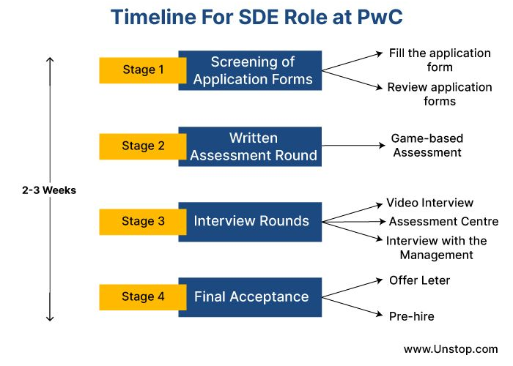
The recruitment process used by PwC is in line with the five-stage model of workforce, job analysis, attraction, selection, and onboarding by CIPD because the process is transparent and consistent.
According to the PwC UK Careers (2025), the assessment process is divided into several steps and involves behavioural, case, and technical interviews.
The company operates on the principle of Right Person, Right Job, Right Time where there is good fit between the capability of an individual and the need of an organisation.
The attraction channels which are utilised in recruitment include internal mobility schemes, LinkedIn, and global graduate portals in order to obtain high-quality candidates.
All the stages are founded on fairness, inclusivity, and equal opportunity and supported by data privacy compliance and ethical review.
Speaker Notes:
PwC has the structured recruitment strategy that guarantees procedural fairness and business focus. Through implementing the evidence-based model of CIPD, the organisation will standardize the evaluation process and will uphold the credibility of the employer and decrease the turnover and encourage new employees to engage..

Slide 5: Job Analysis, Description and Person Specification
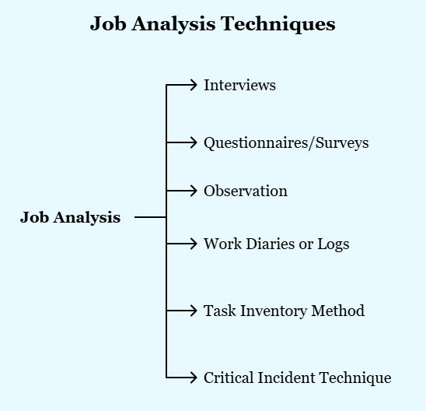
With Job Analysis, it is possible to determine the most important tasks, the authority to make decisions, and the skills to transform jobs (CIPD, 2023), which allows making recruitment-based decisions using the data.
CIPD (2023) indicates that the reliability of selection is improved by the use of structured selection techniques, which reduces the level of bias during the evaluation of the candidate.
Job post of a Transformation Project Manager involves management of digital projects, coordination of stakeholders, and provision of innovation-based results.
PwC combines psychometric mapping and digital-skills models to compare the candidates with behavioural and technical criteria.
Speaker Notes:
A rigorous job analysis justifies the recruitment requirements and reduces bias, and guarantees strategic fit. The data-centric approach of PwC makes sure that the chosen person fits in regards to transformation objectives and leadership requirements.

Slide 6: Interview Type 1: Behavioural Interview
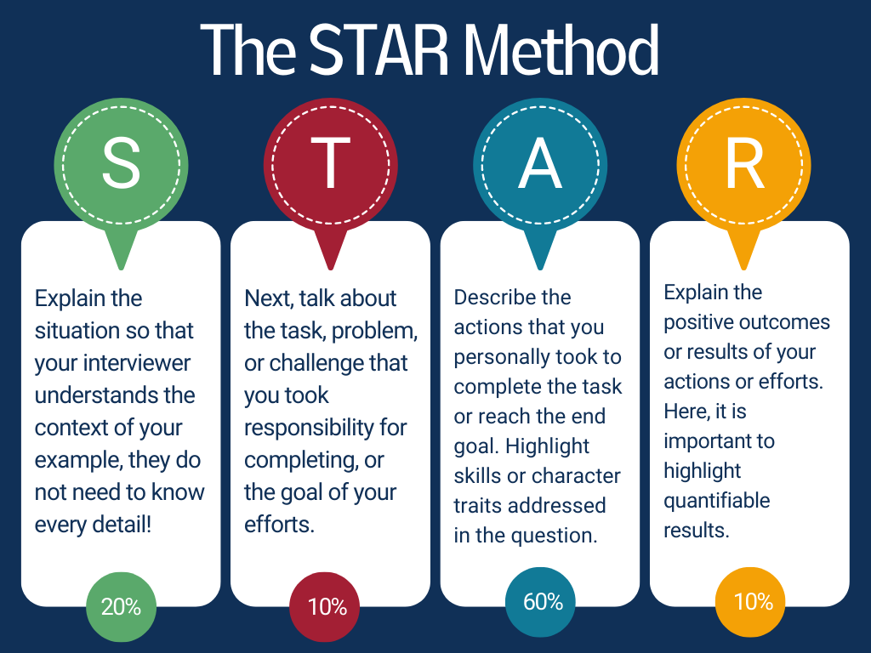
The behavioural interviews evaluate the past experiences that showed how PwC conducts its core values, which are teamwork, leadership, and integrity when interacting with clients.
The candidates answer structured questions such as, tell me when you brought change in your team.
Consistency and reliability in scoring answers is done through the use of the STAR method (Situation, Task, Action, Result).
Alder and Dinnen (2022) point out that the digital transformation demands organisations to change the models of talent-acquisition to attract professionals with tech-enabled skills.
Speaker Notes:
Through evidences of the past behaviour, behavioural interviews are used to predict future behaviour. PwC interviewers test emotional intelligence and self-awareness. They assist in the forecasting of performance, which is made possible through investigating actual instances of leadership and decision making in difficult situations.

Slide 7: Interview Type 2: Competency-Based Interview
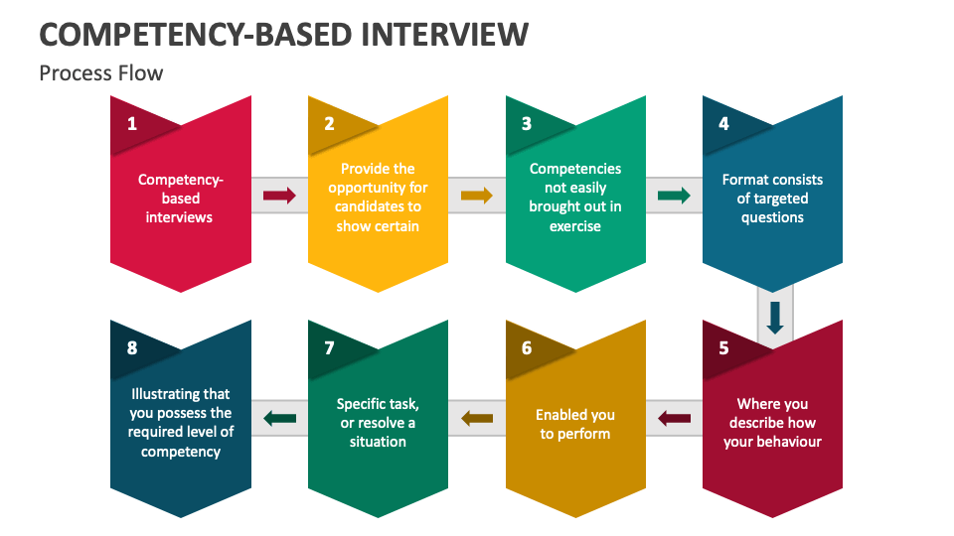
Emphasizes technical and leadership skills, especially the strategic thinking skills, stakeholder management skills, and flexibility in delivering the transformation.
Applicants are evaluated based on how they can use their knowledge in real business scenarios to make sure that they have measurable ability.
PwC relies on preset competency models and scoring rubrics correlated with the internal performance models.
According to Brown, Souto-Otero and Sadik (2023), the emergence of hybrid work reinvents the recruitment and employee-experience strategies.
Speaker Notes:
Skills can be objectively measured using competency interviews. To guarantee the consistency, PwC relies on the pre-built competency grids and scoring rubrics. Competency interviews are objective in assessing skills and behaviours. As a means of fairness, PwC uses mapping of responses to a rubric reflecting the organisational capability models and leadership frameworks.

Slide 8: Interview Type 3: Case Interview
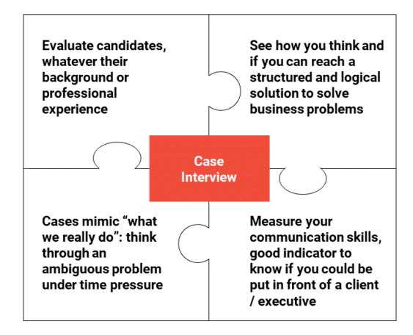
Case interviews are simulated real-life consulting scenarios that involve problem-solving, analysis, and innovations.
In order to evaluate the analytical form and clarity, candidates read information, determine the main problems, and suggest solutions.
Challenges the imagination, reasoning, and time management, which are similar to project requirements at the client level.
Mirrors the PwC culture of consultancy, based on pragmatic thinking, collaboration, and evidence-based advice.
Speaker Notes:
Case interviews evaluate the capability to think and behave intelligently. PwC interviewers also note how the candidates cope with ambiguity, share knowledge, and exhibit self-control in the conditions of a real project.

Slide 9: Questioning Techniques in Interviews
Probing Questions aim to elaborate as a response to incomplete answers or vague responses to find out the decision-making procedures.
Open questions: motivate the candidates to share ideas without restrictions, which leads to the discovery of motivation, creativity and thought.
The Socratic questioning: questions thought, introspection and questions thought to determine the level of understanding and flexibility in problem solving.
Leading questions: avoided as it is very unfair and can lead to confirmation bias. According to Bellantuono et al. (2021), digital transformation initiatives require change-management lessons to remain viable.
Speaker Notes:
The interviewers of PwC use evidence-based questioning to increase objectivity. This is a practice suggested by CIPD where the interviews are done to determine actual competence and not memorized responses, thus fostering inclusion and equity.

Slide 10: Face-to-Face Interviews at PwC
Taking place at the offices of PwC, e.g. London Bridge or Manchester, where it was possible to directly interact with assessors and team members.
Make possible the monitoring of non-verbal communication, such as confidence, professionalism, and interpersonal awareness.
Evaluate cultural fit and teams compatibility, which is critical to transformation and consulting work.
Group exercises and presentation of technical topics are often used together in the assessment.
Speaker Notes:
Face-to-face interview would involve actual interaction enabling the recruiters to determine communication and rapport building. PwC embraces interpersonal presence as a predictor of good interaction with clients and leadership preparedness.

Slide 11: Online Interviews at PwC
According to Kolhe and Bhat (2024), a successful recruitment plan should not focus on the economic but rather on the psychological competency evaluation.
Administered via HireVue, Microsoft Teams, or its own assessment platform (PwCs) which is global and flexible.
Increase diversity through elimination of geographic and scheduling costs, to ensure fair access.
Restrict low-level interpersonal monitoring, which can at times diminish the level of assessment.
Speaker Notes:
Virtual interviewing is more inclusive and efficient to help achieve the PwC sustainability goals. Nevertheless, they need to be counterbalanced with live communication to assess subtleties of communication and genuineness of candidates.

Slide 12: Comparison: Online vs Face to Face Interviews.
Criterion | Face-to-Face | Online
Observation | High level of non-verbal insight | Limited body language cues
Accessibility | Location dependent | Global access and flexible participation
Cost & Time | Higher logistical costs | Lower costs and faster scheduling
Bias Control | Subjective potential | Structured digital scoring reduces bias
Speaker Notes:
There are the advantages of both types of interviews. PwC has a strategic approach in combining techniques where early rounds would be digital and final rounds would be in-person cultural-fit evaluations to avoid wastage but not quality.

Slide 13: Recruitment Ethics and Diversity
PwC has zero-tolerance levels with regard to discrimination practices, and all its recruiting policies incorporate equality and diversity.
Interview boards are designed in a way to provide gender and ethnic representation minimizing unconscious bias.
According to Jedynak et al. (2021), digital transformation relies on adaptive leadership and restructured HR.
Each and every assessor undertakes diversity and bias-awareness training every year.
Data management is in accordance with the GDPR and internal ethics, which guarantees confidentiality and transparency.
Speaker Notes:
Ethical recruitment strengthens the reputation of PwC and its stakeholders all over the world. The policies that are based on diversity do not only ensure fairness but also enhance inventiveness and innovation among the transformation teams.

Slide 14: Conclusion
The recruitment process at PwC UK is structured, consistent and it is consistent with the business transformation objectives.
The behavioural interview, competency and case interview will ensure that there is a multi-dimensional assessment of potential among the candidates.
The styles of interrogation represent the compatibility with organisational culture and emotional intelligence.
The combination of face-to-face and online assessment will enhance agility, inclusivity and sustainability of the environment.
Speaker Notes:
The most important factor in the outstanding recruitment in PwC is the balance between the structure and innovation. It has been in a position to retain the finest workforce in responsive roles that will advance organisational growth basing on data-driven analysis and ethical leadership.

Slide 15: References
PwC UK Careers, 2025. Assessment Journey and Interview Tips. Available at: https://www.pwc.co.uk/careers.html. [Accessed On: 06.11.2025]
CIPD, 2023. Selection Methods Factsheet. Available at: https://www.cipd.org/en/knowledge/factsheets/selection-factsheet. [Accessed On: 06.11.2025]
Kolhe, D. and Bhat, A., 2024. Recruitment and Selection in a Global Market: Economic Costs and Psychological Competencies. International Journal of Intellectual Human Resource Management (IJIHRM), 5(02), pp.15-29.
Alder, M. and Dinnen, M., 2022. Digital talent: Find, recruit and retain the people your business needs in a world of digital transformation. Kogan Page Publishers.
Jedynak, M., Czakon, W., Kuźniarska, A. and Mania, K., 2021. Digital transformation of organizations: what do we know and where to go next?. Journal of Organizational Change Management, 34(3), pp.629-652.
Brown, P., Souto-Otero, M. and Sadik, S., 2023. Digital transformation and the future of work. In The SAGE Handbook of Digital Society (pp. 559-572). SAGE Publications Ltd.
Bellantuono, N., Nuzzi, A., Pontrandolfo, P. and Scozzi, B., 2021. Digital transformation models for the I4. 0 transition: Lessons from the change management literature. Sustainability, 13(23), p.12941.

Slide 16: Thank You

