Title: Sanding and Surface Preparation, a Practical Repeatable Workflow

Slide 1 — Why Prep Matters
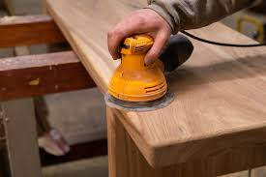
- Preparation determines adhesion, durability, final appearance, reducing rework from start.
- Assess substrate: wood, metal, filler, composites, check moisture and grain.
- Define defects: highs, lows, scratches, contamination; map using raking light.
- Plan workflow: level, fill, sand, clean, verify; allocate time wisely.
Speaker notes:
Now compare a hurry job with one which has been completed by meticulous work preparation. Ask the participants to hand sand rather than use machine in order to experience the surface and be able to have control. Close by explaining basic safety regulations in order to provide a clean, efficient, and injury free working environment.

Slide 2— Read the Surface First
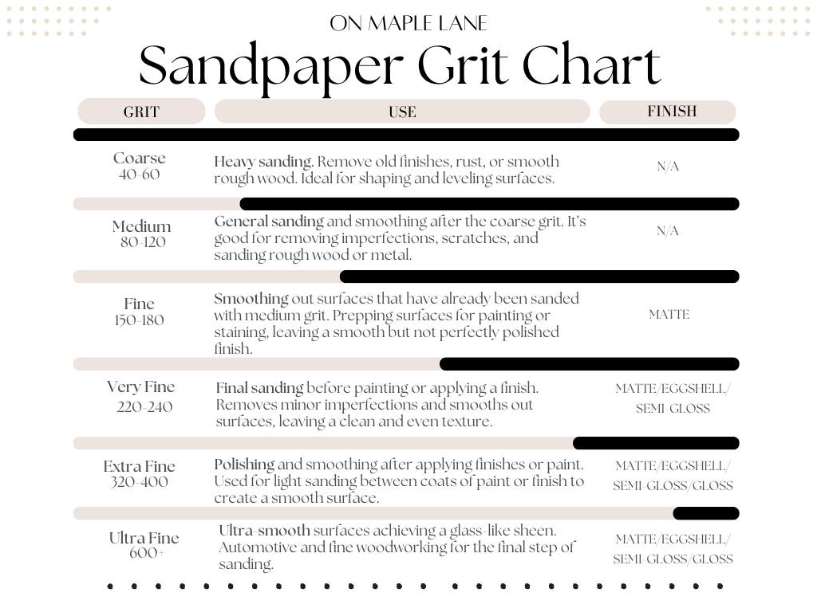
- Study defects under raking light, circle, label, use pencil guides.
- Wood surfaces: note grain, knots, end grain absorption; recheck passes (da Vera et al., 2022).
- Metal surfaces: identify scale, oxidation, coatings, discoloration; choose solvent first.
- Fill lows, chamfer edges lightly, protect profiles, mask before sanding.
Speaker notes:
When cleaning metal surfaces, it becomes important to ensure that the type of coating and the solvent are compatible to avoid damages and correct adhesion in the future during the other stages of the finishing.

Slide 3— Grit Selection and Progression

- Match starting grit to defect size and substrate; test scrap.
- Wood: 80,120,180,220; finish grain (Rao et al., 2024) as recommended.
- Metal: start finer, 120 to 180, nonwoven pads for blend.
- Following the removal of all the prior scratches, proceed and ensure the use of pencil or guide coat.
Speaker notes:
Elaborate cross hatch passes that leave scratches that are visible behind to move up. Discuss the reason why primers are not colorful, but not texturally. Explain crosshatch passes that leave other scratches visible before proceeding and they go over them.

Slide 4— Tools and Technique
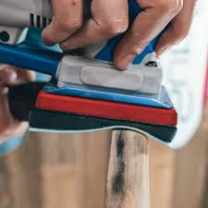
- Random orbit sanders flatten efficiently; vacuum plus interface pads contour.
- Sanding blocks preserve edges, keep faces flat, control pressure (Andrews et al., 2021).
- Hand sanding suits profiles, break sharp edges gently to prevent chipping.
- Move slowly, overlap, change discs, avoid pressure, abrasives cut cleanly.
Speaker notes:
Apply solid cushions to flat and pillow cushions to curved surfaces. Determine the difference between a rounded edge occasioned by bad machine handling and an edge occasioned by hand blocking. Vacuum holes and pad to be cleaned as often as possible to achieve optimum dust removal and cutting performance.

Slide 5— Cleanliness and Conditions
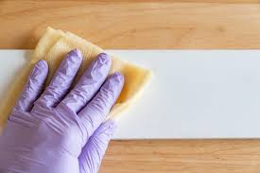
- Dust ruins adhesion and appearance; vacuum thoroughly with brush nozzle.
- Tack carefully with clean cloth, avoid silicone contamination sources always (Aldwais et al., 2025).
- Degrease metals with approved solvent, confirm compatibility before wiping thoroughly.
- Control temperature, humidity, moisture; inspect with bright light before coating.

Speaker notes:
Demonstrate Show vacuum technique which literally removes dust in pores and then show example of light touch using tack cloth. Importance of warning about the residues of furniture polish and fabric softener that create fiskeyes. In the case of metal, lint free wipe and approved degreasers are to be used. Watch store conditions, particularly in colder areas as temperature variations are extremely dramatic on open time.

Slide 6— Inspect and Verify
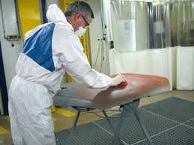
- Preview scratches with mineral spirits, reversible check before staining wood.
- On primers, mist guide coat, sand lightly to reveal lows.
- Document defects, correct immediately, use pencil guides for tracking consistently.
- Run a ready-or-not panel; train eyes, invite votes before reveals.
Speaker notes:
Demonstrate mineral spirits on a sample board, then wipe dry to show reversibility. On primed panels, dust a contrasting guide coat, sand until highs clear and lows remain shaded. Invite the room to vote ready or not, then discuss fixes. Emphasize documenting steps so recurring defects are traced and prevented.

Slide 7: Reference
- da Vera, N.O., Pio, I.H.P., da Luz, F.D.B., de Sá Brandim, A. and Leite, R.C., 2022. Procedures for preparing metallic specimens for submission to optical microscopy. Conjecturas, 22(5), pp.93-109.
- Rao, S.S., Kuang, D. and McManus, C., 2024, March. Study of Minimal Surface Preparation for Various Patch Repair Coating Products Applied under the Minimum Allowable Temperatures. In CONFERENCE 2024 (pp. 1-13). Association for Materials Protection and Performance.
- Andrews, A.S., Powers, J.R., Cichowicz, J.K., Coffey, C.C., Fries, M.L., Yorio, P.L. and D'Alessandro, M.M., 2021. Respiratory protection in a time of crisis: NIOSH testing of international respiratory protective devices for emergency use. Health security, 19(4), pp.379-385.
- Aldwais, S., Al-Muntaser, A.A., Chen, C., Robles, J., Pal, A. and Abiade, J.T., 2025. Enhancing the Adhesion of Polyaniline on Steel Substrates Without a Binding Agent: Evaluated by ASTM D 3359 Tape Test and Sodium Chloride (NaCl) Exposure. Polymers, 17(8), p.1082.

